Science Priorities for Mars Sample Return

By the MEPAG Next Decade Science Analysis Group

MEPAG Next Decade Science Analysis Group (ND_SAG):
Lars Borg (co-chair), David Des Marais (co-chair), David Beaty, Oded Aharonson, Steve Benner, Don Bogard, John Bridges, Charles Budney, Wendy Calvin, Ben Clark, Jennifer Eigenbrode, Monica Grady, Jim Head, Sidney Hemming, Noel Hinners, Vicky Hipkin, Glenn MacPherson, Lucia Marinangeli, Scott McLennan, Hap McSween, Jeff Moersch, Ken Nealson, Lisa Pratt, Kevin Righter, Steve Ruff, Chip Shearer, Andrew Steele, Dawn Sumner, Steve Symes, Jorge Vago, Frances Westall

March 15, 2008

With input from the following experts:
MEPAG Goal I. Anderson, Marion (Monash U., Australia), Carr, Mike (USGS-retired), Conrad, Pamela (JPL), Glavine, Danny (GSFC), Hoehler, Tori (NASA/ARC), Jahnke, Linda (NASA/ARC), Mahaffy, Paul (GSFC), Schaefer, Bruce (Monash U., Australia), Tomkins, Andy (Monash U., Australia), Zent, Aaron (ARC)
MEPAG Goal II. Bougher, Steve (Univ. Michigan), Byrne, Shane (Univ. Arizona), Dahl-Jensen, Dorthe (Univ. of Copenhagen), Eiler, John (Caltech), Engelund, Walt (LaRC), Farquahar, James (Univ. Maryland), Fernandez-Remolar, David (CAB, Spain), Fishbaugh, Kate (Smithsonian), Fisher, David (Geol. Surv. Canada), Heber, Veronika (Switzerland), Hecht, Mike (JPL), Hurowitz, Joel (JPL), Hvidberg, Christine (Univ. of Copenhagen), Jakosky, Bruce (Univ. Colorado), Levine, Joel (LaRC), Manning, Rob (JPL), Marti, Kurt (U.C. San Diego), Tosca, Nick (Harvard University)
MEPAG Goal III. Banerdt, Bruce (JPL), Barlow, Nadine (Northern Ariz. Univ.), Clifford, Steve (LPI), Connerney, Jack (GSFC), Grimm, Bob (SwRI), Kirschvink, Joe (Caltech), Leshin, Laurie (GSFC), Newsom, Horton, (Univ. New Mexico), Weiss, Ben (MIT)
MEPAG Goal IV. McKay, David (JSC), Allen, Carl ((JSC), Jolliff, Brad (Washington University), Carpenter, Paul (Washington University), Eppler, Dean (JSC), James, John (JSC), Jones, Jeff (JSC), Kerschman, Russ (NASA/ARC), Metzger, Phil (KSC)

Recommended bibliographic citation:
MEPAG ND-SAG (2008). Science Priorities for Mars Sample Return, Unpublished white paper, 73 p, posted March 2008 by the Mars Exploration Program Analysis Group (MEPAG) at http://mepag.jpl.nasa.gov/reports/index.html.

Correspondence authors:
Inquiries should be directed to David Des Marais (David.J.DesMarais@nasa.gov, 650 604 3220), Lars Borg (borg5@llnl.gov, 925-424-5722), or David W. Beaty (David.Beaty@jpl.nasa.gov, 818-354-7968)
TABLE OF CONTENTS
I. EXECUTIVE SUMMARY 1
II. INTRODUCTION 4
III. EVALUATION PROCESS 5
IV. SCIENTIFIC OBJECTIVES OF MSR 6
IV-A. History, Current Context of MSR’s scientific objectives 6
IV-B. Possible Scientific Objectives for a Next Decade MSR 7
V. SAMPLES REQUIRED TO ACHIEVE THE SCIENTIFIC OBJECTIVES 13
V-A. Sedimentary materials rock suite. 13
V-B. Hydrothermal rock suite 14
V-C. Low temperature altered rock suite. 15
V-D. Igneous rock suite. 16
V-E. Regolith 17
V-F. Polar Ice 19
V-G. Atmospheric gas 20
V-H. Dust 22
V-I. Depth-resolved suite 23
V-J. Other 24
VI. FACTORS THAT WOULD AFFECT THE SCIENTIFIC VALUE OF THE RETURNED SAMPLES 26
VI-A. Sample size 26
VI-B. Number of Samples. 32
VI-C. Sample Encapsulation. 35
VI-D. Diversity of the returned collection 36
VI-E. In situ measurements for sample selection and documentation of field context. 37
VI-F. Surface Operations 39
VI-G. Sample acquisition system priorities 39
VI-H. Temperature. 40
VI-I. Planning Considerations Involving the MSL/ExoMars Caches 42
VI-J. Planetary Protection 46
VI-K. Contamination Control 49
VI-L. Documented Sample Orientation 49
VI-M. Program Context, and Planning for the First MSR 50
VII. SUMMARY OF FINDINGS AND RECOMMENDED FOLLOW-UP STUDIES 52
VIII. ACKNOWLEDGEMENTS 54
IX. REFERENCES 55

LIST OF TABLES
Table 1 Scientific Objectives, ‘03/’05 MSR, 2009 MSL, and 2013 ExoMars (order listed as in the originals) 7
Table 2 Planning aspects related to a returned gas sample. 21
Table 3 Summary of Sample Types Needed to Achieve Proposed Scientific Objectives. 25
Table 4 Subdivision history of Martian meteorite QUE 94201 28
Table 5 Generic plan for mass allocation of individual rock samples 30
Table 6 Summary of number, type, and mass of returned samples. 34
Table 7 Rover-based Measurements to Guide Sample Selection. 38
Table 8 Science Priorities Related to the Acquisition System for Different Sample Types. 40
Table 9 Effect of Maximum Sample Temperature on the Ability to Achieve the Candidate Science Objectives. 41
Table 10 Relationship of the MSL cache to planning for MSR. 45
Table 11 Science priority of attributes of the first MSR. 51

ACRONYM GLOSSARY
AMS | Accelerator mass Spectrometry
APXS | Alpha Proton X-ray Spectrometer
ATLO | Assembly, Test, and Launch Operations
COSPAR | Committee on Space Research.
EDL | Entry, Descent, and Landing, a critical phase for Martian landers
EDX | Energy Dispersive analysis
EMPA | Electron Microprobe Analysis
ExoMars | A rover mission to Mars planned by the European Space Agency
FTIR | Fourier transform infrared spectrometer
GC | Gas Chromatograph
GCR | Galactic cosmic rays
GSFC | Goddard Space Flight Center
IMEWG | International Mars Exploration Working Group
INAA | Instrumental Neutron Activation Analysis
JSC | Johnson Space Center
KSC | Kennedy Space Center
LaRC | Langley Research Center
LD-BH | Life Detection and Biohazard Testing; used in the context of the test protocol
LDMS | laser-desorption mass spectrometry
MAV | Mars Ascent Vehicle. The rocket that will lift the samples off the Martian surface.
MEP | Mars Exploration Program
MEPAG | Mars Exploration Program Analysis Group
MER | Mars Exploration Rover. A NASA mission launched in 2003
MEX | Mars Express, a 2003 mission of the European Space Agency
MI | Microscopic Imager. An instrument on the 2003 MER mission.
MOD | Mars Organic Detector.
MOMA | Mars Organic Molecule Analyzer; an instrument proposed for the 2013 ExoMars mission
MRO | Mars Reconnaissance Orbiter, a 2005 mission of NASA
MS | Mass Spectrometry
MSL | Mars Science Laboratory—a NASA mission to Mars scheduled to launch in 2009
MSR | Mars Sample Return.
ND-MSR SAG | Next Decade Mars Sample Return Science Analysis Group
OCSSG | Organic Contamination Science Steering Group, a MEPAG committee
PI | Principal Investigator
PLD | Polar Layered Deposits
PP | Planetary Protection
SAM | Surface Analysis at Mars; an instrument on the 2009 MSL mission
SEM | Scanning Electron Microscopy
SIMS | Secondary Ion Mass Spectrometry
SNC Meteorites | The group of meteorites interpreted to have come from Mars
SRF | Sample Receiving Facility
SSG | Science Steering Group. A subcommittee of MEPAG.
TEM | Transmission Electron Microscopy
TIMS | Thermal Ionization Mass Spectrometry
TOF-SIMS | Time of Flight Secondary Ion Mass Spectrometry
VNIR | Visible/near infrared
XANES | X-Ray Absorption Near Edge Structure
XRD | X-Ray Diffraction. A generic method for determining mineralogy
XRF | X-Ray Fluorescence. A generic method for determining sample chemistry

EXECUTIVE SUMMARY
The return of Martian samples to Earth has long been recognized to be an essential component of a cycle of exploration that begins with orbital reconnaissance and in situ surface investigations. Major questions about life, climate and geology require answers from state-of-the-art laboratories on Earth. Spacecraft instrumentation cannot perform critical measurements such as precise radiometric age dating, sophisticated stable isotopic analyses and definitive life-detection assays. Returned sample studies could respond radically to unexpected findings, and returned materials could be archived for study by future investigators with even more capable laboratories. Unlike Martian meteorites, returned samples could be acquired with known context from selected sites on Mars according to the prioritized exploration goals and objectives.
The ND-MSR-SAG formulated the following 11 high-level scientific objectives that indicate how a balanced program of ongoing MSR missions could help to achieve the objectives and investigations described by MEPAG (2006).
  - Determine the chemical, mineralogical, and isotopic composition of the crustal reservoirs of carbon, nitrogen, sulfur, and other elements with which they have interacted, and characterize carbon-, nitrogen-, and sulfur-bearing phases down to submicron spatial scales, in order to document processes that could sustain habitable environments on Mars, both today and in the past.
  - Assess the evidence for pre-biotic processes, past life, and/or extant life on Mars by characterizing the signatures of these phenomena in the form of structure/morphology, biominerals, organic molecular and isotopic compositions, and other evidence within their geologic contexts.
  - Interpret the conditions of Martian water-rock interactions through the study of their mineral products.
  - Constrain the absolute ages of major Martian crustal geologic processes, including sedimentation, diagenesis, volcanism/plutonism, regolith formation, hydrothermal alteration, weathering, and cratering.
  - Understand paleoenvironments and the history of near-surface water on Mars by characterizing the clastic and chemical components, depositional processes, and post-depositional histories of sedimentary sequences.
  - Constrain the mechanism and timing of planetary accretion, differentiation, and the subsequent evolution of the Martian crust, mantle, and core.
  - Determine how the Martian regolith was formed and modified, and how and why it differs from place to place.
  - Characterize the risks to future human explorers in the areas of biohazards, material toxicity, and dust/granular materials, and contribute to the assessment of potential in-situ resources to aid in establishing a human presence on Mars.
  - For the present-day Martian surface and accessible shallow subsurface environments, determine the preservation potential for the chemical signatures of extant life and pre-biotic chemistry by evaluating the state of oxidation as a function of depth, permeability, and other factors.
  - Interpret the initial composition of the Martian atmosphere, the rates and processes of atmospheric loss/gain over geologic time, and the rates and processes of atmospheric exchange with surface condensed species.
  - For Martian climate-modulated polar deposits, determine their age, geochemistry, conditions of formation, and evolution through the detailed examination of the composition of water, CO₂, and dust constituents, isotopic ratios, and detailed stratigraphy of the upper layers of the surface.
MSR would attain its greatest value if samples are collected as sample suites that represent the diversity of the products of various planetary processes. Sedimentary materials likely contain complex mixtures of chemical precipitates, volcaniclastics, impact glass, igneous rock fragments, and phyllosilicates. Aqueous sedimentary deposits are important for performing measurements of life detection, observations of critical mineralogy and geochemical patterns and trapped gases. On Earth, hydrothermally altered rocks can preserve a record of hydrothermal systems that provided water, nutrients and chemical energy necessary to sustain microorganisms and also might have preserved fossils in their mineral deposits. Hydrothermal processes alter the mineralogy of crustal rocks and inject CO₂ and reduced gases into the atmosphere. Chemical alteration occurring at near-surface ambient conditions (typically < ~20°C) create low temperature altered rocks and includes, among other things, aqueous weathering and various nonaqueous oxidation reactions. Understanding the conditions under which alteration proceeds at low temperatures would provide important insight into the near-surface hydrological cycle, including fluid/rock ratios, fluid compositions (chemical and isotopic, as well as redox conditions), and mass fluxes of volatile compounds. Igneous rocks are expected to be primarily lavas and shallow intrusive rocks of basaltic composition. They are critical for investigations of the geologic evolution of the Martian surface and interior because their geochemical and isotopic compositions constrain both the composition of mantle sources and the processes that affected magmas during generation, ascent, and emplacement. Regolith samples (unconsolidated surface materials) record interactions between crust and atmosphere, the nature of rock fragments, fine particles that have been moved over the surface, exchange of H₂O and CO₂ between near-surface solid materials and the atmosphere, and processes involving fluids and sublimation. Regolith studies would help facilitate future human exploration by assessing toxicity and potential resources. Polar ices would constrain present and past climatic conditions and help elucidate water cycling. Surface ice samples from the Polar Layered Deposits or seasonal frost deposits would help to quantify surface/atmosphere interactions. Short cores could help to resolve recent climate variability. Atmospheric gas samples would constrain the composition of the atmosphere and processes that influenced its origin and evolution. Trace organic gases (e.g., methane and ethane) could be analyzed for abundances, distribution, and relationships to a potential Martian biosphere. Returned atmospheric samples containing Ne, Kr, CO₂, CH₄ and C₂H₆ would confer major scientific benefits. Chemical and mineralogical analyses of Martian dust would help to elucidate the weathering and alteration history of Mars. Given the global homogeneity of Martian dust, a single sample is likely to be representative of the planet. A depth-resolved suite of samples should be obtained from depths ranging from cm to several m within regolith or from rock outcrop in order to investigate trends in the abundance of oxidants (e.g., OH, HO₂, H₂O₂ and peroxy radicals) the effects of radiation, and the preservation of organic matter. Other sample suites include impact breccias that might sample rock types that are otherwise not available locally, tephra consisting of fine-grained regolith material or layers and beds possibly delivered from beyond the landing site, and meteorites whose alteration history could provide insights into Martian climatic history.
The following factors would affect our ability to achieve MSR’s science objectives.
1. Sample size. A full program of science investigations would likely require samples of >8 g for bedrock, loose rocks and finer-grained regolith. To support required biohazard testing, each sample requires an additional 2 g, leading to an optimal size of 10 g. Textural studies of some rock types might require one or more larger samples of ~20 g. Material should remain to be archived for future investigations.
2. Number of samples. Studies of differences between samples could provide more information than detailed studies of a single sample. The number of samples needed to address MSR scientific objectives effectively is 35 (28 rock, 4 regolith, 1 dust, 2 gas), If the MSR mission recovers the MSL cache, it should also collect 26 additional samples (20 rock, 3 regolith, 1 dust and 2 atmospheric gas). The total mass of these samples is expected to be about 345 g (or 380 g with the MSL cache). The total returned mass with sample packaging would be about 700 g.
3. Sample encapsulation. To retain scientific value, returned samples must not commingle, each sample must be linked uniquely to its documented field context, and rocks should be protected against fragmentation during transport. A smaller number or mass of carefully managed samples is far more valuable than a larger number or mass of poorly managed samples. The encapsulation of at least some samples must retain any released volatile components.
4. Diversity of the returned collection. The diversity of returned samples must be commensurate with the diversity of rocks and regolith encountered. This guideline substantially influences landing site selection and rover operation protocols. It is scientifically acceptable for MSR to visit only a single site, but visiting two independent landing sites would be much more valuable.
5. In situ measurements for sample selection and documentation of field context. Relatively few samples can be returned from the vast array materials that the MSR rover will encounter, thus we must be able to choose wisely. At least three kinds of in situ observations are needed (color imaging, microscopic imaging, and mineralogy measurement), and possibly as many as five (also elemental analysis and reduced carbon analysis). No significant difference exists in the observations needed for sample selection vs. sample documentation. Revisiting a previously occupied site might result in a reduction in the number of instruments.
6. Surface operations. To collect the samples required by MSR objectives, the lander must have significant surface mobility and the capability to assess and sample the full diversity of materials. Depending on the geology of the site, at least 6 to 12 months of surface operation will be required in order to explore a site and to assess and collect a set of samples.
7. Sample acquisition system. This system must sample weathered exteriors and unweathered interiors of rocks, sample continuous stratigraphic sequences of outcrops that might vary in their hardness, relate the orientation of sample structures and textures to those in outcrop surfaces, bedding planes, stratigraphic sequences, and regional-scale structures, and maintain the structural integrity of samples. A mini-corer and a scoop are the most important collection tools. A gas compressor and a drill have lower priority but are needed for certain samples.
8. Sample temperature. Some key species (e.g., organics, sulfates, chlorides, clays, ice, and liquid water) are sensitive to temperatures above surface temperatures. Objectives could most confidently be met if samples are kept below -20ºC, and with less confidence if they are below +20ºC. Significant loss, particularly to biological studies, occurs if samples reach +50ºC for 3 hours. Temperature monitoring during return would allow any changes to be evaluated.
9. Planning considerations involving the MSL/ExoMars caches. Retrieving the MSL or ExoMars cache might alter other aspects of the MSR mission. However, given the limitations of the MSL cache, differences in planetary protection requirements for MSL and MSR, the possibility that the cache might not be retrievable, and the potential for MSR to make its own discoveries, the MSR rover should be able to characterize and collect at least some of returned samples.
10. Planetary protection. A scientifically compelling first MSR mission does not require the capability to access and sample a special region, defined as a region within which terrestrial organisms may propagate. Unless MSR could land pole-ward of 30° latitude, access rough terrain, or achieve significant subsurface penetration (>5 m), MSR is unlikely to be able to use incremental special regions capabilities. Planetary protection draft test protocols should be updated to incorporate advances in biohazard analytical methods. Statistical principles governing mass requirements for sub-sampling returned samples for these analyses should be re-assessed.
11. Contamination control. Inorganic and organic contamination must be minimized in order to achieve MSR science objectives. A study is needed to specify sample cleanliness thresholds that must be attained during sample acquisition and processing.

INTRODUCTION
Since the dawn of the modern era of Mars exploration, the return of Martian samples to Earth has been recognized as an essential component of a cycle of exploration that began with orbital reconnaissance and in situ surface investigations (see, for example, the discussion of sample return in three decades of reports by the National Research Council: e.g. NRC, 1978; 1990a, 1990b, 1994; 1996; 2001; 2007). Global reconnaissance and surface observations have “followed the water” and revealed a geologically diverse Martian crust that could have sustained near-surface habitable environments in the distant past. However, major questions about life, climate, and geology remain, and many of these require answers that only Earth-based state-of-the-art analyses of samples could provide. The stems from the fact that flight instruments cannot match the adaptability, array of sample preparation procedures, and micro-analytical capability of Earth-based laboratories (Gooding et al., 1989). For example, analyses conducted at the submicron scale were crucial for investigating the ALH84001 meteorite, and they would be essential for interpreting the returned samples. Furthermore, spacecraft instrumentation simply cannot perform certain critical measurements, such as, precise radiometric age dating, sophisticated stable isotopic analyses, and comprehensive life-detection experiments. If returned samples yield unexpected findings, subsequent investigations could be adapted accordingly. Moreover, potions of returned samples could be archived for study by future generations of investigators using ever more powerful instrumentation.
Some samples from Mars are available for research on Earth in the form of the Martian meteorites. The Martian meteorites, while indeed valuable, provide a limited view of Martian geologic processes. These samples are all igneous in nature, and minimally altered and thus do not record the history of low temperature water based processes. These samples certainly do not represent the most promising habitable environments (Gooding et al., 1989), and it is possible that the most extensively water-altered materials might be too fragile to survive an interplanetary journey. Most meteorites have young crystallization ages less than 1.3 billion years indicating that they represent only the most recent igneous activity on Mars (Borg and Drake, 2005). Their geochemical characteristics suggest that they are closely related to one another and are consequently not representative of all of the lithologic and geochemical diversity that is likely to be present in igneous Martian rock suite (Borg and Draper, 2003; Borg et al., 2003; Symes et al., 2008). Because the meteorites arrived by natural processes, and lack geologic context, it is extremely difficult to extrapolate the results from geologic studies of these samples to rocks observed from space or on the Martian surface by landed spacecraft. In contrast, returned samples could be obtained from sites within a known geologic context and be selected in order to achieve the goals and objectives of the Mars exploration community. Nevertheless, sample return missions must surmount key challenges such as, engineering complexity, cost, and planetary protection concerns, before their enormous potential could be recognized. This document is intended to define this critical step forward toward realizing the enormous potential of Mars sample return.
On July 10, 2007, Dr. Alan Stern, Associate Administrator for the Science Mission Directorate (SMD), described to the participants in the 7th International Conference on Mars his vision of achieving Mars Sample Return (MSR) no later than the 2020 launch opportunity. He requested that the financial attributes, scientific options/issues/concerns, and technology development planning/budgeting details of this vision be analyzed over the next year. The Mars Exploration Program Analysis Group (MEPAG) is contributing to this effort by preparing this analysis of the science components of MSR and its programmatic context. To this end, MEPAG chartered the Next Decade MSR Science Analysis Group (ND-MSR-SAG) to complete four specific tasks:
(1) Analyze what critical Mars science could be accomplished in conjunction with, and complementary to, a next decade MSR mission.
(2) Evaluate the science priorities associated with guiding the makeup of the sample collection to be returned by MSR.
(3) Determine the dependencies of mobility and surface lifetime of MSR on the scientific objectives, sample acquisition capability, diagnostic instrument complement, and number and type of samples.
(4) Support MSR science planning as requested by the International Mars Exploration Working Group (IMEWG) MSR study. The charter is presented in Appendix I.
The return of any reasonable sample mass from Mars would significantly increase our understanding of atmospheric, biologic, and geologic processes occurring there, as well as permit evaluation of the hazards to humans on the surface. This is largely independent of how the samples are selected, collected, and packaged for return, and stems from the fact that there are no analogous samples on Earth. Thus, a mission architecture in which a limited number of surface samples are collected in a minimum amount of geologic context has been recommended in the past and has huge scientific merit (e.g., MacPherson et al., 2005). It is also important to realize that a significantly greater scientific yield would result from samples that are more carefully selected. Analytical results from samples that are screened, placed in detailed geologic context, collected from numerous locations and environments, and are packaged and transported under conditions that more closely approximate those encountered on the Martian surface, would dramatically clarify the picture of Mars derived from the mission, as well as allow analytical results to be more rigorously extrapolated to the planet as a whole. As a consequence of these facts, this document outlines a sampling strategy that is necessary to maximize scientific yield. The inability to complete all of the surface operations associated with this sampling strategy by no means negates the usefulness of these samples. Rather, it results in a proportional loss of science yield of the mission. Thus, this study is expected to constitute input to a Mars program architecture trade analysis between scientific yield and cost.

EVALUATION PROCESS
Prior to beginning this study, the ND-SAG was briefed on the conclusions of the NASA Mars Sample Return Science Steering Group II (MacPherson et al., 2005; Appendix III) and the NRC Committee on an Astrobiology Strategy for the Exploration of Mars. These reports document the importance of sample return in a complete strategy for the exploration of Mars, and many of their conclusions are reiterated here. However, the current analysis has benefited from discoveries made in the interval since these reports were written, such as phyllosilicates, silica, and the distribution and context of poly-hydrated sulfates on the surface of Mars. It is expected that some of the conclusions of this report will be further elucidated and/or strengthened as results from Phoenix, MSL, and ExoMars become available. This may be particularly true of the results from analyses of organic matter and ices.
Assumptions used in this study are:
(1) The sample return mission would begin in either 2018 or 2020.
(2) MSL will launch in 2009, and will prepare a rudimentary cache of samples that would be recoverable by the MSR mission. ExoMars would carry a similar cache.
(3) The functionality of sample acquisition associated with MSR would be independent of MSL. This functionality may either be landed at the same time as the sample return element of MSR, or it may be separated into a precursor mission.
(4) The Mars Exploration Program would maintain a stable program budget of about $625M/year that grows at 2%/year.
In order to complete these tasks and to link strongly the report of the ND-SAG to the MEPAG Goals document, the ND-SAG was divided into four subteams corresponding to each of the four main MEPAG goals. The goals, as outlined in the Goals document, are: determine if life ever arose on Mars, understand the processes and history of climate on Mars, determine the evolution of the surface and interior of Mars, and prepare for human exploration. Each group examined the individual investigations outlined in the MEPAG Goals Document and considered the following:
- Whether sample return would facilitate the investigation.
- The type, mass, number, and diversity of samples that would be required to complete the investigation.
- The physical condition of the samples (rock, pulverized rock, etc.).
- The vulnerability of specific sample types to degradation effects during sample collection, encapsulation, and transport, as well as the impact of this degradation on individual investigations.
- The measurements required at the time of sample collection in order to select appropriate samples and place them in the necessary geologic context.
- The mobility necessary to obtain required samples.
- The packaging and handling priorities necessary to preserve the characteristics of interest in the samples.
The results of this analysis are presented in detail in Appendix II. Below we summarize the consensus of the ND-SAG that was derived from this analysis.

SCIENTIFIC OBJECTIVES OF MSR

History, Current Context of MSR’s scientific objectives
The 2003/2005 Mars Sample Return mission (which was cancelled in 2000, prior to launch) was the most recent effort that formulated scientific objectives for MSR. The way this mission chose to frame its scientific objectives are listed in Table 1. Since 2000, there have been numerous scientific advances that have greatly increased our understanding of the red planet. It is critical to take these into consideration in setting the new scientific objectives for MSR. In particular, it is important to incorporate actual or anticipated results from the following:
Recent and on-going flight missions
Since the last MSR analysis in 2000, the Mars Global Surveyor (1999-2006), Mars Odyssey (2002-present), Mars Exploration Rovers (2004-present), Mars Express (mapping from 2004-present), and the Mars Reconnaissance Orbiter (mapping from 2006-present) have made important discoveries. These investigations have greatly improved our understanding of Mars and have resulted in progressive refinement of key Martian scientific objectives, as documented by the evolution of the MEPAG Goals Document (MEPAG, 2001; MEPAG, 2004; MEPAG, 2005; MEPAG, 2006).
Future (but pre-MSR) flight missions
Two major missions to the Martian surface are scheduled during the next six years - the Mars Science Laboratory (MSL; scheduled for launch in 2009), and ExoMars (scheduled for launch in 2013). Both missions will analyze rock samples on the surface of Mars using in-situ methods. It is therefore necessary to consider the scientific objectives of these missions when planning the objectives of the first MSR mission, and to build upon their expected accomplishments. The scientific objectives of the MSL and ExoMars missions, as of 2007, are listed in Table 1.
Meteorite studies
More than 35 Martian meteorites have been found in Antarctica and desert environments by meteorite recovery programs, including private and government-sponsored efforts. The number of recovered meteorites continually increases. As a consequence, MSR science objectives and sample selection strategy must respond to scientific advances derived from meteorite studies and also strive to complement the existing meteorite collections.

Table 1 Scientific Objectives, ‘03/’05 MSR, 2009 MSL, and 2013 ExoMars (order listed as in the originals)
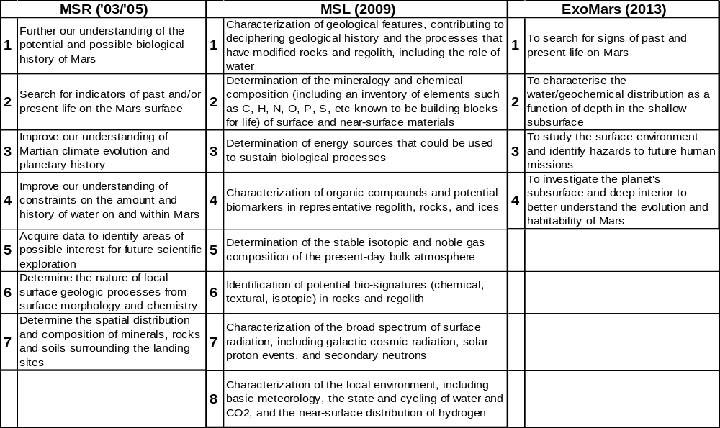Sources of information: MSR: O’Neil and Cazaux (2000); MSL: http://mepag.jpl.nasa.gov/MSL_Science_Objectives.html (as of Jan. 7, 2008); ExoMars: Vago and Kiminek (2007)

Possible Scientific Objectives for a Next Decade MSR
To translate the general statements about the possible value of MSR into specifics, in Appendix II, the ND-SAG analyzed how returned samples might contribute to each of the scientific objectives and investigations described by MEPAG (2006). The investigations listed in MEPAG (2006) do not have equal scientific priority, nor do they benefit equally from returned sample analyses. By considering the most important potential uses of returned samples, the ND-SAG has formulated eleven relatively high-level scientific objectives for MSR. However, we note that no single landing site could address all of these objectives. Those objectives that any single MSR mission could achieve would reflect the capabilities of its architecture/hardware and the geologic terrain and local climate of the site. Even though all of these objectives could not be achieved on the first MSR mission, it is ND-SAG’s hope that by making this analysis as complete as possible, it will set the scene for future MSR missions beyond the first one.
Prioritization of the science objectives
The ND-SAG team considered the relative priority of the possible objectives listed below, using the following prioritization criteria:
- The investigation priority in the Goals Document (MEPAG, 2006). The analysis in Appendix II finds that returned samples could significantly advance 34 of the investigations identified by MEPAG (2006), and each of these investigations has been assigned a priority by MEPAG. The way in which these 34 investigations are consolidated into the 11 objective statements below is shown graphically in Appendix IV.
- The impact of MSR on investigation(s) associated with these objectives. For thirteen of the 34 investigations, MSR would not only be expected to advance them more substantially than for the others, in some cases MSR is essential (shown by the color coding in Appendix IV).
However, the achievable degree of progress towards these scientific questions would also depend on the choice of landing site (and the kinds of samples that are available to be collected there), the capability of the engineering system (e.g. number and quality of samples), the degree of complexity of the geologic process under study (and how many samples it might take to evaluate it), and other factors. For example, Objective #5 involves processes that are very complex, and a quantum jump in our understanding may be difficult with only a few samples. However, the objective is clearly important, and we should let it help guide the engineering. For these reasons, the ND-SAG team felt it appropriate to list the scientific objectives below in only two general priority groups: the first five are considered high priority, and the last six are considered medium priority. These priorities will clearly need to be reconsidered as the specifics of MSR are refined.
  - Determine the chemical, mineralogical, and isotopic composition of the crustal reservoirs of carbon, nitrogen, sulfur, and other elements with which they have interacted, and characterize carbon-, nitrogen-, and sulfur-bearing phases down to submicron spatial scales, in order to document processes that could sustain habitable environments on Mars, both today and in the past.
Discussion. A critical assessment of the habitability of past and present Martian environments must determine how the elemental building blocks of life have interacted with crustal and atmospheric processes (Des Marais et al., 2003). On Earth, such interactions have determined the bioavailability of these elements, the potential sources of biochemical energy, and the chemistry of aqueous environments (e.g., Konhauser, 2007). Earth-based investigations of Martian meteoritic minerals, textures and chemical composition at the sub-micron scale have yielded discoveries of their igneous volatiles, impact-related alteration, carbonates, organic carbon, atmospheric composition and the processes that shaped them. The search for extant live requires exploration of special regions (sites where life might be able to propagate) and thereby invokes stringent planetary protection protocols. These protocols are less stringent at sites other than special regions where the search for past life would target fossil biosignatures preserved in rocks. This objective is an extension of MSL Objectives 1 through 4 (Table 1), ExoMars Objectives 2 and 4 (Table 1), and MEPAG Objective I-A, which collectively address the habitability potential of Martian environments.
  - Assess the evidence for pre-biotic processes, past life, and/or extant life on Mars by characterizing the signatures of these phenomena in the form of structure/morphology, biominerals, organic molecular and isotopic compositions, and other evidence within their geologic contexts.
Discussion. The MER mission demonstrated that habitable environments existed on Mars in the past and that their geologic deposits are accessible at the surface (Squyres and Knoll, 2005; Des Marais et al., 2007). The Mars Express Orbiter OMEGA IR spectrometer mapped aqueous minerals that formed during the Noachian (Bibring et al., 2005; Poulet et al., 2005). The upcoming MSL and ExoMars missions will be able to provide information about the habitability (past or present) of their specific landing sites at even greater detail. Although ExoMars is designed to search for traces of past and present life (it should also be able to detect prebiotic organic materials), experience with Martian meteorites and, more especially, microfossil-containing rocks from the early Earth, has shown that identifying traces of life reliably is extraordinarily difficult because: (1) microfossils are often very small in size and (2) the quantities of organic carbon in the rocks that are identifiable as biogenic or abiogenic are often very low (Westall and Southam, 2006). The reliable identification of mineral and chemical biosignatures typically requires some particular combination of sophisticated high-resolution analytical microscopes, mass spectrometers and other advanced instrumentation. The particular combination of instruments that are most appropriate and effective for a given sample is often determined by the initial analyses. Accordingly, sample measurements must be conducted on Earth because they require adaptability in the selection of advanced instrumentation. . Note that the specifics of how this objective is pursued will be highly dependent on landing site selection. The search for extant life will require that the rover meet planetary protection requirements for visiting a “special region.” The localities that are judged to be most prospective for evaluating prebiotic chemistry and fossil life might not be the most favorable for extant life. However, all returned samples will assuredly be evaluated for evidence of extant life, in part to fulfill planetary protection requirements, whether or not the samples were targeted for this purpose. This objective is an extension of MSL Objective 6 (Table 1), ExoMars Objective 1 (Table 1), and MEPAG Objectives I-A, I-B and I-C, which address habitability, pre-biotic chemistry and biosignatures.
  - Interpret the conditions of Martian water-rock interactions through the study of their mineral products.
Discussion. Both igneous and sedimentary rocks are susceptible to a broad range of water-rock interactions ranging from low-temperature weathering through hydrothermal interactions. These processes could operate from the surface to great depths within the Martian crust. Rocks and minerals affected by such processes are significant repositories of volatile light elements in the Martian crust, and they have also recorded evidence of climate and crustal processes, both past and present. The compositions and textures of rock and mineral assemblages frequently reveal the water to rock rations, fluid compositions and environmental conditions that created those assemblages (also discussed by MacPherson et al., 2001). A significant fraction of the key diagnostic information exists as rock textures, crystals and compositional heterogeneities at sub-micrometer to nanometer spatial scales. Textural relationships between mineral phases could help to determine the order of processes that have affected the rocks. This is key to determine, for example, whether a rock is of primary aqueous origin or alternatively was affected by water at some later time in its history. Accordingly, state-of-the art Earth-based laboratories are required to read the record of water-rock interactions and infer their significance for the geologic and climate history of Mars. This objective is an extension of the discoveries of MRO, MEX, and MER that there is an extensive history of ancient interaction between water and the Martian crust. Understanding these interactions over a broad range of spatial scales is critical for interpreting the hydrologic record and records of thermal and chemical environments. This objective is an extension of MSL Objectives 1, 2 and 8 (Table 1), ExoMars Objectives 2 and 4 (Table 1), and MEPAG Objectives I-A, II-A, III-A and IV-A.
  - Constrain the absolute ages of major Martian crustal geologic processes, including sedimentation, diagenesis, volcanism/plutonism, regolith formation, hydrothermal alteration, weathering, and cratering.
Discussion. Constraining the absolute ages of Martian rock-forming processes is an essential part of understanding Mars as a system. There are two aspects to this objective. First, dating individual flow units with known crater densities would provide a calibration of Martian cratering rates. This is critical for the interpretation of orbital data because crater chronology is the primary method for interpreting both relative and absolute ages of geologic units from orbit, and the method can be applied on a planetary scale. The scientific community has strongly advocated for the calibration of the crater chronology method since the inception of the Mars exploration program (MEPAG Investigation III-A-3). Second, we need to understand the timing of different geologic processes in the past as the planet has evolved in time and space. The suitability of the products of different geologic processes to the methods of radiometric geochronology depends on when the isotopic systems closed. Igneous rocks are by far the most useful (see summary in Borg and Drake, 2005). Constraints on low temperature processes, such as sedimentation, weathering, and diagenesis could be obtained most easily and definitively by finding sites that show discernable field relationships with datable igneous materials. For example, by determining the ages of igneous rocks that are interbedded with sedimentary rocks, the interval of time when the sediments were deposited could be constrained. In addition, the ages of secondary alteration of Martian meteorites have been measured with some success (Borg et al., 1999; Shih et al., 1998; 2002; Swindle et al., 2000). Accordingly, chemical precipitates formed during diagenesis, hydrothermal activity, and weathering may be datable using Ar-Ar, Rb-Sr and Sm-Nd chronometers. However, sophisticated Earth-based laboratories are required to perform these difficult measurements precisely, with multiple chronometers to provide an internal cross-check, and to reliably interpret the meanings of these ages. This objective is an extension of MSL Objective 1 (Table 1), ExoMars Objective 4 (Table 1), and MEPAG Objectives I-A, II-B, III-A and III-B, and has long been considered a major objective of MSR (e.g. McPherson et al., 2001; 2002).
  - Understand paleoenvironments and the history of near-surface water on Mars by characterizing the clastic and chemical components, depositional processes, and post-depositional histories of sedimentary sequences.
Discussion. Experience with the Mars Exploration Rovers Spirit and Opportunity demonstrates that sedimentary rock sequences, which include a broad range of clastic and chemical constituents, are exposed and that sedimentary structures and bedding are preserved on the Martian surface. Discoveries by MRO and Mars Express further demonstrate the great extent and geological diversity of such deposits. Sedimentary rocks could retain high-resolution records of a planet’s geologic history and they could also preserve fossil biosignatures. As such, sedimentary sequences are among the targets being considered by MSL and ExoMars. Previous missions have also demonstrated that the sedimentologic and stratigraphic character of these sequences could be evaluated with great fidelity, comparable to that attained by similar studies on Earth (e.g., Squyres and Knoll, 2005; Squyres et al., 2007). The physical, chemical and isotopic characteristics of such sequences would reveal the diversity of environmental conditions of the Martian surface and subsurface before, during and after deposition. But much of the key diagnostic information in these sequences occurs as textures, minerals and patterns of chemical composition at the submicron scale. Future robotic missions might include microscopic imaging spectrometers to examine these features. However, definitive observations of such features probably will also require thin section petrography, SEM, TEM, and other sophisticated instrumentation available only in state-of-the-art Earth-based laboratories. This objective is an extension of MSL Objectives 1, 2 and 8 (Table 1), ExoMars Objectives 2 and 4 (Table 1), and MEPAG Objectives I-A, II-A, III-A and IV-A .
  - Constrain the mechanism and timing of planetary accretion, differentiation, and the subsequent evolution of the Martian crust, mantle, and core.
Discussion. Studies of Martian meteorites have provided a fascinating glimpse into the fundamental processes and timescales of accretion (e.g., Wadhwa, 2001; Borg et al., 2003; Symes et al., 2008; Shearer et al., 2008) and subsequent evolution of the crust, mantle, and core (e.g. Treiman, 1990; Shearer et al., 2008). Martian meteorites also record a history of fluid alteration as shown by the presence of microscopic clay and carbonate phases (e.g. Gooding et al. 1991, McKay et al. 1996, Bridges et al. 2001). Although the trace element and isotopic variability of the Martian meteorite suite far exceeds that observed in equivalent suites of basalts from Earth and Moon (Borg et al., 2003) the apparent diversity of igneous rocks identified by both orbital and surface missions far exceeds that of the meteorite collection. This implies that an extensive record of the differentiation and evolution of Mars has been preserved in igneous lithologies that have not been sampled. Samples returned from well-documented Martian terrains would provide a broader planetary context for the previous studies of Martian meteorites and also lead to significant insights into fundamental crustal processes beyond those revealed by the Martian meteorites. Key questions include the following: (1) When did the core, mantle, and crust first form? (2) What are the compositions of the Martian core, mantle, and crust? (3) What additional processes have modified the crust, mantle, and core and how have these reservoirs interacted through time? (4) What processes produced the most recent crust? (5) What is the evolutionary history of the Martian core and magnetic field? (6) How compositionally diverse are mantle reservoirs? (6) What are the thermal histories of the Martian crust and mantle and how have they constrained convective processes? (7) What is the nature of fluid-based alteration processes in the Martian crust? Coordinated studies of Martian meteorites and selected Martian samples involving detailed isotopic measurements in multiple isotopic systems, the study of microscopic textural features (melt inclusions, shock effects), and comparative petrology and geochemistry are needed to answer these questions definitively. These data will provide the basis for model ages of differentiation that are placed in the context of solar system evolution. They will also permit some of the compositional characteristics of crust, mantle, and core to be determined, which in turn will allow geologic interactions between these reservoirs to be evaluated, as well as their thermal histories to be elucidated. The tremendous value of this approach has been validated by geochemical studies on the returned lunar samples that have been more informative than any other means in deciphering the geologic history of the Moon. This objective is an extension of MSL Objective #1 (Table 1), ExoMars Objective #4 (Table 1), and MEPAG Objectives I-A, II-A, III-A and III-B and has long been considered a major objective of MSR (e.g. McPherson et al., 2001; 2002).
  - Determine how the Martian regolith was formed and modified, and how and why it differs from place to place.
Discussion. The Martian regolith preserves a record of crustal, atmospheric and fluid processes. Regolith investigations would determine and characterize the important ongoing processes that have shaped the Martian crust and surface environment during its history. It is a combination of broken/disaggregated crustal rocks, impact-generated components (Schultz and Mustard, 2004), volcanic ash (Wilson and Head, 2007), oxidized compounds,, ice , aeolian deposits and meteorites. The Viking, Pathfinder and MER landers have also revealed diverse mineral assemblages within regolith that include hematite nodules, salt-rich duricrusts, and silica-rich deposits (e.g. Ruff et al. 2007; Wanke et al. 2001) that show local fluid-based alteration. The regolith contains fragments of local bedrock as well as debris that were transported regionally or even globally. These materials would accordingly provide local, regional and global contexts for geological and geochemical studies of the returned samples. Martian surface materials have also recorded their exposure to cosmic ray particles. Cosmic ray exposure ages obtained at Apollo landing sites have helped to date lunar impact craters (e.g. Eugster, 2003). Regolith returned from Mars should provide similar information that could in turn be used to constrain the absolute ages of local Martian terrains. An MSR objective would be to examine returned samples of regolith mineral assemblages in order to determine the abundances and movement of volatile-forming elements and any organic compounds in near-surface environments and to determine their crustal inventories. The abundance of ice in the regolith varies dramatically across the Martian surface. At high latitudes water ice attains abundances of tens of weight-percent below the top few tens of cm. Inventories of water ice at near equatorial latitudes are less understood but ice might occur below the top few cm (Feldman et al. 2004). The regolith is assumed to harbor large fraction of the Martian CO₂ and H₂O inventories but their abundance has not yet been accurately determined. This objective is an extension of MSL Objectives 1, 2, 3, 4, 6, 7, 8 (Table 1), ExoMars Objectives 1, 2 and 3 (Table 1), and MEPAG Objectives I-A, I-B, I-C, II-B, III-A and IV-A.
  - Characterize the risks to future human explorers in the areas of biohazards, material toxicity, and dust/granular materials, and contribute to the assessment of potential in-situ resources to aid in establishing a human presence on Mars.
Discussion. Returned samples could help to accomplish four tasks that are required to prepare for human exploration of Mars (see Appendix II). These tasks include: 1). Understanding the risks that granular materials at the Martian surface present to the landed hardware (Investigation IVA-1A), 2) Determining the risk associated with replicating biohazards (i.e., biological agents, Investigation IVA-1C), 3) Evaluating possible toxic effects of Martian dust on humans (Investigation IVA-2), and 4) Expanding knowledge of potential in-situ resources (Investigation IVA-1D). The human exploration community has consistently advocated that these tasks are essential for understanding the hazards and to plan the eventual human exploration of Mars at an acceptable level of risk (Davis, 1998; NRC, 2002; Jones et al., 2004). Regarding possible Martian biohazards, analyses of robotically returned Martian samples might be required before human missions could commence, in order to quantify their medical basis and to address concerns related to planetary protection from both a forward and back contamination perspective (Warmflash et al, 2007). This objective is an extension of MSL Objective 7 (Table 1), ExoMars Objective #3 (Table 1), and MEPAG Objective IV-A.
  - For the present-day Martian surface and accessible shallow subsurface environments, determine the preservation potential for the chemical signatures of extant life and pre-biotic chemistry by evaluating the state of oxidation as a function of depth, permeability, and other factors.
Discussion. The surface of Mars is oxidizing, but the composition and properties of the responsible oxidant(s) are unknown. Characterizing the reactivity of the near surface of Mars, including atmospheric (e.g. electrical discharges) and radiation processes as well as chemical processes with depth in the regolith and within weathered rocks is critical investigating in greater detail the nature and abundance of any organic carbon on the surface of Mars. Understanding the oxidation chemistry and the processes controlling its variations would aid in predicting subsurface habitability if no organics are found on the surface, and also in understanding how such oxidants might participate in redox reactions that could provide energy for life. Potential measurements include identifying species and concentrations of oxidants, characterizing the processes forming and destroying them, and characterizing concentrations and fluxes of redox-sensitive gases in the lower atmosphere. Measuring the redox states of natural materials is difficult and may require returned samples. This objective is an extension of MSL Objective 1, and 8 (Table 1), ExoMars Objective #2 (Table 1), and MEPAG Objectives I-A, III-A and IV-A.
  - Interpret the initial composition of the Martian atmosphere, the rates and processes of atmospheric loss/gain over geologic time, and the rates and processes of atmospheric exchange with surface condensed species.
Discussion. The modern chemistry of the Martian atmosphere reflects the integration of three major processes, each of which is of major importance to understanding Mars: 1). The initial formation of the atmosphere, 2). The various processes that have resulted in additions or losses to the atmosphere over geologic time, and 3). The processes by which the atmosphere exchanges with various condensed phases in the upper crust (e.g., ice, hydrates and carbonates). Many different factors have affected the chemistry of the Martian atmosphere, however if the abundance and isotopic composition of its many chemical components could be measured with sufficient precision, definitive interpretations are possible. We have already gathered some information about Martian volatiles from isotopic measurements by Viking and on Martian meteorites (Owen et al., 1977; Bogard et al., 2001). In addition, MSL will have the capability to measure some, but not all, of the gas species of interest with good precision. This leaves two planning scenarios: If for some reason MSL does not deliver its expected data on gas chemistry, this scientific objective would become quite important for MSR. However, even if MSL is perfectly successful, it will not be able to measure all of the gas species of interest at the precision needed, so returning an atmosphere sample could still be an important scientific objective for MSR. This objective is an extension of MSL Objective 5 (Table 1) and MEPAG Objectives I-A, II-A, II-B, and III-A.
  - For Martian climate-modulated polar deposits, determine their age, geochemistry, conditions of formation, and evolution through the detailed examination of the composition of water, CO₂, and dust constituents, isotopic ratios, and detailed stratigraphy of the upper layers of the surface.
Discussion. The polar layered deposits represent a detailed record of recent Martian climate history. The composition of the topmost few meters of ice reflect the influence of meteorology, depositional episodes, and planetary orbital/axial modulation over the timescales of order 10⁵ to 10⁶ years (Milkovich and Head, 2005). This objective addresses the priorities of MEPAG Investigation IIB-5. Terrestrial ice cores have contributed fundamentally to interpreting Earth’s climate history. Similar measurements of Martian ices could be expected to reveal critical information about that planet’s climate history and its surface/atmosphere interactions (Petit et al., 1999; Hecht et al., 2006). The ability of ice to preserve organic compounds (and, potentially, organic biosignatures) may help address objectives associated with habitability and pre-biotic chemistry and life (MEPAG Goal 1; Christner et al., 2001). By exploring lateral and vertical stratigraphy of active ice layers and facilitating state-of-the-art analyses of returned materials, a rover-equipped sample return mission would significantly improve our understanding beyond what the Phoenix stationary lander is expected to achieve at its single high-latitude site. This objective is an extension of MEPAG Objectives I-A, II-A, II-B, and III-A.

SAMPLES REQUIRED TO ACHIEVE THE SCIENTIFIC OBJECTIVES
The MSR science objectives imply the return of several types of Martian samples. These types arise from the variety of significant processes (e g., igneous, sedimentary, hydrothermal, aqueous alteration, etc.) that played key roles in the formation of the Martian crust and atmosphere. Each process creates varieties of materials that differ in their composition, location, etc. and that collectively could be used to interpret that process. Accordingly we define a “sample suite” as the set of samples required to determine the key process(es) that formed them. On Earth, suites typically consist of a few to hundreds of samples, depending on the nature, scale, and detail of the process(es) being addressed. However, as discussed in a subsequent section, suites of about 5 to 8 samples are thought to represent a reasonable compromise between scientific needs and mission constraints. The characteristics of each type of sample suite are presented below.

Sedimentary materials rock suite.
Sedimentary materials would be a primary sampling objective for MSR. Data from surface-roving and orbiting instruments indicate that lithified and unlithified sedimentary materials on Mars likely contain a complex mixture of chemical precipitates, volcaniclastic materials and impact glass, igneous rock fragments, and phyllosilicates (McLennan and Grotzinger, in press). Chemical precipitates detected or expected in Martian materials include sulfates, chlorides, silica, iron oxides, and, possibly, carbonates and borates (McLennan and Grotzinger, in press). Sand- to silt-sized igneous rock fragments are likely to be the dominant type of siliciclastic sediment on Mars. Sediments rich in phyllosilicates are inferred to derive from basaltic to andesitic igneous rocks that have undergone weathering leading to the formation of clay minerals and oxides (Poulet et al., 2005; Clark et al., 2007). Products of weathering are moved by transporting agents such as wind, gravity, and water to sites of deposition and accumulation. Sedimentary materials accumulate by addition of new material on the top of the sediment column, thereby permitting historical reconstruction of conditions and events starting from the oldest at the bottom and continuing to the youngest at the top of a particular depositional sequence. However pervasive impacts have “gardened” (stirred and disrupted) many such layered sedimentary deposits, therefore undisturbed sequences must be sought. Although hydrothermal deposits and in situ low-temperature alteration products of igneous rocks are products of sediment-forming processes, they are presented in separate sections in order to emphasize their importance.
Chemical precipitates formed under aqueous conditions could be used to constrain the role of water in Martian surface environment (e.g., Clark et al., 2005; Tosca et al., 2005). Precipitates could form within the water column and settle to the sediment surface or they could crystallize directly on the sediment surface as a crust. Any investigation that involves habitability, evidence of past or present life, climate processes, or evolution of the Martian atmosphere would be enabled by the acquisition of these rocks(Farmer and Des Marais, 1999). Some, but not all, chemical precipitates have interlocking crystalline textures with low permeability, potentially allowing preservation of trapped labile constituents such as organic compounds and sulfides (e.g., Hardie et al., 1985). Thus, intact samples of chemical precipitates would be critical for unravelling the history of aqueous processes, including those that have influenced the cycling of carbon and sulfur.
Siliciclastic sedimentary materials are moved as solid particles and are deposited when a transporting agent loses energy. Variation in grain size and textural structures at scales from millimeters to meters are important indicators of depositional processes and changing levels of energy in the environment (Grotzinger et al., 2005). Secondary mineralization of sedimentary materials is likely to be minimal if pores spaces are filled with dry atmospheric gases but is likely to be substantial if pore spaces are filled with fresh water or brine (McLennan et al., 2005). Sub-mm textures at grain boundaries are indicative of processes that have modified the sedimentary deposit.. Thus, individual samples of siliciclastic sedimentary materials would provide insights into transporting agents, chemical reactions, availability of water in surface environments, and the presence of currents or waves. A series of samples through a sedimentary sequence would provide critical insight into rates and magnitudes of sedimentary processes. Certain deposits such as chemically precipitated sediments, varved sediments, ice, etc. could provide insights into climatic cycles. Siliciclastic sedimentary materials are central to investigations involving past and present habitability and the evolution of the Martian surface. Fine-grained siliciclastic materials rich in phyllosilicates are likely to have low permeability, thus increasing the potential for preservation of co-deposited organic matter and sulfide minerals (Potter et al., 2005). Like chemical precipitates, samples of phyllosilicates that were deposited in aqueous environments would be critical for unravelling the carbon and sulfur cycle on Mars.

Hydrothermal rock suite
Hydrothermal deposits are relevant to the search for traces of life on Mars for several reasons (Farmer, 1998). On Earth, such environments can sustain high rates of biological productivity (Lutz et al., 1994). The microbial life forms inhabiting these environments benefit from various thermodynamically favorable redox reactions, such those involving hot water and mineral surfaces. These conditions can also facilitate the abiotic synthesis of organics from CO₂ or carbonic acid (McCollom and Shock, 1996). The kinds of molecules that are thus synthesized include monomeric constituents used in the fabrication of cell membranes (Eigenbrode, 2007). Not only do microorganisms inhabiting hydrothermal systems have ready access to organics, they are also supplied with abundant chemical energy provided by the geochemical disequilibrium due to the mixing of hot hydrothermal fluids and cold water. These energy-producing reactions are highly favorable for the kinds of microorganisms that obtain their energy from redox reactions involving hydrogen or minerals containing sulfur or iron (Baross and Deming, 1995
Another important aspect of the habitability of hydrothermal systems is the ready availability of nutrients. High temperature aqueous reactions leach volcanic rocks and release silica, Al, Ca, Fe, Cu, Mn, Zn and many other trace elements that are essential for microorganisms. Because hydrothermal fluids are rich in dissolved minerals, they create conditions favorable for the preservation of biosignatures, i.e., traces of the life forms that inhabit them. Although the organic components of mineralized microfossils can be oxidized at higher temperatures (>100°C), more recalcitrant organic materials (e.g., cell envelopes and sheaths) can be trapped and preserved in mineral matrices at lower temperatures (<35ºC; Cady and Farmer, 1996; Farmer, 1999), thus allowing chemical and isotopic analysis of organic biosignatures. Minerals implicated in the fossilization of hydrothermal microorganisms include silica, calcium carbonate and iron oxide.
Some of the earliest life forms on Earth might have inhabited hydrothermal environments (Farmer, 2000). Hyperthermophiles occupy the lowest branches of the tree of life (Woese et al., 1990). Indeed, hydrothermal vent environments, with their organic molecule-forming reactions, chemical disequilibria and high nutrient concentrations are considered as a possible location for the origin of life (Russell and Hall, 1996). However some would argue that the position of hyperthermophiles at the base of the tree of life is an artifact caused by the fact that such environments would have represented protected habitats during the late heavy bombardment period when a large part of the world ocean was probably volatilized (Sleep et al., 1989). But the fact that hydrothermal environments could serve as protected habitats in hostile conditions is relevant to the early history of Mars.
Recently, it has been suggested that the suites of minerals found at the surface of Mars (including silica and sulfates) could be related to hydrothermal/fumarolic activity (e. g. Bishop et al., 2002; Squyres et al., 2007; Yen et al., 2007; Squyres et al., Science, submitted). Hydrothermal activity is to be expected because volcanic activity has occurred at the surface within the last couple of million years, demonstrating that active heat sources still exist (Neukum et al., 2004). Hypothesizing that life arose on Mars and flourished at the surface during the first 500 My of its history, the gradual deterioration in surface conditions would have confined life forms beneath the surface, perhaps to be preserved in the cryosphere and elsewhere. Conceivably, life might have adapted to subsurface environments during the first 500 My and has persisted there since. The subsurface environment might have sustained only very low rates of productivity, but it is also the most stable environment and a potential haven for life during large impacts. Volcanic activity in the vicinity of the cryosphere would lead to active hydrothermal systems that, in some cases, might extend to the surface (Clifford, 1987).
The detection of hydrothermal activity on Mars is extremely significant since these environments could represent ideal habitats for microorganisms that obtain their carbon and energy from inorganic sources. They might host extant life as well as the fossilized traces of its ancestors. Returning intact samples of this lithology might be difficult for geologically recent material, which tends to be friable. It would therefore be very important to document the geologic context of such samples in case they do not survive the return trip whole.
Criteria for sample size, selection, and acquisition protocol would be the same as for the sedimentary suite. Examples of possible lithologies for the hydrothermal suite include samples from subsurface veins, fumarole deposits, surface spring deposits from vent areas to distal apron environments, as well as altered host rocks.

Low temperature altered rock suite.
Low temperature alteration processes occur at near ambient conditions on the Martian surface (typically less than about 20°C) and include, among other things, aqueous weathering (including, certain forms of palagonitization) and a variety of oxidation processes. Spectral observations made by Viking and Pathfinder first inspired the notion that rock surfaces on Mars are coated with thin veneers of altered material. Crude depth profiling provided by the RAT experiment on the MER rovers revealed thin (mm-scale) alteration rinds on most rock surfaces studied. The exact nature of the alteration processes remains under discussion, but most investigators agree that low-temperature, relatively acidic aqueous conditions were involved (e.g., Haskins et al., 2005; Hurowitz et al., 2006; Ming et al., 2006).
Low temperature processes also influence the regolith during and after its deposition. The sulfur-rich composition of regolith has long been attributed to low temperature aqueous processes that yielded sulfate and other secondary minerals. This was confirmed when the MER rovers identified reactive magnesium and ferric sulfate minerals in the soils (Yen et al., 2007). The Viking gas exchange and labelled release experiments also demonstrated that a reactive and oxidizing compound in the regolith was capable of breaking down many organic species. The nature and origin of this compound remains controversial, but various models call for low temperature processes, such as photochemical alteration, impact crushing, or oxidizing acid interactions (Yen et al., 2000; Hurowitz et al., 2007).
Understanding the conditions under which low temperature alteration processes proceed would provide important insight into the near-surface hydrological cycle, including fluid/rock ratios, fluid compositions (chemical and isotopic, as well as redox conditions), and the mass fluxes of volatile compounds (see also MacPherson et al., 2001, 2002). It would be particularly important to analyze complete alteration profiles, whether on rock surfaces or within regolith columns, because they would also constrain the kinetics of these alteration reactions.
Representative, intact (or at least reconstructed) profiles on rock surfaces would be required in order to understand these alteration reactions. Recent experimental work has shown that parent rock compositions (mineralogy) are an important variable in understanding these processes (Tosca et al., 2004; Golden et al., 2005). Consequently, a diverse compositional suite would be highly desirable and would require sample site characterization during sample selection. Alteration profiles on rock surfaces would most readily be acquired by coring. The scales of alteration profiles range from less than one mm to perhaps as much as one cm, and so sample sizes of at least 2 cm would be needed. Because alteration profiles are likely to contain small amounts of sulfate and perhaps other reactive minerals, these samples would be susceptible to degradation during sampling and transport to Earth by processes such as dehydration and chemical reaction, which in turn could also affect their physical integrity. Accordingly, sample encapsulation is deemed critical.

Igneous rock suite.
The igneous rocks on Mars are expected to be composed primarily of lavas and shallow intrusive rocks of basaltic composition (McSween et al., 2003; Christensen et al., 2005), along with volcanic ash deposits (e.g. Wilson and Head, 2007). Although more and less evolved silicic and ultramafic magmatic rocks may potentially be present and would be of great interest, they have not yet been unambiguously identified on the surface. Igneous rocks would be central to investigations that reveal the geologic evolution of the Martian surface and interior because their geochemical and isotopic compositions constrain both the composition of mantle source regions as well as the processes that affected magmas during their generation, ascent, and emplacement (see also MacPherson et al., 2001; 2002). Although spacecraft instrumentation could measure many major elements, Earth-based analyses of returned samples would be necessary to determine most trace element and isotopic abundances of rocks. Melting and crystallization experiments in terrestrial laboratories would be based on the compositions of igneous rocks. Trace siderophile element abundances and isotopic compositions in igneous rocks could constrain the nature of the core and possibly its interaction with the mantle. Because magmas carried dissolved volatiles to the surface, these rocks would also be critical to understanding the inventories of degassed volatiles and the cycling of water and carbon.
Only igneous rocks could be reliably dated using absolute radiometric dating techniques, therefore they would be critical for calibrating the Martian stratigraphic timescale. Quantifying cratering rates would allow absolute ages of Martian surfaces to be derived from crater densities (Hartmann and Neukum, 2001). Unaltered igneous rocks that are geographically linked to extensive terranes with known crater densities would be required. This linkage would likely be accomplished by comparing their geochemical/mineralogical characteristics with local bedrock and by characterizing regional units using orbital remote sensing.
A large proportion of rocks on the Martian surface are likely to have experienced at least some low-temperature alteration (Wyatt et al., 2004). However significantly weathered samples would not satisfy the needs of these investigations and instead would be better suited to investigations involving rock/water interactions. Consequently, the low-temperature alteration products associated with the weathering of the igneous rock suite are discussed separately.
To accommodate these investigations, a suite of igneous samples with as much chemical and textural diversity as possible would be required. Although some basaltic rocks may appear similar in terms of major element abundances and mineralogy, a suite collected over some geographic area would be likely to exhibit differences in trace element and isotopic compositions that would be highly informative. If different types of igneous rocks are present, (e.g. ultramafic or silicic rocks), additional samples of these rocks should be collected, as these could constrain fractionation processes on Mars. It is important to note that many different scientific objectives could be met with the same samples. For example, radiometric dating of a lava flow that overlies a sedimentary sequence might constrain the cratering rate, the mechanisms and timing of planetary differentiation and evolution, and the period when sedimentation occurred. The igneous rock suite is relatively robust, therefore most geologic objectives could be met with minimal temperature control and encapsulation procedures. However, interactions with fluids derived from dehydration of other samples, physical mixing, and the abrasion of rock chips during transport could all be detrimental to these investigations.
FINDING. MSR would have its greatest value if the rock samples were organized into suites of samples that represent the diversity of the products of various planetary processes. Similarities and differences between samples in a suite can be as important as the absolute characterization of a single sample. Four primary suites of rock samples are called for:
- Sedimentary
- Hydrothermal
- Low-temperate water/rock products (weathering)
- Igneous

Regolith
The Martian regolith reflects interactions between the crust and the atmosphere, the nature of rock fragments, dust and sand particles that have been moved over the surface, H₂O and CO₂ migration between ice and the atmosphere, and processes involving fluids and sublimation. Understanding regolith chemistry and mineralogy is vital to determining the fates of any organic constituents. Some aspects of regolith studies necessarily overlap studies of the local rock petrology, geochemistry, and hydrothermal and low- temperature alteration processes. Although global-scale transport processes may have homogenized much of the fine-grained Martian regolith components, as shown by the similarity of most Viking and Pathfinder soil compositions (e.g. Carr, 2006), the MER rovers have demonstrated that the regolith also contains a diverse range of mineral assemblages, some of which originated locally. Other materials, such as volcanic ash (Wilson and Head, 2007) and impact glass (Mustard and Schultz, 2004), may have come from greater distances. Understanding the mechanisms by which these assemblages are produced is necessary in order to understand the evolution of the Martian surface and key fluid processes. The recent identification of a silica-rich component in a Gusev crater soil deposit that perhaps formed though hydrothermal processes (Ruff et al. 2007) and the presence of hematite spherules in the Opportunity soil (Squyres et al. 2004) highlight the importance of regolith studies. The mm-scale alteration rinds identified on rocks in the regolith in Gusev might have resulted from the reaction of S- and Cl-bearing species with minute amounts of liquid water (Haskins et al., 2005). Studying the mineralogy of alteration rinds within regolith granules would give an insight to water and oxidation processes on Mars over long timescales (MacPherson et al. 2001).
A returned regolith sample would likely be evaluated in the following way: Size distribution studies of regolith particles may yield information about local vs. distal provenance, as they did for Apollo regolith samples (McKay et al., 1974). Studies of regolith minerals and their morphology (by SEM, TEM, FTIR, and raman spectroscopy techniques) and the chemistry of various lithologies within the regolith (SEM, TEM and EMPA) can help to quantify the mobility of water, weathering processes, diagenesis, and chemical alteration in Martian regolith, as has been done for Martian meteorites (Gooding et al., 1988; Velbel, 1988; Treiman et al., 1993) and Antarctic dry valley soils (Gibson et al., 1983; Wentworth et al., 2005). Through studies of major elements, water soluble cations (Na⁺, K⁺, Ca²⁺) and anions (Cl⁻, SO4²⁻, NO³⁻),the relative extent and importance of the aeolian, salt-rich, seasonally active, and permanently frozen soil horizons can be determined, and should be possible to evaluate for martian regolith as well. Finally, we already know that Martian impact glasses contain trapped atmospheric gases (Bogard and Johnson, 1983), and the regolith could be an ideal sample in which to find this component. Gas release studies would be important to interpret the history and evolution of the Martian atmosphere. Finally, a regolith sample would be used for toxicity tests, including intratracheal, corneal, dermal and ingestion studies.
The mixed and complex nature of regolith samples could lead to unexpected findings. For example, Bandfield et al. (2003) proposed that atmospheric dust on Mars contains a few percent carbonate. This is important because carbonate provides a record of atmosphere-water-crust interaction. However, carbonates have not yet been conclusively identified on the surface of Mars, making the search for carbonates within the dust from a regolith sample an important component for detailed mineralogical study. Microscopic examination of the regolith sample in terrestrial laboratories would enable micrometeorites to be identified from which meteorite fluxes could be estimated.
A regolith sample is also likely to retain some CO₂ and H₂O. These might occur as ice or mixed clathrates. If acquired samples could be refrigerated at -10° to -20°C, it might be possible to identify their various potential species. Determination of CO₂ and H₂O abundance and isotopic compositions would lead to a greater understanding of the global inventories and cycling between crust, atmosphere and poles of these compounds. For example, accurate paleotemperatures of hydrothermal systems could be determined from measurements of ¹⁸O/¹⁶O isotopic fractionation during water-mineral isotopic exchange in hydrothermal assemblages (sampled across Mars or in meteorites) using the isotopic analyses of Martian ice as the starting water reservoir composition (Bridges et al. 2001, Valley et al. 1997). If a polar landing is not chosen then the regolith sample would take on additional importance as a likely source of the ice.
It is important to note that for a geologic unit with a high presumed degree of heterogeneity, like the Martian regolith, many of the measurements of interest could (and should) be done in situ, and regolith studies should be an important target for both landed missions and MSR. The basic field relationships, including measuring physical properties and their variation vertically and laterally, would best be done in place. However, sample return would be the best way to identify the altered and partially altered materials, trace minerals (e.g., carbonates), rare lithologies, etc. It is also important to note that our experience with the Spirit rover has shown us that we don’t really have a good way of knowing the magnitude of geochemical/geologic variability within this unit on a planetary scale, and how many samples will be necessary to characterize it. This objective should be thought of as one that would require more than just the first MSR mission.
FINDING. The regolith is an important part of the Martian geologic system. Understanding how it was formed and modified, how and why it varies from place to place, and the role it plays in the water and dust cycles would be an important component of sample return.

Polar Ice
Samples of polar ice would be necessary to constrain the present and past climatic conditions, as well as elucidate cycling of water, on Mars. The samples necessary to achieve these objectives could include discreet samples of surface ice from the Polar Layered Deposits (PLD) or a seasonal frost deposit. Short cores (~1 cm diameter x 30 cm length) from the PLD or subsurface ice deposit would also be desirable. A single sample could provide critical input on surface/atmosphere interactions. A short core might resolve climate variability in the last few 100 Ka to 1 Ma [Milkovich and Head, 2005]. Annual layers could be observed in core samples and isotopic signatures (δ¹⁸O, D/H) are expected to define annual temperature variability, changes in water reservoir availability and exchange with the atmosphere, and short-term climate variations (Fisher, 2007). The composition of entrained non-ice dust materials (e.g., aeolian, volcanic tephra, impact glass) would help determine the sources and relative proportions of dust reaching the poles. Changes in the amount of entrained non-ice dust with depth would help to constrain estimates of the modulation of large-scale dust events and their seasonal variability (Herkenhoff et al., 2007). The desired sample localities include both north and south residual ice deposits, both north and south PLD, and both mid-latitude and tropical glacial deposits (Head et al., 2006; Head and Marchant, 2003; Shean et al., 2005; Shean et al., 2007). Ideally several core samples would be extracted over lateral distances of ~1 km to validate stratigraphic models based on orbital imagery. On the polar plateaus, the areas between scarps and troughs are wide and flat, and the north polar troughs have walls whose maximum slopes are ~10°. A traverse that acquires multiple discreet samples along trough slopes where stratigraphy is well exposed would afford extensive vertical sampling of climate history (Carsey et al., 2005). Trough slopes are well within the range of slopes that the Mars Exploration Rovers successfully traversed in Endurance and Victoria craters and the Columbia Hills.
FINDING. A single ice sample could provide critical input on surface/atmosphere interactions. A carefully selected short core might resolve climate variability during the last few 10⁵ to 10⁶ years. Although ND-SAG recognizes that returning an ice sample on the first MSR is implausible, it is important to keep this sample type in mind for future MSRs.

Either drilling or coring technologies would be required to sample the ice. The capability to acquire 30 cm cores is not expected to require significant technology development. Technologies for coring or small drills exist from MSL and have been proposed for Scout missions. Scooping or drilling would be required to sample surface ice or ice buried under dry soil. These samples must be encapsulated and kept frozen; however, melt water would still provide critical isotopic and compositional information. Dividing cores into sub-samples is expected to be similar to that for rock samples but it must be conducted under controlled conditions. Stratigraphic analyses of the cores must be conducted before they are divided and, if sub-samples are accurately catalogued, the core could be returned to Earth in sections.

Atmospheric gas
Scientific objectives related to investigating the geochemistry of Martian atmospheric volatiles, include determining the following:
- Composition, origin, and evolution of the Martian atmosphere through time as well as the processes that have modified the atmosphere.
- Concentration of trace organic gases, such as methane and ethane, their variation in space and time, and their relationship to a possible Martian biosphere.
- Transient photochemical gases, such as ozone, hydrogen peroxide, and others, and their relationship to the oxidation of the Martian surface.
As discussed in Appendix II, the systematics of Martian volatiles should be studied in two complementary ways: analysis of atmospheric gas and analysis of gas released by the thermal decomposition of rocks of various types and ages. Collected gas samples could be utilized to determine the stable isotopic abundances, including noble gases, and trace gas composition of the present-day bulk atmosphere (Appendix II, IIB-1). Likewise, the thermal decrepitation studies of solid samples could help to determine the history of the composition of the atmosphere (Appendix II, IIB-3). However, ND-SAG has concluded that determining the production/loss, reaction rates, and global 3-dimensional distributions of key photochemically reactive species is not easily possible using sample return, because the species of interest are present in trace quantities, and the species degrade relatively rapidly. The gas placed in the container on Mars would not be the same as the gas received in the lab on Earth. Characterizing organic gases to interpret possible biologic implications, although important to Goal I (Appendix II; e.g. IA-4, IB-1, IB-3), may also encounter similar difficulties in sample preservation. Thus, for the remainder of this section, the scientific objectives are considered in the context of the major inorganic gases, including the noble gases.
Our present knowledge of the Martian volatile system comes from previous measurements by the 1976 Viking landers, and from analysis of gases trapped in Martian meteorites. Those results show that that some atmospheric species (e.g., N, H, Ar, Xe) have been isotopically fractionated by atmospheric loss into space. Models of both continuous loss and early episodic loss have been advanced (e.g., Pepin, 1991), but the details of volatile loss remain largely unanswered. Atmospheric loss also has occurred on other terrestrial planets, such as Earth. To understand the specific atmospheric loss mechanisms, it is important to know the initial isotopic compositions of these gas species. Such knowledge may also indicate to what degree these volatiles were acquired during the accretion of Mars and later degassed from the interior, versus to what degree volatiles were added after accretion by, for example, comet impacts.
Knowledge about initial isotopic compositions mainly derives from analyses of volatiles trapped in solid samples, either ancient rocks containing volatiles accreted with Mars, or in condensed phases such as carbonates and hydrates, which represent major inventories of these volatiles on Mars. Earlier atmospheric gases also could be trapped in impact melts. The potential exists to use gaseous isotopes formed over time through radioactive decay (e.g., ⁴⁰Ar, ¹²⁹Xe) and measured in samples of different ages to characterize early Martian differentiation and evolution of the atmospheric inventory. Ancient volatiles trapped in Martian meteorites give hints of initial volatile compositions, but some initial isotopic compositions (e.g., D/H, ¹³C/¹²C, light noble gases) are largely unknown, as are details of variations in isotopic compositions through Martian history, generated by volcanic degassing, loss to space, climatic cycles, etc. The ¹³C/¹²C, ¹⁸O/¹⁶O, and D/H isotopic ratios of atmospheric gases are important parameters in understanding chemical equilibria among atmospheric and condensed volatile phases, but these ratios are poorly known. Further, measurements of various volatiles in solid samples (igneous and sedimentary rock, chemical precipitates, impact glass, etc) could elucidate the important volatile-containing phases within Mars and possibly variations in these phases across Martian history and climatic cycles. An understanding of the C, O, and S isotopic compositions in condensed Martian phases could be important in determining formation temperature and distinguishing biotic from abiotic chemical reactions that produced such phases (e.g., Farquhar et al., 2000; Valley et al., 1997).
Table 1 Planning aspects related to a returned gas sample.
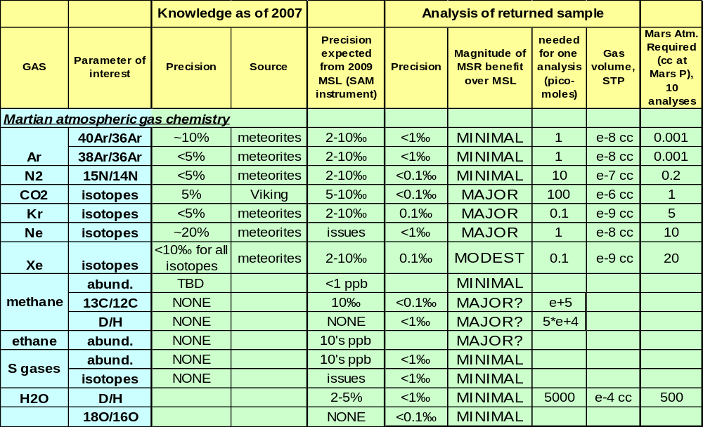Notes on Table 2: 1). More abundant Xe and Kr isotopes are known more accurately, but the low abundance isotopes, with the least accurate precision, are important in order to decipher the starting compositions. 2). CAVEAT on the use of meteorites to interpret gas chemistry: Assumes gas trapped in Martian meteorites is the same as the current Martian atmosphere.
Comparisons of isotopic compositions of volatile elements like C, O, H, and S in various chemical forms and in different phases of returned samples could give a potential wealth of geochemical information about atmospheric and volatile interactions and evolution. The isotopic compositions of such species are subtly changed when they undergo chemical reactions or phase changes, and these isotopic differences may elucidate these phases and processes and the temperatures involved. For example, the isotopic composition of carbon differs in predictable ways in carbonates precipitated from carbonate-bearing groundwater and in equilibrium with atmospheric CO₂. Further, such data could provide information about genetic relationships among sulfur- and oxygen-bearing phases, the oxidation pathways for compounds in the regolith that involve atmospheric species with anomalous oxygen isotope compositions (which could be affected by oxygen sinks), and the sources and mixing of Martian sulfate. Although the isotopic compositions of these elements in the present and ancient Martian atmosphere are important for such considerations, their atmospheric compositions are poorly known. Solid samples also are certain to contain noble gases produced by cosmic ray bombardment of the Martian surface, and these have likely altered the atmospheric noble gas composition over time.
In addition to what we know from Viking and study of the Martian meteorites, MSL will carry an instrument (SAM) that is capable of measuring many components of the Martian atmosphere, including the isotopic ratios of Ar, N₂, CO₂ (both C and O), Kr, Ne, Xe, the concentration of methane and sulfur gases, and the D/H ration in H₂O. The precisions and detection limits of SAM’s capability in these areas is summarized in Table 2 (Appendix V; data from Mahaffy, writ. comm., 2008).
ND-SAG concludes that analysis of a returned Martian atmospheric sample for Ne, Kr, CO₂ and CH₄ and C₂H₆ would confer major scientific benefit (Table 2). Characterizing the initial Kr component in the primitive atmosphere would require analytic precision beyond MSL’s capabilities. Understanding processes of exchange between CO₂, CH₄ and exchangeable crustal reservoirs of carbon, oxygen and hydrogen requires highly precise stable isotopic measurements. A returned Xe sample would provide an improved estimate of the initial atmospheric Xe component and of minor components that have been added. However, returned samples of Ar, N₂, S gases and H₂O would confer minimal benefits relative to what we expect to learn from MSL. The abundance and isotopic measurements of Ar and N₂ achievable by MSL in situ would be sufficient to address the key open scientific questions in those areas. The S gases and H₂O have such low abundances and high reactivity that they would not be expected to survive the return to Earth in unmodified form. Appendix V explains the rationale for these findings in greater detail.
FINDING.
- A precise, multi-component analysis of a returned Martian gas sample would make a major contribution to understanding the origin, evolution, and current state of Mars, even given the expected accomplishments by MSL in this area.

Dust
Dust is the pigment of Mars, supplying the reddish hue to the Red Planet. Thick accumulations of dust are a significant component of the Martian surface. The globally extensive high albedo, low thermal inertia regions of Mars may contain a meter or more of dust (Christensen, 1986). Intermediate albedo regions like those visited by four of the five landed missions show a patchy dust cover that is several cm thick in places. Even the low albedo surface of Meridiani Planum includes isolated occurrences of dust in the lee of obstacles as well as mixed into the regolith (Yen et al., 2005). This dust is carried aloft during seasons of atmospheric turbulence, encircling the globe and then falling out over time onto all exposed surfaces both natural and human-made. Despite the ubiquity of dust and the multitude of orbital and surface analyses applied to it, some of the details of its mineralogy and chemistry remain elusive. Without these details, an important window into the weathering and alteration history of Mars remains closed (see also MacPherson et al., 2001; 2002), and questions about its potential hazard to human explorers are left unanswered.
Beginning with telescopic observations, the bright regions of Mars were recognized as rich in oxidized iron. Visible/near infrared (VNIR) spectra are reasonably well matched by certain palagonitic tephras from Hawaii [Singer, 1982], which are described as hydrated amorphous silicate materials containing nanophase ferric oxide particles. The role of water in altering the dust and/or its parent material has been recognized in subsequent years with orbiter observations of spectral features attributable to a water-bearing phase(s) (e.g., Murchie et al., 1993) including the possibility of zeolite (Ruff, 2004). Thermal infrared spectra provide evidence that a few weight percent of carbonate minerals may be present in the dust (Bandfield et al., 2003). Measurements by the MER rovers clearly show that sulfur is enriched in the dust (Yen et al., 2005) and that virtually all dust particles, which very likely are agglomerates, contain a magnetic phase (Bertelsen et al., 2004) that probably is magnetite (Goetz et al., 2005). Although Martian dust shows evidence for aqueous alteration, the presence of olivine demonstrates that water did not play a dominant role in its formation (Goetz et al., 2005).
FINDING. In order to acquire enough dust mass, and to do so relatively quickly, ND-MSR-SAG recommends that a single dust sample of at least 5g should be collected from a surficial geological deposit.

Depth-resolved suite
Several of the life-related MSR objectives assign high priority to returning samples that contain reduced carbon. Because the surface of Mars is oxidized, organic matter might exist only at depth. Even if MSR is unable to acquire organic-bearing samples, it is important to acquire data in order to model the preservation potential of reduced species and thereby determine where organic matter might be accessible. The organic carbon measurements of the Viking landers indicated clearly that the surface (regolith) of Mars is oxidized to such an extent that any volatile organic components are being continuously destroyed. Although organic carbon compounds are raining down continuously from carbonaceous chondrites, cometary material, interplanetary dust particles, and micrometeorites (Flynn and McKay, 1990), the Viking experiments found no trace of them (Klein, 1978, 1979). It is hypothesized that prebiotic compounds that are relatively nonvolatile have been destroyed. Although there is indication that reduced organic compounds survive in the parent lithologies of Martian meteorites (Steele et al., 2007 and references therein), chemical modelling suggests that the depth of the oxidized surface layer is of the order of cm to several meters (Dartnell et al., 2007). Various oxidizing agents have been proposed, including OH, HO₂ and H₂O₂ species produced by photolysis of atmospheric water vapor (Zent and McKay, 1994; Zent et al., 2003). These species could form complexes with metals in the Martian regolith to create peroxy radicals. Another source of oxidation could be UV-silicate interactions that trap oxygen, resulting in highly oxidized dust and soil particles, or perhaps even unknown “super-oxidants".
Models indicate that impact “gardening” of the regolith could mix the oxidant(s) to depths of a few meters (Zent, 1998). Kminek and Bada (2006) concluded that over geologic time scales, ionizing radiation destroys organic matter (specifically, amino acids) to depths of at least 1.5 to possibly 2 m, although Dartnell et al. (2007) have shown that this effect is intrinsically linked to the amount of shielding of organic materials. Permeability-based modelling estimates that oxidants penetrate to depths between 10 cm to 5 m in the regolith, depending on the model, time of exposure and the nature of the regolith material (Bullock et al., 1994). Thus it might be desirable to obtain samples from as deep as 3 m into regolith. Although it would be preferable to collect a set of samples from several depths, an alternative would be to collect a single larger sample from the maximum depth reached. Regarding bedrock and detached rocks, the depth of oxidation presumably depends principally on time and the permeability and reactivity of the rock. Analyses of RAT holes during the MER mission indicate that Hesperian-age basalts have remained largely unoxidized within <1 cm of their surfaces (McSween et al., 2006). Data from Martian meteorites has shown that reduced carbon could be detected within carbonates from 3.6Ga on Mars (Steele et al., 2007, Jull et al., 1997, Flynn et al., 1998). Sedimentary bedrock at the MER Meridiani site has been oxidized to greater undetermined depths. A rock core at least several cm in length from an outcrop would allow the change with depth in composition (organic, inorganic, oxidation state) due to surface oxidation to be determined.
An important strategic consideration is that MSL (2009) and ExoMars (2013) will both collect data that will either increase or decrease the priority of the depth-resolved sample suite (see Fig. 1). MSL will carry a highly sensitive organic detection system (the SAM instrument) and obtain samples by drilling 5 cm into rocks and wheel-trenching up to tens of cm into regolith. ExoMars will also carry a very sensitive organic detection instrument (MOMA) and an oxidant detector (MOD). They will characterize gradients with depth in oxidation state, as well as the organic carbon, using so-called Vertical Surveys (VS), obtaining samples at 50-cm depth intervals from the surface down to 2 m. Two such VS acquisitions are planned for the nominal mission. If MSL discovers organic carbon at shallow depths in either rocks or regolith, the importance of a depth-resolved set of samples for MSR would decline. If MSL fails to detect organic carbon in shallow samples, but ExoMars detects it in deeper samples, the importance would increase substantially.
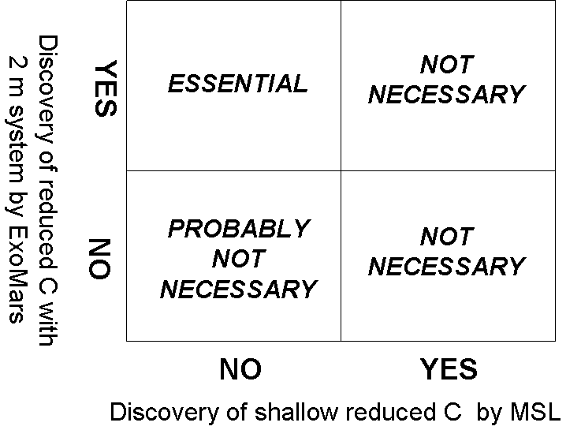
Figure 1. Importance of sampling to a depth of 2-3 m by MSR, given various potential scientific results from MSL and ExoMars.

Other
Other types of samples would be of interest if encountered by an MSR sampling rover, but it would likely be hard to target the mission to acquire them. It is perhaps useful to think of them as samples of opportunity.

Impact Products. Breccias might sample rock types that are otherwise not available in local outcrops and thus might be the most valuable. The utility of breccias in the Apollo collection has been demonstrated repeatedly (e.g. James et al., 1989). Impact excavation is the most plausible means of producing rock fragments on Mars, so it is possible that rocks from deeper levels in the crust might only be sampled in breccias. Diversity would be a major goal in collecting returned samples, and breccias often contain diverse materials. Impact melts would be highly significant for understanding the bombardment history. Testing the idea of a late heavy bombardment is particularly crucial and could be accomplished only by dating impact melts. Admittedly, these are not easy to identify and all the basins are filled, but there may be places where craters have excavated below sedimentary or volcanic fill (e.g. perhaps Hellas?).
Volcanic Products. Volcanic tephra is also likely to be encountered as fine-grained components of the regolith, or as layers and beds of tephra from nearby or faraway sources (e.g., Wilson and Head, 1994; 2007). Such samples would supply important information on the mineralogy of explosive volcanic eruptions, grain-size information critical to the interpretation of volcanic eruptions and tephra transport, and ages of explosive eruptive phases of the history of Mars. Volcanic glasses would also represent a unique opportunity to sample primitive magmas from the mantle, as demonstrated on the Moon (e.g., Delano, 1986).
Meteorites. Several iron meteorites have been found at both MER landing sites (Squyres et al., 2006), and a few small cobbles in Meridiani have been suggested to be chondrites. If the residence time of a meteorite on the surface could be determined, the alteration histories of materials with well-known mineralogy, chemistry, and texture could give useful information about the rate of weathering (e.g. Ashely et al., 2007). It may be possible to do the same with a sample of fresh basalt that has been excavated to the surface. Obviously, allocating precious return mass to a meteorite would require a strong justification for the hypothesis being tested.
Table 2 Summary of Sample Types Needed to Achieve Proposed Scientific Objectives.
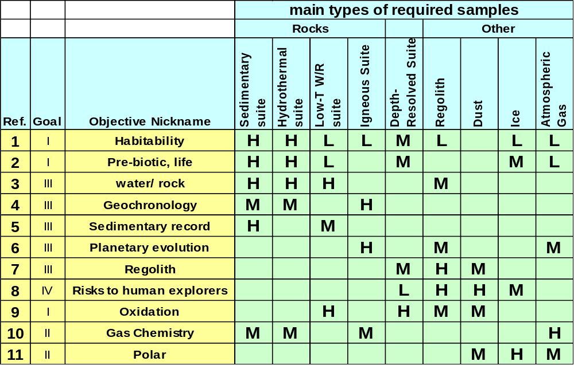
Note: Priorities are expressed as relative High, Medium, and Low. Where there is no entry, the sample type would not make a meaningful contribution to the scientific objective.

FACTORS THAT WOULD AFFECT THE SCIENTIFIC VALUE OF THE RETURNED SAMPLES

Sample size
The mass of the individual samples and the total mass of the returned collection should be sized so as to provide enough material for (1) preliminary characterization, (2) life detection (LD) and biohazard (BH) tests needed for planetary protection, (3) allocations to scientific investigations, and (4) representative reserves to be archived for future investigations. We need to plan for all future uses of sample material in order to determine the optimal sample size.
Preliminary examination
Preliminary examination is necessary to make decisions on what actions to take with each sample, including how each sample is subdivided. The samples from the Apollo, Antarctic Meteorite, Cosmic Dust, Stardust, and Genesis collections provide excellent precedents for planning this step for samples from Mars. Accordingly, the discussion here is based on nearly 30 years of experience gained from such activity at Johnson Space Center. As part of preliminary examination, techniques that are non-destructive or require minimal sample mass (e.g., Raman spectroscopy, XRF, FTIR spectroscopy, laser desorption-mass spectrometry, optical microscopy, SEM, EMPA, TOF-SIMS) could be used to classify and characterize the samples (table 5). The use of non-destructive techniques would maximize the quantity of sample available for subsequent investigations by the planetary science community. Preliminary determination of mineralogy would also be required, in part to place the biohazard tests in context (XRD, XRF, EDX, electron microprobe)--toxicity of the samples to biology requires a knowledge of the inorganic species present to ensure any toxic effects are linked to a biohazard (e.g. presence of As, Cl, Br etc.)
In addition, thin sections could be prepared and curated as is done for lunar and meteorite samples, using standard thin sectioning methods for small rocks and coarse fines. Focussed ion beam milling would be used to prepare small sections if necessary; this technique is being used for all kinds of samples from the lunar (Noble et al., 2007), meteorite (Goldstein et al., 2006), pre-solar grain (Stroud et al., 2006), Stardust (Nakamura-Messenger et al., 2007) and Mars (Clemett et al., 2006) communities. For very small samples, ultramicrotomy would be used to prepare thin slices that could be distributed to multiple scientists (Figure 12 in Nakamura-Messenger et al., 2006). Destructive techniques used during preliminary examination for sample preparation should be limited to those required to prepare the thin sections and slices by these three techniques.
Life detection and biohazards testing
The most recent analysis of the test protocol for life detection and biohazard testing for returned Martian samples was published by Rummel et al. (2002; based on technical analysis done in 2000-01). There have been significant improvements in analytic methodology since then, so the list of analytical methods and the required sample sizes must be updated substantially (for example, many techniques could be performed on a thin section, and the more extensive destructive techniques could be performed on sample splits on the order of 50 to 100 mg; dependent on the concentration of organic material (Glavin et al., 2006; Elsila et al., 2005). These tests would be grouped into two categories: non-destructive (e.g., Raman and confocal Raman spectroscopy, XRF, FTIR spectroscopy, laser-desorption mass spectrometry (LDMS), and 3D tomography) and destructive techniques designed to look for carbon compounds and their molecular structures (e.g. GC-MS, LC-MS, Py-GC-MS LAL, TOF-SIMS), and nucleic acids via amplification techniques (i.e. PCR--up to 1 gram of sample may be needed for this analysis). Since the volatile inventory is critical for assessing the presence of extant or extinct biomass, we would need some way to determine the abundance of the four light elements (C, H, N, and S) likely to co-occur in biosynthesized organic matter. In addition, the draft test protocol specifies plant and animal challenge tests, which would also be destructive.
The total amount of sample to carry out the life-detection and biohazard tests was estimated by Rummel et al. (2002) as 15-25 g, although has sometimes been represented subsequently as ~10% of the returned sample. Given the near certain that the total quantity of returned sample would be relatively small, it is important that only the amount absolutely needed be used for such purposes. We need to plan for the sample size and packaging that would be needed to carry out the hazard assessment protocol. A specific open issue is how to achieve statistically significant subsampling of the returned collection, particularly involving the rock samples.
There are two alternative strategies for allocating enough sample mass for these tests. Both strategies need further discussion by the community.
- Collect most of the incremental mass in the form of larger regolith samples (e.g. one or more samples >30 g). Since the regolith is composed of components derived from multiple geologic sources, the regolith samples would contain a mixture of rocks, dust, volcanic ash, ejecta, decomposed bedrock, etc. Moreover, all of these have interacted with the Martian atmosphere and obliquity-driven climate change. In short, they may represent an integration of Martian surface geologic processes. This might best kind of sample in which to test for the possibility of forms that proliferate on the surface during intermittent warmer/wetter intervals, and then become wind-blown constituents of the regolith. If there are significantly warmer periods during extreme obliquity there may be the possibility of intermittent proliferation of a surface microbial community that is adapted to long periods of inactivity. Searching for spores or biopolymers (something equivalent to extracellular polymeric substances) could be a goal for regolith studies. If there is an extant microbial organism or community on Mars, it would need to be encased in desiccation, oxidation, and radiation resistant molecules. This collection plan could allow for processing individual samples through the entire test protocol.
- Collect rock samples 1-2 g above what would be needed for scientific purposes, so that a split could be taken from each rock for destructive hazard assessment testing. The hazard assessment protocol consists of a package of tests, each of which would have different mass requirements. Thus, in this strategy it would be possible to run individual samples through some of the tests, but other more mass-intensive tests (e.g. plant growth experiments?) may require the use of composite samples. As input to future more detailed discussion of this topic, ND-SAG offers that the rocks themselves could be the most probable habitat for Martian life. The protective coating of the rock could help retain water, protect the interior from radiation, and reduce exposure of the endolithic (rock interior) habitat to surface oxidants. Thus, ND-SAG would be uncomfortable with a strategy that did not test for biohazards in at least some of the rocks.
Many of the non-destructive techniques could be performed on a thin section. Of the more extensive destructive techniques sample splits on the order of 0.05-0.5 g would be needed per analysis depending on the technique and sample composition. Given these mass estimates and allowing for multiple analyses of several different rock sub-samples, an estimate of 2 g for these tests would be required. This estimate may be more or less depending on the rock type, initial screenings, and changes in the analytical requirements as instrumentation advances. If less is used, that mass could be available for either the scientific investigations or future measurements (see ranges in Table 5).
FINDING. ND-SAG recommends follow-up studies in two areas:
- Update the draft test protocol, incorporating recent advances in biohazard analytic methodology. Which tests need to be carried out on each sample, which can make use of composite samples, and what is the minimum quantity of sample material needed for each test?
- Develop agreement on the criteria for taking a statistically significant subsample of the returned sample collection for the purpose of drawing conclusions related to the biosafety of the entire collection. What options for splitting individual samples are acceptable for this purpose?

Research requests through principal investigators
In order to estimate the mass of rock sample that must be collected to meet analytical needs for various scientific investigations, we can turn to experience gained from the Martian meteorite collection. In 1994, a 12.02 g meteorite, now referred to as QUE-94201, was found in the Queen Alexandra Range of the Transantarctic Mountains. This sample is a basaltic rock that also contains hydrous minerals (phosphate), and evaporites. Both of these mineral types could provide information about Martian volatiles and igneous processes. Since 1994, this sample has been subdivided into 63 splits, including 27 bulk samples (4.416 g) for destructive analysis, and 13 thin sections (using 2.2 g). To date 23 principal investigators have studied the first set of splits (sub-samples), and 29 principal investigators examined splits that were created subsequently. In addition, 5.16 g of material is still available for study using new techniques or by a new generation of scientists. Of relevance to any sample return mission is the attrition measured during sample processing and in the case of QUE 94201, 0.346 g (or ~3%) were lost during processing.
Table 3 Subdivision history of Martian meteorite QUE 94201
Type | Mass (g) | Techniques / notes | Information gained
a) Destructive analysis | 4.416 | SEM, TEM, AMS, INAA, TIMS, stable isotope MS, noble gas MS, XANES, EMPA | Samples allocated to 23 PIs for studies of: Bulk composition (INAA)  Crystallization age (Lu-Hf, Rb-Sr, Sm-Nd, K-Ar, U-Pb)  Differentiation age (Hf-W, Sm-Nd)  Exposure ages (³He, ²¹Ne, ³⁸Ar, ⁸¹Kr, ¹⁰Be, ²⁶Al, ³⁶Cl, ¹⁴C, ⁵³Mn)  Rock-atmosphere interactions (C, S, O, H isotopes)
b) Thin section production | 2.2 | SEM, TEM, SIMS, XANES, EMPA, optical microscopy | 13 thin sections produced and studied by 29 different PI's from many scientific disciplines; first section allowed classification
c) Non-destructive analysis | 0.372 | SEM, magnetic | Textural analysis, rock magnetization
d) Still available for study | 5.160 | Includes mass from c) | Sample material still being allocated 12 years later using new techniques and by next generation of planetary scientists
e) attrition | 0.346 | Material lost during processing
Abbreviations: SEM – scanning electron microscopy; TEM – transmission electron microscopy; EMPA – electron microprobe analysis; INAA – instrumental neutron activation analysis; AMS – accelerator mass spectrometry; TIMS – thermal ionization mass spectrometry; SIMS – secondary ion mass spectrometry; XANES – x-ray absorption near edge structure; MS – mass spectrometry.
The manner in which QUE 94201 was subdivided and the number of investigators involved provides a relevant analog situation that might be expected for Martian samples of similar size in a collected suite of rocks such that a rock sample could be divided into subportions that are subsequently divided for various analyses. This would allow application of single analytical techniques on one portion of a sample or multiple analyses for techniques that have low mass requirements that may reveal spatial distributions. Also, an estimate of mass required for destructive techniques part of scientific investigations is provided by the QUE 94201 example: the average mass of QUE 94201 used for destructive analysis by individual PIs is 0.2 g (based on analysis in Table 1). Therefore, if 12-15 PIs were allocated material from an individual sample from a suite, that would require ~ 2.5 to 3.0 g. Notably, QUE 94201 was not tested for organic composition. Consequently, either additional sample mass would be necessary for organic tests for science investigations that extend beyond life-detection and biohazard screening by the SRF, or all the destructive tests applied would be limited to a select number of techniques determined based on the sample
Sizing the rock samples
Adding up all of the currently understood proposed uses of the returned Martian samples, the minimum size for the purpose of the mission’s scientific objectives would be about 8g for both rock and regolith samples. If we assume an additional 1-2g of sample needs to be taken from each rock and regolith sample to support biohazard testing, a good standard sample size would be 10g each. Alternatively, if most of the biohazard testing is to be done on regolith samples, it may be possible to standardize on 8g rock samples, and 20g regolith samples. A very similar conclusion (10-20g samples) was reached in Appendix III by MacPherson et al. (2005).
Occasionally, rocks and sediments exhibit fabrics and textures at the mm to cm scale that are highly diagnostic of their formation and/or subsequent alteration. For example, the MER rover Opportunity documented the shapes and sizes of both grains and laminations that were consistent with the former presence of a shallow playa lake (Grotzinger et al., 2005), and these features are of a scale that is best observed in larger samples. On Earth, other rock types (e.g., igneous cumulates and high grade metamorphic rocks) also locally exhibit large-scale textures having high diagnostic value (e.g. foliation, flow features, layering, segregations, etc.). Having the capability of collecting one or more samples of about 20 g may help to correctly interpret such features. This may be achievable from two 10-g samples collected adjacent to each other (e.g. 1-2 cm apart). Alternatively, we may need to put a priority on documenting larger-scale textures in situ, so that the local context within heterogeneities larger than the sample size is documented.
Special note about the size of sedimentary rock samples
The minimal mass of samples of sedimentary deposits depends on the specific nature of the intended investigation. Experience from Earth suggests that sedimentological and stratigraphic studies normally need at least 5 g per sample in order to have a sufficient area of bed surface and internal structure to observe and document orientation of stratification, sedimentary structures, grain-size distributions, grain contacts, and mineral composition. Although we don’t know the concentration of organic molecules that might be present in returned Martian samples, studies on terrestrial samples commonly involve 10-20 g per sample. Solvent-extractable organic compounds are present in many samples in low concentrations that approach instrumental detection limits. In such cases, 1-2 g of sample is needed per measurement; however, multiple analyses are commonly required to verify molecular structures. Careful documentation of geological context is required for samples of sedimentary materials in order to relate their interpretation to the regional scale.
Table 4 Generic plan for mass allocation of individual rock samples
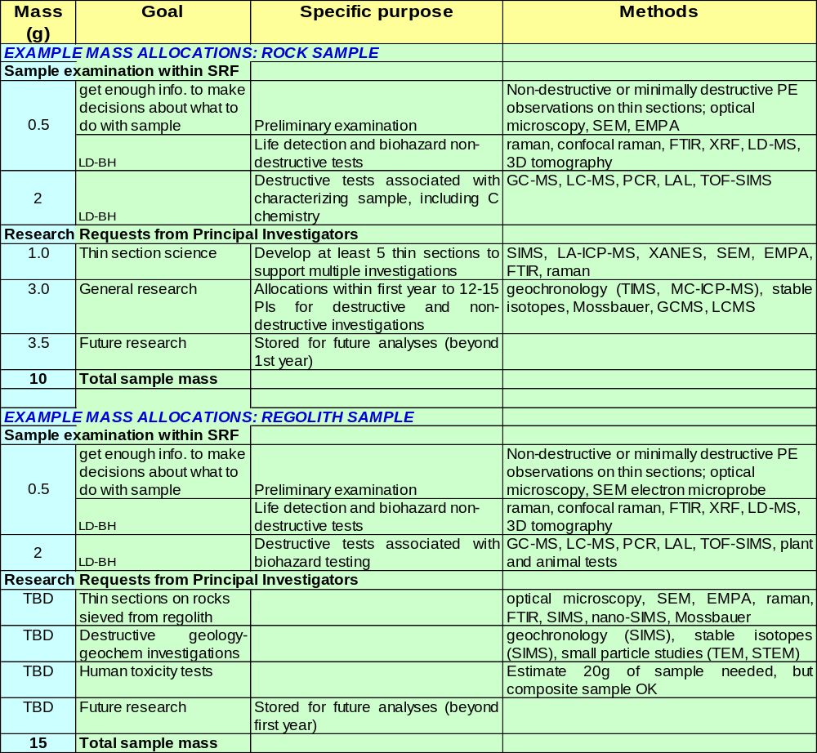

Sizing the regolith sample(s)
The likely diversity of regolith materials, particularly at a geologically complex landing site, means that a number of separate regolith samples e.g. 3, each of 1 to 25g, are preferred. A regolith sample of this mass is also likely to be appropriate for biohazard testing at the Sample Return Facility. More detailed information on sampling involving trenching or drilling to depths on the order of tens of cm is given in Appendix II. For the purpose of MEPAG Investigation IVA-5 (possible toxic effects of Martian dust/regolith on humans), it is currently estimated that a minimum of 20 grams may be necessary, although this kind of test can make use of composite samples.
Sizing the dust sample(s)
Given the global homogeneity of dust on Mars (Christensen et al., 2004; Yen et al., 2005), a single sample from anywhere would likely be representative of the planet as a whole. However, because relatively pure dust deposits often are only mm thick, scooping a pure sample may be challenging in some locations. It is recommended that enough material be acquired to satisfy the needs of the various scientific investigations, as well as to provide an amount material sufficient to allow its potential hazard to humans and machines to be assessed. As discussed in Appendix III, for human toxicity studies, we need to plan for enough material to be able to conduct intratracheal, corneal, dermal and ingestion studies that would allow assessment of toxic effects. Past experience with lunar sample material and with lunar stimulant has shown that 20 grams is likely to be sufficient, but these tests could be carried out with either dust or regolith. The fraction of interest for toxicity studies is in the <20 μm size fraction, and especially the <5 μm fraction.
Sizing the gas sample(s)
Because of the wide range of concentration of the various gas species in the Martian atmosphere, the quantity of atmospheric gas needed for measurement varies greatly among the different major species (Table 2). Also, higher analytic precision would be possible with larger samples, and multiple analyses of most species would be desirable. Consideration should also be given to possible gas sample contamination during return to Earth and distribution of sub-samples of gas to various analytic labs. We suggest that a minimum returned gas sample should be 10 cm³ at a pressure of 0.5 bar (since ambient martian atmospheric pressure in about 0.006 bar, this would require a compressed gas sample)—this would provide enough gas material for a robust analytic program. However, if it is not possible to collect a pressurized Martian gas sample, it would be possible to make 10 determinations with a 20 cc sample of gas at Martian ambient pressure, and achieve four high priority measurements (Table 2)—although this is lower priority than a compressed sample, it is well worth doing. Finally, it should be possible to recover the headspace gas within the sample canister, although this gas will be significantly less useful for scientific purposes than a sample that has been isolated. For example, the headspace gas may be contaminated by welding byproducts during the sealing of the canister.
Atmospheric species probably would occur in some form and in widely varying concentrations in nearly all returned solid samples, either as trapped volatiles or as condensed phases such as hydrates, carbonates, or sulfates. One important property of Martian rocks is that several components are present, including primitive trapped gases and atmospheric components, and these must be resolved. This is important for atmospheric gases, as these may have been incorporated at different times (paleoatmospheres) and may provide samples of the evolving Martian atmosphere. Therefore, the precision of the measurements must permit these components to be resolved. Unfortunately their concentrations are typically much lower in rocks from Mars, compared to those from Earth. For example, in nakhlite NWA998, the observed gas release is typically 0.2 ppm of N per temperature step, giving an uncertainty of ~0.5‰ from zero to +150 (Mathew and Marti, 2005). The release of xenon (¹³²Xe 0.1 to 5 e⁻¹² cm³/g) gave (one sigma) precision of 1% for rare isotopes (¹²⁴Xe, ¹²⁶Xe) and < 5‰ for the abundant isotopes (e.g. ¹³¹Xe). When highly variable anomalies, due to radiogenic (¹²⁹Xe), fission (e.g. ¹³⁶Xe) and spallation components (e.g. 126Xe), are observed the uncertainties increase. ND-SAG concludes from all of this that it is not feasible to set the minimum sample size of the rock samples based on their proposed use in gas-release experiments—we simply don’t have enough information to know how to set the thresholds.
A final note
As Deep Impact has demonstrated, a small amount of material may make it possible to make a “preliminary investigation”, and we should not underestimate what can be accomplished with samples smaller than ideal.
FINDINGS.
- A full program of scientific investigations (12-15 PI allocations, multiple thin sections, wide diversity of applied instrumentation, save 50% for future researchers) is expected to require samples of rock and regolith at least 8 g in size. However, for study of some kinds of heterogeneities, there may be value in one or more larger samples of ~20 g.
- To support the sample mass required biohazard testing, either some of the samples need to be larger (e.g. 30 g), or each sample should be increased by about 2 g (endorsed) leading to an optimal sample size of about 10 g.
- Because of the importance of the trace atmospheric species, it would be scientifically valuable to have a gas sample that is both compressed (to get more mass), and isolated from rock and mineral samples.

Number of Samples.
Natural materials are heterogeneous at scales ranging from atomic to planetary. Mineralogical, geochemical, biogeochemical, and morphological properties would be assumed to vary among samples depending on the temporal and spatial distribution of processes active on Mars. In many studies, characterization of heterogeneities could provide as much information about processes as the specific characteristics of a given sample. Thus, for maximum scientific benefit, Mars sample return missions would need to capture as much of this diversity as reasonable through careful selection of both landing sites and samples from each site.
The number of samples needed to capture appropriate heterogeneity depends on the local Martian environment and geological history. Field experience on Earth has taught us the importance of acquiring sufficiently diverse samples to evaluate whether or not a specific result is representative as well as to extrapolate interpretations of processes from variations among and within samples. In many cases, carefully selected suites related rocks allow one to reasonably evaluate: 1) how representative each sample may or may not be of the geologic unit; 2) the consistency of processes creating and altering the samples; and 3) abundances of specific attributes such as minerals and geochemical signatures.
Without pre-characterization of a specific Martian site, it is not possible to define the number of samples required to capture local to regional diversity in geological materials. However, an estimate of sample number is necessary for mission planning. For many studies, a suite consisting of about five to eight samples would be sufficient for a first-order evaluation of the heterogeneity of units, the consistency of processes, and the abundances of representative features. Two examples demonstrate this. In Endurance Crater, Mars, the analysis of seven stratigraphically distributed sites in the Burns Formation allowed the Opportunity Rover team to identify several significant diagenetic events, some of which were associated with variations in groundwater (McLennan et al., 2005). In a second example, APXS analyses of a eight separate samples of alkaline volcanics revealed that they were formed under different conditions or from very different starting composition compared to the bulk of Martian rocks; thus, shedding new insight on the complexity of the Martian interior (McSween et al., 2006). In both of these examples, a smaller number of the “right” samples could have provided sufficient information for the resulting interpretations, but pre-selection of the smaller set of samples would have required significant characterization. Thus, for Mars sample return, either extensive in situ characterization capabilities would be needed or a suite of at least five to eight samples should be collected from each geological unit. More samples would provide better information, but a suite of five to eight samples should provide sufficient diversity to provide substantial scientific return.
Quantity of samples to be cached by MSL
The MSL cache is designed to accept rock samples 0.5–1.5 cm in size provided by MSL's soil scoop, collected over 5–10 separate caching events (Karcz et al., 2007). The cache will have mesh sides to allow fines to filter out, leaving behind rocks. The strategy for employing the scoop to acquire either individual targeted rocks, or rock-bearing regolith would depend on further experience with prototype scoops (note that the volume of the scoop is roughly half the volume of the cache). The empty cache is specified to have a mass less than 52 g. However, the mass of the latest revision of the design (as estimated by the CAD software) is 29 g (Karcz, writ. comm., 01-07-08). A draft specification (as of this writing) is for the mass of the cache container when full to be 200 g or less. Because the mass of the contents will be uncertain, it is likely that the science team will fill it to somewhat less than capacity--to, say, 180 g instead of 200 g.
Table 6 summarizes some possibilities regarding sample number and overall mass. For the purpose of this table, both rock and regolith samples are assumed to be 10 g each (as per Table 5), and that encapsulation mass is assumed to be an additional 10 g per sample. In Case A (MSL cache would be recovered), the return of 20 rock, three regolith, one dust and one gas samples, along with the MSL cache, would lead to a total returned mass of 690 g, of which 380 g would be samples. If 500 g is a firm limit for the total returned sample mass, the number of rock samples would have to be reduced to 12. In Case B (no MSL cache), the mass allocated for the cache could be used for additional rock and regolith samples of the same aggregate size. This could allow the number of rock samples to be raised to 28, and the number of regolith samples to four; in this model the total amount of sample mass would drop somewhat to 345 g.

Some implications/questions:
- Would a total mass of 700 g inside the returned container (instead of 500 g) break the mission?
- Because it might not be possible to determine whether the MSL cache is recoverable until MSR gets there (for example, MSL may end its life in an inaccessible location), it would be advantageous for MSR to carry enough sample vials for the full set of samples described in Case B of Table 6, not just those in Case A. That way either scenario could be accommodated.
- The value of the MSL cache would need to be explicitly compared to an incremental eight rock and one regolith sample having a known context and far better curation--these are mass-equivalent. This comparison could be meaningfully made only after the cache has been loaded and the MSL science team knows its contents.
Table 5 Summary of number, type, and mass of returned samples.
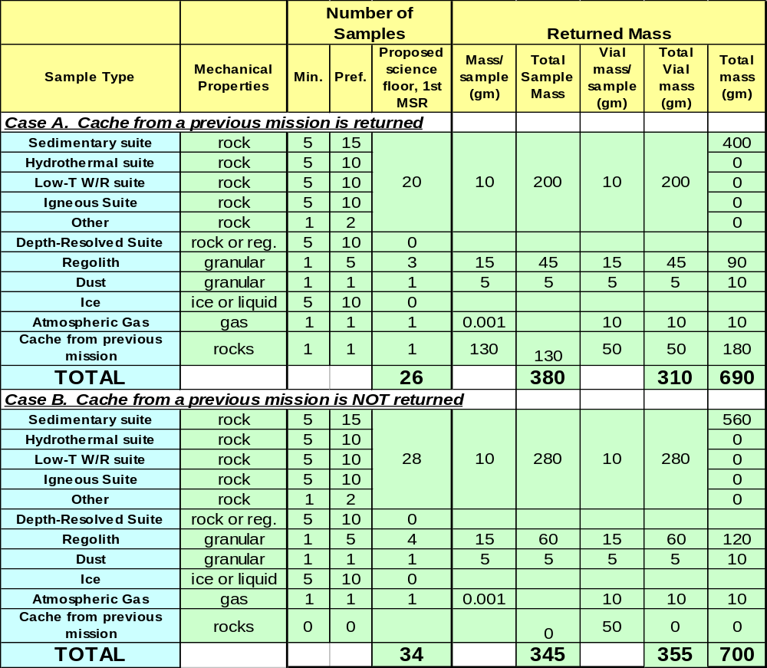
FINDING.
The minimum number of samples needed to address the scientific objectives of MSR is 26 (20 rock, 3 regolith, 1 dust, 2 gas), in the case of recovery of the MSL cache. These samples are expected to have a mass of about 350 g, and with sample packaging, the total returned mass is expected to be about 700 g.

Sample Encapsulation.
For several reasons, the packaging of individual samples on Mars emerged as a central priority elucidated in this study, a conclusion also reached by MacPherson et al. (2005).
- Avoid commingling of samples. First, cross-contamination would likely occur without encapsulation and it would degrade the scientific value of samples, particularly if samples from different sites are mixed. Mixing would be a particular problem for weakly lithified and friable samples that may break apart during transport to Earth.
- Retain volatile components. In addition, hydrous materials that are not maintained at Mars ambient conditions might dehydrate and form sulfur-bearing fluids that could readily react with other samples and the container.
- Sample labelling for linkage to original field context. Individual samples must retain their identities after they are returned to Earth. A friable sample would lose much of its identifying characteristics if it breaks into multiple pieces during transport. It is imperative that the samples be linked to their collection sites even if the sample’s physical and chemical integrity are altered during transport.
- Maintain sample mechanical integrity. Several investigations would require that the samples’ macroscopic structures, microscopic textures and mineralogical spatial relationships be preserved during collection and transport. The samples’ mechanical integrity must be preserved as well as possible. This is a particular concern for friable sedimentary rock samples that would be a major priority for MSR. Aqueous sediments could exhibit fabrics and textures at the mm- to cm-scale that are highly diagnostic of their formation and/or subsequent alteration. For example, the MER rover Opportunity documented the shapes and sizes of both grains and laminations that were consistent with the former presence of a shallow playa lake (Grotzinger et al., 2005). Much of the sulfate-rich bedrock at the Opportunity site appears to be weakly cemented and therefore seems prone to fragmentation that might destroy its valuable sedimentary textures.
The minimal sample encapsulation would be different for different investigations and rock types. Investigations related to organic chemistry, water, and other volatile components would require the most stringent encapsulation procedures in order to minimize any organic and/or biological cross contamination. These investigations would require hermetically sealed containers. In addition, rock samples that contain hydrous phases would require containers in order to prevent fluids from escaping and reacting with other samples. The samples of granular materials (regolith and dust) obviously would require at least some form of mechanical packaging in order to retain their identity as a sample. Although it is a scientific priority that all samples would be encapsulated, it would not be necessary for scientific purposes that they all have airtight seals.
Encapsulation is a particular issue for sedimentary rock samples. Some chemical and siliciclastic sediments are permeable and/or fragile and therefore could be highly susceptible to contamination and degradation during acquisition and transport. Many of these samples have the potential to break, disaggregate, dehydrate, and devolatilize. In addition, iron oxide and phyllosilicate materials, in particular, could adsorb volatile contaminants. Sample-to-sample contamination by water and/or organic compounds is a serious concern. Consequently, gas-tight encapsulation in inert containers is critical for samples of sedimentary materials.
An engineering trade to be evaluated would be whether a single airtight design should be used for all of the samples, or whether mass could be saved by having some vials that would be airtight and some that would be only “dust-tight”.
FINDINGS.
- The scientific usefulness of the returned samples would depend critically on keeping them from commingling, on being able to uniquely identify them for linkage back to documented field context, and in keeping rock samples mechanically intact.
- Trading sample mass for packaging material is painful, but necessary. A smaller number or mass of carefully managed samples would be far more valuable than larger number or mass of poorly-managed samples.
- The encapsulation for at least some of the samples must be air-tight to retain volatile components.

Diversity of the returned collection
The diversity of the suites of returned samples must be commensurate with the diversity of rocks and regolith encountered during the mission. Sample suites that capture this diversity would empower the maximum possible number of investigations and thereby effectively address major questions such as how geologic, climatic, and potential biologic processes have changed through time. The Viking landers and the Pathfinder and Mars Exploration Rovers have demonstrated that the Martian surface is lithologically diverse. By returning samples to state-of-the-art terrestrial laboratories, more subtle mineralogical and compositional variations would be likely to emerge. Because the size of a sample suite reflects the number of samples necessary to characterize a given site, the set of suites that accurately represent the diversity of each key rock type at a site would constitute the minimum quantity of sample that would be required.
Changes in geologic, climatic, and potential biologic processes could only be addressed by examining multiple samples that represent different intervals of time. For example, in order to understand the origin and evolution of fluids responsible for sulfate deposition, numerous sulfate-bearing samples would be required that record evolution of any fluids through time. Likewise, understanding a siliciclastic depositional environment would require determining how the rock sequence changed through time; thus a stratigraphic sequence must be sampled. Finally, understanding the evolution of the Martian interior or an individual volcanic edifice would require sampling igneous rocks produced at different times. The lithologic diversity of the sample collection must be maximized to ensure that a record of any temporal mineralogical, geochemical, and organic chemical variations has been captured in the returned collection.
The lithologic, compositional, and temporal diversity of the returned sample collection may be the single most important factor controlling the range of investigations that could be addressed using the samples. For example, many investigations involving habitability, the carbon cycle, the search for life, and the role of water on the Martian surface would require rocks containing hydrous phases. Some aspects of these investigations, as well as investigations regarding the evolution of the atmosphere, climate, surface, and interior of Mars, could only be addressed with siliciclastic sediments, igneous rocks, and regolith. Consequently, a primary exploration objective of MSR should be to maximize scientific yield by ensuring that the sample collection has the largest possible lithologic diversity. This essential objective should substantially influence both the selection of landing sites and the development of rover operation protocols. For example, mission strategies to acquire samples by visiting multiple sites are more effective at capturing a greater diversity of samples.

FINDING. A primary factor in the ultimate scientific value of MSR would be the diversity of the returned samples. The more diverse the collection, the more useful it would be in understanding the natural processes (past and present) on Mars.

In situ measurements for sample selection and documentation of field context.
The scientific value of MSR would depend critically upon the ability of the mission science team to select wisely the relatively few samples that could be returned, and on the degree to which the field context of these samples is known. In order to achieve these two functions, the MSR sample acquisition rover must be able to perform certain remote and in situ measurements.
ND-SAG has found that the instrument needs for MSR would be different in the two scenarios listed below:
- Case A. The MSR rover either goes to a previously unvisited landing site, or it gets 'off the beaten track' of a previously visited site. In this case, both sample selection and documentation of context would need to be done.
- Case B. The MSR rover “follows in the footsteps” of a previous rover that has already established the field context and identified the exact materials to be sampled.
For Case A, five measurements are important to support the collection of samples that could be used for a wide range of scientific objectives: 1) high quality color panoramic imaging would be essential to identify samples of interest and to determine their local geological context (e.g., Grotzinger et al., 2005). 2) A microscopic imager that examines rock and sediment textures for clues about processes and environments of formation would also be essential. In addition, microbially induced textures are one of the key indicators of life (e.g., Herkenhoff et al., 2004). 3) The mineralogy would need be determined to discriminate one rock from another and to establish geologic context of the samples (e.g., Christensen et al., 2004). Minerals reflect the processes and conditions associated with the formation of geologic materials. For example, understanding compositional variability in the igneous sample suite would require rocks that contain a range of minerals, such as olivine, pyroxene, feldspar, and oxides. Phyllosilicates, sulfates, carbonates and silica-rich minerals are excellent for retaining evidence of aqueous processes and evidence of habitable environments and life. 4) Measurements of elemental abundance have been critically important during the MER mission (e.g., Ming et al., 2006; McSween et al., 2006) and would be essential in understanding the range of variability within a field site, and in identifying the effects of unusual geologic processes. This information would be key to both sample selection and documentation of context. 5) Reduced carbon measurements would be centrally important to understanding prebiotic chemistry, habitability, and life (e.g., Schopf, 1983), therefore reduced carbon should be measured during the sample selection process. Although we could certainly detect reduced carbon in returned samples to better than 1 ppb, ppm-level sensitivity may be sufficient for screening for sample selection on Mars. The SAM instrument on MSL and the Urey and MOMA instruments on ExoMars will presumably give us important guidance on this after 2010. Finally, a rock abrasion tool would be essential to characterize the rocks adequately. Because many rocks on Mars have dusty or weathered surfaces, correctly determining the characteristics of the underlying rocks would require access to fresh surfaces.

Table 6 Rover-based Measurements to Guide Sample Selection.
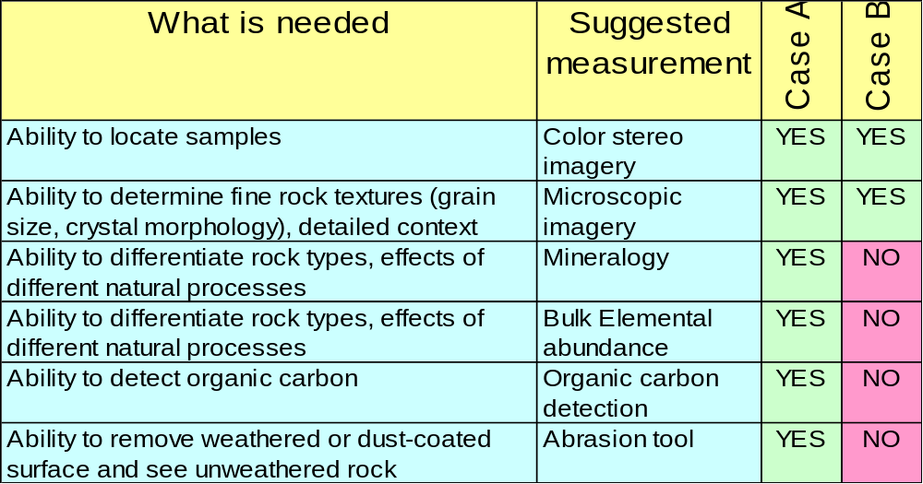
Notes: Case A – MSR gets 'off the beaten track.' This assumes that a future MSR would go to either a fresh site, or outside the area studied by a previous rover, where understanding the geologic context still needs to be done. Case B – MSR follows the tracks of a previous rover, which has documented the context.

For Case B, ND-SAG has concluded that the payload could be reduced to the following two instruments: color stereo imagery and microscopic imagery. In this case, the MSR rover would not need to determine the geologic context and identify the materials to be collected - the prior mission would have achieved these tasks. However, ND-SAG also concludes that Case B has substantial risk, and it is not endorsed unless this is the only way the mission could be done. For a variety of reasons it may not be possible for the MSR rover to follow the tracks of the previous rover. In addition, MSR would not have enough functionality to make excursions off the previous rover traverse, which may be desirable to follow-up on unexpected results, including from the previous mission. The Case B rover would have minimal analytical capabilities for an extended mission after the MAV leaves. Finally, if the MSR rover follows another rover that is neither as clean nor as sterile as the MSR rover, important implications arise involving planetary protection and contamination control, and these should be evaluated further.
FINDINGS.
- There is a difference in the minimum measurement capability of the MSR rover depending upon whether it would go to a previously visited site, or to a fresh site.
- For a fully functional MSR rover, capable of interpreting geologic context on its own, five kinds of observations would be needed (macroscopic and microscopic imagery, mineralogy, elemental analysis, and organic carbon detection).
- If MSR were restricted to previously occupied sites, and was dependent on prior information for sample selection decisions, the number of instruments could be reduced to two. However, restricting the retrieval of documented samples to previously visited sites would increase both science risk and planetary protection concerns.

Surface Operations
In order to achieve the MSR scientific objectives and access the kinds of sites of greatest current interest, a high priority would be to deploy a spacecraft that has significant horizontal range and could navigate rough terrain. Although the current orbital imagery provides excellent context and mineralogical information in order to identify high priority landing sites, experience from the Mars Exploration Rovers has shown that the diversity of potential samples that exists at the size scale of a rover must be analyzed in-situ. The MSR lander/rover must have instrumentation that could interpret the diversity of geologic materials and help to select the highest priority samples for return (see section IV.D). Color imagery, remote spectroscopic observations and contact geochemical/mineralogical analyses constitute the minimum set of techniques would be needed to optimize sample selection. The duration of surface operations would also influence the quality of the sample collection. ND-SAG expects that a minimum of 6-12 months of surface operation would be required in order to reconnoiter a site and identify, characterize and collect a set of samples that captures its compositional diversity. To place this in context, the Opportunity rover did not complete the stratigraphic characterization in Endurance crater until Sol 315 (Squyres and Knoll, 2005) and Spirit did not identify significant indicators of aqueous processes until it reached the Columbia Hills (roughly Sol 180; Arvidson et al., 2006). Sending MSR to a previously visited site (either of the two MER sites, the MSL or ExoMars site, or potential future sites) might substantially reduce the time needed for reconnaissance, but revisiting a site might also compromise samples intended for organic analyses by increasing the risk of terrestrial contamination.
FINDING. The collection of a diverse set of rock samples from known geologic context would require significant surface mobility. Also necessary is information about the diversity of surface materials (could be collected either by a prior mission or by the MSR rover), in order to select samples that span that variation. A minimum duration for surface operations of at least 6-12 months is anticipated, depending on landing site geography/geology and relationship to prior missions.

Sample acquisition system priorities
In order to attain the full scientific value of rock samples, the sample acquisition system must be able to achieve the following:
- Sampling both the weathered exterior and unweathered interior of rocks.
- The ability to sample a continuous stratigraphic sequence of outcrops (e.g. the Burns Cliff at Meridiani Planum).
- In the case of rocks in outcrop with differential hardness, the ability to sample both less-resistant beds and more-resistant beds.
- Relate the orientation of structures and textures in samples to those in outcrop surfaces, bedding planes, stratigraphic sequences, and regional-scale geologic structures.
- Maintain the structural integrity of samples.
Given the sample sizes discussed in this report, these priorities would be best served with a small arm-mounted coring device (this sampling system was judged to be essential by MacPherson et al., 2005). An example geometry that would be of the right size is a small core of about 1 cm in diameter and 2 to 3 cm in length (how to optimize these parameters is still under discussion). To distinguish this from larger drills with depth capability of 2-3m, we refer to as a mini-corer.
The simplest way to sample granular materials, such as regolith and dust, might be using a scoop. However, it may be possible to engineer a mini-corer so that it could also be used to sample granular materials.
Table 7 Science Priorities Related to the Acquisition System for Different Sample Types.
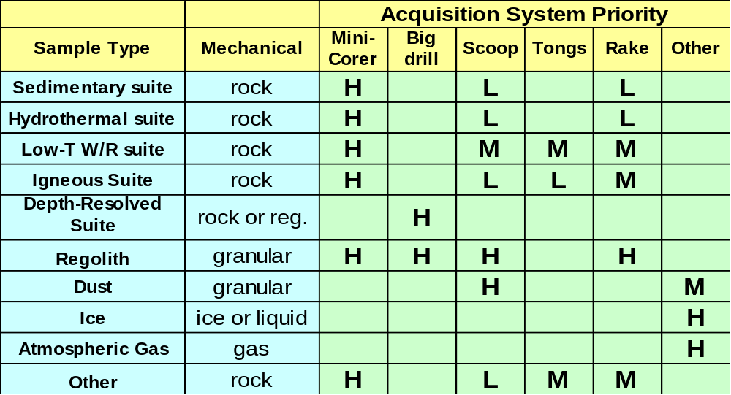

FINDING.
The most important sample collection tools for MSR would be a mini-corer and a scoop. Of lower priority, but valuable for specific kinds of samples, would be a gas compressor and a drill.

Temperature.
The issues related to temperature sensitivity of Martian minerals and organics were reviewed in great detail by MacPherson et al. (2005; see Appendix III) and so are not repeated here. At that time, the science community expressed significant concerns about sample degradation at temperatures above 0°C, and if anything, the scientific accomplishments of the Mars program over the past three years appear have intensified those concerns (e.g. Clark et al., 2005; Bibring et al., 2006; Peterson et al., 2007). The perceived effects of temperature on achieving science goals are summarized in Table 9.
Certain chemical species that would have great science value for MSR are also sensitive to temperatures barely above those attained in the current Martian environment. Examples include organic material as well as reactive minerals that might be common (e.g., sulfates, chlorides, and clays) yet whose stability could be compromised even at modest temperatures (<20°C). Liquid water or ice also might be present in samples, either interstitially or sorbed onto mineral surfaces. Accordingly, the temperatures experienced by samples during collection and return to Earth would be a critical issue. In order to maintain sample integrity, returned samples ideally should be kept as close as possible to the ambient temperature (and atmospheric) conditions of the location where they were collected. However the ND-SAG recognizes that if this were set as a mission requirement, it might pose a major technological challenge that may not be achievable within cost constraints. If sample integrity were seriously affected by temperature excursions, then the next best option would be to monitor the temperature history closely and also ensure that samples are fully encapsulated so that all components would be retained. Under these conditions, any chemical reactions that may take place during transport to Earth conceivably could be evaluated and reconstructed.

Table 8 Effect of Maximum Sample Temperature on the Ability to Achieve the Candidate Science Objectives.
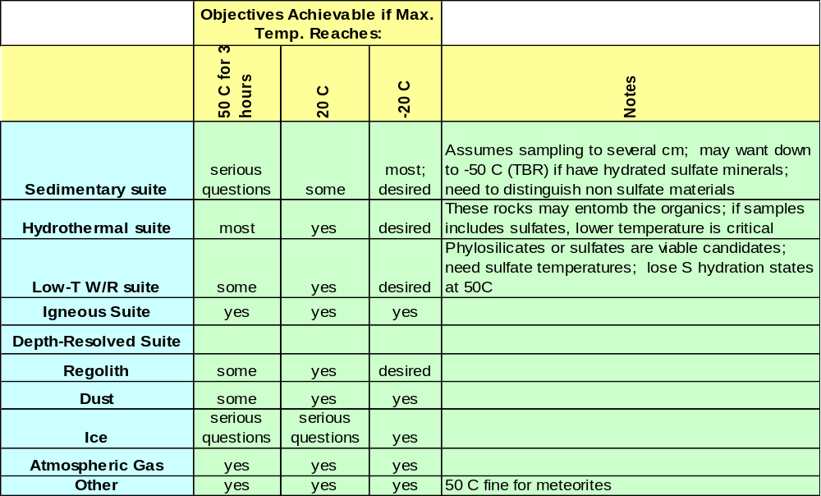
Elevated temperatures could compromise the integrity of organic compounds (see MacPherson et al. 2005 for a good summary table). Even at only –5°C, certain organic compounds are mobilized, and some organic compounds decompose at >-20°C. At temperatures of +50°C, significant decomposition takes place, and if samples remain at this temperature for more than about three hours, science objectives related to life goals could be seriously compromised.
Most inorganic materials should remain suitable for allowing primary scientific objectives to be achieved even if these materials experience temperatures as high as +20°C. At higher temperatures, such as +50°C, some materials (e.g., regolith, dust, clays) might deteriorate and potentially lose key scientific information. Although the kinetics of many reactions is poorly known and some metastable phases may persist well outside their nominal stability ranges, sulfate minerals are very likely to present a special challenge. For example, the hydration states of magnesium and iron sulfates are sensitive to temperature and relative humidity and changes (dehydration and/or melting) might commence at temperatures as low as –2°C. Dehydration and melting should be expected if temperatures reach 20°C. These changes have the potential to seriously influence both the chemical and physical state of the samples. For example, dehydration of MgSO₄•nH₂O from n=11 to n=1 would result in nearly a factor of four loss of mineral volume that could lead to physical disaggregation of weakly cemented samples. Release of water could result in further chemical reactions, such as dissolution of highly soluble minerals (e.g., chlorides), leaching of weakly held ions (e.g., clays) or significant lowering of pH through Fe³⁺ hydrolysis. Finally, water ice may be stable within cm of the Mars surface (e.g. Mellon et al. 2004) therefore it could occur in a regolith sample or drill core. Refrigeration and temperature monitoring would allow an accurate assessment of whether any reaction between this water and the surrounding sulfates or soluble minerals has taken place during sample return.
The ND-SAG has confidence that the MSR scientific objectives that depend upon mineral compositions could be addressed if samples were kept below about –10°C. For preservation of water, it would be preferable to hold the samples below about -20°C (MEPAG SR-SAG, 2006). There is less confidence, but it is likely, that most objectives would be met for samples that are kept below about +20°C. If samples were allowed to reach +50°C for greater than about 3 hours, the damage that ensues would seriously degrade the scientific value of the samples. It is very possible that samples containing Mg- and Fe-sulfates would be altered substantially even if temperatures approach only 20°C, but these effects could be mitigated if samples are encapsulated and their temperature history monitored. Monitoring sample temperature during transport to Earth would help determine any post-sampling melting or recrystallization. For example, MgSO₄ of unknown hydration state was identified at the Opportunity site. This has been speculated to be MgSO₄ .11H₂O, which has subsequently found on Earth (Peterson et al. 2007), is expected to dehydrate at 2°C. Maintaining a low temperature would inhibit this mineralogical transformation.

Far worse for the science value of the samples than heating to 20-50°C would be heating to a level sufficient for biological sterilization. It is a common misconception that heat sterilization of samples would damage them relative only to astrobiological (MEPAG Goal I) goals (e.g., Steele, et al., 2007). Heat sterilization would impact the samples in several ways, some relevant to the other objectives of the mission.
FINDING: MSR’s scientific objectives could most confidently be met if the samples are kept below -20C, and with less confidence if they are kept below +20C. Significant damage, particularly to our life goals, would occur if the samples are allowed to reach +50C for 3 hours. Temperature monitoring during the return mission would allow assessment of any changes to the samples.

Planning Considerations Involving the MSL/ExoMars Caches
A decision was made in mid-2007 to add a simple caching capability to the 2009 MSL mission. As of this writing, a similar cache is under consideration for ExoMars. This capability is part of a larger strategy to utilize pre-MSR landed missions to enhance the value of sample return. It is intended that the recovery of the MSL cache will be an option for MSR, rather than a requirement. The decision would be made several years from now by future science teams and other decision-makers.
The MSL cache design
The MSL cache is designed to accept 0.5–1.5 cm rock samples provided by MSL's soil scoop, collected over 5–10 separate caching events (Karcz et al., 2007). The cache will have mesh sides to allow fines to filter out, leaving behind rocks. The strategy for employing the scoop to acquire either individual targeted rocks, or rock-bearing regolith would depend on further experience with prototype scoops (note that the volume of the scoop is roughly half the volume of the cache). The empty cache is specified to have a mass less than 52 g. However, the mass of the latest revision of the design (as estimated by the CAD software) is 29 g (Karcz, writ. comm., 01-07-08). A draft specification (as of this writing) is for the mass of the full container to be 200 g or less. Because the mass of the contents will be uncertain, it is likely that the science team will fill it to somewhat less than capacity--to, say, 180 g instead of 200 g.
The cache and rover will not be sterilized, but any organisms on the MSL cache and rover, and in MSL's assembly, test, and launch environments will be inventoried using genetic methods. The MSL Project Science Group will direct caching operations and sample selection. The current strategy is to collect samples representative of the common rock and mineral types encountered by MSL during its traverse, rather than specifically targeting “unusual” finds.
Potential consequences of the MSL cache for MSR
The ND-SAG evaluated several major impacts that the MSL cache might have on the design of the first MSR mission. The following three sets of questions and answers summarize the outcome of these deliberations. These answers draw substantially from the findings of Steele et al. (2008).
1. If a cache prepared by MSL (or ExoMars, or any other future mission) is recovered, would MSR necessarily acquire additional samples in order to achieve its key scientific objectives, or would the samples in the cache be sufficient? If additional samples are required, then the MSR spacecraft must have an independent sample acquisition capability.
Discussion. The cache’s samples have the advantage that they might be collected from a wider geographic area than is possible by MSR. This is particularly true for the MSL rover, which has a nominal mobility range that might be an order of magnitude higher than that of an MSR rover. For whatever reason, MSL might discover and collect unique samples that the MSR could not collect on its own. However the MSR mission might not be able to retrieve the MSL cache. For example, the MSR spacecraft might land too far away, the MSL rover might end its mission in an inaccessible location, or the cache itself might be in a state that would render its irretrievable.
MSL’s cached samples will be limited to small rocks that its scoop could retrieve from the Martian surface. Isolated small rocks might be heavily weathered. Several of the MSR objectives require unaltered samples from rock interiors.
The present design of the MSL sample collection and caching system will not permit the assembly and packaging of all of the samples necessary to address the scientific objectives proposed for MSR in this report. The cached samples will be neither labeled nor separated from each other; therefore the identity of each sample and therefore the information about its environmental context might be obscured during caching of the samples. Loss of context data would significantly reduce the science return, particularly for the high priority life-related objectives. Because the cache samples are not to be individually encapsulated, any mechanical disruption during transportation back to Earth might intimately mix the samples and contribute further to the loss of their individual identities.
The standards for organic contamination and planetary protection for the MSL and MSR missions would probably be different (as of this writing, the MSL contamination thresholds are known, but those for MSR are not). The MSL sampling system will not be sterilized. If the MSL cache harbors biological material whose origin could not be determined (Is it from Mars? Or is it Earthly contamination?), planetary protection protocols will require that the returned cache samples be sterilized. Stringent sterilization procedures would severely degrade the scientific value of these samples for several of the MSR science objectives.
Finally the MSR mission should be able to respond to any discoveries whose follow-up would require samples other than those in the MSL cache.
Accordingly, the ND-SAG found that the MSR landed spacecraft should have the capability to collect at least some of the samples to be returned by itself.
2. If the MSR spacecraft must have sample acquisition capability, does the specific nature of that capability depend on whether or not it would attempt to recover a cache?
Discussion. The MSL cache could substantially improve the MSR return if certain scenarios occur. For example, if the time available for MSR surface operations becomes severely limited, it might be able to collect a relatively small number of samples on its own and the MSL cache would become especially important.
According to current plans, the mass and volume of the MSL or ExoMars caches are estimated to occupy about one-third of the proposed returned sample capacity. MSR therefore must acquire either two-thirds or all of the returned samples. As discussed above, the MSR spacecraft must have the capability to collect all of the sample types of interest.
Therefore the design of the sample acquisition system of MSR would be independent of the decision to recover either the MSL or the ExoMars caches. Note that a key consideration in this analysis is whether a given kind of sample discovered by MSL would be sufficiently useful in an Earth-based laboratory if stored in the cache, or whether it would be preferable to have MSR recollect it.
3. If MSR returns to a previously visited site (e.g., those of MSL, ExoMars, MER, other?) where the geologic terrain has been characterized previously to some extent, would the landed instrumentation required for MSR differ from that required in order to visit a new site?
Discussion. MSL will carry a highly capable in-situ laboratory that will be able to characterize the samples and their geologic context in many ways and with superior precision and accuracy. MSL has 10 instruments, including highly capable chemical and mineralogic detectors. It is unlikely that MSR would carry an instrument package of this quality. Therefore the geologic context of the MSL site will be significantly better understood than any other site that the MSR rover might visit. This same argument will also apply to the site visited by ExoMars, and to a lesser extent to the two MER sites (Meridiani and Gusev Crater).
However there are differences in perspective within the ND-SAG regarding how closely the MSR rover would have to follow the footsteps of a previous rover in order to take advantage of that previously acquired information. Opinions range from the view that sampling the same stratigraphic bed would be adequate to the view that the same drill hole must be re-sampled. The further the MSR rover departs from the tracks left by the previous rover, the more important it would be for MSR to have its own instruments to guide its sampling operations. In addition, the presence of instruments on MSR would allow the mission to follow up on unexpected discoveries and/or to pursue scientific questions that were not addressed by the previous mission.
There is also a concern about contamination should MSR re-visit sites. The MSL contact instruments and tools would be decontaminated to a level that allows for the confident detection of Martian organics if present, but this is not true of MER. Does this mean that we would need to avoid sampling directly any location previously sampled by a MER or MSL? If so, returning to a MER site may not provide the benefit of a reduced payload because if we want to sample "sister" materials rather than the exact same materials, we might need a fairly sophisticated instrument payload rather than a minimal one. This topic needs further discussion by the community.
Table 9 Relationship of the MSL cache to planning for MSR.
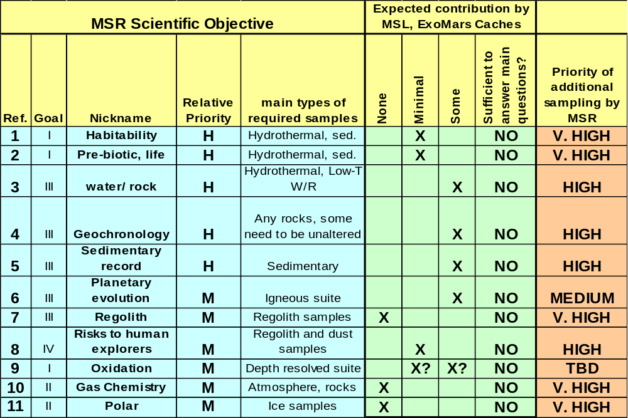Notes on Table 10. For MSL Objective 8 (Risks to Human Explorers), there is a need to acquire both regolith and dust samples. Because samples in the MSL cache will be exposed to the Martian environment during the period of time between MSL and MSR, the samples will be covered with dust. Although this dust could be extracted after return to Earth, the amount would be very little. For MSL Objective 9 (Oxidation), the degree of relevancy of the cached samples depends largely on the design (including depth range) of the ExoMars drilling system, and the capability of ExoMars to cache those samples.

Expected contribution of MSL cache samples to the scientific objectives for MSR
Steele et al. (2007) recently assessed the expected scientific value of the MSL cache. Their results are summarized with respect to the 11 candidate scientific objectives for MSR in Table 10. For Objectives 7 (Regolith), 10 (Gas Chemistry), and 11 (Polar), the MSL cache will not make any contribution because it will not have the capability to acquire and store regolith, atmosphere, and ice samples.

For the rest of the MSR scientific objectives, the contribution of the cached samples would likely be ‘minimal’ to ‘some’, depending on what MSL encounters and the nature of the samples selected for caching. The priorities for additional sampling by MSR reflect the comparison of the objectives for the MSL cache and the MSR mission and are summarized in Table 10.
In its discussions both internally and externally, ND-SAG has observed that the two main sectors of the Mars science community that would be able to make the most use of returned samples, namely astrobiologists and geologists, tend to view the strengths and limitations of the MSL cache differently. For our astrobiology objectives, the limitations are a major concern, whereas for at least some geologists, the strengths are more important. In order for MSR to maximize its scientific return, the samples need to serve the needs of BOTH astrobiology and geology, and we encourage all sectors of the community to be sensitive to other points of view.
In summary, for each of the 11 candidate scientific objectives for MSR, ND-SAG concludes that the expected contribution from the cached samples alone would not be sufficient to achieve the main scientific objectives proposed, and that additional sample acquisition/packaging by MSR would greatly enhance the science return. The MSL cache has the potential to increase the diversity of the samples; however it would imply a larger complexity for MSR in operations and possibly a larger mobility.
FINDING. It is extremely important that MSR have the capability to select and acquire its own samples, even if the decision is made to recover a cache aboard the MSL or ExoMars spacecraft.

Planetary Protection
The purpose of planetary protection is to prevent forward contamination of other solar system bodies (in this case, Mars) by Earth organisms and to prevent harmful contamination of the Earth’s biosphere by extraterrestrial organisms. The requirements associated with planetary protection are a critically important aspect of planning MSR. Although there are many planetary protection issues related to MSR, ND-SAG identified two topics of particular significance to the science value of MSR: 1) The relationship of MSR to “special regions” and 2) The effects of possible heat sterilization of the sample.
In this area, we need to be especially careful to distinguish our discussion of MSR in general from planning for the first MSR.
1. How important is it to hold open the option of sending MSR to a planetary protection "special region"?
In the past few years a new category of planetary protection has been defined and which is of particular interest to astrobiologists and the search for modern life. These are “special regions.” Special regions were defined in order to provide extra protection to Martian environments where terrestrial microbes could propagate (COSPAR, 2002; 2005). In simple terms, special regions have been interpreted to be environments with recent liquid water, and this has been quantitatively refined as locations where two environmental conditions are simultaneously met: the temperature is greater than -20°C, and the activity of water is greater than 0.5 (MEPAG SR-SAG, 2006; COSPAR, in prep.). Such environments, if they could be identified, would be of very attractive targets for MSR because of the potential for extant indigenous Martian life.
Accessing and sampling special regions is permitted by planetary protection policy. Doing so would require the sterilization of the spacecraft components that penetrate the special region. For missions that access a special region by means of roving, reaching, or drilling, the subsystems that penetrate the special region would need to be sterilized. For missions that land within a special region, or missions where a special region is present within the landing error ellipse, the entire landed system would need to be sterilized because of the potential of a spacecraft failure and break-up during EDL. In either case, MSR development would be significantly more complex in an engineering sense, thus increasing mission cost and risk.
At the time of this writing, no Martian environment, either surface or subsurface, has been identified that is known to meet the technical thresholds for a special region. However, there are several kinds of environments that exist on Mars for which it there is ambiguity as to whether they meet the threshold conditions for “special region” or not (e.g. mid-latitude gullies, pasted-on terrain). In the latter case, since they cannot be shown to be “not-special”, and for the purpose of planetary protection, which requires conservative approaches, they are treated as if they are “special”. In addition, MEPAG SR-SAG (2006) pointed out several kinds of geologic environments that if discovered by future researchers could qualify as special (active volcanoes, hydrothermal vents, large very young large craters).
For the purpose of planning MSR, it is important to recognize the difference between the attitude of planetary protection towards an environment with ambiguity (if there is a question, be conservative and treat as if special), and that of the science community (we need a high degree of confidence that the samples we want would be at the site selected—MSR is not the right choice of a mission to be probing sites that have major uncertainty).
Discussion—planning for the first MSR. The reality is that we cannot at present credibly propose that the objective of the first MSR be to find the extant Martian life and return it to Earth—we don’t know where to go or what to sample. We have no information on the environmental habitability factors for unknown Martian life forms. Our best guess is that the most favorable environment would be one with liquid water (which would qualify as a special region), but we have not yet made that discovery. For these reasons, proposed Scientific Objective #2 of this report is phrased “assess the evidence for pre-biotic processes, past life, and/or extant life”. The specific strategy for how to achieve this is left up to future landing site selection committees and other such planning teams. Note that since pre-biotic chemistry and the possibility of past life can be evaluated without the need to go to a special region, special region access is not required to achieve this objective. The objective could be alternatively be achieved through the study of ancient environments and their geologic products (e.g., sedimentary, igneous, and hydrothermal rocks), for which knowledge of their distribution is much more confidently known.
However, retaining the option to sample a special region with the first MSR would be valuable scientifically in the sense that it may allow us to respond to the discovery of liquid water within the next 5-10 years. Thus, for the first MSR mission, this question boils down to balancing the probability of making such a discovery against the increased cost of mission development (the development cost would be incurred whether the mission is eventually sent to a special region or not). This trade is best evaluated by a joint science-engineering team that could specifically evaluate both the cost and the benefit.
ND-SAG additionally observes that MEPAG SR-SAG (2006) presented very convincing arguments that for thermodynamic reasons, the most prospective part of Mars for near-surface modern liquid water is the latitude band 30-60° (both north and south latitude), and that it is almost impossible for liquid water to exist equatorward of 30° latitude. If MSR adopts equatorial landing site restrictions for EDL reasons, there would be little reason to believe that special region access capability could actually be used.
Note that whether MSR would or would not be sent to a special region is unrelated to whether the returned samples would be evaluated for extant Martian life—they assuredly would be, even if they do not come from special regions.
FINDINGS.
- ND-SAG finds that a scientifically compelling first MSR mission could be designed without including the capability to access and sample a special region.
- It would be desirable scientifically to retain the option of responding to a post-2007 discovery that changes our understanding of Martian special regions. However, the same could also be said of many other possible ways to enhance MSR--deciding which would be a prudent investment would entail cost-benefit comparisons of the various options, and consideration of budget availability.
- Based on our understanding of Mars as of 2007, unless MSR had the ability to land poleward of 30 degrees latitude, access very rough terrain, or achieve a significant subsurface penetration (e.g. >5 m), MSR would unlikely to be able to make use of incremental special regions capability.

2. What would be the effect on the science value of the samples if they are heat sterilized prior to Earth return?
Discussion—planning for the first MSR. Since we have no information about Martian life, beyond a reasonable hypothesis that it is most likely to be carbon-based, the only way to be confident of destroying it is to destroy the chemicals on which that life depends (Nealson et al., 1997). This has been interpreted to involve either heating the entire sample to 500C (half a second at the most protected location is presumed to be adequate), or some combination of high temperature and hard radiation (Nealson et al. 1997; Conley, writ. comm., 2008). Treating the samples this harshly would have severe negative impacts on the scientific usefulness of the returned material:
- Destroy or alter organic material within the sample, including components such as amino acids, polycyclic aromatic hydrocarbons, and paraffins, needed to evaluate hypotheses involving prebiotic chemistry, past life, and modern life.
- Destroy or alter many hydrous minerals such as clays, sulfates, and hydroxides that are essential to interpreting the aqueous history of Mars.
- For samples that are not encapsulated, components released from one sample could react with other samples, causing the samples to no longer be representative of the Martian environment.
- Adversely affect studies on possible (unknown) oxidant phases in regolith samples.
In addition, from a planetary protection standpoint there is no rationale to attempt sterilization of samples prior to Earth return. Since no method for the sterilization of putative Martian life has been validated, it would be very difficult to justify allowing the return of uncontained samples regardless of how they had been treated prior to Earth entry (Conley, writ. comm., 2008). ND-SAG concludes that heat sterilization of the samples would entail major negative consequences without any real benefit.
FINDING. Heat sterilization of the samples would have major negative consequences without any real benefit.

Contamination Control
Controlling the amount of contamination of the samples by both inorganic and organic species would be essential for realizing the potential scientific value of MSR. MSR would need to have specific contamination requirements in at least three areas: 1). Earth-sourced organic molecules, 2). Earth-sourced inorganic substances, and 3). live Earth-sourced organisms. Although dead Earth-sourced organisms would also be of interest, if they are detected by molecular methods, they would be covered in category #1. For organic compounds, Mahaffy et al. (2004) proposed an overall limit of 40 ppb, with sub-limits for each of 6 main classes of organic molecules of interest, and MacPherson et al. (2005) recommended that this be reduced for MSR by a factor of 4, to a total of 10 ppb. Although modern instrumentation may be able to detect much lower levels of organics, achieving a significantly lower allowable contamination limits may be impractical as may the realization of lower organic levels in blanks used during the sample analysis. For inorganic contaminants, MacPherson et al. (2005) recommended that the levels be set at 0.1% of the concentration in Shergotty and Nakla, two of the Martian meteorites. This led to the calculation of Table 7 in their report, which has specific recommendations for about 30 elements of interest. For live terrestrial organisms, a draft planetary protection requirement is a 10⁻² probability of a single round-trip organism. We are not aware that the science community has ever proposed a requirement more strict than this. All of the above are the starting point for future discussion as scientific priorities in this area are further refined.
It would also be important that we design an effective strategy for the use of witness plates on MSR to help distinguish carbon compounds in the returned samples from contamination introduced during spacecraft operations and/or sample processing on Earth. We know that sample contamination happens in the terrestrial environment, regardless of how carefully the sample is treated. For example, handling of lunar and meteorite samples has introduced contaminants such as xylan (an amide-based compound) found in lubricant for bolts in the lunar processing cabinets (Wright et al., 1991,1992), Phthalates and siloxanes (Steele 2001), or epsilon amino n-caproic acid formed during hydrolyis of nylon bag material used to contain carbonaceous chondrites (Glavin et al., 2006). Terrestrial microbes are known to be able to propagate on Martian meteorites (Steele, 2001; Toporski and Steele, 2007). A key to identifying and avoiding contaminants such as these is to archive any potential contamination sources during the spacecraft and hardware design and construction a process which has heritage from several sample return missions including Apollo, Genesis, Stardust, and Phoenix. However, this step must be planned for in advance.
FINDING. Effective contamination control procedures will be of central importance to the scientific value of MSR.

Documented Sample Orientation
The scientific value of the returned collection could be improved if sample orientation is documented for at least some of the samples. The primary use for this sample attribute would be in paleomagnetic studies (see Appendix II; Investigations IIIA-10 and IIIB-2), but it may also be useful in interpreting paleoflow directions for sedimentary rock samples. The scientific need could be met if the sample orientation in known to within ~10 degrees.
The orientation measurements could in principle be determined, through a combination of telemetry and imagery (the same technique is used on MER, where orientation precision is determined to within a few degrees). Telemetry includes overall rover orientation from the IMU and joint angles from the arm. Imagery includes the documentation images of the science target as well as operational imagery showing the arm in place and the position of the instruments (and corer) as the samples are obtained. This information is already required for sample documentation and safety monitoring of arm operations, therefore determining the orientation should not add any additional requirements on the system. Finally, we need to know the rotational orientation of the core sample. This may be available for indurated samples by comparing images of the surface with MI images taken before drilling. Although not all samples will preserve the top after drilling, enough may do so to be sufficient to meet the science goals of the mission. Of course alternative methods for marking the rotational orientation might be superior and should be sought.

Program Context, and Planning for the First MSR
MSR would not be a one-time stand-alone mission. During the course of deliberations by ND-SAG it became evident that relationships must be more clearly defined between MSR, the Mars Exploration Program (MEP), and the eventual human exploration of Mars.
The MEP lays out a logical progression of missions that build upon the past and lead to the future. In that sense, the recent, current, and planned missions have already and would continue to contribute to a superior first MSR mission (see Section IV.A). We thus believe that a first MSR mission in the next decade would be far better scientifically than any MSR mission that might have been implemented earlier. This validates NASA’s foresight in establishing the MEP many years ago and its belief that Mars holds a special place in planetary exploration. The ND-SAG anticipates that such a productive return-on-investment would continue after the first MSR mission: there is no doubt that the analyses of the returned samples would significantly alter our understanding of Mars and greatly enhance our interpretation of current and future remote sensing data. This conclusion has been “validated” by the Apollo program in which the results from the Apollo-11 returned samples directly and rapidly impacted subsequent Apollo missions and led to the establishment of many of the science objectives for the current spate of lunar robotic missions.
For the first MSR mission, we need to balance the need to keep the mission from becoming overly complex in an engineering sense, while at the same time retaining the essential attributes that contribute to the scientific value. As input to these trades, the ND-SAG team has summarized in Table 11 the various attributes discussed in this report that would improve the science value of MSR, along with a preliminary assessment of the impact of these attributes on mission engineering. Since there are legitimate differences of opinion within the science community on the priority of these attributes, and the planning for a possible MSR is still in its early stages, rather than try to reach consensus on a single set of priorities, three example priority positions are shown in the columns on the right. This illustrates both the commonalities and the differences in how different sectors of the science community value these attributes.
The question naturally arises as to what follows MSR in the MEP. First, we do not consider MSR to be a single-mission event. The great diversity of Mars makes it probable that not all MSR objectives could be achieved at one sample site. Landing site engineering constraints for the first MSR mission prohibit going to certain terrains, such as polar regions and rough topography (e.g., the gullies of “uncertain special regions” or “special regions”). The data gleaned from the first MSR mission would likely stimulate the desire to conduct additional MSR missions.
There is an aspect of a “second MSR mission” that merits our attention, to wit: the MEP may decide, for reasons of program risk reduction, to advocate replicating the riskier elements of the mission, e.g. landing and ascent systems. If such appears prudent and affordable, we could today make a convincing case that returning samples from two substantially different sites on Mars would be eminently prudent. The living example of this risk-reduction philosophy is the MER mission, for which the NASA administrator chose to send two landers.
Table 10 Science priority of attributes of the first MSR.
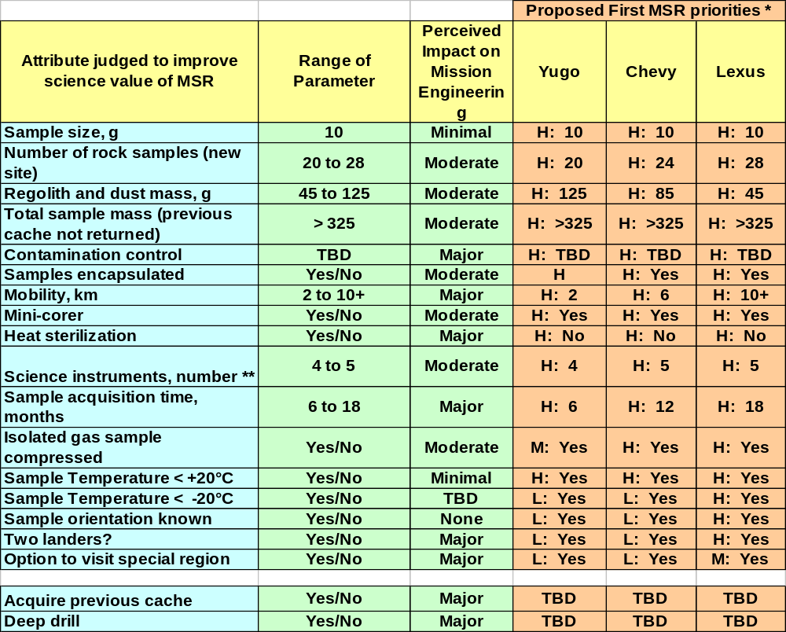Notes on Table 11. KEY: H - High priority, M - Medium priority, L - Lower priority **Revisiting a previously characterized site might require only 2 instruments.

The ND-SAG emphasizes that, however important, the first MSR would not be the finale of a science-driven MEP. We know now that other mission types need to be considered for opportunities immediately following the first MSR. There are already high priority proposed and studied mission concepts that are relatively independent of MSR results (e.g., network missions, orbital science) and that could be implemented immediately after the first MSR. Indeed, it is virtually inevitable that the results of the first MSR would lead to new proposals for non-MSR orbital and surface science missions.
The MSR mission would have a significant relationship to eventual human exploration. As shown both in the MEPAG Goals and in this study, information gleaned from the returned samples would be directly related both to the health and well being of astronauts on Mars and to reliable operations on the Martian surface. There is an associated indirect yet important aspect: the detailed knowledge obtained from the returned sample would inevitably inform what science astronauts would do at Mars and how they would do it. For these reasons an MSR mission probably would be required at the landing site eventually selected for human exploration (which may or may not be a prior MSR site). Again we refer to the Apollo missions in which post Apollo-11 mission science was altered in response to findings from returned samples. Lastly, there would be the “proof-of-concept” element of MSR in which the demonstration of the roundtrip to Mars with successful Earth-return bolsters public understanding and conviction that it is indeed feasible for humans to eventually make that sojourn.

SUMMARY OF FINDINGS AND RECOMMENDED FOLLOW-UP STUDIES
Additional discussion is recommended in the following areas.
- MSR landing site selection process and timing. How would the specific candidate landing sites for MSR be identified and screened for safety? Which sites optimize the science return by effectively addressing the most MSR science objectives? Would it be prudent to use the instruments on MRO for this purpose while the orbiter is still healthy? We need to take into consideration the expected availability of orbital instruments during the second decade.
- Contamination limits. All of the arguments related to contamination limits and priorities discussed above in Section VI-K will need to be reconsidered. Substantial amounts of information now exist (including unpublished data) about contamination relevant to many different missions or sample collections - Antarctic meteorites, lunar samples, Stardust, Genesis, maybe soon Hayabusa. In addition we will need to consider experience and results from the 2007 Mars Phoenix mission, the 2009 Mars Science Laboratory, and the 2013 ExoMars mission. It would be useful to compile a summary for these different cases with an aim to identify common problems, solution philosophies, and lessons learned. Note that for scientific purposes, contamination management planning must address flight system activities as well as sample handling in the SRF, post-SRF curation, and PI laboratories. There is no point in keeping the samples substantially cleaner during any one of these phases than during the others—we need a contamination management plan for the entire life-cycle of the samples.
- Depth of subsurface access. A major open question for MSR is the nature of the relationship between the oxidizing surface zone, and the inferred reduced subsurface zone. What is the depth scale of this gradient into the near subsurface? How does this depth scale vary as a function of the permeability of the particular subsurface material? As we acquire relevant new information either during on-going missions, through new missions, or from new modelling methods, this question needs to be reconsidered. We will require assistance in order to make informed decisions regarding the hardware necessary to access subsurface materials during the MSR mission.
- For core samples: length vs. diameter. This report recommends that a mini-corer be utilized to acquire rock samples and that these samples must be larger than about 10 grams (or if the engineering requirement is defined in terms of volume, about 3.5 cc). However, the ND-SAG team did not attempt to evaluate the optimal combination of length and diameter of these core samples. Preliminary thought within the ND-SAG team was that a mini-core length of about 5 cm would be desirable, but more systematic analysis is required.
- Strategy for splitting the samples in the SRF. A strategy should be devised in advance for splitting the rock samples that arrive intact at the SRF. For the purpose of planetary protection, it will be necessary to take statistically significant sub-samples in order to reach conclusions that can be applied to the entire sample. The decision on how the samples are subdivided will affect the subsequent scientific investigation plan.
- Relationship between landing site targeting precision, minimum roving distance, and time on the surface. If the landing error ellipse has a radius of 3 km, and the sample acquisition traverse is about 2 or 2.5 km, then, if the landing site is a "go-to" site, the total rover distance would be 8.5 km (3 + 3 + 2.5). If landing site targeting precision is reduced to 1 km, this would reduce range to 4.5 km (1 + 1 + 2.5). A relatively firm time constraint might be imposed by the limitations on thermal cycling of the MAV, accordingly it would have to launch within 12 months. This is independent of planetary alignment considerations. Given estimates of rover distance per day, time to use the instruments to do sample selection, and the time to drill and encapsulate each of the rock samples, there is a possibility that all of the work needed cannot fit within the allowable 12 months. These issues would be more severe in ND-SAG’s "Case A", where MSR is sent to a virgin site (time required to determine the geologic context). Thus, it seems likely that the relationships between time on the surface, rover mobility range, landing site targeting precision, and spatial distribution of samples will need more detailed study. Develop strategic ground operation scenarios; e.g., conduct multiple sample collection sorties with periodic sample deliveries to MAV?
- Preparation of a Design Reference Mission. It would be helpful to prepare a Design Reference Mission that would summarize how we would achieve the following: 1) collect samples and characterize the site, 2) address the key questions that this exploration was designed to answer, and 3) respond to new discoveries. We suggest that we do such a study for the Columbia Hills. Such an analysis would tell us how much documentation we have to do to understand the context of a site, how much sample we have to take to characterize a specific type of rock (or process), and how far we have to go to obtain the samples for MSR needed to address key scientific goals and objectives.
- Engineering/cost studies of each of the factors indicated in Section VI. Each of the factors described in Section VI of this report should be evaluated more rigorously for their engineering and costs. (For example, re: Number of Samples - optimal number of encapsulated samples; potential value of an additional large “MSL-like” chamber for local regolith plus “durable” rock chips, etc.)

ACKNOWLEDGEMENTS
In addition to the 30 members of the ND-SAG team, the following additional scientists contributed to the breadth of ideas in Appendix II:
MEPAG Goal I. Anderson, Marion (Monash U., Australia), Carr, Mike (USGS-retired), Conrad, Pamela (JPL), Glavine, Danny (GSFC), Hoehler, Tori (NASA/ARC), Jahnke, Linda (NASA/ARC), Mahaffy, Paul (GSFC), Schaefer, Bruce (Monash U., Australia), Tomkins, Andy (Monash U., Australia), Zent, Aaron (ARC)
MEPAG Goal II. Bougher, Steve (Univ. Michigan), Byrne, Shane (Univ. Arizona), Dahl-Jensen, Dorthe (Univ. of Copenhagen), Eiler, John (Caltech), Engelund, Walt (LaRC), Farquahar, James (Univ. Maryland), Fernandez-Remolar, David (CAB, Spain), Fishbaugh, Kate (Smithsonian), Fisher, David (Geol. Surv. Canada), Heber, Veronika (Switzerland), Hecht, Mike (JPL), Hurowitz, Joel (JPL), Hvidberg, Christine (Univ. of Copenhagen), Jakosky, Bruce (Univ. Colorado), Levine, Joel (LaRC), Manning, Rob(JPL), Marti, Kurt (U.C. San Diego), Tosca, Nick (Harvard University)
MEPAG Goal III. Banerdt, Bruce (JPL), Barlow, Nadine (Northern Ariz. Univ.), Clifford, Steve (LPI), Connerney, Jack (GSFC), Grimm, Bob (SwRI), Kirschvink, Joe (Caltech), Leshin, Laurie (GSFC), Newsom, Horton, (Univ. New Mexico), Weiss, Ben (MIT)
MEPAG Goal IV. McKay, David (JSC), Allen, Carl ((JSC), Jolliff, Brad (Washington University), Carpenter, Paul (Washington University), Eppler, Dean (JSC), James, John (JSC), Jones, Jeff (JSC), Kerschman, Russ (NASA/ARC), Metzger, Phil (KSC)
Part of this work was carried out at the Jet Propulsion Laboratory, California Institute of Technology, under a contract with the National Aeronautics and Space Administration. The contribution to this work performed by Lars Borg was done under the auspices of the U.S. DOE by Lawrence Livermore National Laboratory under Contract DE-AC52-07NA27344. D. J. Des Marais and Lisa Pratt acknowledge support from the NASA Astrobiology Institute.

REFERENCES

Arvidson, R. E., et al. (2006), Overview of the Spirit Mars Exploration Rover Mission to Gusev Crater: Landing site to Backstay Rock in the Columbia Hills, Journal of Geophysical Research-Planets, 111, E02S01, doi:10.1029/2005JE002499.
Ashley, J. W., S. W. Ruff, P. R. Christensen, and L. A. Leshin, 2007, METALLIC IRON IN METEORITES AS A SENSITIVE TRACER OF SURFACE-VOLATILE INTERACTIONS ON MARS – A PROGRESS REPORT (abs.). Lunar and Planetary Science XXXVIII, abs. # 2264.
Bandfield J.L., Glotch T.D., and Christensen P.R. 2003 Spectroscopic identification of carbonate minerals in the Martian dust. Science, 301, 1084-1087.
Baross, J.A., Deming, J.W., 1995. Growth at high temperatures: isolation and taxonomy, physiology, and ecology. In. Karl DM (ed.) The microbiology of deep-sea hydrothermal vents. CRC Press, Boca Raton, FL., p. 169-217.
Bertelsen, P., W. Goetz, M. B. Madsen, K. M. Kinch, S. F. Hviid, J. M. Knudsen, H. P. Gunnlaugsson, J. Merrison, P. Nornberg, S. W. Squyres, J. F. Bell, III, K. E. Herkenhoff, S. Gorevan, A. S. Yen, T. Myrick, G. Klingelhofer, R. Rieder, and R. Gellert (2004), Magnetic properties experiments on the Mars Exploration Rover Spirit at Gusev Crater, Science, 305, 827-829.
Bibring J.-P., Langevin Y., Mustard J. F., Poulet F., Arvidson R., Gendrin A., Gondet B., Mangold N., Pinet P., Forget F., the OMEGA team, Berthe M., Gomez C., Jouglet D., Soufflot A., Vincendon M., Combes M., Drossart P., Encrenaz T., Fouchet T., Merchiorri R., Belluci G., Altieri F., Formisano V., Capaccioni F., Cerroni P., Coradini A., Fonti S., Korablev O., Kottsov V., Ignatiev N., Moroz V., Titov D., Zasova L., Loiseau D., Pinet P., Doute S., Schmitt B., Sotin C., Hauber E., Hoffmann H., Jaumann R., Keller U., Arvidson R., Duxbury T., Forget F., and Neukum G. (2006) Global Mineralogical and Aqueous Mars History derived from OMEGA/Mars Express Data 10.1126/science.1122659. Science 312(5772), 400-404.
Bishop, J. L., S. L. Murchie, C. M. Pieters, and A. P. Zent (2002), A model for formation of dust, soil, and rock coatings on Mars: Physical and chemical processes on the Martian surface, J. Geophys. Res., 107(E11), 5097, doi:10.1029/2001JE001581
Boctor, N., J. Wang, C. Alexander, and E. Hauri, Volatile abundances and hydrogen isotope signatures of melt inclusions and nominally anhydrous minerals in the chassignites and ALH84001, Lunar Planet Sci. XXXVII ,2006, Abst. #1412.
Bogard, D., A reappraisal of the Martian 36Ar/38Ar ratio, J. Geophys Res., Planets 102, NoE1, 1997, p.1653-1661.
Bogard D.D. and Johnson P. (1983) Martian gases in an Antarctic meteorite? Science 221, 651-654.
Bogard D., Clayton R., Marti K., Owen T., and Turner G. (2001) Martian volatiles: isotopic composition, origin, and evolution, Space Sci. Rev. 96, 425.
Borg L. E. and Drake M. J. (2005) A Review of Meteorite Evidence for the Timing of Magmatism and of Surface or Near-Surface Liquid Water on Mars. Journal of Geophysical Research 110,.E12SO3, doi:10.1029/2005JE002402, 2005.
Borg L.E. and Draper D.S. (2003) A petrogenetic model for the origin and compositional variation of the Martian basaltic meteorites. Meteoritics and Planetary Science 38, 1713-1732.
Borg L. E., Nyquist L. E., Wiesmann H., Shih C. –Y., and Reese Y. (2003) The Age of Dar al Gani 476 and the Differentiation History of the Martian Meteorites Inferred from their Radiogenic Isotopic Systematics. Geochim. Cosmochim. Acta 67, 3519-3536.
Borg L. E., J. N. Connelly, L. E. Nyquist, C. -Y. Shih, H. Wiesmann, and Y. Reese (1999), The age of the carbonates in Martian meteorite ALH84001. Science, 268, 90-94.
Brandon, A.D., Walker, R.J., Morgan, J.W., and Goles, G.G. (2000) Re-Os isotopic evidence for early differentiation of the Martian mantle. LPSC XXXI, abstract # 1676.
Bridges J.C., Catling D.C., Saxton J.M., Swindle T.D., Lyon I.C. and Grady M.M. 2001 Alteration assemblages in Martian meteorites: implications for near-surface processes. In Evolution of Mars R. Kallenbach, J. Geiss and W. K. Hartmann, pp.365-392, Kluwer, Dordrecht.
Bullock, M. A., C. R. Stoker, C. P. McKay, A. P. Zent, A coupled soil-atmosphere model of H2O2 on Mars, Icarus; 107, 142 - 154, 1994
Cady, S.L., and J.D. Farmer (1996), Fossilization processes in siliceous thermal springs: trends in preservation along the thermal gradient, in, Evolution of hydrothermal ecosystems on Earth (and Mars), ed. G.R. Bock and J.A. Goodie, Ciba Symposium 202, John Wiley, Chichester, pp 150-173.
Carr M.H. 2006 The Surface of Mars. Cambridge University Press pp307.
Carsey, F.D., L.W. Beegle, R. Nakagawa, J.O. Elliott, J.B. Matthews, M.L. Coleman, M.H. Hecht, A.B. Ivanov, J.W. Head, S.M. Milkovich, D.A. Paige, A.N. Hock, D.I. Poston, M. Fensin, R.J. Lipinski and T.M. Schriener, Palmer Quest: A feasible nuclear fission 'Vision Mission' to the Mars Polar Caps, Proceedings of the 36th Lunar and Planetary Science Con-ference, #1944, 2005
Christensen, P. R. (1986), Regional dust deposits on Mars: Physical properties, age, and history, J. Geophys. Res., 91, 3533-3545.
Christensen, P. R., M. B. Wyatt, T. D. Glotch, A. D. Rogers, S. Anwar, R. E. Arvidson, J. L. Bandfield, D. L. Blaney, C. Budney, W. M. Calvin, A. Fallacaro, R. L. Fergason, N. Gorelick, T. G. Graff, V. E. Hamilton, A. G. Hayes, J. R. Johnson, A. T. Knudsen, H. Y. McSween Jr., G. L. Mehall, J. E. Moersch, R. V. Morris, M. D. Smith, S. W. Squyres, S. W. Ruff, and M. J. Wolff (2004), Mineralogy at Meridiani Planum from the Mini-TES experiment on the Opportunity Rover, Science, 306 (5702), 1733-1739.
Christensen P. R. plus 11 coauthors (2005) Evidence for magmatic evolution and diversity on Mars from infrared observations. Nature 436, 504-509.
Christner, B. C., E. Mosley-Thompson, L. G. Thompson, J. N. Reeve (2001) Isolation of bacteria and 16S rDNAs from Lake Vostok accretion ice. Environmental Microbiology, 3 (9), 570–577. doi:10.1046/j.1462-2920.2001.00226.x
Clark, B. C., Morris, R. V. and 22 others and the Athena Science Team (2005) Chemistry and mineralogy of outcrops at Meridiani Planum, Earth Planet. Sci. Lett. 240, 73-94
Clark, B. C., Arvidson, R. E. and 14 others (2007) Evidence for montmorillonite or its compositional equivalent in Columbia Hills, Mars. J. Geophys. Res., 112, E06S01, doi:10.1029/2006JE002756.
Clemett, S. et al. (2006) Observations and analysis of in situ carbonaceous matter in Nakhla: Part I. Lunar and Planetary Science XXXVII, #2251.
COSPAR (2002, 2005), Planetary Protection Policy, October 2002, as amended, March 2005; http://www.cosparhq.org/scistr/PPPolicy.htm.
Dartnell, L. R., L. Desorgher, J. M. Ward, and A. J. Coates, 2007, Martian sub-surface ionising radiation: biosignatures and geology. Biogeosciences, 4, 545–558
Davis, J. Medical issues for a mission to Mars. Symposium on Space Medicine. Texas Medicine 94(2) Pp 47-55 Feb 1998
Delano J. W. (1986) Pristine lunar glasses: Criteria, data, and implications. Proc. 16th Lunar Planet. Sci. Conf., D201-D213.
Des Marais, D. J., Allamandola, L. J., Benner, S. A., Boss, A. P., Deamer, D., Falkowski, P. G., Farmer, J. D., Hedges, S. B., Jakosky, B. M., Knoll, A. H., Liskowsky, D. R., Meadows, V. S., Meyer, M. A., Pilcher, C. B., Nealson, K. H., Spormann, A. M., Trent, J. D., Turner, W. W., Woolf, N. J., Yorke, H. W. (2003) The NASA Astrobiology Roadmap. Astrobiology 3, 219-235.
Des Marais, D. J., N. Cabrol and the Athena Science Team (2007) Assessing the potential for ancient habitable environments in Gusev crater, Mars. Seventh International Conference on Mars, Pasadena, CA, July 9-13, 2007.
Eigenbrode, J.L. (2007) Fossil Lipids for Life-Detection: A Case Study from the Early Earth Record. Space Science Reviews, doi 10.1007/s11214-007-9252-9
Elsila et al (2005) Alkylation of polycyclic aromatic hydrocarbons in carbonaceous chondrites. Geochim. Cosmochim. Acta 69, 1349-1357.
Eugster O. 2001 Cosmic-ray Exposure Ages of Meteorites and Lunar Rocks and Their Significance. Chemie der Erde, 63, 3-30.
Farmer, J.D. 1998. Thermophiles, early biosphere evolution and the origin of life on Earth: Implications for the exobiological exploration of Mars. Journal of Geophysical Research 103: 28,457-28,461.
Farmer, J., 1999. Taphonomic modes in microbial fossilization. pp. 94-102, In Proceedings of the Workshop on Size Limits of Very Small Microorganisms. Space Studies Board, National Research Council, National Academy Press, Washington D.C.
Farmer J. D. and D. J. Des Marais, 1999, Exploring for a record of ancient Martian life. Journ. Geophys. Res. 104 (E11) 26,977-26,995.
Farmer, J. D. 2000. Hydrothermal Systems: Doorways to Early Biosphere Evolution, GSA Today 10(7), 1-9.
Farquhar J., Savarine J., Jackason T., and Thiemens M. (2000) Evidence of atmospheric sulphur in the Martian regolith from sulphur isotopes in meteorites, Nature 404, 50.
Feldman W.C., Prettyman t.H., Maurice S. et. 2004 The global distribution of near surface hydrogen on Mars. J. Geophys. Res. 109(e9), doi: 10.1029/2003JEO2160.
Fisher, D. A. Mars' water isotope (D/H) history in the strata of the North Polar Cap: Inferences about the water cycle. Icarus, 187 (2), pp. 430-441, 2007, doi:10.1016/j.icarus.2006.10.032.
Flynn, G.J., McKay, D.S., 1990. An assessment of the meteoritic contribution to the Martian dust. J. Geophys. Res. 95, 14 497–14 509.
Gibson, E.K., Wentworth, S.J., and McKay, D.S. (1983) Chemical weathering and diagenesis of a cold desert soil from Wright Valley, Antarctica: an analog of martian weathering processes. Proc. Lunar Planet. Sci. Conf. 13, A912-A928.
Glavin, D.P., Dworkin, J.P., Aubrey, A., Botta, O., Doty, J.H., III, Martins, Z., and Bada, J.L. (2006) Amino acid analyses of Antarctic CM2 meteorites using liquid chromatography – time of flight – mass spectrometry. MAPS 41, 889-902.
Goetz, W., P. Bertelsen, C. S. Binau, H. P. Gunnlaugsson, S. F. Hviid, K. M. Kinch, D. E. Madsen, M. B. Madsen, M. Olsen, R. Gellert, G. Klingelhofer, D. W. Ming, R. V. Morris, R. Rieder, D. S. Rodionov, P. A. de Souza, Jr., C. Schroder, S. W. Squyres, T. Wdowiak, and A. S. Yen (2005), Indication of drier periods on Mars from the chemistry and mineralogy of atmospheric dust, Nature, 436, 62-65.
Golden, D. C., Ming, D. W., Morris, R. V. and Mertzman, S. A. (2005) Laboratory-simulated acid-sulfate weathering of basaltic minerals: Implications for formation of sulfates at meridiani Planum and Gusev crater, Mars. J. Geophys. Res., 110, E12S07, doi:10.1029/2005JE002451.
Goldstein, J.I. et al. (2005) Microstructure and thermal history of metal particles in CH chondrites. Lunar and Planetary Science XXXVI, 1391.
Golombek M.P. et al. (18 authors) 2006 Geology of the Gusev cratered plains from the Spirit rover traverse. J. Geophys. Res. 111(E2), doi:10.1029/2005JE002503.
Gooding, J. L., M. H. Carr and C. P. McKay (1989) The case for planetary sample return missions 2. History of Mars. EOS 70, 745 & 754-755.
Grotzinger, J. P., Bell III, J. F. and 16 others (2005) Stratigraphy and sedimentology of a dry to wet eolian depositional system, Burns formation, Meridiani Planum, Mars. Earth Planet. Sci. Lett. 240, 11-72.
Hardie, L. A., Lowenstein, T. K. and Spencer, R. J. (1985) The problem of distinguishing between primary and secondary features in evaporates. 6th Int’l. Symp. On Salt, 1, 11-39.
Hartmann W. K. and G. Neukum (2001) Cratering chronology and the evolution of Mars. Space Sci. Rev. 96, 165-194.
Haskins, L.A.,et al. 2005. Water alteration of rocks and soils from the Spirit Rover site, Gusev Crater, Mars. Nature 436: 66-69.
Head, J. W., D. R. Marchant, M. C. Agnew, C. I. Fassett and M. A. Kreslavsky, Extensive valley glacier deposits in the northern mid-latitudes of Mars: Evidence for Late Amazonian obliquity-driven climate change, Earth and Planetary Science Letters 241, 663-671, 2006.
Head, J. W. and D. Marchant, Cold-based mountain glaciers on Mars: Western Arsia Mons, Geology, 31:7, 641-644, 2003.
Hecht, M. and the Chronos team, CHRONOS: A journey through Martian history. Fourth International Conference on Mars Polar Science and Exploration (2006), Abstract #8096
Herkenhoff, K. E., et al. (2004) Evidence from Opportunity’s microscopic imager for water on Meridiani Planum. Science 306: 1727-1730.
Herkenhoff, K. E., S. Byrne, P. S. Russell, K. E. Fishbaugh, and A. S. McEwen, Meter scale morphology of the north polar region of Mars. Science 317 (5845) pp. 1711-1715, Sept 21 2007.
Hurowitz, J. A., McLennan, S. M. and 6 others (2006) In situ and experimental evidence for acidic weathering of rocks and soils on Mars. J. Geophys. Res., 111, E02S19, doi:10.1029/2005JE002515.
Hurowitz, J. A., Tosca, N. J., McLennan, S. M. and Schoonen, M. A. A. (2007) Production of hydrogen peroxide in Martian and lunar soils. Earth Planet. Sci. Lett., 255, 41-52.
James O. B., Lindstrom M. M., and Flohr M. K. (1989) Feroan anorthosite from lunar breccia 64435: Implications for the origin and history of lunar ferroan anorthosites. Proc. 19th Lunar Planet Sci. Conf., 219-243.
Jones, JA, Barratt, M., Effenhauser, R., Cockell, C. And Lee, P. Medical Issues for a Human Mission to Mars and Martian Surface Expeditions. Journal of the British Interplanetary Society 57(3/4): March/April 2004 p.144-160
Karcz, J, and the MSL Sample Cache Science Definition Group, 2007, DRAFT scientific requirements for a possible Mars Science Laboratory sample cache, NASA Ames Research Center document A9SP-0703-XR04.
Kieffer H.H., Martin T.Z., Peterfreund A.R., Jakosky B.M. et al. 1977 Thermal and albedo mapping of Mars during the Viking primary mission. J. Geophys. Res. 82, 4249-91.
Klein, H.P., 1978. The Viking biological experiments on Mars. Icarus 34, 666–674.
Klein, H.P., 1979. The Viking Mission and the search for life on Mars. Rev. Geophys. Space Phys. 17, 1655–1662.
Konhauser, K. (2007) Introduction to Geomicrobiology. Blackwell Publishing, Oxford, 425 pp.
Leshin, L., S. Epstein, and E. Stolper, Hydrogen isotope geochemistry of SNC meteorites, Geochim Cosmochim Acta 60, 1996, pp.2635-2650.
Lutz RA, Shank TM, Fornari DJ et al. (1994) Rapid growth at deepsea vents. Nature, 371, 663–664.
MacPherson, G.J. and Mars Sampling Advisory Group (2001) The First Returned Mars Samples: Science Opportunities. In: McCleese D., Greeley, R., and MacPherson G. (eds) Science Planning for Mars. Jet Propulsion Laboratory Publication 01-7 (53 pp). Available on the web at at http://mepag.jpl.nasa.gov/reports/index.html.
MacPherson, G.J., and the MSR Science Steering Group (2002), Groundbreaking MSR: Science requirements and cost estimates for a first Mars surface sample return mission. Unpublished white paper, http://mepag.jpl.nasa.gov/reports/index.html.
MacPherson, G.J. and the Mars Sample Return Science Steering Group II (2005). The first Mars surface-sample return mission: Revised science considerations in light of the 2004 MER results, Unpublished white paper, TBD p, Appendix III of Analysis of Science Priorities for Mars Sample Return, Based on Knowledge Through 2007; posted March 2008 by the Mars Exploration Program Analysis Group (MEPAG) at http://mepag.jpl.nasa.gov/reports/index.html.
Mahaffy, P. and 15 co-authors (2003), Report of the Organic Contamination Science Steering Group. Unpublished white paper, http://mepag.jpl.nasa.gov/reports/index.html.
Mathew K. J. and Marti K. (2005) Evolutionary trends in volatiles of the nakhlite source region of Mars. J. Geophys. Res. 110, E12S05.
McCollum, T.M., Shock, E.L., 1997. Geochemical constraints on chemolithoautotrophic metabolism by microorganisms at seafloor hydrothermal systems. Geochim. Cosmochim. Acta. 61, 4375-4391.
McKay, D. S., Fruland, R. M., Heiken, G. H. (1974) Grain size and the evolution of lunar soils. Lunar Science Conference Proceedings 5th, 887-906.
McLennan, S. M. and Grotzinger, J. P. (in press) The sedimentary rock cycle on Mars. In: J. F. Bell III (ed.) The Martian Surface: Composition, Mineralogy, and Physical Properties. Cambridge Univ. Press (Cambridge).
McLennan, S.M., J.F. Bell III, W.M. Calvin, P.R. Christensen, B.C. Clark, P.A. de Souza, J. Farmer, W.H. Farrand, D.A. Fike, R. Gellert, A. Ghosh, T.D. Glotch, J.P. Grotzinger, B. Hahn, K.E. Herkenhoff, J.A. Hurowitz, J.R. Johnson, S.S. Johnson, B. Jolliff, G. Klingelho¨ fer, A.H. Knoll, Z. Learner, M.C. Malin, H.Y. McSween Jr., J. Pocock, S.W. Ruff, L.A. Soderblom, S.W. Squyres, N.J. Tosca, W.A. Watters, M.B. Wyatt, A. Yen Provenance and diagenesis of the evaporite-bearing Burns formation, Meridiani Planum, Mars Earth and Planetary Science Letters 240 (2005) 95–121
McSween H. Y., T. L. Grove and M. B. Wyatt (2003) Constraints on the composition and petrogenesis of the Martian crust. J. Geophys. Res. 108, E12, 5135, doi:10.1029/2003JE002175.
McSween, H. Y., Arvidson, R. E., Bell III, J. F., Blaney, D., Cabrol, N. A, Christensen, P. R. Clark, B. C., Crisp, J., Crumpler, L. S., Des Marais, D. J., Farmer, J. D., Gellert, R., Ghosh, A., Gorevan, S., Graff, T., Grant, J., Haskin, L. A., Herkenhoff, K. E., Johnson, J. R., Joliff, B. L., Klingelhoefer, G., Knudson, A. T., McLennan, S., Milam, K. A., Moersch, J. E., Morris, R. V., Rieder, R., Ruff, S. W., deSouza, P. A., Squyres, S. W., Wänke, H., Wang, A, Wyatt, M. B, Yen, A., Zipfel, J. (2004) Basaltic rocks at the Spirit landing site in Gusev Crater. Science, Vol. 305. Number 5685, 842-845.
McSween, H.Y. et al., Alkaline Volcanic Rocks from the Columbia Hills, Gusev Crater, Mars. October, 2006. JGR-Planets, Vol. 111, E09S91, doi:10.1029/2006JE002698.
MEPAG (2001), Scientific Goals, Objectives, Investigations, and Priorities, in Science Planning for Exploring Mars, JPL Publication 01-7, p. 9-38. Available on the web at http://mepag.jpl.nasa.gov/reports/index.html.
MEPAG (2004), Scientific Goals, Objectives, Investigations, and Priorities: 2003. Unpublished document, http://mepag.jpl.nasa.gov/reports/index.html.
MEPAG (2005), Mars Scientific Goals, Objectives, Investigations, and Priorities: 2005, 31 p. white paper posted August, 2005 by the Mars Exploration Program Analysis Group (MEPAG) at http://mepag.jpl.nasa.gov/reports/index.html.
MEPAG (2006), Mars Scientific Goals, Objectives, Investigations, and Priorities: 2006, J. Grant, ed., 31 p. white paper posted February, 2006 by the Mars Exploration Program Analysis Group (MEPAG) at http://mepag.jpl.nasa.gov/reports/index.html
MEPAG SR-SAG (Special Regions Science Analysis Group) (2006), Findings of the Mars Special Regions Science Analysis Group, Astrobiology 6, 677-732. The document can also be accessed at http://mepag.jpl.nasa.gov/reports/index.html
MEPAG MHP-SSG (Mars Human Precursor Science Steering Group) (2005). An Analysis of the Precursor Measurements of Mars Needed to Reduce the Risk of the First Human Missions to Mars. Unpublished white paper, 77 p, posted June, 2005 by the Mars Exploration Program Analysis Group (MEPAG) at http://mepag.jpl.nasa.gov/reports/index.html
Michael, T. M., Feldman, W.C. and Prettyman, T.H. 2004 The presence and stability of ground ice in the southern hemisphere of Mars. Icarus , 169, 324-340.
Milkovich, S.M. and J.W. Head, North polar cap of Mars: Polar layered deposit characterization and identification of a fundamental climate signal. Journal of Geophysical Research-Planets 110(E1), p. E01005 (2005).
Ming, D. W., Mittlefehldt, D. W. and 15 others (2006) Geochemical and mineralogical indicators for aqueous processes in the Columbia Hills of Gusev Crater. J. Geophys. Res., 111, E02S12, doi:10.1029/2005JE002560.
Murchie, S., J. Mustard, J. Bishop, J. Head, C. Pieters, and S. Erard (1993), Spatial variations in the spectral properties of bright regions on Mars, Icarus, 105, 454-468.
Nakamura-Messenger, K. et al. (2007) Stardust curation at Johnson Space Center: photodocumentation and sample processing of submicron dust samples from Comet Wild 2 for meteoritics science community. LPSC XXXVIII, 2191.
National Research Council, 1978, Strategy for the Exploration of the Inner Planets: 1977-1987, National Academy of Sciences, Washington, D.C.
National Research Council, 1990a, Update to Strategy for Exploration of the Inner Planets, National Academy Press, Washington, D.C.
National Research Council, 1990b, International Cooperation for Mars Exploration and Sample Return, National Academy Press, Washington, D.C.
National Research Council, 1994, An Integrated Strategy for the Planetary Sciences: 1995-2010, National Academy Press, Washington, D.C.
National Research Council, 1996, Review of NASA’s Planned Mars Program, National Academy Press, Washington, D.C.
National Research Council, 2001, Assessment of Mars Science and Mission Priorities, The National Academies Press, Washington, D.C.
National Research Council, Space Studies Board, 2002, Safe On Mars: Precursor Measurements National Research Council, 2006, Assessment of NASA’s Mars Architecture 2007-2016, The National Academies Press, Washington, D.C.
National Research Council, 2007, An Astrobiology Strategy for the Exploration of Mars, The National Academies Press, Washington, D.C.
Necessary to Support Human Operations on the Martian Surface. National Academy Press, Washington, D.C., www.nap.edu.
Nealson et al. 1997
Neukum, G., R. Jaumann, H. Hoffmann, E. Hauber, J. W. Head, A. T. Basilevsky, B. A. Ivanov, S. C. Werner, S. van Gasselt, J. B. Murray, T. McCord & The HRSC Co-Investigator Team, 2004. Recent and episodic volcanic and glacial activity on Mars revealed by the High Resolution Stereo Camera. Nature 432, 971-979.
Nier, A.O. and M.B. McElroy, Composition and structure of Mars' upper atmosphere: Results from the neutral mass spectrometers on Viking 1 and 2, J. Geophys Res. 82, No 28, 1977, p.4341-4350
Noble, S.K. et al. (2007) Probing the depths of space weathering: a cross sectional view of lunar rock 76015. Lunar and Planetary Science XXXVIII, 1359.
O’Neil, William J., and Cazaux, Christian, 2000, THE MARS SAMPLE RETURN PROJECT, Acta Astronautica, Vol. 47, Nos. 2-9, pp. 453-465.
Owen, T., Biemann, K., Rushneck, D., Biller, J., Howart,h D., and Lafleur, A. (1977) The composition of the atmosphere at the surface of Mars, J. Geophys Res. 82, 4635-4640.
Owen, T., J. Mailard, C. de Bergh, and B. Lutz, Deuterium on Mars: The abundance of HDO adn the value of D/H., Science 240, 1988, p.1767-1770.
Pepin R. (1991) On the origin and early evolution of terrestrial atmospheres and meteoritic volatiles, Icarus 92, 2.
Peterson, R.C.; Nelson, W.; Madu, B.; Shurvell, H.F. 2007 Meridianiite (MgSO4-11H2O): A New Mineral Species Observed on Earth and Predicted to Exist on Mars. Seventh International Conference on Mars, LPI Contribution No. 1353, p.3124.
Petit, J. R. et al. Climate and atmospheric history of the past 420,000 years from the Vostok ice core, Antarctica. Nature 399, 429-436 (3 June 1999) | doi:10.1038/20859.
Potter, P. E., Maynard, J. B. and Depetris, P. J. (2005) Mud and Mudstone: Introduction and Overview. Springer-Verlag, 297pp,
Poulet F., Bibring J.-P., Mustard J. F., Gendrin A., Mangold N., Langevin Y., Arvidson R. E., Gondet B., and Gomez C. (2005) Phyllosilicates on Mars and implications for early Martian climate. Nature 438(7068), 623-627.
Ruff, S. W. (2004), Spectral evidence for zeolite in the dust on Mars, Icarus, 168 (131-143).
Ruff S.W. et al. 2007 Evidence for a Possible Siliceous Sinter Deposit at Home Plate in Gusev Crater. EOS Transactions, AGU 88(52), Fall Meet. Suppl.
Rummel, J.D., Race, M.S., DeVincenzi, D.L., Scad, P.J., Stabekis, P.D., Viso, M., anmd Acevedo, S.E. (2002) A Draft Test Protocol for detecting possible biohazards in martina samples returned to Earth.NASA publication CP-2002-211842, 129 pp.
Russell, M.J. and Hall, A.J., 1996. The emergence of life from iron monosulphide bubbles at a submarine hydrothermal redox and pH front. Journal of the Geological Society, London, Vol. 154, 1997, pp. 377–402.
Schopf, J. W. (1983) Earth’s Earliest Biosphere, its origin and evolution. Princeton University Press, Princeton, 543 pp.
Schultz, P. H. and Mustard, J. F. (2004) Impact melts and glasses on Mars, Jour. Geophys. Res., 09 (E01001), doi: 10:1029/2002JE002025.Woese, C.R., Kandler, O., Wheelis, M.L., 1990. Towards a natural system of organisms: proposal for the domains Archaea, Bacteria, and Eucarya. Proc. Natl., Acad. Sci. USA. 87, 4576-4579.
Shean, D. E., J. W. Head, and D. R. Marchant, Origin and Evolution of a Cold-Based Tropical Mountain Glacier on Mars: The Pavonis Mons Fan-Shaped Deposit. J. Geophys. Research 110, doi:10.1029/JE002360, 2005.
Shean, D. E., J. W. Head, III, J. L. Fastook, and D. R. Marchant, Recent glaciation at high elevations on Arsia Mons, Mars: Implications for the formation and evolution of large tropical mountain glaciers, J. Geophys. Res., 112, E03004, doi:10.1029/2006JE002761, 2007.
Shearer, C.K., Burger, P.V., Papike J.J., Borg, L.E., Irving A.J., and Herd C. (2008) Petrogenetic linkages among Martian basalts. Implications based on trace element chemistry of olivine. MAPS, in press.
Sherwood Lollar, B., Westgate, T.D., Ward, J.A., Slater, G.F., Lacrampe-Couloume, G. (2002) Abiogenic formation of gaseous alkanes in the Earth's crust as a minor source of global hydrocarbon reservoirs. Nature 416, 522-524.
Shih C. -Y., L. E. Nyquist, Y. Reese, and H. Wiesmann (1998), The chronology of the nakhlite Lafayette: Rb-Sr and Sm-Nd isotopic ages, Lunar and Planetary Science Conference XXIX, Abstract #1145.
Shih C. -Y., H. Wiesmann, L. E. Nyquist, and K. Misawa (2002), Crystallization age of Antarctic nakhlite Y000593: Further evidence for nakhlite launch pairing, Antarctic Meteorites XXVII, 151-153.
Singer, R. B. (1982), Spectral evidence for the mineralogy of high-albedo soils and dust on Mars, J. Geophys. Res., 87, 10,159-10,168.
Squyres S.W., Grotzinger J.P., Arvidson R.E., Bell J.F., Calvin W., Christensen P.R., Clark B.C., Crisp J.A., Farrand W.H., Herkenhoff K.E., Johnson J.R., Klingelhofer G, Knoll A.H., McLennan S.M., McSween H.Y., Morris R.V., Rice J.W., Rieder R. and Soderblom LA. 2004 In situ evidence for an ancient aqueous environment at Meridiani Planum, Mars, Science, 306, 1709-1714.
Squyres, S.W., Knoll, A.H., 2005. Sedimentary rocks at Meridiani Planum: origin, diagenesis, and implications for life on Mars. Earth & Planetary Sci. Lett., 240, 1-10.
Squyres, S. W. and Knoll, A. H., Eds. (2005) Sedimentary Geology at Meridiani Planum, Mars. Elsevier, 189pp.
Squyres S. W., et al. (2006) Overview of the Opportunity Mars Exploration Rover mission to Meridiani Planum: Eagle crater to Purgatory ripple. J. Geophys. Res. 111, E12S12, doi:10.1029/2006JE002771.
Squyres, S. W. et al. (2007) Pyroclastic activity at Home Plate in Gusev Crater, Mars. Science 316, 738-742.
Squyres, S. W., and T. A. S. Team (2007), Recent results from the Spirit Rover at Home Plate and "Silica Valley", Eos Trans. AGU, 88 (52, Fall Meet. Suppl.), Abstract P21C-01.
Steele A., Goddard D.T., Stapleton D., Toporski J.K.W., Peters V., Bassinger, V., Sharples G., Wynn-Williams D.D. and McKay D.S. (2000). Imaging of an unknown organism on ALH84001. Meteoritics and Planetary Science. 35 (2). 237 – 241.
Steele, A., Toporski J., Avci, R., Agee, C. and McKay D.S. (2001) Investigations into the Contamination of lunar return material. Part 1 Surface analysis and imaging investigations. Proc. Lunar Planet. Sci. Conf. 32, Abs # 1624.
Steele, A., L Beegle, D. DesMarais, B. Sherwood-Lollar, C. Neal, P. Conrad, D. Glavin, T. McCollom, J. Karcz, C. Allen, E. Vicenzi, S. Cady, J. Eigenbrode, D. Papineau, V. Starke, M. Glamoclija, M. Fogel, L. Kerr, J. Maule, G. Cody, I. Ten Kate, K. Buxbaum, L. Borg, S Symes, D. Beaty, C. Pilcher, M. Meyer, C. Conley, J. Rummel, R. Zurek, and J. Crisp (2008). Report of the joint NAI / MEPAG Mars Science Laboratory Caching Working Group. Unpublished white paper, 17 p, posted Feb. 2008 by the Mars Exploration Program Analysis Group (MEPAG) at http://mepag.jpl.nasa.gov/reports/index.html.
STEELE, A., M. D. FRIES, H. E. F. AMUNDSEN, B. O. MYSEN, M. L. FOGEL, M. SCHWEIZER, and N. Z. BOCTOR, 2007, Comprehensive imaging and Raman spectroscopy of carbonate globules from Martian meteorite ALH 84001 and a terrestrial analogue from Svalbard. Meteoritics & Planetary Science, 42, Nr 9
Stroud, R.M. et al. (2006) Polymorphism in presolar Al2O3 grains from asymptotic giant branch stars. Science 305, 1455-1457. Wilson, L., and J. Head (2007), Explosive volcanic eruptions on Mars: Tephra and accretionary lapilli formation, dispersal and recognition in the geologic record, J. Volcanol. Geotherm. Res., 163, 83-97, doi: 10.1016/j.jvolgeores.2007.03.007.
Swindle T. D., A. H. Treiman, D. L. Lindstrom, M. K. Burkland, B. A. Cohen, J. A. Grier, B. Li, and E. K. Olsen (2000), Noble gasses in iddingsite from the Lafayette meteorite: Evidence for liquid water on Mars in the last few hundred million years, Meteoritic Planet. Scie., 35, 107-115.
Symes, S.J., Borg, L.E. Shearer, C.K., and Irving, A.J. (2008) The age of the Martian meteorite Northwest Africa 1195 and the differentiation history of the shergottites. Geochimica et Cosmochimica Acta, 71, in press.
Toporski J and Steele, A. (2007). Observations from a 4 year contamination study of a sample depth profile through Martian meteorite Nakhla. Astrobiology, April 1: 389 – 401.
Tosca. N. J., McLennan, S. M., Lindsley, D. H. and Schoonen, M. A. A. (2004) Acid-sulfate weathering of synthetic Martian basalt: The acid fog model revisited. J. Geophys. Res., 109, E05003, doi:10.1029/2003JE002218.
Tosca, N. J., McLennan, S. M. and 6 others (2005) Geochemical modeling of evaporation processes on Mars: Insight from the sedimentary record at Meridiani Planum. Earth Planet. Sci. Lett. 240, 122-148
Treiman A.H. (1990) Complex petrogenesis of the Nakhla (SNC) meteorite: Evidence from petrography and mineral chemistry. Proc. Lunar Planet. Sci. Conf. 20th, 273–280. Lunar and Planetary Institute, Houston.
Vago, J. L. and Kminek, G., 2007, Putting Together an Exobiology Mission: The ExoMars Example, Chp. 12 in Complete Course in Astrobiology, G. Horneck and P. Rettberg editors, Wiley-VCH, Weinheim.
Valley J.W., Eiler J.M., Graham C.M., Gibson E.K., Romanek C.S. and Stolper E.M. 1997 Low-temperature carbonate concretions in the Martian meteorite ALH84001: Evidence from stable isotopes and mineralogy. Science, 275, 1633-1637.
Wadhwa, M. (2001) Redox state of Mars’ upper mantle and crust from Eu anomalies in shergottite pyroxene. Science, 292, 1527-1530.
Wanke H., Bruckner J., Dreibus G., Rieder R. and Ryabchikov !. 2001 Chenical composition of rocks and soil at the Pathfinder site. Space Scinec Reviews, 96, 317-332.
Warmflash, D., M. Larios-Sanz, J. Jones, G.E. Fox, and D.S. McKay , 2007, Biohazard Potential of Putative Martian Organisms During Missions to Mars, Aviation, Space, and Environmental Medicine, V. 78, No. 4, Section II, p. A79-A88.
Wentworth, S. J., E. K. Gibson, M. A. Velbel, and D. S. McKay (2005) Antarctic Dry Valleys and indigenous weathering in Mars meteorites: implications for water and life on Mars. Icarus, v. 174, p. 382-395
Westall, F. & Southam, G. 2006. Early life on Earth. In Archean Geodynamics and Environments (K. Benn, et al. Eds.). pp 283-304. AGU Geophys. Monogr., 164.
Wilson, L. and J.W. Head, (1994) Mars: Review and analysis of volcanic eruption theory and relationships to observed landforms, Reviews of Geophysics, 32, 221-263.
Wright, I.P., Hartmetz, C.P., Russell, S.S., Boyd, S.R., and Pillinger, C.T. (1991) On the properties of Xylan, a lubricant paint used in the dry-nitrogen sample handling cabinets at NASA-JSC. Lunar Planet. Sci. XXII, 1523-1524.
Wright, I.P., Russell, S.S., Boyd, S.R., Meyer, C., and Pillinger, C.T. (1992) Xylan: a potential contaminant for lunar samples and Antarctic meteorites. Proc. Lunar Planet. Sci. Conf. 22, 449-458.
Wyatt M. B., H. Y. McSween, K. L. Tanaka and J. W. Head (2004) Global geologic context for rock types and surface alteration on Mars. Geology 32, 645-648.
Yen, A. S., R. Gellert, C. Schroder, R. V. Morris, J. F. Bell, III, A. T. Knudson, B. C. Clark, D. W. Ming, J. A. Crisp, R. E. Arvidson, D. Blaney, J. Bruckner, P. R. Christensen, D. J. Des Marais, P. A. de Souza, Jr., T. E. Economou, A. Ghosh, B. C. Hahn, K. E. Herkenhoff, L. A. Haskin, J. A. Hurowitz, B. L. Joliff, J. R. Johnson, G. Klingelhofer, M. B. Madsen, S. M. McLennan, H. Y. McSween Jr., L. Richter, R. Rieder, D. S. Rodionov, L. A. Soderblom, S. W. Squyres, N. J. Tosca, A. Wang, M. B. Wyatt, and J. Zipfel (2005), An integrated view of the chemistry and mineralogy of Martian soils, Nature, 436, 49-54.
Yen, A. S., R. V. Morris, R. Gellert, B. C. Clark, D. W. Ming, G. Klingelhofer, T. J. McCoy, and M. E. Schmidt (2007), Composition and formation of the "Paso Robles" class soils at Gusev crater, Lunar Planet. Sci., 38, abstract #2030.
Zent, A.P., McKay, C.P., 1994. The chemical reactivity of the Martian soil and implications for future missions. Icarus 108, 146–457.
Zent, A. P., On the thickness of the oxidized layer of the Martian regolith, J. Geophys. Res.,103, 31491-31498, 1998
Zent, A.P., R.C. Quinn, F.J. Grunthaner, M.H. Hecht, M.G. Buehler, C.P. McKay, A.J. Ricco, 2003. Mars atmospheric oxidant sensor (MAOS): an in-situ heterogeneous chemistry analysis. Planetary and Space Science 51. 167 – 175

APPENDIX 1 (ND-SAG CHARTER)

Science Issues and Priorities for a Next Decade MSR
Science Analysis Group (ND-SAG)

Introduction
On July 10, 2007, Dr. Alan Stern, AA-SMD, described to the participants in the 7th International Conference on Mars his vision of achieving MSR no later than the 2020 launch opportunity. He requested that the details of this vision be analyzed over approximately the next year for financial attributes, for scientific options/issues/concerns, and for technology development planning/budgeting.

MEPAG has been asked to contribute to this effort by preparing an analysis of the science components of MSR and its programmatic context. To this end, MEPAG hereby charters the Next Decade MSR Science Analysis Group (NDMSR-SAG). The output of this team will constitute input to a Mars program architecture trade analysis.
Starting assumptions
- Assume that the sample return mission would begin in either 2018 or 2020.
- Assume that MSL will launch in 2009, and will prepare a simple cache of samples that is recoverable by the MSR rover. Assume that ExoMars may carry a similar cache.
- Assume that a post-MSL sample acquisition functionality would be associated with MSR. This functionality may either be landed at the same time as the sample return element of MSR, or it may be separated into a precursor mission.
- Assume a stable program budget, about $625M/year, growing at 2%/year.
Requested Tasks
- Evaluate the science priorities associated with the design of the sample collection to be returned by a next decade MSR mission.
  - Returned sample characteristics. Based on the 2006 version of the MEPAG Goals Document, which scientific objectives could be achieved/supported by sample return, and for each objective identified, what kind of samples would be necessary to answer the questions that have been posed?
    - Estimated number of samples
    - Physical condition of the samples
    - Contamination limits
      - Earth-sourced organic contamination
      - Inorganic contamination by sampling hardware and/or sample containers
      - Cross contamination between Martian samples
      - Contamination by Martian airborne dust
    - Environmental controls needed for storage on the surface and during return to Earth
  - Samples acquirable at a single operational site. Assuming that it is not possible to acquire all of the samples of interest at one landed operational site, prepare models for different kinds of geologic terrain showing how large a fraction of the samples of interest could reasonably be acquired at each, and by derivation, the kinds of scientific objectives that would be realistically achievable in a single sample return mission.
- What are the dependencies of the achievable scientific objectives on the following:
  - The sample acquisition functionality of the post-MSL MSR-affiliated sample acquisition functionality?
  - The instrument complement of the post-MSL MSR-affiliated sample acquisition functionality to provide information to support sample collection decisions consider ideal and minimal instrumentation sets.
  - Mobility and lifetime of surface operations for the post-MSL MSR-affiliated sample acquisition functionality
- Analyze what critical Mars science could be accomplished in conjunction with and complementing MSR.
- In planning Mars Sample Return to launch in 2020, it is expected that at least one launch opportunity would need to be skipped for the Mars Exploration Program to remain within its financial resources. Given the launch opportunities of 2013 and 2016 (2018 being skipped), what would be the first and second priorities for strategic missions in the next decade?
- As necessary, support MSR science planning as requested by the IMEWG MSR study.

Timing
The SAG should begin its discussions as soon as possible.
Results are requested in two phases, which will have different levels of fidelity. An interim report is requested in early November, 2007, and a draft report by Dec. 15, 2007.
Assume that this report will be discussed in detail by MEPAG at its next full meeting, tentatively February 20-21, 2008, and that the final report will consider feedback received in this exchange.

Report Format
The results of this SAG should be presented in the form of both a Powerpoint presentation and a text white paper. Additional supporting documents can be prepared as needed. After the report has been accepted, it will be posted on a publicly accessible website.
The report may not contain any proprietary information or material that is ITAR-sensitive.

Michael Meyer, NASA Senior Scientist for Mars Exploration, NASA HQ
David Beaty, Mars Exploration Directorate Chief Scientist, Mars Program Office, JPL
Rich Zurek, Mars Exploration Program Chief Scientist, Mars Program Office, JPL
Jack Mustard, Brown University, MEPAG Chair
July 24, 2007
APPENDIX II Analysis of the use of returned Martian samples to support the investigations described in the MEPAG Goals Document

THIS APPENDIX IS APPROXIMATELY 100 PAGES IN LENGTH, AND IS PRESENTED AS A SEPARATE DOCUMENT. TO VIEW, CLICK ON THE FOLLOWING LINK.

Sci_Prior_MSR–App_II

APPENDIX III The first Mars Surface-Sample Return mission: revised science considerations in light of the 2004 MER results

Unpublished report, 62 pages in length.
Authorship: Mars Sample Return Science Steering Group II (Glenn MacPherson, Chair)
Report Date: February 16, 2005
THIS APPENDIX IS PRESENTED AS A SEPARATE DOCUMENT. TO VIEW, CLICK ON THE FOLLOWING LINK.

Sci_Prior_MSR–App_III

APPENDIX IV Science traceability from MEPAG Goals (2006 version) to candidate MSR science objectives.

The MEPAG science Investigations (left) are color coded into the flowing 4 areas:
- Gold – Has been significantly addressed by missions to date, but MSR would still contribute
- Green – High priority for MSR with significant MSR contribution
- Blue – MSR would contribute
- Grey – would not significantly addressed by MSR.

The candidate MSR science objectives (right) are color-coded purple for high priority and pink for medium priority.

The arrows trace the linkage from the MEPAG science Objectives and Investigations to the candidate MSR science objectives. Green areas indicate linkages from MEPAG high priority Investigations for MSR to candidate objectives. Blue arrows indicate lower priority MSR contributions.

Note that the arrows originate both at the MEPAG Investigation and Objective levels. Where they originate at the Investigation level, they link the specific Investigation to the MSR candidate objective. Where they originate at the MEPAG Objective level, they indicate that several of the Investigations in that Objective address the MSR candidate objective.

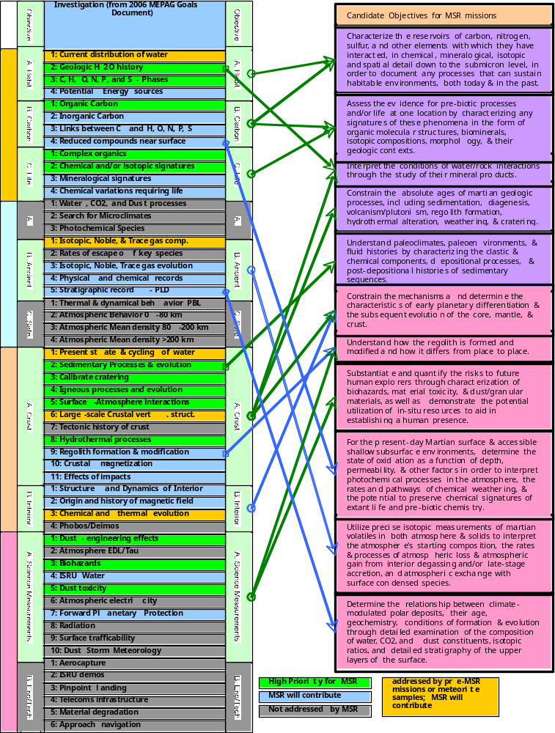

APPENDIX V Comparison of the analysis of the Martian atmosphere by MSL and in a returned sample on Earth.

Krypton and Xenon.
The major questions to be addressed are the starting isotopic compositions and to what extent those have been mass fractionated. Other questions involve the amounts of added nuclear components, which include ¹²⁹Xe from decay of extinct ¹²⁹I, ⁸⁰Kr and ⁸²Kr from neutron capture on Br, heavy Xe (e.g., ¹³⁶Xe) from fission of extinct ²⁴⁴Pu, and possibly light Xe (e.g., ¹²⁴Xe) from cosmic ray-induced spallation. Within our present knowledge, Kr isotopes appear fractionated by <7% and possibly much less across the 78-86 amu mass range. Xe isotopes appear to be mass fractionation about 40% across the ¹²⁴Xe-¹³⁶Xe mass range, or ~4% per a.m.u.. In the analysis here, we assume each Xe and Kr isotopic ratio can be measured by MSL to at least 1%, but possibly 0.1% on Earth.
For Xe, MSL’s 1% precision in ¹²⁴Xe/¹³⁶Xe or ¹²⁶Xe/¹³⁶Xe could answer the question of the Xe starting composition. Also, a 1% precision in ¹²⁹Xe/¹³²Xe would give the ¹²⁹I decay component to satisfactory precision. However, characterizing the smaller anticipated Xe isotopic effects arising from GCR spallation and fission of Pu and U require a precision better than 1%, and their characterization could yield better data for the initial Xe composition than that likely to be determined by MSL.
For Kr, the issue of starting composition may not be made clear by MSL analyses, especially considering that mass 78 is often contaminated and mass 80 and 82 will likely have an added component from neutron capture on ⁷⁹Br and ⁸¹Br. If we must determine the starting composition from the ⁸³Kr/⁸⁶Kr ratio, and given this ratio only varies in Martian meteorites by 2-3%, then a 1% precision on MSL measurement is not sufficient to answer the question of Kr starting composition. Also, knowledge of the exact neutron component of Kr is not obtained from a 1% precision. Measuring these Kr isotopes on Earth to 0.1% precision would give much more information. Thus a returned Xe sample is of at least modest additional benefit, whereas a returned Kr sample is required to answer the fundamental science questions.
Argon.
There are two main science questions: to what extent has atmospheric loss fractionated ³⁶Ar/³⁸Ar, and how much ⁴⁰Ar has been added from decay of ⁴⁰K. These are interacting data sets. We believe the current ³⁶Ar/³⁸Ar ratio is ~4, fractionated from a starting ratio of ~5.4 (Bogard, 1997). A 1% MSL precision in measuring this ratio (i.e., 4.00 ±0.04) would be quite adequate for modeling Ar loss processes. Also, a 1% MSL precision in ⁴⁰Ar/³⁶Ar (e.g., 1800 ±18) would be quite adequate in determining the amount of radiogenic ⁴⁰Ar. Thus, there would be modest rationale for a returned Ar sample.
Nitrogen.
The main science question is the degree of ¹⁵N/¹⁴N fractionation due to atmospheric loss over time. Viking found this ratio to be enriched over Earth by a factor of 1.62 ±0.16 (Nier and McElroy, 1977). For modeling atmospheric loss processes, a 1% precision is quite adequate, and little would be added from a returned sample.
Neon.
The Martian neon composition is very poorly known, as is the mixing concentration. Because of its low molecular weight, we expect Ne isotopes to have been strongly fractionated during atmospheric loss. For MSL, the analysis of ²⁰Ne will have a problem with interference from doubly ionized ⁴⁰Ar. SAM will try to generate some information on ²¹Ne/²⁰Ne and they will certainly take a shot at Ne isotope measurement with the GC separation of Ar from Ne, but it is difficult to get a good isotope measurement on a rapidly changing signal. There is very strong rationale for a returned sample.
Methane, volatile hydrocarbon, and sulfur gases.
In low concentrations, some trace gases probably could not be returned to Earth without serious alteration. They are better measured on Mars. However, this may not be true of methane, which is relatively inert at ambient and lower temperatures, particularly if the gas sample is isolated from solid Martian materials. Methane would be an important measurement target for understanding regional to sample scale isotopic systematics and differentiating abiogenic and biogenic hydrocarbon gas sources (Sherwood Lollar, et al. 2002). Also important to distinguishing models of methane formation would be the methane/ethane ratio. Neither of these measurements will be possible with MSL.
C and O in CO₂ and H₂O.
Viking reported ¹³C/¹²C and ¹⁸O/¹⁶O in CO₂ to only 5% precision (Nier and McElroy, 1997; Owen et al., 1977). There are two different science questions. First, could we measure mass fractionation due to atmospheric loss? To do so would require precisely measuring not only the atmospheric isotopics, but those of condensed phases as well, in order to know starting compositions. The second science goal relates to isotopic fractionations that occur when these atmospheric gases achieve chemical equilibria (including reactions) with condensed phases. Again this would require precisely measuring not only the atmospheric isotopics, but those of condensed phases. Many of these isotopic fractionations occur at 0.1-1%, some much less. Thus to fully utilize the science potential inherent in the O and C isotopics in atmospheric CO₂ probably would require their measurement to better than 0.1%. We conclude that sample return of CO₂ would be highly desirable to answer both science questions posed.
As for H₂O, it occurs in low concentrations in Mars’ atmosphere and would likely be altered during sample return. Thus, we conclude that measuring O isotopic ratio in H₂O would be better done on Mars.
D/H.
A very elevated ratio in Mars' atmosphere (about 4.5 times Earth's) has been measured from Earth (Owen et al., 1988). Controversy remains over the D/H in Martian meteorites. Leshin and co-workers have suggested that it is enriched perhaps by a factor of two over Earth, but Boctor and co-workers have argued it is more like Earth's (Leshin et al., 1996; Boctor et al., 2006). It would be very useful to get the D/H in various hydrated samples. Also, H is known to be rapidly lost from the atmosphere, and this loss over billions of years should produce D/H fractionation even larger than observed in the atmosphere. Thus, the D/H probably varies over time and could be a measure of variations in climate and volcanic degassing. There exists the potential to use the D/H ratio in samples of different ages to examine climatic and degassing episodes on Mars. It would be very useful to get the D/H in various hydrated samples, which should be of greater value in addressing these issues than a more precise determination of the present atmospheric D/H.

