MEPAG

MARS SCIENCE AND TELECOMMUNICATIONS ORBITER

Report of the Science Analysis Group
March 2006

This report has been approved for public release by JPL Document Review Services (CL#06- 1101), and may be freely circulated.

MSTO Science Advocacy Group Members

Barney Farmer (JPL, Chair)
Wendy Calvin (U. Nevada)
Bruce Campbell (S.Inst.)
Jane Fox (Wright State U.)
Bob Haberle (ARC)
Jim Kasting (Penn State)
Janet Luhmann (UC Berkeley)
Andy Nagy (U. Michigan)
Mark Allen (Caltech/JPL)
Daniel Winterhalter (JPL, Study Scientist)

MSTO Science Advocacy Group Members ii
Introduction 1
science goals 3
Background 3
Approaches to studying Martian atmospheric evolution 3
Atmospheric composition: implications for extant processes 5
Major Questions 6
Science Objectives 7
Exosphere and Atmospheric Escape 8
The Near-Space Environment 8
Boundaries 8
Escape Mechanisms 9
Crustal Magnetic Fields 14
Upper Atmosphere Winds 15
Recommended Measurements 16
Mars lower Atmosphere 16
Composition 16
Inventory of Molecular Species 16
Methane 17
Circulation 20
recommended Measurements 21
Composition 21
Circulation 22
Mission Characteristics 23
Launch Date 23
Orbit Design Considerations 24
Summary of Measurement Requirements 26
Instrument Payload 26
Instrument development needs 27
References 29
Figures and tables 34

Introduction
The Mars Science and Telecommunications Orbiter (MSTO) is a major infrastructure component for the next decade of Mars exploration. MSTO, a Mars Reconnaissance Orbiter (MRO) – class spacecraft, is proposed for launch in 2011 or 2013, depending on the findings of the Mars Program Planning group. MSTO is to provide a combination of science and telecommunications capabilities over nearly a full solar cycle (≈ 11 years).
This document reports the findings of the MSTO Science Advocacy Group (SAG), which was convened by the Mars Exploration Program Analysis Group (MEPAG) and the Mars Exploration Office at JPL to identify and prioritize areas of Mars atmospheric and surface science objectives for Mars that can be accomplished from orbit on a MSTO like mission.
The MSTO SAG consists of 11 members of the Mars science community with a range of expertise in atmospheric and surface science. In addition, mission architecture and design support was provided by the MSTO Pre-Project group at JPL. The SAG communicated via teleconference and electronic means from December 2005 through March 2006.
The MSTO SAG was asked to include in its deliberations consideration of the following issues related to the Martian atmosphere and surface:
- The evolution of the Martian atmosphere is a subject for which little direct evidence has been found. The timing and rates of atmospheric escape, ancient and present, are important if scientists are to understand the habitability of Mars, particularly the potential for an early atmosphere that was thicker and wetter than the one seen on Mars today.
- There are recent announcements of the possible discovery of methane in the Martian atmosphere. The origin of the trace amounts of methane has been variously suggested to be geologic or biologic. Investigators from the Mars Express mission and Earth-based telescopic measurement programs have speculated about the presence of life, gas seeps, and active volcanism. However, there remain significant unanswered questions about possible sources and sinks of trace gases on the surface and in the atmosphere, as well as their spatial and temporal distributions.
- Two radar sounders are about to return information on the unseen subsurface of Mars: The Mars Express MARSIS is now making measurements of the deep subsurface and MRO SHARAD radar will soon arrive at the planet to observe the structure to depths of several hundred meters. Undoubtedly, by 2011 or 2013 there will be observations and/or discoveries that need to be followed up with shallow subsurface imaging.
In addition, the objectives of the MSTO mission should align with those of MEPAG (“Mars Scientific Goals, Objectives, Investigations, and Priorities”, MEPAG, February 2006), as well as with the Decadal Study ("New Frontiers in the Solar System").

MSTO would be inserted into Mars orbit in 2012 (2014) and, through a series of aerobraking and energetic maneuvers over a period of 10 or more years, would perform the function of a telecommunications link with other spacecraft during this period, obtain important data on the long-term variability of upper atmosphere density and other EDL-relevant parameters required for subsequent missions, while satisfying the varying orbital requirements of scientific investigations of the upper atmosphere from altitudes as low as 100 km together with the observational needs for temporal and spatial coverage dictated by remote sensing composition measurements of the lower atmosphere. These observations will add a great deal of information about the loss of atmospheric species to space and the determination of the nature, abundance, fluxes, and source locations for trace species. The measurements are fundamental for understanding the evolution of the atmosphere, climate, and the presence of habitable zones.
In addition to the atmospheric observations, there are distinct advantages presented by the timing of MSTO to make high spatial resolution measurements of the uppermost few km of the Martian crust to map, for example, the locations of ice deposits, magmatic intrusions, etc. The surface of Mars is covered, to varying degrees, by surficial sediments deposited and modified by aeolian, volcanic, fluvial, impact, or other processes. Many aspects of the geologic and climate history of Mars are hidden beneath these sediments. A radar imaging system can penetrate the mantling materials to reveal buried fluvial, volcanic, impact, and perhaps glacial or ancient shoreline features. In addition, monitoring of the backscatter properties of the near surface through the Martian year may reveal subtle variations due to volatile cycling or migration.
As required by its charter, the SAG considered early in its deliberations the potential for the addition of a subsurface imager/mapper which could make high resolution observations of regions of special interest identified from previous and current missions. It had been thought that a particular advantage to the MSTO atmospheric science would be the ability to use the radar data to aid in interpreting the nature of the sources of molecular constituents of the lower atmosphere that were found to be spatially variable.
It was realized however that, despite the powerful advantages of SAR, there was not sufficient evidence to suggest that the present level of detailed knowledge of the near surface environment of the planet, especially when combined with the refinements to be gained from ongoing MEX and MRO observations, would be inadequate for the purpose of correlating the spatial variability of atmospheric constituents with variations in surface/subsurface characteristics. The SAG concluded therefore that a strong case could not be made for attempting to accommodate a radar system in the MSTO science payload, particularly in view of the large fraction of the spacecraft resources likely to be utilized by the atmospheric science instruments. This decision, of course, does not reflect on the science value of subsurface remote sensing studies made within this same time period.

science goals

Background
Mars has intrigued planetary scientists for many years, and especially so since 1971 when Mariner 9 returned photographic evidence of fluvial features on the Martian surface. Ever since there has been ongoing debate about how the channels formed and what the climatic conditions must have been to produce them. Because most of the channels are found on heavily cratered parts of Mars' surface, most authors agree that they formed prior to ~3.8 billion years ago (the end of the so-called “heavy bombardment period” of solar system history). A warm, wet, essentially Earth-like Mars prior to that time has been favored by some authors (e.g., Mangold, et al., 2004; Pollack, et al., 1987; Sagan, et al., 1973), whereas others (e.g., Clifford, 1993; Peale, et al., 1975; Segura, et al., 2002; Squyres and Kasting, 1994) have argued that the fluvial features could have formed under much colder conditions. Recent evidence from the MER rover mission (Squyres, et al., 2004a; Squyres, et al., 2004b) supports the case for standing liquid water, although this interpretation has already been challenged (Knauth, et al., 2005; McCollum and Hynek, 2005).
The papers cited above represent only a small fraction of the literature on Martian atmospheric and climate history. Although progress continues to be made with each new Mars mission, there is still no consensus view as to how the Martian atmosphere evolved and how it helped shape the surface that we see today. Understanding Mars’ atmospheric evolution is thus a high priority for the NASA planetary science program. This question is of great interest to astrobiologists also, as the potential for life on or near Mars’ surface depends critically on the planet’s climate history, along with other environmental factors.

Approaches to studying Martian atmospheric evolution
Two different approaches have proved useful in studying the evolution of Mars’ atmosphere and climate. One approach is to simply ask what is possible from a climatic standpoint. One-dimensional, globally averaged climate models have been used to investigate the magnitude of the greenhouse effect on early Mars to see what, if any, type of atmospheric composition would have been needed to warm its surface substantially. An interesting result has emerged from these calculations: The Sun is thought to have been only about 75 percent as bright as today at the time when most of the channels formed, ~3.8 Ga. (billions of years before present). Because of this, and because CO₂ condenses at low temperatures, a gaseous CO₂-H₂O atmosphere could not have produced Earth-like conditions, regardless of the amount of CO₂ that was originally present (Kasting, 1991). If these calculations are correct, such an atmosphere could have produced a mean surface temperature no higher than 225 K at or prior to 3.8 Ga. This is probably too cold to have allowed the formation of fluvial channels, unless transient heating by impacts is invoked as their cause (Segura, et al., 2002). Additional radiative heating could have been provided by CO₂ ice clouds (Forget and Pierrehumbert, 1997; Mischna, et al., 2000), but near 100 percent cloud cover would be required to produce global mean surface temperatures above freezing, and this is considered unrealistic. Venus and Titan are completely shrouded in clouds, but in both cases the clouds are produced photochemically. CO₂ clouds on Mars, like H₂O clouds on Earth, are formed by condensation and are unlikely to cover a planet’s entire surface. So, a CO₂-H₂O atmosphere on early Mars would have been cold.
One possible way to get around this problem is if the early Martian atmosphere contained additional greenhouse gases besides CO₂ and H₂O. Sagan and Mullen (1972) (see also Sagan and Chyba, 1997) suggested NH₃ as the additional greenhouse gas; however, NH₃ is known to be photochemically unstable with respect to conversion to N₂ and H₂ (Atreya, 1979), even in the presence of a UV-shielding organic haze (Pavlov, et al., 2001). CH₄ is a more plausible alternative (Kasting, 1997). CH₄ is itself photochemically unstable; however, as discussed further below, its lifetime is much longer than that of NH₃. CH₄ is thought to have been abundant in Earth’s atmosphere prior to about 2.4 Ga and may have provided much of the warming required to keep the early Earth warm (Pavlov, et al., 2000). Definitive calculations showing that CH₄ could have kept early Mars warm have not been published, but this remains a viable possibility. As discussed below, the putative discovery of CH₄ in the present Martian atmosphere lends credence to the idea that CH₄ could have been abundant in Mars’ distant past.
An alternative approach to studying Martian atmospheric evolution is to start from the present atmosphere and to back-calculate what it was like in the past. This approach itself has two components: (i) Current isotopic ratios in different atmospheric gases can be used to show that Mars has lost an appreciable amount of its atmosphere over time. For example, the elevated ¹⁵N/¹⁴N ratio in Mars’ atmosphere, 1.7 times the ratio on Earth, shows that Mars has lost substantial amounts of N₂ (Fox, 1993b). The exact amount is model dependent, but it is probably of the order of 90 percent or more of Mars’ original inventory (Jakosky and Phillips, 2001). Similar heavy isotope enrichments are seen for H, C, O, and non-radiogenic Ar. (ii) Theoretical models also suggest that Mars has lost substantial amounts of atmosphere over time.
Some models suggest that the dominant loss process for molecules heavier than H₂ is sputtering by solar wind particles (Kass and Yung, 1995; Luhmann, et al., 1992). Kass and Yung (1995) concluded that Mars may have lost as much as 3 bars of CO₂ by this sputtering mechanism during the course of its history. This prediction is consistent with the observed enrichments in heavy isotopes, as well as with the need for a greenhouse gas-rich atmosphere although, as pointed out above, an enhanced CO₂ concentration cannot by itself explain how Mars’ climate could have been warm early in its history. Other processes such as ionosphere initiated outflow (Ma, et al., 2004) and ion-neutral chemistry processes (Fox, 1993b) yield similar results.
Collaborative studies of Phobos and Mars Global Surveyor (MGS) data have demonstrated that there is a thin, sharp boundary at ≈ 1.2 Mars radii (similar in shape, but not in physics, to a magnetopause), where the solar wind proton flux terminates and is replaced by planetary heavy ions (Nagy, et al., 2004). Thus, the removal of atmospheric components is not via direct sputtering, but rather by a mass loading process.
In any case, all of the models for how the Martian atmosphere evolved are at best poorly constrained by the available data. Based on the above discussion, better answers are needed to the important questions: is there a good reason to believe that CH₄ was present in the early Martian atmosphere, what processes have contributed to atmospheric escape over Mars’ history, and how much of the original volatile inventory has been lost in this manner? These questions can be addressed, in part, by making detailed measurements of Mars’ present atmosphere. The MSTO orbiter is ideally suited to examine both issues. A high-resolution spectrometer could be used not only to determine definitively whether CH₄ is present in Mars’ lower atmosphere, but also to map its vertical profile and spatial distribution. The vertical profile would provide a valuable test of current models of the chemistry of the atmosphere. And from an elliptical orbit MSTO could be used to make detailed measurements of Mars’ upper atmosphere and ionosphere and study their interaction with the solar wind. This will lead to a much better understanding of current atmospheric escape processes and allow a more reliable extrapolation back into Mars’ past.

Atmospheric composition: implications for extant processes
It has long been understood that the presence of life on a planet would modify the atmosphere in such a fashion that this "disequilibrium" condition could be detected by remote sensing. Moreover, active abiogenic geological processes also will modify the environment in which these processes exist.
Again, the earliest discussions about detection of life through remote sensing identified methane as one example of a biosignature, say, in the Mars atmosphere, where methane would not otherwise be present simply due to standard atmospheric photochemistry. So the presence of methane in the current atmosphere would be highly suggestive of extant active processes--geological or even biological, and most probably in the subsurface. One line of reasoning that leads to these conclusions is that the atmospheric lifetime is short, ~400 years, so there is no chance that the existing atmospheric methane is an atmospheric remnant from billions of years ago.
In fact, if active subsurface processes do exist in the current epoch, there may be other chemical constituents in the atmosphere, albeit with very small abundances, that may arise from processes that produce methane or from other active geological or biological processes. Thus a sensitive survey of the chemical composition of the Mars atmosphere will provide important insights into the extent of active processes that exist in the Martian subsurface and the character of these processes. These observations should include the isotopic variants of methane and possible species that would be co-generated in potential methanogenic processes to seek an identification of the particular process forming methane.
A broad understanding of the atmospheric chemistry of Mars is important for distinguishing true "disequilibrium" chemical species. In addition, the chemistry of the atmosphere controls the lifetime of potential species that can be introduced into the atmosphere by subsurface active processes. While the recent observations, at the limits of their sensitivity, suggest that spatial and temporal variability in methane has been detected, the current understanding of the methane lifetime and the magnitude of the dynamical atmospheric circulation suggests that methane should be well-mixed. If methane were found to be not well-mixed, there would be significant implications for atmospheric chemical processes that are not known at present (this is discussed further in the following section).
In addition to trying to understand the character of subsurface active processes forming the disequilibrium chemical species that may be detected in the atmosphere, it is equally important to identify specific locations on the surface where these species enter the atmosphere. Such locations would be important sites for further exploration, and may offer the best locales for future sample return. Depending on whether methane is well-mixed in the atmosphere or not, methane itself may not be the best tracer to identify these "oases" of subsurface activity. Other disequilibrium species with shorter atmospheric lifetimes may form distinct emitted plumes and therefore be easier to trace back to the source locale. Knowledge of the chemical lifetimes of these tracer species and the atmospheric circulation are key elements in localizing potential source regions.

Major Questions
The MSTO SAG identified several major science questions related to the escape of the atmosphere over time, the detailed composition of the lower atmosphere, the spatial variation of the composition, and what this reveals in terms of its interaction with the near-surface environment.
(Q1) Could the present atmospheric escape processes currently occurring at Mars account for climatologically significant amounts of loss of atmosphere, particularly CO₂ and H₂O, in the early history of the planet - i.e., after the era of hydrodynamic escape and after impact erosion ceased to be important?
(Q2) Could liquid water have been present on the surface of Mars at that time?
(Q3) Do present day values for the nitrogen and argon isotopes in the upper atmosphere, when compared with their surface values, suggest a loss of atmosphere consistent with the CO₂ and H₂O escape? Are the mechanisms responsible for atmospheric erosion consistently manifested through all of the volatile species, C,H,O,N and Ar?
(Q4) What is the present day inventory of molecular species in the lower atmosphere?
(Q5) Are the relative abundances of these species consistent with contemporary models of Mars atmospheric chemistry, including the effects of dust and aerosols?
(Q6) What are the dynamic processes (winds) that distribute and mix the constituents on short time scales?
(Q7) Is there a clear correlation between the spatial variability of trace species and identifiable surface or subsurface features?
(Q8) Are CH₄ and its close derivatives present in the boundary layer atmosphere?
(Q9) If so, do the abundance patterns of these species, and their isotopic compositions, provide unambiguous discrimination between geological and biological sources?

Science Objectives
From the science questions detailed above, the MSTO SAG identified the following prioritized science objectives for further analysis:
(O-1) Characterize the present day escape of the atmosphere in sufficient detail, and over a period sufficiently long to account for changes induced by seasonal and solar cycle variability, to allow realistic backwards extrapolation of the atmospheric composition.
(O-2) Determine the relative abundances of the major, minor and trace constituents of the lower atmosphere and their isotopic components to provide a definitive inventory of species, in order to better understand the current interaction between the atmosphere and the near surface environment and, in particular, to determine whether spatially non-uniform species are in chemical equilibrium.
(O-3) Characterize the winds, both zonal and meridional, with good altitude resolution, and their seasonal variations.
(O-4) Map the crustal magnetic field with approximately 100 km resolution. These data are required in part to aid in elucidating the mechanisms contributing to atmospheric escape; they are also of importance in advancing our understanding of the surface mineralogy and evolution of the planetary interior.
Table 1 lists the relationship between the science goals and the recommendations of MEPAG. The science objectives developed in this report are also in alignment with the Decadal Study recommendations related to investigations of the evolution of the Mars atmosphere.

Exosphere and Atmospheric Escape

The Near-Space Environment

Boundaries
To answer questions concerning the erosion of the Martian atmosphere over time, we must have a detailed understanding of the physical mechanisms that are involved, their variability, and the causes of this variability.
It was realized early on that Mars’ ionosphere is too thin to routinely stand off the solar wind. Thus the effectiveness of the solar wind in scavenging the upper atmosphere hinged on the question of whether or not Mars possesses an Earth-like, dynamo-generated, planetary magnetic field to protect the atmosphere from erosion by the solar wind. Only very recently was it shown conclusively (by Mars Global Surveyor) that Mars does not posses such a dynamo field. However, large remanent magnetic fields were detected in localized regions on the planet, indicating that a dynamo field did exist, probably until some 4 billion years ago (Acuna, et al., 1999; Acuna, et al., 1998; Connerney, et al., 2004). The magnetic remanents, larger than any seen on Earth, add a dynamic character to the interaction as they rotate into view of the solar wind every Mars rotation, periodically adding magnetic pressure to help stand off the solar wind. They also indicate that during the early history of Mars a global magnetic field of significant strength must have influenced solar wind interaction-related loss processes.
Measurements by the Mars Global Surveyor (MGS) and by the Phobos-2 spacecraft led to a significant improvement in our knowledge of the regions and boundaries surrounding Mars (e.g., Winterhalter, et al., 2004). Figure 1, based primarily on recent insights gained from analyses of MGS and Phobos-2 data, depicts our current understanding of the Mars near-space environment. The main signatures include a bow shock which reflects the size of the Martian obstacle to the solar wind, a magnetosheath wherein the solar wind picks up planetary ions in a process known as mass-loading, and variously named features (such as "Magnetic Pileup Boundary") of the solar wind boundary (see Figure 2).
The boundary layer of the solar wind interaction, at altitudes between the exobase (~200 km) and the middle magnetosheath (~ 0.5 Rm) is a key region for characterizing the physics of solar wind interaction-related atmosphere escape. Neither Phobos-2 nor Mars Express has had the orbit or measurements to achieve this characterization. MGS did not carry thermal ion and electron instruments, and so it is impossible to determine whether the boundary layer at sites removed from the strong remanent magnetic fields is an "ionopause" in the sense of that observed at Venus on PVO. It has long been known from Viking mission measurements, that the ionospheric thermal pressure at Mars is frequently insufficient to balance the total incident solar wind pressure (e.g. Zhang, et al., 1991). Thus it is expected that the Martian ionosphere is magnetized, much like Venus' ionosphere during times of high solar wind dynamic pressure and/or low fluxes of ionizing solar radiation. The Viking Landers did not carry magnetometers, but the MGS magnetometer supports this expectation down to the altitudes sampled by that orbiter during its aerobraking phase (Acuna, et al., 1998). The presence of this magnetization is an essential factor in the erosion of the upper ionosphere by the solar wind interaction. Locally, crustal magnetic fields vastly complicate the topology of the boundary layer, and thus ionosphere escape, in as yet undetermined ways (e.g. Brain, et al., 2005; Mitchell, et al., 2001).
Both Phobos-2 and Mars Express established the existence of significant present-day escape of atmospheric constituents from the boundary layer in the form of ions observed in Mars’ solar wind wake (Lundin and al., 1990, 1993; Zakharov, 1992; Verigin, et al., 1991). However, the total flux, composition, and solar cycle variability of this escaping ion population is only roughly estimated, as is the pickup ion influx that sputters neutral atmosphere constituents at the exobase rather than escaping (Luhmann, et al., 1992; Luhmann and Kozyra, 1991). The lack of a magnetometer and other supporting contextual information on Mars Express seriously compromises that mission’s ability to obtain definitive results from its continuing ion escape measurements.
The solar wind pressure varies over the solar cycle, as does the upper atmosphere and ionosphere-controlling solar EUV flux, providing a changing view of the solar wind interaction that can be used to extrapolate related atmosphere escape into the past. As a whole, the measurements from the Viking, Phobos, MGS and Mars Express missions hint at the complexity and potential importance of the solar wind interaction with Mars in atmosphere escape, but no mission has had the necessary instrument complement, orbital coverage, and duration to sufficiently characterize this aspect of the evolution of the Martian atmosphere.

Escape Mechanisms
Mass loading and ion pickup are intimately related by the transfer of solar wind momentum and energy to planetary ions by the convective electric field, their common underlying physical cause. Mass loading is a manifestation of the replacement of solar wind protons by planetary ions or of the addition of significant masses of planetary ions to the solar wind. Ion pickup is the energization of planetary ions by the penetrating solar wind convection electric field, which can occur with or without the local penetration of the solar wind protons themselves. Whether one refers to mass loading or ion pickup, the end result can be removal of planetary ions if enough solar wind energy is transferred to accelerate them beyond the escape velocity of ~5 km/s. How the solar wind-related erosion varies with time, and on what external and/or internal parameters the variations depend, is unclear. Measurements of the boundary positions, and the escaping particle composition and fluxes are crucial aspects in the understanding of the impacts of the atmospheric erosion by the solar wind.
In addition to mass loading /ion pickup, there are other escape processes that are occurring at Mars, but have not been measured sufficiently to allow their overall influences to be determined. These include: photochemical escape; sputtering (by pick-up ions); possible other ion outflows in the wake and from the crustal field cusps; and bulk ionospheric plasma removal.
Photochemical escape relies on ionospheric photochemistry to generate suprathermal neutral populations above the escape velocity (e.g. by dissociative recombination). Nagy, et al. (1990) and Zhang, et al. (1993) estimated photochemical escape rates for Mars neutral oxygen based on the few Viking Lander altitude profiles of ionospheric composition. The observation of the hot oxygen corona of Mars (e.g. Paxton and Anderson, 1991), inferred from UV spectrometer measurements on Mariner 9, provides one way to study photochemical escape rates for oxygen by modeling the observed neutral exosphere altitude profile. Other photochemically escaping constituents, such as carbon, can also be indirectly detected by this method (Kim, et al., 1998), which remains unexploited. The sputtering of the neutral upper atmosphere at the exobase level by impacting atmospheric pickup ions, which models suggest is significant for atmosphere escape over time (Kass and Yung, 1995; Luhmann, et al., 1992) has yet to be established by any observation. It is difficult to observe the low energy sputtered neutrals except by indirect means. In addition, poorly characterized upper atmosphere properties play a significant role by determining what species are available to be ionized and removed. Nevertheless, impacting pickup ions can be detected by an ion spectrometer at the appropriate location, and upper atmosphere neutral particle density profiles can show evidence of some nonthermal heating by impacting pickup ions. In a similar manner model calculations (e.g. Ma, et al., 2004) indicate that ionospheric plasma outflow through the tail may be another escape channel, but no measurements exist to either confirm or contradict these suggestions. Study of special ion outflows that may be associated with the wake structure or with crustal magnetic fields are a subject of current analysis in the Mars Express community, but the lack of local magnetic field measurements represents major difficulties to those efforts. Similarly, the idea of bulk ionospheric plasma removal processes, such as proposed shear instabilities in the solar wind/ionosphere boundary layer (Penz, et al., 2005), also remain to be tested observationally.
Photochemical escape
Various investigators have modeled photochemical escape rates of heavy atoms from Mars, such as N, O, and C (e.g., Fox, 1993a, 1993b; Fox and Bakalian, 2001; Fox and Hac, 1997a, 1997b, 1999; Hodges, 2000; Jakosky, et al., 1994; Kim, et al., 1998; McElroy, et al., 1977; Nagy, et al., 2001). Planetary escape processes have been reviewed, for example by Chamberlain and Hunten (1987), Shizgal and Arkos (1996), and Hunten (2002).
The ¹⁵N/¹⁴N ratio in the Martian atmosphere was measured as about 1.62 times the terrestrial value (Nier and McElroy, 1976, 1977). The enhancement is presumably due to preferential escape of ¹⁴N. There are several sources of escaping nitrogen, including photodissociation (Brinkmann, 1971), photodissociative ionization and electron impact dissociative ionization of N₂, dissociative recombination of N₂⁺, and the reaction of N₂⁺ with O. Quantifying the sources involving N₂ requires in situ measurements of the number density profiles of N₂ as a function of altitude in the thermosphere from about 100 km to 350 km at both low and high solar activities, and as a function of solar zenith angle and season. The only solid information we have about thermospheric density profiles of N₂ comprises the measurements made by the Vikings 1 and 2 entry probe neutral mass spectrometers, each in one pass at one location, one solar zenith angle, and low solar activity through the atmosphere. The altitude profiles cannot be simply determined from the measured N₂ mixing ratio of about 2.5 %, because the vertical distribution depends on the diffusion coefficients, the strength of mixing due to turbulence and convection. Usually this distribution is modeled in 1D atmospheres with the use of an eddy diffusion coefficient. The MTGCM’s of Bougher (2000) and Bougher, et al. (2004b) do not contain N₂ as a separate species, and the altitude profiles derived from these models are therefore only estimates.
For the contribution to escape of N from dissociative recombination of N₂⁺, density profiles of the ions and electrons are required from below the F1 peak to altitudes above the exobase. Estimates of the O densities over a small altitude range have been derived from the Viking RPA measurements of CO₂⁺ and O₂⁺ at low solar activity. There is no direct information about the density profiles of either N₂⁺ or any of the other minor ions, although several models have been constructed of many major and minor ions (e.g., Fox, 1993a, 1993b, 2004; Krasnopolsky, 2002), which have allowed estimates to be made of the source due to dissociative recombination.
Quantifying the important source of escaping N due to reaction of N₂⁺ with O requires knowledge also of the density profiles of O. There is no direct information about either the mixing ratio of O or the altitude profiles. Estimates over a small altitude range at one altitude have been made based on the low solar activity Viking 1 O₂⁺/CO₂⁺ peak ratio (Fox and Dalgarno, 1979; Hanson, et al., 1977), and from remote sensing of the moderate solar activity Mariner 9 1304A emission (Stewart, et al., 1992). The inferred mixing ratios range by about a factor of 3 from about 0.7 % to 2% at 130 km. There is no in situ information about the high solar activity mixing ratios or density profiles. Experience with Venus tells us that there may be large variations in the photochemically produced species, such as O, CO, C and N. This is a major uncertainty in important quantities, which requires in situ measurement by an (open source) mass spectrometer capable of measuring O, C, and N.
The most recent calculations by Fox and Hac (1997b) have shown that the presence of a dense, early atmosphere of 100 to 500 mb at 3.8 Gyr before present reduces the isotopic fractionation of nitrogen to the observed value. Thus quantifying the present escape rates of N is necessary to estimate the escape rates as a function of time before present, and thus to determine whether a dense, early atmosphere is needed to reduce the isotope fractionation.
The largest source of photochemical escape of C is photodissociation of CO, followed by dissociative recombination of CO⁺ Other sources of escaping C have been found to be negligible compared to these two mechanisms (Fox and Bakalian, 2001; Nagy, et al., 2001). Quantifying the sources of these mechanisms requires knowledge of the density profiles of CO and CO⁺, the total electron density, and their variations with location, solar zenith angle, season and solar activity.
The Viking 1 neutral mass spectrometer measured a CO mixing ratio of about 0.42% at 120 km, and a density profile over the lower thermosphere for ~45 degrees solar zenith angle and low solar activity. The only measurements available are those from the Vikings 1 and 2 descent modules, at only two locations and for low solar activity. Models have been constructed by, for example, Krasnopolsky (1993) of the CO profile in the lower thermosphere. There is no direct information available about the solar activity variation of CO. The CO airglow emissions arise from both CO and CO₂, and so are not indicative of the CO mixing ratio, with the possible exception of the (14v) series of the CO fourth positive bands, which are produced by scattering of Lyman alpha by CO. The CO variations have been computed by the MTGCM of Bougher (2000), but high accuracy is not expected from this model.
Altitude profiles of CO⁺ have not been measured, but they have been modeled by several investigators (e.g., Fox, 1993a, 1997, 2004). The model altitude profiles of CO+ should be verified by in situ spacecraft measurements from high altitudes down to the F1 and E peaks (~130 and ~105 km at low solar activity). The altitudes of the peaks are predicted to be higher at high solar activity than at low solar activity ({Fox, 1995 #144; Fox, et al., 1995; Krasnopolsky, 2002). As it is now, it is not possible to distinguish the models, since there are no measurements of minor ions in the Martian ionosphere, other than the O⁺ “measurements” from the Viking RPA (e.g., Hanson, et al., 1977).
Quantifying the present escape rates of O is necessary for determining the history of water on Mars. The sources of photochemical O escape include dissociative recombination of O2⁺, and charge transfer of H⁺ to O in the Martian exosphere. The major source is dissociative recombination, determination of which source requires measurements of the density profiles of O₂⁺ and electrons. Information from the RPA on Viking and models suggests that, since O₂⁺ is the major ion, its density profile is close to that of the electrons. Dissociative recombination reactions tend to produce very energetic neutrals and their rate coefficients are dependent on the electron temperatures. Generally the dissociative recombination coefficients are of the form k=A (300/Te) ^{(0.2-0.7)}. Thus determining the magnitude of the escape fluxes due to dissociative recombination requires knowledge of the altitude profiles of the electron temperature, and their variation with solar zenith angle and solar activity, for which comprehensive (e.g. time, season, solar cycle variations) information has not been available from either measurements or models. Estimates from the Viking RPA indicate values of Te of 2000-3000 K above 200 km, at one solar zenith angle and low solar activity. The values below 200 km have only been modeled. Modeling the Viking measured electron and ion temperature profiles has required imposing an ad hoc energy source at the top of the atmosphere, the origin of which is unknown. The ion temperature is also important in determining the high altitude density profiles of ions, and the rate coefficients for some ion-molecule reactions. An instrument that is capable of measuring the plasma temperatures and their variation with solar zenith angle, local time, season and solar activity, such as an RPA, would be necessary. Such an instrument would also be important for determining the source of energy at high altitudes that is necessary to model the plasma temperatures.
The computed values of the O escape rate have been compared to the thermal escape rate of McElroy (1972). McElroy et al. (1977) suggested that H and O escape in the stoichiometric proportions of water, (2:1). If this is true it implies that the oxidation state of the atmosphere has remained unchanged over time. Hydrogen escapes thermally mostly as H with a small additional component due to H₂ escape. There are also some non-thermal mechanisms for H escape, such as the charge transfer reaction of H⁺ with atomic H in the thermosphere and corona. These non-thermal escape rates are more important for D than for H. Recently, many investigators have modeled the rate of O escape due to dissociative recombination and found that the rates are too small to balance the H escape rate, and have thus questioned this “balanced escape hypothesis”. (We note here that this conclusion has been debated by Hodges (2000). Thus it is possible that the atmosphere of Mars may have been more reducing in the past, leading to larger densities of H₂ in the atmosphere. Fox (2003) modeled the ionosphere of Mars, for various H₂ mixing ratios from 4 to 100 ppm. Since H₂ reacts with N₂⁺, CO⁺, CO₂⁺ and O⁺, the nonthermal escape rates of heavy atoms arising from these species will be greatly reduced as the mixing ratio of H₂ increases, i.e. for a more reducing atmosphere. The implications of a more reducing atmosphere for escape rates of C and N due to dissociative recombination of CO⁺ and N₂⁺ are that the escape rates are reduced by a factor of ~6 and 2.3, respectively, as the H₂ mixing ratio in the thermosphere increases from 10 ppm, approximately the current value (Krasnopolsky and Feldman, 2001) to 100 ppm. The escape rates of N and C due to photodissociation of N₂ and CO are reduced by factors of 2-3 as the H₂ mixing ratio increases from 10 to 100 ppm. Since the modeled rates of N escape seem to be too large at present, and integrating backwards in time actually over-fractionates the N isotopes, a more reducing state of the atmosphere in the past would decrease the escape rates and provide a possible other or additional mechanism to that of a dense early atmosphere for inhibiting the escape of Nitrogen.
In summary, quantifying the photochemical escape rates of heavy atoms and the thermal escape rates of H requires in situ measurements of both major and minor ions, and major and minor neutral species. The mass range required is from 1 to 44 amu for both ions and neutrals. Also required are the neutral, ion and electron temperatures as a function of altitude. The escape rates are expected to be dominated by those at high solar activity, where we have essentially no in situ data at present. Thus measurements at high solar activity are essential. The only in situ data we have at low solar activity is from the neutral mass spectrometers and the retarding potential analyzers of Vikings 1 and 2, which sampled the atmosphere at only two locations, and at low solar activity. We have no data on the minor ion profiles, since the Viking RPA could measure only O₂⁺, CO₂⁺ and O⁺.
Ion Escape
The escape of ions is by traditional ion-pickup processes (McElroy, et al., 1977 Luhmann, 1990), and by ion outflows (Ma, et al., 2004). The computed rates of traditional ion pickup are computed as the rates of ionization of the atoms above the ionopause, followed by “pickup” by the convection electric field of the flowing solar wind plasma. Fox (1997) suggested, however, that theoretically all the ions above the photochemical equilibrium region could be stripped away, rather than only those created above the ionopause. This theory has been confirmed by MHD (Ma, et al., 2002; Ma, et al., 2004) models in which the computed escape rates are more similar to those computed by Fox than to those computed as traditional ion pickup. On Mars, the major ion flowing away from the planet is predicted to be O₂⁺ (Fox, 1997), whereas the main ion observed in the planetary wake is O⁺ (e.g., Lundin, et al., 1989). The MHD model of Ma, et al. (2004) suggested the major escaping ion is O⁺ rather than O₂⁺, but their model ion profiles showed an F2 peak of O⁺, while other models have shown that O₂⁺ is the major ion over the whole ionosphere. Their model was computed with ad hoc plasma temperature profiles designed to produce an F2 peak of O⁺ at high altitudes. This is yet another reason for measuring the values of Te and Ti in the ionosphere at several values of the solar zenith angle and solar activity.
The escape of species as ions has the potential to be more important than those of the photochemical processes. For example, the predicted O⁺ escape rates are larger than the H nonthermal escape rates, and can more than make up for the smaller predicted values of the photochemical escape of O. H atoms will escape also as H⁺. Quantifying the escape rates of ions requires density profiles of minor ions from 1 amu (H⁺) to 44 amu (CO₂⁺).
The escape rates of ions can be estimated by determining the scale heights of the ions above the photochemical equilibrium region. This was done for O₂⁺ by Chen et al. (1978) and by Fox (1997). The altitude profiles could only be fitted if an upward flux or velocity boundary condition were imposed on the ions. Determining the scale height compared to that expected for zero flux requires altitude profiles of ions from below the peaks, i.e., from about 110 km to 350 km. Measurements that would provide only high altitude scale heights are of little value for the determination of escape rates of ions because comparisons to models with zero flux upper boundary conditions would not be possible without simultaneous measurements of the peaks. It should be noted here that an upward flux boundary condition in a one-dimensional model probably actually represents the divergence of the horizontal fluxes of ions (Shinagawa and Cravens, 1989).
In summary, determining the rates of escape of ions requires in situ measurements of major and minor ions from high altitudes, i.e., in the solar wind, down to below the F1 peaks (near 110 to 140 km), as well as measuring the fluxes of ions in the wake of the planet.

Crustal Magnetic Fields
Present day escape processes are certainly affected by the Martian crustal fields, in the sense that some of the upper atmosphere is shielded from direct interaction with the solar wind and the associated direct planetary ion scavenging. However, recent observations by Mars Express suggest that there are some additional ion escape processes that exist because of the presence of the crustal fields. It has yet to be determined whether the associated additional losses are significant compared to the general upper atmosphere/ionosphere removal related to unmagnetized planet solar wind interaction physics.
Specifically, Mars Express UV observations showed evidence of aurora occurring in the vicinity of the strong crustal field regions, which was henceforth backed up by observations on both Mars Express and MGS of accelerated electrons moving down the field lines into the crustal field region-dominated upper atmosphere. These electrons probably excite the observed UV emissions. Associated with the inflowing electrons, Lundin et al. report (in Science, to appear shortly) outflowing "auroral ion beams", and make an analogy to outflowing (oxygen) ion beams in Earth's auroral zones that occur in response to electron precipitation. Whether the ion fluxes in these beams at Mars constitute a major escape route for Mars upper atmosphere in the form of heavy ions is not yet determined, but it certainly indicates that understanding the magnetic context of the observed escaping ions is important for diagnosing the operating physical mechanisms.
Would deep observations of the Mars magnetic field make a major difference to the above diagnosis? Certainly local (to the ion escape sites) measurements of the magnetic field context are crucial to understanding the nature of observed ion escape. It is important to determine whether the crustal fields are involved and how interplanetary conditions make a difference with or without the crustal field involvement. Deeper atmosphere observations are only critical in this respect if it is determined that auroral outflow mechanisms are significant for overall planetary ion escape. Such measurements could verify assumptions (from existing crustal field models) of the field strength where those ion outflows or other crustal field-associated ion outflows may be accelerated - below the region of existing spacecraft measurements of the fields. Their importance to present ion escape is thus dependent on how important the crustal field-related outflows turn out to be. To some extent this will be further pinned down by Mars Express ASPERA observations and their analysis. Within the time frame of the next six months the general answer may be known. Where the deep magnetic field measurements are most definitely important is in further constraining the early history of the Martian magnetic field - especially during the first 1.5 billion years of Mars' history when solar conditions should have greatly enhanced all present-day ion scavenging-related processes.

Upper Atmosphere Winds
A knowledge of the thermospheric winds (over the solar cycle and seasons, and spanning the globe) is of fundamental importance to our understanding of the Mars thermosphere-ionosphere system, and its coupling with the Mars lower atmosphere. The Mars global thermospheric circulation is thought to significantly modify the thermal and density structure about the planet (e.g. Bougher, et al., 1999, 2000; Bougher, et al., 1990). Strong horizontal (~100-300 m/sec) and vertical (~1-10 m/sec) winds are estimated, especially during the solstices, providing adiabatic heating/cooling and horizontal advection. Observed winter polar warming is attributed to this inter-hemispheric circulation (Bougher, et al., 2006; Keating, et al., 2003), and its seasonal variations owing to changing solar and aerosol heating. The distributions of light species (e.g. O, N, H, H₂, He) are surely controlled by the thermospheric circulation, resulting in winter polar night bulges of these species and corresponding nightglow emissions (e.g. Bertaux, et al., 2005). Finally, dynamical coupling with the Mars lower atmosphere, especially during dust storm events, helps regulate the thermospheric structure and dynamics. These winds also serve as a background through which upward propagating thermal tides must propagate, on their way to driving variations in the Mars lower thermosphere (~100-130 km) which affect aerobraking operations (e.g. Forbes, et al., 2002; Wilson, 2002; Withers, et al., 2003). In short, a comprehensive characterization of the Mars upper atmosphere must include neutral wind measurements in order to understand the processes that regulate density, temperature and airglow distributions, and their variations over the solar cycle and Martian seasons.
Knowledge of Mars thermospheric winds is also key to understanding some of the processes that control Mars volatile escape. Escape processes are mediated by the Mars upper atmosphere structure, which in turn is regulated strongly by the global thermospheric circulation (see above). For instance, the “thermostatic” effect of the global winds on temperatures is calculated to regulate solar cycle variations of the Mars thermospheric densities and temperatures (e.g. Bougher, et al., 1999, 2000); a reduced variation of dayside topside temperatures (from that otherwise expected) results as the solar cycle advances. Photochemical processes (e.g. O₂⁺ production and recombination) will vary as the background neutral structure changes. The time variable upper atmosphere structure (near the exobase) also serves as the seed population for O⁺ sputtering, driving both atomic and molecular escape fluxes. Furthermore, the horizontal and vertical winds also have a direct influence on the actual neutral escape fluxes. Hence, an understanding of these “present day” dynamical processes and their impact on volatile escape rates must be quantified before extrapolations to ancient Mars conditions can be made (Bougher, et al., 2004a). Mars upper atmosphere wind measurements are thus crucial to evaluating these dynamical feedbacks upon present day volatile escape rates.

Recommended Measurements
For measurements of the escape fluxes from each of these processes, measurements of the neutral and ionized species listed in Error: Reference source not found should be made over the altitude range from above the bowshock to as low as possible - 100 km being suggested as the desirable minimum altitude, especially during the solar maximum phase of the mission. The flux measurement should map the space around Mars, i.e., the dayside, the dawn-dusk regions and down the tail.
In addition, observations of the crustal, upper atmosphere and solar wind vector magnetic fields, and the ion and electron 3-dimensional energy distributions in the upper atmosphere and solar wind are required.

Mars lower Atmosphere

Composition

Inventory of Molecular Species
Measurements which would provide an inventory of the molecular constituents of the lowest few scale-heights of the atmosphere, i.e., from the surface to, say, 100 km altitude, hold the key to understanding the processes involved in interactions of the boundary layer with the regolith, to looking for current geological activity and, most important in the context of NASA's exploratory goals, to look for biological activity in the near-surface environment. The analogy with Earth's stratosphere above 20 km altitude is relevant: the pressure and temperature are not dissimilar (6 mb, 220 K), and the major radiatively active gases, H₂O, CO₂, O₃, play similar roles, despite their considerably smaller relative concentrations on Earth. These gases, together with nitrogen oxides, give rise to a rich variety of transient, reservoir and sink molecules which, in turn, provide a clear indication of processes occurring at lower altitudes and at the surface. A spectroscopic survey of the Earth stratosphere, which set out initially to acquire an inventory of molecular constituents at the parts per billion level, and to define the spectral radiative environment of this region of the atmosphere - the Shuttle-based ATMOS experiment - revealed the presence of more than 40 different molecular species and their isotopologues, many of which were unexpected new detections (e.g., ClNO₃, N₂O₅, CH₃Cl, HNO₄, C₂H₂, C₂H₆, SF₆; (see Farmer, 1987; Irion, 2002). In the case of Mars, it would be surprising not to find an even richer inventory of constituents resulting from contemporary geological activity, from catalytic cycles enhanced by the surface mineralogy, or from biological processes. Thus measurements of the spectral environment made at the high resolution achievable today from orbit could be expected to reveal the presence of such transient products of the major atmospheric constituents as CH₄, CH₃S, CH₃X, H₂CO, NOx, NH₃, SO₂, HCN etc. lists current upper limits for a number of other molecular species of interest for which searches have been made from both ground based and spacecraft observations.
Whether Mars is biologically or geologically active is one of the most important questions in the scientific exploration of the planet. Previous observations of Mars have demonstrated that evidence of life is neither obvious nor trivial. Nevertheless, if life ever existed on Mars, it likely exists today, having adapted as the Martian climate evolved. This assertion is supported by the ever-growing list of extremophile life forms on Earth that can be found in almost any niche where even minimally supportive conditions exist. Furthermore, geomorphologic evidence suggests that Mars may also have been volcanically active in its recent past.

Methane
One of the most intriguing questions that will be addressed by MSTO is whether or not the recent reports of methane in Mars’ atmosphere are correct. Within the past two years, three different groups have claimed detections of Martian methane (Formisano, et al., 2004; Krasnopolsky, et al., 2004; Mumma, et al., 2003). Two of these measurements (Mumma, Krasnopolsky) have been made using ground-based telescopes on Earth, combined with high resolution infrared spectroscopy; the other (Formisano) was made from ESA’s Mars Express orbiter with a relatively low-resolution spectrometer. All of them searched for absorption in the 3.3-μm absorption band of CH₄. Krasnopolsky et al. measured a constant 10 ppbv of CH₄ over the surface, whereas Mumma and Formisano et al. both reported spatial gradients. Mumma’s measurements suggest a CH₄ concentration that is higher at the equator than at the poles, although these past conclusions are currently (2/23/06) being tested by a new series of measurements (private communication, M.Mumma). Formisano et al. claim orbit-to-orbit CH₄ variations that suggest longitudinal gradients in CH₄ concentration.

Implied CH₄ source
All of these measurements have been carefully made and analyzed; however, they are all close to or perhaps beyond, the limiting detectivity of CH₄ of their respective instruments. If they are correct, the measurements may have far-reaching implications for the nature of the Martian surface environment and possibly for astrobiology. Consider first what is implied by a constant 10-ppbv concentration of methane. The Martian surface pressure is about 6 mbar, and Martian gravity is 3.73 m/s², so the mass of a vertical column of atmosphere is about 16 g/cm². The corresponding column density, assuming nearly pure CO₂, is 2.2×10²³ molecules/cm². (Henceforth, “molecules” will be eliminated from the units, in accordance with standard atmospheric chemists’ practice.) Hence, a 10-ppbv concentration of CH₄ corresponds to a column density, N_{col}, of 2.2×10¹⁵ cm⁻². The photochemical lifetime, τ, of methane in Mars’ atmosphere is about 340 years (Krasnopolsky, et al., 2004), or ~10¹⁰ s. Since CH₄ has no appreciable photochemical sources in the Martian atmosphere, its concentration must be maintained by a surface flux of N_{col}/τ = 2.2×10⁵ cm⁻²s⁻¹. By comparison, Earth’s (mostly biological) methane flux is 535 Tg(CH₄)/yr (Watson, et al., 1990), or 1.24×10¹¹ cm⁻²s⁻¹. The required Martian methane flux is thus about 2×10⁻⁶ times the biological methane flux on Earth.
This immediately raises the question: Could such a CH₄ flux on Mars be maintained abiotically, or would it necessitate a biological source? Again, we can turn to Earth for an analogy. Could volcanism provide this amount of methane? At first glance, it seems not. CH₄ is neither a predicted component of surface volcanic gases, nor one that is observed (Holland, 1984). The magmas from which such gases are released on Earth are relatively oxidized; they have an oxygen fugacity near the QFM (quartz-fayalite-magnetite) synthetic buffer. Furthermore, the high temperatures associated with surface melts, ~1200ºC (ibid.), favor molecules that are smaller than the 5-atom CH₄ molecule. Both of these factors conspire against emission of CH₄ from surface volcanism.

CH₄ from serpentinization reactions at midocean ridges
CH₄ may be released, however, by submarine volcanic outgassing or by related submarine processes. Substantial quantities of CH₄, ~ 2 mmol/kg, are observed in vent fluids emanating from the off-axis Lost City vent field on the Mid-Atlantic ridge (Kelley, et al., 2001; Kelley, et al., 2005). (The original measurements of Kelley, et al., 2001, were subsequently revised upwards by a factor of 10 by Kelley, et al., 2005) Kelley et al. originally suggested that this CH₄ was produced by serpentinization of peridotite within the hydrothermal circulation cells deep beneath the seafloor. Such reactions have been studied in the laboratory (e.g., Berndt, et al., 1996). Warm water in contact with ultramafic (Fe- and Mg-rich) rocks will react with the rock to produce various serpentine minerals. These minerals exclude iron; thus, the iron in the rock has to find another stable phase. Over a wide range of oxygen fugacities the stable oxide phase is magnetite, Fe₃O₄. This may be considered a combination of one ferrous ion, Fe⁺⁺ or FeO, and two ferric ions, Fe⁺³ or Fe₂O₃. By contrast, the iron in the original rock was entirely ferrous iron. Hence, for each mole of magnetite that is produced, two moles of iron are oxidized. In order to achieve redox balance, something else must be reduced. If H₂O itself is the oxidant, then H₂ is released. If the water contains dissolved CO₂, then CH₄ can be produced (Berndt, et al., 1996). So, serpentinization is one possible source for the CH₄ observed in the Lost City vent fluids. Indeed, this interpretation is supported by D/H measurements of Lost City CH₄ and H₂, which suggest that both compounds are being produced by relatively high-temperature (>110ºC), abiotic processes (Proskurowski et al., in press). There are, however, methanogens (methane-producing bacteria, or Archaea) living within the hydrothermal circulation systems. The presence of Archaeal biomarkers within the vent fluids suggests that at least some of the methane may be biogenic (Kelley, et al., 2005; J. Hayes, priv. comm..). Full resolution of this question awaits C isotope measurements of a suite of higher hydrocarbons that are also observed within the vent fluids. We return below to the question of how carbon isotopes can be used to discriminate between biogenic and abiogenic CH₄ sources.

Suppose for the moment that the methane emanating from the Lost City vent fields is abiogenic. What would this imply about the global abiotic CH₄ flux? Kasting and Catling (2003) (Section 4.4) have used heat flow arguments to extrapolate the Lost City measurements to the entire globe. Their estimates used the Kelley et al. (2001) CH₄ values. If the Lost City vents are representative of other off-axis vents worldwide, they concluded that the global abiotic CH₄ flux would be ~1×10¹¹ mol/yr, or 1.6 Tg(CH₄)/yr. This is about 1/300th of the biological methane flux. Ramping this up to the revised Kelley, et al. (2005) CH₄ concentrations implies an abiotic CH₄ flux of 1/30th the biological CH₄ flux. In atmospheric chemists’ units, this flux would be 4×10⁹ cm⁻²s⁻¹. This is larger than the flux required to sustain 10 ppbv in the Martian atmosphere by a factor of ~2×10⁴.

Possible subsurface sources of Martian methane
What do these arguments imply about the possible source of Martian methane? Obviously, the answer is unclear. (That is part of why we need a mission to confirm the CH₄ measurements.) Liquid water probably is present in the Martian crust at depths of one to several kilometers (Clifford, 1993). How much water is present, and how vigorously it circulates is unknown. Only a small fraction of Earth’s midocean ridge methane source would be required to maintain a CH₄ concentration of 10 ppbv. The potential for generation of methane is increased by the apparent low oxygen fugacity of the Martian crust, as indicated by the composition of SNC meteorites (Wadhwa, 2001). It is conceivable that 10 ppbv of Martian methane could be sustained by serpentinization reactions deep beneath the Martian surface. It is also conceivable that methanogens could be living in the underground Martian aquifer and metabolizing hydrogen produced by serpentinization of ultramafic rock.

Distinguishing between biotic and abiotic CH₄ sources
Recent investigations of the terrestrial sources of methane suggest that distinguishing between abiotic and biotic sources of Martian methane would be most successful if based on simultaneous observations of the carbon and hydrogen isotopic composition of methane and the presence of higher alkanes. Biogenic methane on Earth is depleted in ¹³C by an average value of about 45‰ relative to the carbon source. By comparison, the CH₄ in the Lost City vent fluids is only 8.8-13.6 ‰ depleted in ¹³C relative to dissolved inorganic carbon in seawater (Kelley, et al., 2005). Martian methanogens would presumably be using CO₂ as the carbon source, so a simultaneous measurement of the ¹³C/¹²C ratio of atmospheric CO₂ and CH₄ would be a significant contribution to answering the question of source origin. The observed ranges of the terrestrial ¹³C/¹²C ratio in CH₄ (-40 to -115 ‰ for methanogenesis, and 0 to -60 ‰ for abiotic sources) do overlap to some extent, so that a ¹³C/¹²C ratio measurement alone becomes ambiguous at the low depletion end where biotic and abiotic source values overlap (Horita, 2005). Investigations of sources of terrestrial methane have found that both biogenic and abiogenic methane can have similar values of ¹³C depletion (Schoell, 1988 Onstott, 2006 #118}). Thus, an observation on Mars of a ¹³C/¹²C ratio of -100‰ relative to the carbon source would be a strong indicator of biotic origin, but one of only -60‰ would be ambiguous. In this event, additional discrimination is needed.
Considering D/H values, some measurements of CH₄ derived from low-temperature serpentinization show a depletion in deuterium about double that of biogenically-derived CH₄ (-400‰ vs -200‰ relative to mean ocean water). Therefore, since water is the source of the hydrogen in CH₄, measurements of the isotopic composition of near-surface water vapor might yield insights into the subsurface water fractionation and identification of the methane source.
Measurements of the presence of higher alkanes, e.g., ethane and propane, provide important additional information. Abiotic synthesis of organics, whether by serpentinization or by Fischer-Tropsch-type reactions (Lollar, et al., 2002) tends to generate the entire sequence of alkanes, with the abundance decreasing with carbon number. Methanogenesis starting from CO₂ (CO₂ + 4 H₂ → CH₄ + 2H₂O) generates only methane. If methane is derived from the decomposition of more complex organic material, higher alkanes are produced as well, but the abundance typically increases with increasing carbon number (ibid.). Hence, a search for ethane and propane assists in separating different ways of generating methane. The abundance ratio of methane to simultaneous measurements of ethane, propane, and butane when correlated with ¹³C/¹²C values shows a clear separation between samples from extant microbial processes and abiogenic water-rock reactions (Horita et al.).

Connection with past atmospheric conditions
The possibility that methane is present on Mars is interesting for another reason. If it is present now, then regardless of whether it is biogenic or abiogenic, methane is likely to have been more abundant in the distant past. The addition of methane to a CO₂-rich paleoatmosphere could possibly have provided the additional greenhouse warming needed to bring the average surface temperature closer to the freezing point of water, and thus to explain the presence of the fluvial features observed on the ancient, heavily cratered southern highlands of Mars (Pollack, et al., 1987). Climate modelers have not yet produced a self-consistent CH₄-CO₂-H₂O greenhouse for early Mars, but the possibility of doing so still looms. If we were to verify that methane exists in the present Martian atmosphere, this would provide additional motivation for studying its possible effect in the Martian atmosphere of long ago.

Circulation
There is a scarcity of observational data sufficient to characterize Martian atmospheric dynamics. The temperature field has been the only global measurement used to characterize the circulation (Leovy, 2001). In fact, only Mars Global Surveyor has really been able to provide more than sparse profile measurements (Conrath, et al., 2000; Smith, et al., 2001) although the main instrument used for this purpose (the Thermal Emission Spectrometer, TES) was not specifically designed for that goal.
Within that context, our current vision of the circulation is largely based on numerical simulations performed using General Circulation Models (see Forget, et al., 1999; Haberle, et al., 1993; Hourdin, et al., 1993; Wilson and Hamilton, 1996). These studies have shown that the global circulation is characterized by an extended Hadley circulation modulated and modified by several kinds of waves propagating through the atmosphere, as illustrated in Figure 3.
Of particular importance are the thermal tides of diurnal or semi-diurnal period which are excited by the near-surface diurnal cycle and propagate through the atmosphere with increasing amplitude as the atmospheric density decreases with altitude (Wilson and Hamilton, 1996; Zurek, et al., 1992). The tidal waves are thought to be the primary phenomenon controlling the dynamics of the atmosphere above 50 km, although very few observations are available. With regard to comparative meteorology, the traveling planetary waves observed at high- and mid-latitudes in winter are of primary interest since they are counterparts of the mid-latitude low and high pressure weather systems that control the weather in Europe and North America. Compared to Earth, one key characteristic of the Mars atmosphere is the vertical extent of most meteorological phenomena. On Earth, the stratosphere confines the Hadley cell and most planetary waves to the troposphere, below 20 km. On Mars, many structures extend vertically up to the thermosphere (120 km), as suggested by MGS aerobraking density measurements (Keating, et al., 1998).
Of great importance to the specific goals of MSTO is the simultaneous measurement of the winds and trace gases. Such measurements will allow us to infer the time and spatial variation of various surface sources and sinks. Methane is the obvious trace gas of interest, but CO would also be interesting to measure and there may be others as well.

recommended Measurements

Composition
Measurements of the detailed molecular composition of the atmosphere should be made over the altitude range from the surface to 100 km with sufficient sensitivity to provide detectivity levels of parts per billion or less, and at 1/2 scale height (4 - 5 km) vertical resolution. These measurements should also achieve high enough spatial resolution to reveal horizontal variability at a scale of 10 km to aid in identifying localized sources of variable species. The measurements should be of adequate sensitivity to allow determination of the relative isotopic abundances ¹²C/¹³C, ¹⁶O/¹⁷O/¹⁸O, H/D and ³²S/³⁴S in relevant constituent species with sufficient accuracy to permit unambiguous discrimination between biogenic and abiogenic origins.
High sensitivity (in terms of measurable relative concentrations) in remote sensing detection and quantification of the trace molecular constituents of the atmosphere from orbit requires recording high resolution, near-infrared absorption spectra in the solar occultation mode. For such observations to be of sufficient sensitivity to allow "unambiguous interpretation", (i.e., identification of species and quantitative analysis at detection levels well below current upper limits for the molecular species of interest) the spectral resolution must be at least one, and preferably two, orders of magnitude higher than has been employed at Mars to date.
This can be readily illustrated with reference to typical oscillator strengths for molecules of interest at these wavelengths: For "expected" species of interest (CH₄, H₂CO, H₂S, etc.) the strongest transitions in the rotation-vibration region are ~ 10⁻¹⁹ cm⁻¹cm⁻²molec⁻¹. In an atmosphere with a base pressure of 6mb and scale height 12 km, the column cross section is ~2x10²³ molecules cm⁻². Consider an instrument with a spectral resolution of 1cm⁻¹ (FWHM) and a noise level equivalent to 1% of the background radiance level. An absorption feature equal to the noise level (i.e., a signal to noise of 1) would have an equivalent width (integrated absorption) of 10⁻² cm⁻¹. In this case, molecular spectral transitions of the strongest lines would correspond (for nadir viewing) to uniform mixing at a relative concentration of 2x10⁻⁷. Clearly, trace species present at mixing ratios of parts per billion would not be detectable, and either the spectral resolution would have to be improved by several orders or the effective path length increased, or both. For the wide variety of candidate species under consideration, the required sensitivity is probably best achieved by exploiting the source intensity and amplified path length advantages of the solar occultation technique. The observations should be made in conjunction with nadir-looking measurements by, for example, a tunable sub-mm radiometer at selected frequencies and in specific locations as determined by the results of the broad coverage, molecular trace species inventory from the infrared instrument. This combination would allow localized sources of spatially variable species to be identified and provide insight into their origin.

Circulation
Except for the surface measurements performed by the Viking landers and Pathfinder, winds on Mars have never been directly measured from spacecraft observations. Typically, winds have been derived from the temperature field using the thermal gradient wind approximation or similar, more sophisticated, techniques that assume zero velocity at the surface. However, these estimates may be far from accurate on Mars because of the near-surface winds driven by the strong diurnal cycle, and because of the large amplitude of the waves above 40 km and the difficulty of accounting for the complex interactions among the different wind components. For instance, a very limited number of Doppler shift measurements of the CO lines have been obtained using Earth-based radio-telescopes and interferometers (Lellouch, et al., 1993; Lellouch, et al., 1991; Moreno, et al., 1999; Moreno, et al., 2001). These measurements suggest that retrograde winds around 60 km dominate at almost all latitudes, even around equinox (Jegou, et al., 2000). This disagrees strongly with thermal wind estimates based on MGS TES data as well as with theoretical GCM predictions. The enigma raised by these remote measurements suggests that new data, obtained from direct measurements, is essential to understand processes controlling the dynamics of the Martian atmosphere.
The wind measurements should maximize the latitudinal coverage (0˚to ≥ |70˚|), in order to observe winter jets and baroclinic waves. The horizontal resolution needs to be smaller than the scale of the free atmosphere structures (i.e., ≤ 5˚ latitude). The vertical coverage should be from the surface to 120 km altitude, with resolution better than 10 km. The accuracy of the wind speed measurements should be better than 20 m/s

Mission Characteristics
The investigations described above can be accomplished with a high performance orbiter such as MRO, the most recent of the current Mars orbiters. A long duration orbital mission, as is projected for the decade-long telecommunication function of MSTO, is especially well suited to the particular combination of the primary science goals discussed here. Investigation of the solar-planetary environment at the top of the Mars atmosphere and measurement of the escape fluxes of key atmospheric species requires access to a range of altitudes, to allow sampling from below the peak region of the ionosphere to above the bow shock, in order to understand and quantify the different processes by which the solar wind has eroded the Mars atmosphere over time. Thus an elliptical orbit that samples this range of distances (i.e., from ~100 to 6000 km) from the surface of the planet is necessary. A second, vital aspect of the compatibility between MSTO and investigations concerned with the evolution of the atmosphere is the non-linear nature of the dependence of escape processes on the intensity of the solar input. In order to model these processes correctly, therefore, it is essential that measurements be made at a time close to the maximum of solar activity as well as at times between maxima. Against this, remote sensing measurements of the detailed composition of the neutral lower atmosphere favor near-circular orbits, with precession periods that provide global coverage on seasonal time scales; investigation of spatial and secular variability of the atmospheric composition again points to the need for extended observations made at intervals spanning several Mars years. Thus, a mission design characterized by orbital flexibility, and an overall duration which ensures inclusion of a solar maximum, provides the ideal opportunity for carrying out the atmospheric investigations that are the focus of this report. Further detailed discussion of orbit design considerations is given below.
Nine instrument types were identified by the SAG as being necessary to make the required measurements. These are described briefly in the preceding sections and are summarized in Table 4, which includes examples of instruments having characteristics and performance capability similar to the present requirements. A rough estimate of the expected mass of this instrument complement indicates that a mass allocation of about 100 kg would be required for the science payload. Again, an MRO-class orbiter is appropriately suited to this purpose.

Launch Date
The MSTO mission is proposed for the 2011 or 2013 launch opportunities. Among the many factors that should enter into consideration in choosing between these dates is the expected timing with respect to the maxima of solar activity. The approximately 11-year solar cycle has nominal dates of 2011 and 2022 for the next two maxima. Figure 4 shows the expected variation of the solar output through this period. It can be seen that a 2011 launch, which would have an arrival date at Mars of September, 2012, may be too late to commence science activities in time to capture the effects of the 2011 maximum. This would put the only opportunity to observe a true maximum beyond the end of the nominal mission, with the attendant increase in risk from component failure or depletion of fuel margins. The 2013 launch, however, would permit a slower build up of the science activities and give some 5 or 6 years for initial aeronomy and lower atmosphere spectroscopy before the crucial measurements at solar maximum are made.
MSTO will arrive at Mars (in 2012 or 2014) at a time when other relevant measurements will have been made and will be ongoing. The Mars Science Laboratory (MSL) will be completing two years of operations on the surface, providing a wealth of data on atmospheric composition, including isotope ratios. Instruments such as the Mars Climate Sounder (MCS) on Mars Reconnaissance Orbiter (MRO) will continue to map water vapor, dust and aerosol, and Phoenix will have completed its high latitude observations on the surface.
Scientific investigations from MSTO will be made independently and in context with data from MSL and MRO that can be used for validation of remote sensing instruments. For example, measurements from the SAM suite on MSL will include the localized abundance of methane, its ¹³C/¹²C ratio with respect to that of CO₂, whether hydrogen peroxide is present in the atmosphere and soil, the presence of organics, and several other gases. For the Martian atmosphere, MSTO will take advantage of ground-truth opportunities with MSL, but then expand the localized in situ measurements of MSL’s targeted species to full global maps that will become a subset of the full atmospheric inventory capability of MSTO. Measurements of dust and water from MRO and initial isotopic water abundances from MSL will be dovetailed with the MSTO inventory to provide unprecedented capability for linking photochemical and heterogeneous chemical models of Mars that will be vital for assessing human habitability.

Orbit Design Considerations
The MSTO orbit design must accommodate the requirements of three separate functions: lower atmosphere science, upper atmosphere science, and command and data relay. At the outset of the SAG deliberations it was suggested that perhaps the "ideal" orbits (i.e., those that would best satisfy the individual needs of these three separate functions) are not sufficiently advantageous, in terms of the respective returned science value or communications coverage, to warrant the risk and expenditure of fuel to make the frequent orbit changes required in order to meet these idealized needs.
The preferred orbit characteristics for the individual functions are as follows: For the remote spectroscopic observations of the lower atmosphere, a high inclination, near-circular orbit at an altitude of a few hundred km would provide the best spatial and seasonal coverage, together with the required vertical resolution. The orbital motion should provide global coverage over a period short compared to a quarter of the Mars year and should be maintained, or at least repeated, over two or more Mars years to allow for the observation of inter-annual and other secular variability.
For the investigation of atmospheric escape processes at Mars the ideal orbit is one with an eccentricity sufficient to probe, on every orbit, regions from below the exobase (i.e., down to the ionospheric peak region at ~110 km altitude) to above the bow shock (to, say, 5000 km average altitude at local noon). Using the Mars-centric Solar Ecliptic (MSE) coordinate system (X-axis pointing from Mars towards the sun, Z-axis towards the ecliptic north pole), the line of apsides for the ideal, high inclination orbit would rotate through 360˚ several times per Mars year. The rotation should take place primarily in the X-Y plane, although some rotation in the X-Z plane also has benefits. A rapid orbit walk will allow the mapping of Mars’ near-space volume on the day-side, through the dawn and dusk regions and into the tail, over a short enough period to allow for the detection of seasonal variations. It is essential that the orbit configuration allow variations in escape fluxes throughout the solar cycle to be determined (solar maxima will occur at around 2011 +/-1 and 2022+/-1).
For the telecommunications functions it is understood that a 400 x 2000 km orbit would be ideal.
The SAG studied the spatial, seasonal and solar cycle coverage achievable with several different orbit configurations and combinations. These included the initial design suggested by the MSTO mission design study team, viz. a 3-phase design (Figure 5) consisting of:
Phase 1. Post aerobraking science phase: 150 km x 6500 km; 1 (earth) year
Phase 2. Solar occultation phase: 400 x 400 km; 1earth year
Phase 3. Telecomm. plus science phase: 400 km x 2000 km; 8 years,
as well as several other elliptical orbits which might provide good, albeit not ideal, coverage for all three orbiter functions simultaneously.
The SAG also took into consideration the relative advantages and disadvantages for the lower atmosphere occultation and down-looking observations provided by the "ideal" circular orbit, maintained for a duration of one year, versus the more limited coverage of the low altitude portions of an elliptical orbit which could be utilized over a period of several Mars years to acquire data pertaining to inter-annual variability and other effects, such as the occurrence of dust storms and clouds and hazes. The long duration of the mission - essential to the upper atmosphere and exosphere observations - is also of importance to the scientific goals of the lower atmosphere investigations, and the correct weighting of the many factors involved in the choice of the "best" orbit, or sequence of orbits, is difficult to balance. Figure 6 illustrates, for example, the coverage achieved, for solar occultation observations, with the 150 x 6500 km orbit over one Mars year.
The most important outcome of these considerations was the realization that there are, in fact, many orbit strategies that will satisfy to a large extent the key requirements of the three functions of the orbiter, provided the activities for the science investigations can be maintained at appropriate intervals throughout the duration of the mission, as opposed to attempting to accommodate them within fixed "one time only" science phases. This applies particularly to the measurements of solar-planetary interactions. Further, in the context of the requirement that in situ observations of the atmosphere be made as low as possible (100 km being a desired minimum altitude), the SAG assumed that opportunities to acquire science data at the lowest altitudes encountered during the aerobraking maneuver can be exploited for this purpose. The SAG concluded that orbit design and strategy should not be an outstanding problem in the accomplishment of the science goals of the mission.

Summary of Measurement Requirements
The following summarizes the required measurements:
Lower Atmosphere:
- Infrared limb spectrum: 800 to 4000 cm⁻¹ x 0.02 cm⁻¹; all L_{s}; 3 or more Mars years.
- Sub-mm radiometry: nadir to limb scan; selected frequencies from IR spectrum; same seasonal and duration coverage.
- Winds: surface to 130 km
Upper Atmosphere and Exosphere
Measurements of the following parameters are required throughout the solar cycle and particularly at solar maximum and solar minimum:
- Atomic and molecular neutral and ions listed in Error: Reference source not found
- Vector magnetic field: crustal, upper atmosphere and solar wind.
- Ion and electron 3-Dim. energy distribution in the upper atmosphere and solar wind.
- Atmospheric winds above 130 km

Instrument Payload
The SAG identified the following candidate instruments that would be required to make the recommended observations described above:
- High Resolution IR Spectrometer. Measure the IR spectrum 800 to 5000 cm⁻¹. Limb measurements (solar occultation).of molecular composition to <10⁻¹⁰ mrbv
- Sub-mm Radiometer; channel frequencies by command; nadir to limb scan. Measure the spatial distribution selected species in lower atmosphere. Measure zonal and longitudinal components of lower atmosphere winds.
- High Resolution Neutral Mass Spectrometer; mass range 1 to 100amu, mass resolution ~3000. Measure the neutral composition and structure of the upper atmosphere.
- Retarding Potential Analyzer. Measure neutral and ion (thermal ions) species and fluxes in upper atmosphere; measure upper atmosphere winds.
- Ion/Electron Detector. Measure the velocity distribution of solar wind ions and electrons, pickup ions, etc.
- UV Spectrometer. Determine the properties of the hot corona and the aurora.
- Langmuir probe. Measure the electron temperature and plasma density.
- Vector Magnetometer. Characterize the solar wind, the bow shock, and the magnetic pile-up boundary. Characterize the magnetic properties of the ionosphere and exosphere, and map the crustal magnetic field.
- Context camera; record atmospheric phenomena, hazes, clouds, dust storms, polar activity; synoptic nadir observations; limb observations w/<1 km vertical resolution
This information is also displayed in Table 4.

Instrument development needs
A major characteristic of the science activities on MSTO is to carry out measurements that span the relatively long time period of a solar cycle. The requirement that the instrument payload be capable of functioning in the Mars environment for this duration will necessitate a development program that adequately ensures their survival. Previous missions, such as Cassini, Rosetta, etc., have carried out such design-lifetime verification programs within acceptable financial resource allocations and a similar program will be necessary for MSTO.
Additionally, many of the proposed instrument types have technical issues that would require early attention. Even those with a high Technology Readiness Level (TRL) will benefit from developments resulting in lower mass and power requirements. Upper atmosphere neutral wind devices and mass spectrometers will need some further development resources to enable them to fit the MSTO mission profile, for example.
Instruments needed to make critical atmospheric measurements include Fourier Transform Infrared Spectrometers and Sub-millimeter Radiometers. Both of these are relatively mature instrument types. However, technology development needs arise from the constant evolution of mission and system architectures and the needs for new, more sensitive measurements.
Fourier Transform Infrared Spectrometers require detectors cooled to the temperature range of 80-100K in order to achieve the required sensitivity. Instruments with detectors cooled to this temperature range have been used in earth orbit, in sun synchronous orbits, and in a small number of planetary instruments. For many of these the low detector temperature was achieved by the use of radiative coolers, designed to minimize structural and environmental heat loads and maximize the view of a radiator to cold space. Minimizing heat loads implies very careful structural, thermal and electronic design to isolate the cold detectors or optics from warmer parts of the instrument and spacecraft. Maximizing and maintaining the view from the radiator to cold space places constraints on the spacecraft configuration, orbit design and spacecraft pointing, to prevent solar or planetary radiation from entering the radiator field of view.
Recently, mechanical refrigerators (cryocoolers) have been used in earth orbiting spacecraft to avoid these problems. They have been designed to achieve multi-year lifetime and to minimize vibration inputs to the detectors. The tradeoff is that these coolers have been heavy and expensive. Technology approaches have recently been identified which have the potential to provide long life, low cost, low mass cryocoolers. These designs have been produced in response to military requirements for cooling infrared detectors in harsh environments. They are pulse tube coolers using non-contacting, flexure bearing compressors that provide refrigeration in the range of 1W to 4W at 80K. The new mechanical designs reduced their mass to just a few kg. Similarly, recent improvements in cooler drive electronics have reduced electronics packaging mass and volume significantly over their predecessors.
Consideration of cooler options in the overall spacecraft design would ensure that cooled instruments can be accommodated at reasonable cost without overly constraining the spacecraft design or placing too great a burden on instrument design. Provision of cooling as a spacecraft resource is one way to accomplish that objective.
Sub-millimeter spectrometers are in demand for multiple planetary science mission applications. These instruments have in the past used detector technology that was difficult to fabricate and provided low device yield. To meet future demands for instrument performance and cost, promising new detector technologies, e.g. membrane-based sub-millimeter receiver components, must be developed to a Technology Readiness Level appropriate to insertion into a flight project. Even though sub-millimeter receiver technology has been infused into flight instruments in the past (e.g. MIRO on the Rosetta Orbiter, EOS MLS, Herschel HIFI), the new membrane-based process offers several advantages over these previous device processing approaches, including better yield and greater spectral coverage. Development of this technology will provide lower cost, higher performance instruments that can be developed in the time frames required by flight projects.

References
Acuna, M. H., et al. (1999), Global Distribution of Crustal Magnetization Discovered by the Mars Global Surveyor MAG/ER Experiment, Science, 284, 790.
Acuna, M. H., et al. (1998), Magnetic Field at Mars: Preliminary Results of the Mars Global Surveyor Mission, paper presented at Lunar and Planetary Institute Conference Abstracts, March 1, 1998.
Atreya, S. K. (1979), Models of the Jovian Upper-Atmosphere, Reviews of Geophysics, 17, 388.
Berndt, M. E., D. E. Allen, and W. E. Seyfried (1996), Reduction of CO2 During Serpentinization of Olivine at 300 C and 500 Bar, Geology, 24, 351.
Bertaux, J. L., et al. (2005), Nightglow in the Upper Atmosphere of Mars and Implications for Atmospheric Transport, Science, 307, 566.
Bougher, S. W., J. M. Bell, and J. L. Fox (2004a), Mars Atmospheric Evolution: What Can Dynamical Simulations Tell Us? AGU Fall Meeting Abstracts, 12, 05.
Bougher, S. W., et al. (2006), Polar Warming in the Mars Thermosphere: Seasonal Variations Owing to Changing Insolation and Dust Distributions, Geophysical Research Letters, 33, 02203.
Bougher, S. W., S. Engel, D. P. Hinson, and J. R. Murphy (2004b), MGS Radio Science Electron Density Profiles: Interannual Variability and Implications for the Neutral Atmosphere, J. Geophys. Res, 109.
Bougher, S. W., S. Engel, R. G. Roble, and B. Foster (1999), Comparative Terrestrial Planet Thermospheres 2. Solar Cycle Variation of Global Structure and Winds at Equinox, Journal of Geophysical Research, 104, 16591.
Bougher, S. W., S. Engel, R. G. Roble, and B. Foster (2000), Comparative Terrestrial Planet Thermospheres 3. Solar Cycle Variation of Global Structure and Winds at Solstices, Journal of Geophysical Research, 105, 17669.
Bougher, S. W., R. G. Roble, E. C. Ridley, and R. E. Dickinson (1990), The Mars Thermosphere. Ii - General Circulation with Coupled Dynamics and Composition, J. Geophys. Res., 95, 14811.
Brain, D. A., et al. (2005), Variability of the Altitude of the Martian Sheath, Geophys. Res. Lett., 32, L18203.
Brinkmann, R. T. (1971), Mars: Has Nitrogen Escaped? Science, 179.
Chamberlain, J. W., and D. M. Hunten (1987), Theory of Planetary Atmospheres, Academic Press, New York.
Chen, R. H., T. E. Cravens, and A. F. Nagy (1978), The Martian Ionosphere in Light of the Viking Observations, J. Geophys. Res, 88, 3871.
Clifford, S. M. (1993), A Model for the Hydrologic and Climatic Behavior or Water on Mars, J. Geophys. Res., 98, 10.
Connerney, J. E. P., et al. (2004), Mars Crustal Magnetism, Space Sci. Rev., 111, 1.
Conrath, B. J., et al. (2000), Mars Global Surveyor Thermal Emission Spectrometer (TES) Observations: Atmospheric Temperatures During Aerobraking and Science Phasing, J. Geophys. Res., 105, 9509.
Farmer, C. B. (1987), High Resolution Infrared Spectroscopy of the Sun and the Earth's Atmosphere from Space, Microchimica Acta (Wien), III, 189.
Forbes, J., G. Keating, and M. A. I. Coll (2002), Nonmigrating Tides in the Thermosphere of Mars: A Quasi-Empirical Description, paper presented at COSPAR, Plenary Meeting, January 1, 2002.
Forget, F., et al. (1999), Improved General Circulation Models of the Martian Atmosphere from the Surface to above 80 Km, J. Geophys. Res., 104, 24155.
Forget, F., and R. T. Pierrehumbert (1997), Warming Early Mars with Carbon Dioxide Clouds That Scatter Infrared Radiation, Science, 278, 1273.
Formisano, V., et al. (2004), Detection of Methane in the Atmosphere of Mars, Science, 306, 1758.
Fox, J. L. (1993a), On the Escape of Oxygen and Hydrogen from Mars, Geophys. Res. Lett., 20, 1747.
Fox, J. L. (1993b), The Production and Escape of Nitrogen Atoms on Mars, J. Geophys. Res, 98, 3297.
Fox, J. L. (1997), Upper Limits to the Outflow of Ions at Mars: Implications for Atmospheric Evolution, Geophys. Res. Lett., 24, 2901.
Fox, J. L. (2003), The Effect of H2 on the Martian Ionosphere: Implications for Atmospheric Evolution, J. Geophys. Res., 108, 1223.
Fox, J. L. (2004), Co2+ Dissociative Recombination: A Source of Thermal and Nonthermal C on Mars, J. Geophys. Res., 109, A08306.
Fox, J. L., and F. B. Bakalian (2001), Photochemical Escape of Atomic Carbon from Mars, J. Geophys. Res., 106, 28785.
Fox, J. L., and A. Dalgarno (1979), Ionization, Luminosity and Heating of the Upper Atmosphere of Mars, J. Geophys. Res., 84, 7315.
Fox, J. L., and A. Hac (1997a), The Spectrum of Hot O at the Exobases of the Terrestrial Planets, J. Geophys. Res., 102, 24005.
Fox, J. L., and A. Hac (1997b), 15N/14N Isotope Fractionation in N2+ Dissociative Recombination, J. Geophys. Res., 102, 9191.
Fox, J. L., and A. Hac (1999), Velocity Distributions of C Atoms in CO+ Dissociative Recombination: Implications for Atmospheric Evolution, J. Geophys. Res., 104, 24729.
Fox, J. L., P. Zhou, and S. W. Bougher (1995), The Martian Thermosphere Ionosphere at High and Low Solar Activities, Adv. Space Res., 17, 203.
Haberle, R. M., et al. (1993), Mars Atmospheric Dynamics as Simulated by the NASA Ames General Circulation Model. I - the Zonal-Mean Circulation, J. Geophys. Res., 98, 3093.
Hanson, W. B., S. Sanatani, and D. R. Zuccaro (1977), The Martian Ionosphere as Observed by the Viking Retarding Potential Analyzers, J. Geophys. Res., 82, 4351.
Hodges, R. R. (2000), Distributions of Hot Oxygen for Venus and Mars, J. Geophys. Res., 105, 6971.
Holland, H. D. (1984), in The Chemical Evolution of the Atmosphere and Oceans, edited, p. 50, Princeton University Press, Princeton.
Horita, J. (2005), Some Perspectives on Isotope Biosignatures for Early Life, Chem. Geol., 218, 171.
Hourdin, F., F. Forget, and O. Talagrand (1993), The Annual Pressure Cycle on Mars: Results from the LMD Martian Atmospheric General Circulation Model, paper presented at Atmospheric Transport on Mars, January 1, 1993.
Hunten, D. M. (2002), Exospheres and Planetary Escape, in Atmospheres in the Solar System: Comparative Aeronomy, edited by M. Mendillo, et al., pp. 191, American Geophysical Union, Washington.
Irion, W. (2002), Atmospheric Trace Molecule Spectroscopy ATMOS Experiment Version 3 Data Retrievals, Appl. Opt., 41, 6968.
Jakosky, B. M., R. O. Pepin, R. E. Johnson, and J. L. Fox (1994), Mars Atmospheric Loss and Isotopic Fractionation by Solar-Wind-Induced Sputtering and Photochemical Escape, Icarus, 111, 271.
Jakosky, B. M., and R. J. Phillips (2001), Mars Volatile and Climate Evolution: Water the Real Constraints? paper presented at Lunar and Planetary Institute Conference Abstracts, March 1, 2001.
Jegou, F., et al. (2000), Ground-Based Millimeter Observations of the Middle Atmosphere of Mars: Why Are the Retrograde Winds So Strong? Bulletin of the American Astronomical Society, 32, 1096.
Kass, D. M., and Y. L. Yung (1995), Loss of Atmosphere from Mars Due to Solar Wind-Induced Sputtering, Science, 268, 697.
Kasting, J. F. (1991), CO2 Condensation and the Climate of Early Mars, Icarus, 94, 1.
Kasting, J. F. (1997), Update: The Early Mars Climate Question Heats Up, Science, 278, 1245.
Kasting, J. F., and D. Catling (2003), Evolution of a Habitable Planet, Annual Review of Astronomy and Astrophysics, 41, 429.
Keating, G. M., et al. (1998), The Structure of the Upper Atmosphere of Mars: In Situ Accelerometer Measurements from Mars Global Surveyor, Science, 279, 1672.
Keating, G. M., et al. (2003), Winter Polar Conditions in the Mars Upper Atmosphere at Both the North and South Poles, paper presented at Sixth International Conference on Mars, July 1, 2003.
Kelley, D. S., et al. (2001), An Off-Axis Hydrothermal Vent Field near the Mid-Atlantic Ridge and 30 Degrees N, Nature, 412, 145.
Kelley, D. S., et al. (2005), A Serpentinite-Hosted Ecosystem: The Lost City Hydrothermal Field, Science, 307, 1428.
Kim, J., A. F. Nagy, J. L. Fox, and T. E. Cravens (1998), Solar Cycle Variation of Hot Oxygen Atoms in the Martian Upper Atmosphere, J. Geophys. Res., 103, 29.
Knauth, L. P., D. M. Burt, and K. H. Wohletz (2005), Impact Origin of Sediments at the Opportunity Landing Site on Mars, Nature, 438, 1123.
Krasnopolsky, V. A. (1993), Solar Cycle Variations of the Hydrogen Escape Rate and the CO Mixing Ratio on Mars, Icarus, 101, 33.
Krasnopolsky, V. A. (2002), Mars' Upper Atmosphere and Ionosphere at Low, Medium, and High Solar Activities: Implications for Evolution of Water, J. Geophys. Res., 107, 5128.
Krasnopolsky, V. A., and P. D. Feldman (2001), Detection of Molecular Hydrogen in the Atmosphere of Mars, Science, 294, 1914.
Krasnopolsky, V. A., J. P. Maillard, and T. C. Owen (2004), Detection of Methane in the Martian Atmosphere: Evidence for Life? Icarus, 172, 537.
Lellouch, E., et al. (1993), Mars' Middle Atmosphere Circulation near Equinox from Microwave Observations, Bulletin of the American Astronomical Society, 25, 1060.
Lellouch, E., et al. (1991), First Absolute Wind Measurements in the Middle Atmosphere of Mars, Astrophysical Journal, 383, 401.
Leovy, C. (2001), Weather and Climate on Mars, Nature, 412, 245.
Lollar, S. B., et al. (2002), Abiogenic Formation of Alkanes in the Earth's Crust as a Minor Source for Global Hydrocarbon Reservoirs, Nature, 412, 522.
Luhmann, J. G. (1990), The Solar Wind Interaction with Unmagnetized Planets: A Tutorial, Geophysical Monograph, 58, 401.
Luhmann, J. G., R. E. Johnson, and M. H. G. Zhang (1992), Evolutionary Impact of Sputtering of the Martian Atmosphere by O(+) Pickup Ions, Geophys. Res. Lett., 19, 2151.
Luhmann, J. G., and J. U. Kozyra (1991), Dayside Pickup Oxygen Ion Precipitation at Venus and Mars: Spatial Distributions, Energy Deposition and Consequences, J. Geophys. Res., 96, 5457.
Lundin, R., and e. al. (1990), Plasma Composition of Martian Magnetosphere Morphology, Geophys. Res. Lett., 17, 877.
Lundin, R., and e. al. (1993), Aspera Observations of Martian Magnetospheric Boundaries, in Plasma Environments of Non-Magnetic Planets, edited by T. I. Gombosi, p. 311, Pergamon Press.
Lundin, R., et al. (1989), First Measurements of the Ionospheric Plasma Escape from Mars, Nature, 341, 609.
Ma, Y., et al. (2002), Three-Dimensional Multispecies MHD Studies of the Solar Wind Interaction with Mars in the Presence of Crustal Fields, J. Geophys. Res., 107, 1282.
Ma, Y., A. F. Nagy, I. V. Sokolov, and K. C. Hansen (2004), 3-D, Multi-Species, High Spatial Resolution MHD Studies of the Solar Wind Interaction with Mars, J. Geophys. Res., 109, A07211.
Mangold, N., et al. (2004), Evidence for Precipitation on Mars from Dendritic Valleys in the Valles Marineris Area, Science, 305, 78.
McCollum, T. M., and B. M. Hynek (2005), A Volcanic Environment for Bedrock Diagenesis at Meridiani Planum on Mars, Nature, 438, 1129.
McElroy, M. B. (1972), Mars: An Evolving Atmosphere, Science, 175, 443.
McElroy, M. B., T. Y. Kong, and Y. L. Yung (1977), Photochemistry and Evolution of Mars' Atmosphere: A Viking Perspective, J. Geophys. Res., 82, 4379.
MEPAG (2006), Mars Scientific Goals, Objectives, Investigations, and Priorities: 2006, edited by J. Grant.
Mischna, M. M., J. F. Casting, A. A. Pavlov, and R. Freedman (2000), Influence of Carbon Dioxide Clouds on Early Martian Climate, Icarus, 145, 546.
Mitchell, D. L., et al. (2001), Probing Mars' Crustal Magnetic Field Ionosphere with the Mgs Electron Reflectometer, J. Geophys. Res., 106.
Moreno, R., et al. (1999), Mars Middle-Atmosphere Dynamic from Mapping Co with the Iram Plateau De Bure Interferometer, AAS/Division for Planetary Sciences Meeting Abstracts, 31.
Moreno, R., et al. (2001), Mars' Wind Measurements at Equinox: Iram PDB Interferometric CO Observations, Bulletin of the American Astronomical Society, 33, 1072.
Mumma, M. J., R. E. Novak, M. A. DiSenti, and B. P. Bonev (2003), A Sensitive Search for Methane on Mars, Bull. Am. Astron. Soc., 35, 977.
Nagy, A., et al. (1990), Venus Mantle - Mars Planetosphere: What Are the Similarities and Differences, Geophys. Res. Lett., 17, 865.
Nagy, A., M. Liemohn, J. L. Fox, and J. Kim (2001), Hot Carbon in the Atmosphere of Mars, J. Geophys. Res., 106, 21.565.
Nagy, A. F., et al. (2004), The Plasma Environment of Mars, Space Science Reviews, 111, 33.
Nier, A. O., and M. B. McElroy (1976), Structure of the Neutral Upper Atmosphere of Mars: Results from Viking 1 and Viking 2, Science, 194, 1298.
Nier, A. O., and M. B. McElroy (1977), Composition and Structure of Mars Upper Atmosphere: Results from the Neutral Mass Spectrometers of Viking 1 and Viking 2, J. Geophys. Res., 82, 4341.
NRC (2003), New Frontiers in the Solar System: An Integrated Exploration Strategy.
Pavlov, A. A., L. L. Brown, and J. F. Kasting (2001), UV Shielding of NH3 and O2 by Organic Hazes in the Archean Atmosphere, J. Geophys. Res., 106, 23267.
Pavlov, A. A., et al. (2000), Greenhouse Warming by CH4 in the Atmosphere of Early Earth, J. Geophys. Res., 105, 11981.
Paxton, L. J., and D. E. Anderson (1991), Far Ultraviolet Remote Sensing of Venus and Mars, in Venus and Mars: Atmospheres, Ionospheres, and Solar Wind Interactions, edited, Geophysical Monograph 66, American Geophysical Union, Washington DC.
Peale, S. J., G. Schubert, and R. E. Lingenfelter (1975), Origin of Martian Channels - Clathrates and Water, Science, 187, 273.
Penz, T., et al. (2005), A Comparison of Magnetohydrodynamic Instabilities at the Martian Ionopause, Adv. Space Res., 36, 2049.
Pollack, J. B., J. F. Kasting, S. M. Richardson, and K. Poliakoff (1987), The Case for a Wet, Warm Climate on Early Mars, Icarus, 71, 203.
Sagan, C., and C. Chyba (1997), The Early Faint Sun Paradox: Organic Shielding of Ultraviolet-Labile Greenhouse Gases, Science, 276, 1217.
Sagan, C., and G. Mullen (1972), Earth and Mars: Evolution of Atmospheres and Surface Temperatures, Science, 177, 52.
Sagan, C., O. B. Toon, and P. J. Gierasch (1973), Climatic Change on Mars, Science, 181, 1045.
Schoell, M. (1988), Multiple Origins of Methane in the Earth, Chem. Geol., 71, 1.
Segura, T. L., O. B. Toon, A. Colaprete, and K. Zahnle (2002), Environmental Effects of Large Impacts on Mars, Science, 298, 1977.
Shinagawa, H., and T. E. Cravens (1989), A One-Dimensional Multi-Species Magnetohydrodynamic Model of the Dayside Ionosphere of Mars, J. Geophys. Res., 94, 6506.
Shizgal, B. D., and C. G. Arkos (1996), Nonthermal Escape of the Atmospheres of Venus, Earth and Mars, Reviews of Geophysics, 34, 483.
Smith, M. D., J. C. Pearl, B. J. Conrath, and P. R. Christensen (2001), Thermal Emission Spectrometer Results: Mars Atmospheric Thermal Structure and Aerosol Distribution, J. Geophys. Res., 106, 23929.
Squyres, S. W., et al. (2004a), The Opportunity Rover's Athena Science Investigation at Meridiani Planum, Mars, Science, 306, 1698.
Squyres, S. W., et al. (2004b), In Situ Evidence for an Ancient Aqueous Environment at Meridiani Planum, Mars, Science, 306, 1709.
Squyres, S. W., and J. F. Kasting (1994), Early Mars - How Warm and How Wet, Science, 265, 744.
Stewart, A. I. F., et al. (1992), Atomic Oxygen in the Martian Thermosphere, J. Geophys. Res., 97, 91.
Verigin, M. I., et al. (1991), Ions of Planetary Origin in the Martian Magnetosphere (Phobos 2/Taus Experiment, Planet Space Sci., 39, 131.
Wadhwa, M. (2001), Geochemical Effects of Alteration on Mars: Insights from Trace Element Distributions in Martian Meteorites, AGU Fall Meeting Abstracts, 51, 05.
Watson, R. T., H. Rohde, H. Oeschger, and U. Siegenthaler (1990), in Climate Change: The IPCC Scientific Assessment, edited by J. T. Jenkins and J. J. Ephraums, p. 1, Cambridge University Press, Cambridge, U.K.
Wilson, R. J. (2002), Evidence for Non-Migrating Thermal Tides in the Mars Upper Atmosphere from the Mars Global Surveyor Accelerometer Experiment, Geophysical Research Letters, 29, 10.1029.
Wilson, R. W., and K. Hamilton (1996), Comprehensive Model Simulation of Thermal Tides in the Martian Atmosphere, Journal of Atmospheric Science, 53, 1290.
Winterhalter, D., M. H. Acuña, and A. Zakharov (Eds.) (2004), Mars' Magnetism and Its Interaction with the Solar Wind, Kluwer Academic Press, Dordrecht.
Withers, P., S. W. Bougher, and G. M. Keating (2003), The Effects of Topographically-Controlled Thermal Tides in the Martian Upper Atmosphere as Seen by the MGS Accelerometer, Icarus, 164, 14.
Zakharov, A. (1992), The Plasma Environment of Mars: Phobos Mission Results. A 1990 Status., Adv. Space Res., 12, 169.
Zhang, M. H. G., et al. (1993), Oxygen Ionization Rates at Mars and Venus: Relative Contributions of Impact Ionization and Charge Exchange, J. Geophys. Res., 98, 3311.
Zhang, T. L., et al. (1991), Interplanetary Magnetic Field Control of the Mars Bow Shock - Evidence for a Venuslike Interaction, J. Geophys. Res., 96, 11265.
Zurek, R. W., et al. (1992), Dynamics of the Atmosphere of Mars, in Mars, edited, pp. 835.

Figures and tables

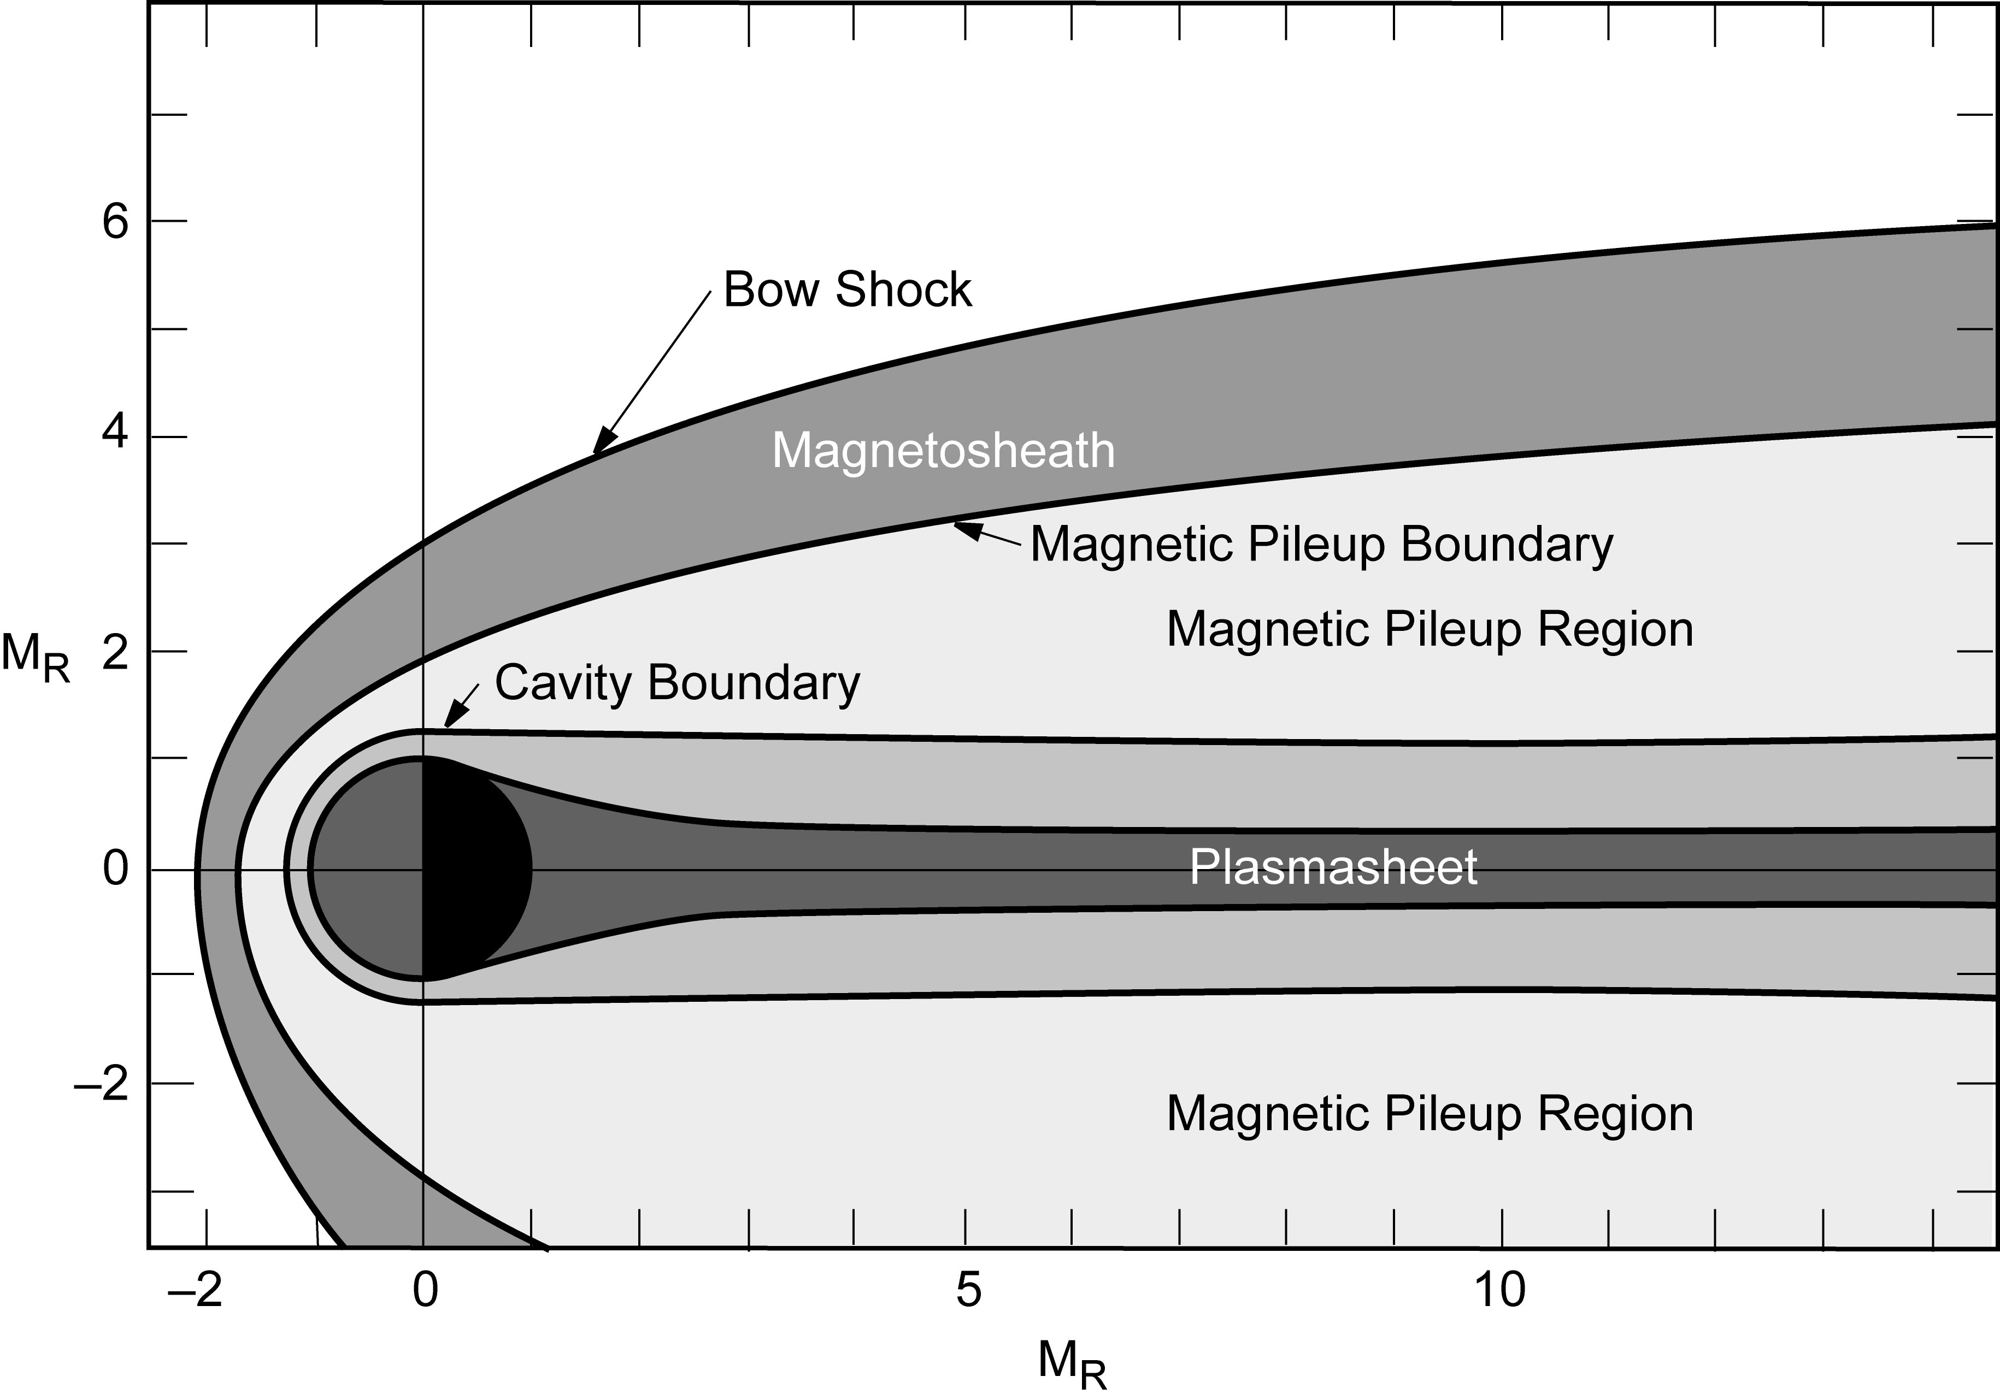
Figure 1. A sketch of the structure of the Martian plasma environment, depicting the major boundaries and regions in the equatorial plane. The scales are Mars radii.

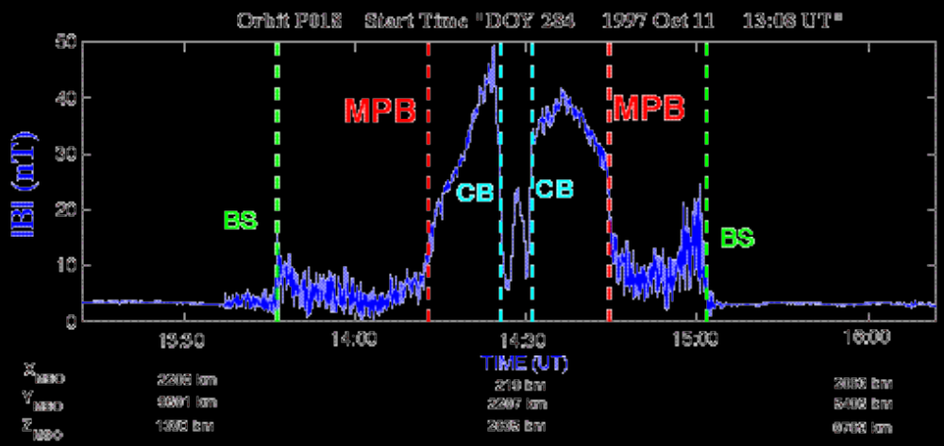
Figure 2. (After Mazelle et al., 2002; See also Winterhalter et al, 2001). Magnitude of the magnetic field recorded by Mars Global Surveyor during an early elliptical orbit (October 11, 1997) around periapsis (14:28 UT, altitude 120 km, 17.6 local time) displaying the major plasma boundaries symmetrically on both sides: BS, MPB and CB denote the bow shock, the magnetic pile-up boundary and the magnetic ‘cavity boundary’, respectively. The horizontal axis shows both time and the spacecraft coordinates in the Mars-centered solar orbital (MSO) system (the X-axis points from Mars to the Sun, the Y-axis points anti-parallel to Mars' orbital velocity, and the Z-axis completes the right-handed coordinate system).

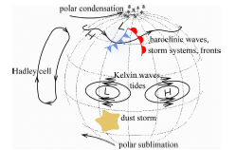
Figure 3. Key components of the Mars general circulation.

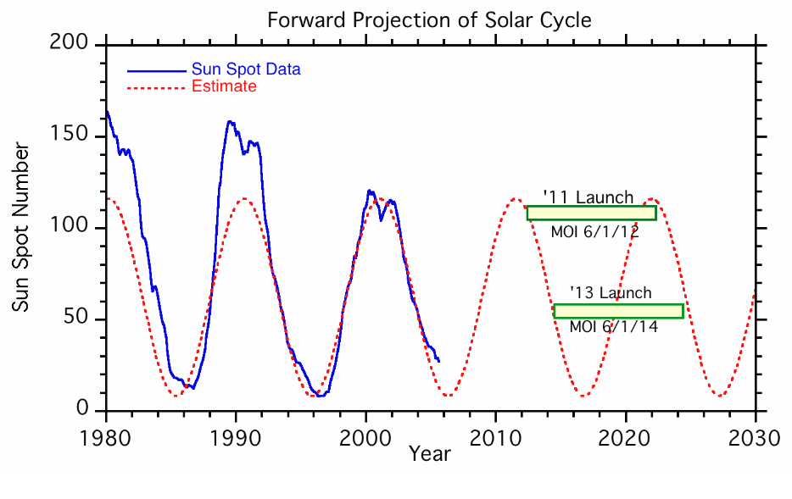
Figure 4. The solar wind pressure varies over the solar cycle, as does the upper atmosphere and ionosphere-controlling solar EUV flux. The escape rates of heavy atoms and H are expected to be significant at high solar activity. There is no in situ data at present. Thus measurements at solar max are essential (necessary, but not sufficient).

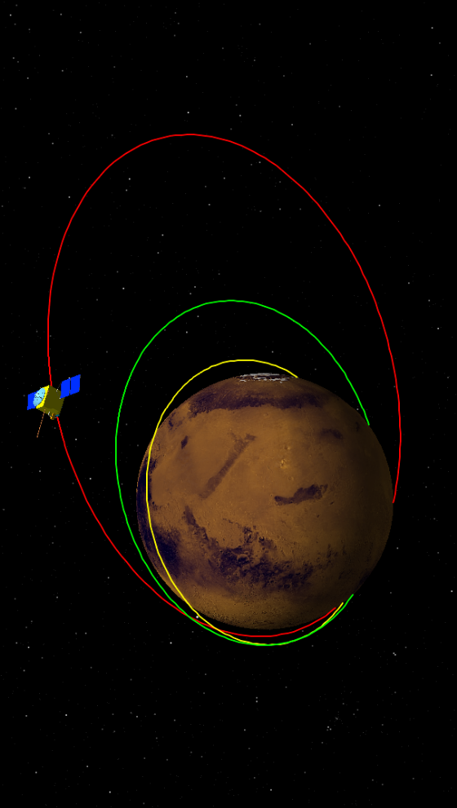
Figure 5. MSTO initial orbit design: Science Phase 1 (red) 150 x 6500 km, duration 1 year. Science Phase 2 (yellow) 400 x 400 km, duration 1 year. Telecom Infrastructure Phase (green) 400 x 2000 km, duration 8 years.

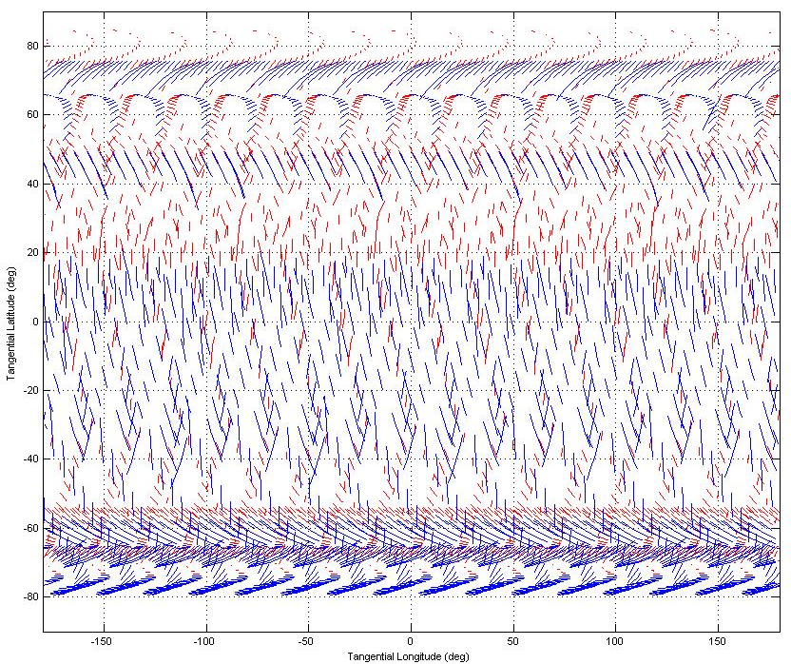
Figure 6. Solar occultation coverage for a 150 x 6500 km orbit over 2 years. Red and blue footprints correspond to 8 and 4 km vertical resolution, respectively.

 | Science Objective Description | Applicable MSTO SAG Questions | MEPAG Investigation Addressed
SO-1 | Characterize present-day atmospheric escape | Q1, Q3, | II.A.1, II.A.3, II.B.2
SO-2 | Determine relative abundances of minor and trace molecular species of lower atmosphere | Q4, Q5, Q7-9 | I.C.4, II.A.1, II.B.1
SO-3 | Measure zonal and meridional winds | Q1, Q6 | II.A.1, II.A.3, II.B.2
SO-4 | Map crustal magnetic field w/100km resolution | Q1 | II.B.2
SO-5 | Use radar or SAR to locate subsurface regions of special interest | Q7 | III.A.1, III.A.2, III.A.5

Table 1. Relationship between MSTO Science Questions and Objectives, MEPAG Mars Scientific Goals, (MEPAG 2006) and the recommendations of the Decadal Study, (New Frontiers in the Solar System, NAS 2003).

H, H⁺, H₂, H₂⁺, D, D⁺, HD, HD⁺
¹²C, ¹²C⁺, ¹³C
¹⁴N, ¹⁴N⁺, ¹⁵N, ¹⁴N₂, ¹⁴N₂⁺, ¹⁴N¹⁵N, ¹⁴N¹⁵N⁺
¹⁶O, ¹⁶O⁺, ¹⁸O, ¹⁶O₂, ¹⁶O₂⁺, ¹⁶O¹⁸O, ¹⁶O¹⁸O⁺
H₂O, HDO
CO, CO⁺, CO₂, CO₂⁺
NO, NO⁺
³⁶Ar, ⁴⁰Ar, ⁴⁰Ar⁺

.

Table 2. Upper atmosphere atomic and molecular species to be monitored.

Species | Upper limit (mixing ratio) | Type of observation | Reference
C₂H₂ | 2x10⁻⁹ | IRIS-Mariner 9 | Maguire (1977)
C₂H₄ | 5x10⁻⁷ | " | "
C₂H₆ | 4x10⁻⁷ | " | "
C₂H₈ | 4x10⁻⁷ | " | "
N₂O | 1x10⁻⁷ | " | "
NO₂ | 1x10⁻⁸ | " | "
NH₃ | 5x10⁻⁹ | " | "
PH₃ | 1x10⁻⁷ | " | "
SO₂ | 3x10⁻⁸ | Ground-based, mm | Encrenaz et al. (1991)
OCS | 7x10⁻⁸ | " | "
H₂S | 2x10⁻⁸ | Ground-based, IR | "
CH₂O | 3x10⁻⁹ | " | Krasnopolsky et al. (1997)
HCl | 2x10⁻⁹ | " | "

Table 3. Upper limits for some of the plausible trace molecular constituents of the Martian atmosphere for which spectroscopic searches have been made. (From Ecrenaz et al., 2004.)

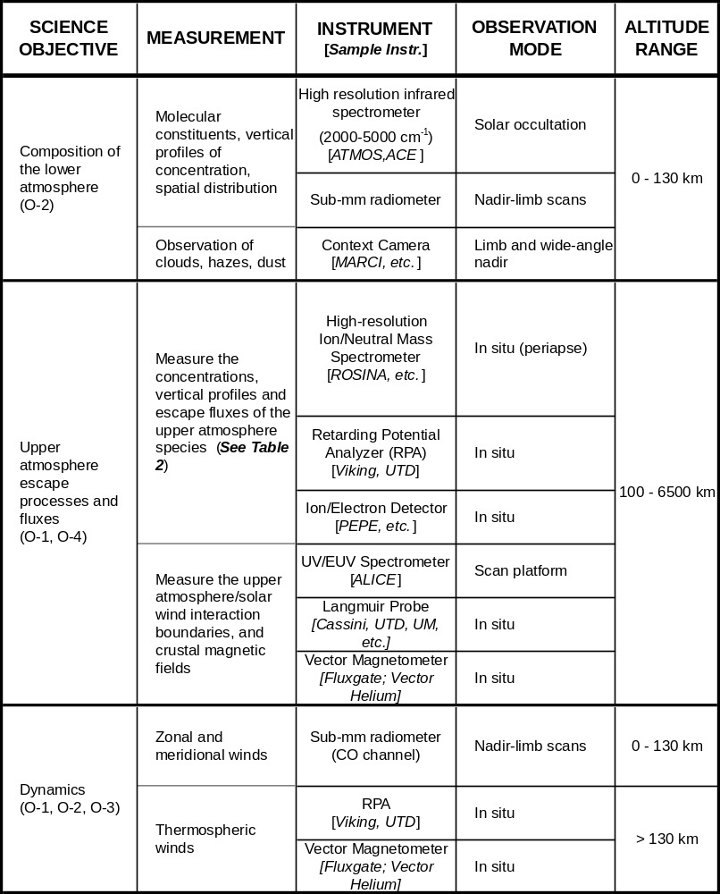
Table 4. Relationship between MSTO science objectives, required measurements and proposed instrument types.

