Appendices to the Report of the Mars 2020
Science Definition Team

J.F. Mustard, chair; M. Adler, A. Allwood, D.S. Bass, D.W. Beaty, J.F. Bell III, W.B. Brinckerhoff, M. Carr, D.J. Des Marais, B. Drake, K.S. Edgett, J. Eigenbrode, L.T. Elkins-Tanton, J.A. Grant, S. M. Milkovich, D. Ming, C. Moore, S. Murchie, T.C. Onstott, S.W. Ruff, M.A. Sephton, A. Steele, A. Treiman
July 1, 2013

Recommended bibliographic citation:
Mustard, J.F., M. Adler, A. Allwood, D.S. Bass, D.W. Beaty, J.F. Bell III, W.B. Brinckerhoff, M. Carr, D.J. Des Marais, B. Drake, K.S. Edgett, J. Eigenbrode, L.T. Elkins-Tanton, J.A. Grant, S. M. Milkovich, D. Ming, C. Moore, S. Murchie, T.C. Onstott, S.W. Ruff, M.A. Sephton, A. Steele, A. Treiman (2013): Appendix to the Report of the Mars 2020 Science Definition Team, 51 pp., posted July, 2013, by the Mars Exploration Program Analysis Group (MEPAG) at http://mepag.jpl.nasa.gov/reports/MEP/Mars_2020_SDT_Report_Appendix.pdf

or

Mars 2020 SDT (2013), Committee members: Mustard, J.F. (chair), M. Adler, A. Allwood, D.S. Bass, D.W. Beaty, J.F. Bell III, W.B. Brinckerhoff, M. Carr, D.J. Des Marais, B. Drake, K.S. Edgett, J. Eigenbrode, L.T. Elkins-Tanton, J.A. Grant, S. M. Milkovich, D. Ming, C. Moore, S. Murchie, T.C. Onstott, S.W. Ruff, M.A. Sephton, A. Steele, A. Treiman: Appendix to the Report of the Mars 2020 Science Definition Team, 51 pp., posted July, 2013, by the Mars Exploration Program Analysis Group (MEPAG) at hthttp://mepag.jpl.nasa.gov/reports/MEP/Mars_2020_SDT_Report_Appendix.pdf.

Inquiries regarding this report should be directed to Jack Mustard, SDT Chair (John_Mustard@brown.edu), David Beaty, MED chief scientist (David.W.Beaty@jpl.nasa.gov), or Mitch Schulte, NASA SMD (mitchell.d.schulte@nasa.gov)
This document has been cleared for public release by JPL Document Review, clearance number CL#13-2464

Appendix 1. Charter: Science Definition Team For a 2020 Mars Science Rover 157
Appendix 2. Mars 2020 Science Definition Team Call for Applications, SDT Roster, and Independent Review Team (IAT) Roster 160
1. Mars 2020 Science Definition Team Call for Applications 160
2. Mars 2020 Science Definition Team Roster 163
3. Mars 2020 Independent Assessment Team 164
Appendix 3: Acronym Glossary 165
Appendix 4: Possible Instrument Concepts 168
Appendix 5: Strawman Payload 173
1. Straw Payload Example Instruments 173
2. In-Situ Resource Utilization (ISRU): Oxygen Production from Atmosphere 178
3. MEDLI+ 179
4. Biomarker Detector System 180
5. Surface Weather Station 181
6. Instrument Cost Estimation 182
Appendix 6: Candidate Landing Site Supporting Information 183
Appendix 7: Reference Landing Site Summary Characteristics 193
Appendix 8: Surface Operations Scenario Modeling 199
1. Model Overview and Assumptions 199
2. Traverse Model (Sols spent driving) 200
3. Fieldwork Model (Sols spent conducting fieldwork) 201
4. Coring and Caching Model (Sols spent coring and caching) 203
5. Free Parameters 203
6. Model results 204
Appendix 9: Errata 206
Aug, 1 2013 Errata Sheet 206

Appendix 1. Charter: Science Definition Team For a 2020 Mars Science Rover
Summary Statement of NASA Intent
The NASA Mars Exploration Program (MEP) has made dramatic progress in the scientific investigation of the Red Planet, most recently with the landing and initial surface operations of the Mars Science Laboratory (MSL) Curiosity rover (Aug. 2012 to present). In combination with discoveries from the ESA Mars Express orbiter, the state of knowledge of Mars points to a planet with a rich geologic history of past environments in which liquid water has played a significant role. On the basis of the results achieved by the ongoing surface reconnaissance activities of the Mars Exploration Rovers and the initial findings of the MSL Curiosity rover, it is increasingly evident that the “scientific action” is at the surface. Furthermore, thanks to the comprehensive inputs by the broader science community, there is an emerging consensus that the search for signs of past life within the accessible geologic record via missions that include the ESA ExoMars rover (2018) and future NASA surface missions is a fertile exploration pathway for the next decade.
Thus, NASA plans to continue the pursuit of its “Seeking the Signs of Life” Mars Exploration Program science theme beyond the near-term missions that include Curiosity and MAVEN. The 2020 launch of a Mars science rover mission will focus on surface-based geological and geochemical reconnaissance in search of signs of life, with clearly defined preparation for eventual return to Earth of carefully selected materials. Supporting in situ measurements will be undertaken to address key questions about the potential for life on Mars via possible preservation of biosignatures within accessible geologic materials. This mission will enable concrete progress toward sample return, thereby satisfying NRC Planetary Decadal Survey science recommendations, and will provide opportunities for accommodation of contributed Human Exploration & Operations Mission Directorate (HEOMD) payload element(s), technology infusion, and international participation.
To support definition of the pre-Phase A 2020 mission concept, the 2020 Mars rover Science Definition Team (SDT) is formed within the framework described below.
Primary Objectives
A. Explore an astrobiologically relevant ancient environment on Mars to decipher its geological processes and history, including the assessment of past habitability and potential preservation of possible biosignatures.
B. In situ science: Search for potential biosignatures within that geological environment and preserved record.
C. Demonstrate significant technical progress towards the future return of scientifically selected, well-documented samples to Earth.
D. Provide an opportunity for contributed HEOMD or Space Technology Program (STP) participation, compatible with the science payload and within the mission’s payload capacity.
Primary Assumptions and Guidelines
- The mission will launch in 2020.
- The total cost of the instruments has a nominal cost limit of ~$100M (including margin/reserves). This includes the development and implementation costs of US instruments (~$80M) and the estimated costs of any contributed elements (~$20M), but not including surface operations costs. The cost of science support equipment, such as an arm, is budgeted separately and not included in this ~$100M/$80M limit for instruments.
- The mission will employ Mars Science Laboratory (MSL) SkyCrane-derived entry, descent, and landing flight systems, and Curiosity-class roving capabilities. Consideration of the scientific value and cost implications of improving access to high-value science landing sites should be provided by the SDT in consultation with the pre-project team.
- The mission lifetime requirement is surface operation for one Mars year (~690 Earth Days).
- Mission pre-project activities will provide additional constraints on payload mass, volume, data rate, and configuration solutions that will establish realistic boundary conditions for SDT consideration.

Statement of Task
The SDT is tasked to formulate a detailed mission concept that is traceable to highest priority, community-vetted scientific goals and objectives (i.e., Vision and Voyages NRC Planetary Decadal Survey and related MEPAG Goals/Objectives) that will be formally presented to the Mars Exploration Program and leaders of the Science Mission Directorate (SMD); any and all mission concepts must fit within available resources and associated levels of acceptable risk as provided by the pre-project team.
As such, the SDT shall:
1. Determine the payload options and priorities associated with achieving science objectives A, B, and C. Recommend a mission concept that will maximize overall science return and progress towards NASA’s long-range goals within the resource and risk posture constraints provided by HQ.
2. Determine the degree to which HEOMD measurements or STP technology infusion/demonstration activities (Objective D) can be accommodated as part of the mission (in priority order), consistent with a separate (from SMD) budget constraint also to be provided by HQ.
3. Work with the pre-project team in developing a feasible mission concept.
4. For the favored mission concept, propose high-level supporting capability requirements derived from the scientific objectives, including both baseline and threshold values.
5. Develop a Level 0 Science Traceability Matrix (similar to those required for SMD mission Announcements of Opportunity) that flows from overarching science goals/objectives to functional measurements and required capabilities for the surface mission in 2020.
6. Define the payload elements (including both instruments and support equipment) required to achieve the scientific objectives, including high-level measurement performance specifications and resource allocations sufficient to support a competitive, AO-based procurement process:
- Provide a description of at least one “strawman” payload as an existence proof, including cost estimate
- For both baseline and any threshold payloads, describe priorities for scaling the mission concept either up or down (in cost and capability) and payload priority trades between instrumentation and various levels of sample encapsulation.

Methods and Schedule
The following delivery points are specified:
- Interim results (presentation format) shall be delivered no later than 2 April 2013.
- A near-final summary presentation to be delivered by 31 May 2013, in which the essential conclusions and recommendations are not expected to change during final report writing.
- A final text-formatted report to be delivered by July 1, 2013.
The Mars-2020 pre-project engineering team at JPL has been tasked to support the SDT as needed on issues related to mission engineering.
The SDT report will be essential in formulating the HQ-approved set of 2020 Mars rover mission science goals and measurement objectives suitable for open solicitation via a NASA SMD Payload AO that is to be released for open competition in Summer 2013.
Point of contact for this task:
Dr. Mitchell Schulte, NASA Program Scientist for the 2020 Mars science rover mission
Email: mitchell.d.schulte@nasa.gov

References (see http://mepag.nasa.gov/reports/index.html)
- Vision and Voyages for Planetary Science in the Decade 2013-2022
- Mars Program Planning Group Report 2012
- “Baseline” arm- and mast-mounted measurement functionalities for Objective A as described in Appendix 6 of JSWG (2012) [see also MPPG Final Report Appendix A].
- Candidate measurements and priorities for HEO and OCT from MEPAG P-SAG (2012).
- Assume (as a one point of departure) the scientific objectives and priorities for returned sample science from the recent work of E2E-iSAG, 2018 JSWG, and MPPG (2012)

Appendix 2. Mars 2020 Science Definition Team Call for Applications, SDT Roster, and Independent Review Team (IAT) Roster

Mars 2020 Science Definition Team Call for Applications
Call for Letters of Application for Membership on the Science Definition Team for the 2020 Mars Science Rover

Solicitation Number: NNH13ZDA003L
Posted Date: December 20, 2012
FedBizOpps Posted Date: December 20, 2012
Recovery and Reinvestment Act Action: No
Original Response Date: January 10, 2013
Classification Code: A – Research and Development
NAICS Code: 541712 – Research and Development
in the Physical, Engineering, and Life
Sciences (except Biotechnology)

The National Aeronautics and Space Administration (NASA) invites scientists, technologists, and other qualified and interested individuals at U.S. institutions and elsewhere to apply for membership on the Science Definition Team (SDT) for the 2020 Mars science rover mission (hereafter Mars-2020). Mars-2020 is a strategic mission sponsored by NASA’s Planetary Science Division, through the Mars Exploration Program, all of which are part of the Science Mission Directorate (SMD).

This mission will advance the scientific priorities detailed in the National Research Council’s Planetary Science Decadal Survey, entitled “Vision and Voyages for Planetary Science in the Decade 2013-2022” (the Decadal Survey is available at http://www.nap.edu). Mars-2020 rover development and design will be largely based upon the Mars Science Laboratory (MSL) architecture that successfully carried the Curiosity rover to the Martian surface on August 6, 2012 (UTC). The 2020 rover is intended to investigate an astrobiologically relevant ancient environment on Mars to decipher its geological processes and history, including the assessment of its past habitability and potential for preservation of biosignatures within accessible geologic materials.

Furthermore, because NASA is embarking on a long-term effort for eventual human exploration of Mars, the mission should provide an opportunity for contributed Human Exploration Mission Directorate (HEOMD) or Space Technology Program (STP) participation via payload elements aligned with their priorities and compatible with SMD priorities for Mars-2020 (e.g., MEPAG P-SAG report, posted June 2012 to MEPAG website: http://mepag.jpl.nasa.gov).

The members of the Mars-2020 SDT will provide NASA with scientific assistance and direction during preliminary concept definition (Pre-Phase A) activities. Near-term activities of the SDT will include the establishment of baseline mission science objectives and a realistic scientific concept of surface operations; development of a strawman payload/instrument suite as proof of concept; and suggestions for threshold science objectives/measurements for a preferred mission viable within resource constraints provided by NASA Headquarters. The products developed by the SDT will be used to develop the NASA Science Mission Directorate (SMD) Announcement of Opportunity (AO) that will outline the primary science objectives of the baseline mission and the character of the payload-based investigations solicited under open competition via the AO. The SDT will be formed in January 2013, and disbanded after the work is complete approximately four months later.
All reports and output materials of the Mars-2020 SDT will be publicly available, and the SDT will be disbanded prior to any future Announcement of Opportunity (AO) for participation in the Mars-2020 mission, including provision of instrumentation and investigation support. Participation in the Mars-2020 SDT is open to all qualified and interested individuals. The formal NASA charter for the Mars-2020 SDT will be posted to the NASA Science Mission Directorate Service and Advice for Research and Analysis (SARA) website (http://science.nasa.gov/researchers/sara/grant-solicitations/).

DETAILS OF THIS CALL FOR SDT PARTICIPATION

Response to this Call for Membership in the Mars-2020 SDT is in the form of a Letter of Application. SDT members will be selected by NASA Headquarters senior officials from the pool of respondents and other qualified candidates. The selected members will have demonstrated expertise and knowledge in areas highly relevant to the Mars-2020 primary scientific goals and related technologies and instrumentation. The Letter of Application should provide clearly defined evidence of the candidate’s demonstrated expertise in one or more areas associated with the preliminary mission description given above.

The Letter of Application may also contain a brief list of references to scientific or technical peer-reviewed papers the applicant has published that formally establish their position of scientific leadership in the community. The letter should also contain a statement confirming the applicant’s time availability during the next three to six months to participate on the SDT, particularly if there are any major schedule constraints that may restrict full engagement in the significant amount of work that will be required in a reasonably short time frame. Applicants should indicate interest in serving as the chair or co-chair of the SDT.

Membership in the SDT will be determined by NASA after formal review of the Letters of Application solicited by this Call for Membership. Approximately 12-15 SDT members and an SDT Chair will be selected. The NASA Mars-2020 Program Scientist, the NASA Mars Exploration Program Lead Scientist, and possibly other Agency representatives will serve as ex officio members of the SDT.
Letters of Application are invited only from individuals, and group applications will not be considered. In addition, collaborations and teams will not be considered.

Each Letter of Application is limited to two pages, with 11-point font with 1-inch margins. Letters of Application submitted by E-mail are preferred, but may also be submitted by regular mail or fax. Responses to this invitation should be received by the Mars-2020 Program Scientist no later than January 10, 2013, at the address below.

The issuance of this Call for Letters of Application does not obligate NASA to accept any of the applications. Any costs incurred by an applicant in preparing a submission in response to this Call are the responsibility of the applicant.

Dr. Mitch Schulte
Planetary Sciences Division
Science Mission Directorate
National Aeronautics and Space Administration
300 E Street, SW
Washington, DC 20546
Phone: 202-358-2127
Fax: 202-358-3097
E-mail: mars2020-sdt@lists.hq.nasa.gov

Mars 2020 Science Definition Team Roster
Name | Professional Affiliation | Interest/Experience
Chair
Mustard, Jack | Brown University | Generalist, geology, Remote Sensing, MRO, MEPAG, DS, MSS-SAG
Science Members (n = 16)
Allwood, Abby | JPL | Field astrobiology, early life on Earth, E2E-SAG, JSWG, MSR
Bell, Jim | ASU | Remote Sensing, Instruments, MER, MSL, Planetary Society
Brinckerhoff, William | NASA GSFC | Analytical Chemistry, Instruments, AFL-SSG, MSL(SAM), EXM, P-SAG
Carr, Michael | USGS, ret. | Geology, Hydrology, ND-SAG, E2E, P-SAG, Viking, MER, PPS
Des Marais, Dave | NASA ARC | Astrobio, field instruments, DS, ND-SAG, MER, MSL, MEPAG
Edgett, Ken | MSSS | Geology, geomorph, MRO, MSL, MGS, cameras, E/PO
Eigenbrode, Jen | NASA GSFC | Organic geochemistry, MSL, ND-SAG
Elkins-Tanton, Lindy | DTM, CIW | Petrology, CAPS, DS
Grant, John | Smithsonian, DC | geophysics, landing site selection, MER, HiRISE, E2E, PSS
Ming, Doug | NASA JSC | Geochemistry, MSL (CHEMIN, SAM), MER, PHX
Murchie, Scott | JHU-APL | IR spectroscopy, MRO (CRISM), MESSENGER, MSS-SAG
Onstott, Tullis (T.C.) | Princeton Univ | Geomicrobiology, biogeochemistry
Ruff, Steve | Ariz. State Univ. | MER, spectral geology, MGS (TES), MER, ND, E2E, JSWG
Sephton, Mark | Imperial College | Organics extraction and analysis, ExoMars, Astrobiology, E2E
Steele, Andrew | Carnegie Inst., Wash | astrobiology, meteorites, samples, ND-, P-SAG, AFL-SSG, PPS
Treiman, Allen | LPI | Meteorites, Samples, Igneous Petrology
HEO/OCT representatives (n = 3)
Adler, Mark | JPL | Technology development, MER, MSR,
Drake, Bret | NASA JSC | System engineering, long-lead planning for humans to Mars
Moore, Chris | NASA HQ | technology development, planning for humans to Mars
Ex-officio (n = 7)
Meyer, Michael | NASA HQ | Mars Lead Scientist
Mitch Schulte | NASA | Mars 2020 Program Scientist
George Tahu | NASA | Mars 2020 Program Executive
David Beaty | JPL | Acting Project Scientist, Mars Program Office, JPL
Deborah Bass | JPL | Acting Deputy Proj. Sci, Mars Program Office, JPL
Jim Garvin | NASA | Science Mission Directorate
Mike Wargo | NASA | HEO Mission Directorate
Observer (n = 1)
Jorge Vago | ESA | Observer
Supporting resources (n = 2)
Wallace, Matt | JPL | Deputy Project Manager, 2020 Surface Mission, designated engineering liaison
Milkovich, Sarah | JPL | SDT documentarian, logistics

Mars 2020 Independent Assessment Team

Appendix 3: Acronym Glossary
Acronym Definition
AGU American Geophysical Union
AO Announcement of Opportunity
APXS Alpha Particle X-Ray Spectrometer, an instrument on both the 2003 MER mission and
the 2011 Mars Science Laboratory mission
ARC Ames Research Center, a field center within the NASA system
BPP Biosignature Preservation Potential
CEDL Cruise, Entry, Descent and Landing
ChemCam Chemistry and Camera Instrument, an instrument on the 2011 Mars Science Laboratory
mission
CHNOPS Carbon, Hydrogen, Nitrogen, Oxygen, Phosphorous, Sulfur
CRIS Confocal Raman Imaging Spectroscopy.A measurement technique/class of
instrumentation
CRISM Compact Reconnaissance Imaging Spectrometer for Mars, an instrument on the 2005
Mars Reconnaissance Orbiter mission.
DBS Definitive Biosignature. Conclusive evidence of past life
DEM Digital Elevation Model. Computerized "model" that shows terrain heights
DRT Dust Removal Tool, a device on the 2011 Mars Science Laboratory mission
DSN Deep Space Network. Network of world-wide satellite dishes to send spacecraft signals
and receive data
DTE Direct-to-Earth
E2E-iSAG End-to-end International Science Analysis Group, a 2011 study team sponsored by the
Mars Exploration Program Analysis Group (MEPAG)
EDL Entry, Descent and Landing
EGA Evolved Gas Analysis. A specific implementation of a differential scanning calorimetry
experiment
ESA European Space Agency
FIB Focused Ion Beam. A measurement technique/class of instrumentation
FOV Field of View
FTIR Fourier Transform Infrared, a type of spectrometer
GWU George Washington University
HAT Human Spaceflight Architecture Team. Team charged with working the strategic vision
for Human Spaceflight
HEO Human Exploration and Operations
HEOMD Human Exploration and Operations Mission Directorate, an organization within NASA
HGA High Gain Antenna
HiRISE High Resolution Imaging Science Experiment, an instrument on the 2005 Mars
Reconnaissance Orbiter mission.
HIT HEOMD Instrument Team. Team working to understand the priorities and possible
implementation of instruments that will help pave the way for Human Exploration.
HQ Headquarters (NASA)
IAT Independent Assessment Team aka "Red Team" or supplementary review team for the
2020 Science Defintion Team
IMU Inertial Measurement Unit. Spacecraft "gyroscope"
InSight Interior Exploration using Seismic Investigations, Geodesy and Heat Transport, a
Discovery mission to Mars in development for launch in 2016.
IR Infrared Reflectance Spectroscopy. A measurement technique/class of instrumentation
ISRU In Situ Resource Utilization. A general term that refers to making use of resources in
space or on target objects.
JHU/APL John Hopkins University/Applied Physics Laboratory
JPL Jet Propulsion Laboratory, a field center within the NASA system
JSC Johnson Space Center, a field center within the NASA system
JSWG Joint Science Working Group. The International Science Team for the proposed (but not approved) 2018 Joint Mars Rover Mission
LaRC Langley Research Center, a field center within the NASA system
LASP Laboratory for Atmospheric Space Physics, an organization within the University of Colorado
LOD Limit of Detection
MAHLI Mars Hand Lens Imager, an instrument on the 2011 Mars Science Laboratory mission
MARDI Mars Descent Imager, an instrument on the 2011 Mars Science Laboratory mission
MastCam Mast Camera, an instrument on the 2011 Mars Science Laboratory mission
MAV Mars Ascent Vehicle. The spacecraft that could "blast off" from the martian surface
MAVEN Mars Atmosphere and Volatile EvolutioN, a Mars orbiter mission to be launched in 2013
MAX-C Mars Astrobiology Explorer-Cacher. The name of a mission proposed in the MRR-SAG study, which was in turn sponsored by MEPAG.
MEDLI Mars Science Laboratory Entry, Descent, and Landing Instrument, an instrument on the
2011 Mars Science Laboratory mission
MEDLI+ Mars Entry, Descent, and Landing Instrumentation Plus, the next generation of MEDLI
MEP Mars Exploration Program
MEPAG Mars Exploration Program Analysis Group, an analysis group affiliated with NASA's
Planetary Science Subcommittee
MER Mars Exploration Rovers, a dual Mars rover mission launched in 2003
MI Microscopic Imager, an instrument on the 2003 MER mission
micro-XRF ultraminiaturized X-Ray Fluorescence Spectrometer, an instrument in development
Mini-TES Miniature Thermal Emission Spectrometer, an instrument on the 2003 MER mission
MIT Massachusetts Institute of Technology
MMC Macromolecular Carbon
MMI Mars Microscopic Imager, an instrument in development
MMRTG Multi-Mission Radioisotope Thermoelectric Generator
MOLA Mars Orbiter Laser Altimeter, an instrument on the 1996 Mars Global Surveyor mission
MPF Mars Pathfinder, a Mars rover mission launched in 1996
MPO Mars Program Office
MPPG Mars Program Planning Group, a Mars planning team active in 2012
MRO Mars Reconnaissance Orbiter, a Mars orbiter mission launched in 2005
MRR-SAG Mars Mid Range Rover Science Analysis Group, a 2009 study team sponsored by MEPAG
MSFC Marshall Space Flight Center, a field center within the NASA system
MSL Mars Science Laboratory, a Mars rover mission launched in 2011
MSR Mars Sample Return
MSR-SSG Mars Sample Return - Science Steering Group sponsored by MEPAG
MSSS Malin Space Science Systems
NanoSIMS Nano Secondary Ion Mass Spectroscopy. A measurement technique/class of
instrumentation
NASA National Aeronautics and Space Administration
ND-SAG Next Decade Science Analysis Group, a 2008 study team sponsored by MEPAG
NRC National Research Council
OCSSG Organic Contamination Science Steering Group, a study team sponsored by MEPAG.
Findings were used to set the contamination standards for MSL.
OM Organic Matter
P-SAG Precursor Strategy Analysis Group
PBS Potential Biosignature
PDR Preliminary Design Review
PHX Phoenix Mars Lander, a Mars lander mission lauched in 2007
PP (Category) Planetary Protection
ppb parts per billion
ppm parts per million
PSG Project Science Group
Pyr/CELAS Pyrolysis/Cavity-Enhanced Laser Absorption Spectroscopy. A measurement
technique/class of instrumentation
Pyr/GC-MS Pyrolysis/Gas Chromatography Mass Spectrometry. A measurement technique/class of
instrumentation
Pyr/MS Pyrolysis/Mass Spectrometry. A measurement technique/class of instrumentation
RT Range Trigger. A technology for improving EDL capabilities
RAT Rock Abrasion Tool, a tool on the 2003 MER mission
ROI Regions of Interest. Operational term used to define geographic areas where robotic
actions may be grouped
RSL Recurring Slope Lineae, a surface feature on Mars
SA Sample Acquisition
SAED Selected Area Electron Diffraction, a measurement technique/class of instrumentation
SAG Science Analysis Group
SAM Sample Analysis at Mars, an instrument on the 2011 Mars Science Laboratory mission
SDT Science Definition Team
SKG Strategic Knowledge Gap. Term for areas that need additional study.
SMD Science Mission Directorate, an organization within NASA
SPaH Sample Processing and Handling System, a device on the 2011 Mars Science Laboratory mission
STMD Space Technology Mission Directorate, an organization within NASA
STP Science Technology Program. Now known as STMD
TGO Trace Gas Orbiter, a Mars orbiter to be launched in 2016
THA Terminal Hazard Avoidance. A technology for improving EDL capabilities
THEMIS Thermal Emission Imaging System, an instrument on the 2001 Mars Odyssey mission
TIR Thermal Infrared
TRL Technology Readiness Level
TRN Terrain Relative Navigation. A technology for improving EDL capabilities
TWTA Traveling-Wave Tube Amplifier
UCIS Ultra-compact Imaging Spectrometer, an instrument in development
UHF Ultra High Frequency
UV Ultraviolet
V&V Validation and Verification
VISIR Visible and Infrared

Appendix 4: Possible Instrument Concepts
This table is the result of a survey of potential instruments for a Mars surface mission. This survey primarily draws from concepts publicly presented at two recent conferences: the International Workshop on Instrumentation for Planetary Missions (IPM-2012) held on Oct. 10-12, 2012 in Greenbelt, MD (http://ssed.gsfc.nasa.gov/IPM/) and the Concepts and Approaches for Mars Exploration Workshop held on June 12-14 in Houston, TX (http://www.lpi.usra.edu/meetings/marsconcepts2012/). From all the instrument concepts presented in these venues, we selected the subset relevant for a Mars surface mission. The survey also includes a number of heritage instruments.

This table indicates the instrument name, acronym/short name, category, and a more detailed measurement description. We have also listed references to the specific papers or presentations used to compile this database.

Appendix 5: Strawman Payload

Straw Payload Example Instruments

In-Situ Resource Utilization (ISRU): Oxygen Production from Atmosphere
Description
- Dust filtration & non-intrusive measurement during Mars carbon dioxide (CO₂) capture
- CO₂ collection via CO₂ freezing (Option: rapid-cycle adsorption pump)
- Oxygen (O₂) and fuel production from CO₂ via Reverse Water Gas Shift/Water Electrolysis and Sabatier (Options: Microchannel reactors and Solid Oxide Electrolysis)
- Produce small quantities of O₂ and analyze O₂ purity (TBD instrument)
Rationale
- ISRU can greatly reduce mass transported to the Martian surface.
- Mars carbon dioxide can be acquired at all locations on Mars with technologies similar to life support
Measurement detail
- CO₂ collection rate: 0.011 - 0.045 kg/hr.
- Analyze dust particle size/shape and number density during CO₂ collection
- O₂ production rate: 0.015 kg/hr
Resources needed
- Mass: 10-20 Kg
- Power: 50-150 W
- Cost: $20 -25M for Dust/CO₂ Capture
- $50-55M for Dust/CO₂ Capture & O₂/Fuel production
- Operational concept: Operate 7 to 8 hrs per sol.
- Operate as many Sols as possible
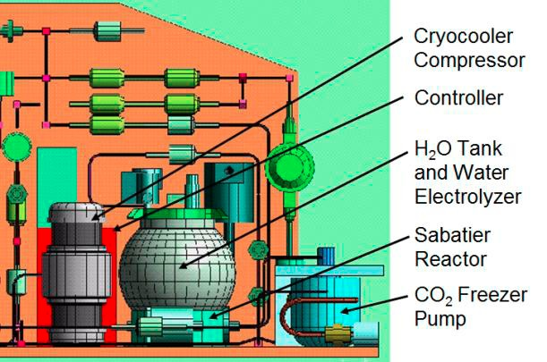
Figure Appx 5-1. Instrument concept for ISRU

MEDLI+
Description
- Reflight of MEDLI with some pressure and temperature sensors moved to afterbody.
- Corroborate MEDLI data in areas where the results were contrary to original predictions.
- Add new technology sensors (surface heat flux, catalysis, time-dependent recession).
- Uplooking camera to observe parachute inflation (optional)
Rationale
- Validate Mars atmospheric models and thermal protection system performance to design aerocapture, EDL, aerobraking and launch systems
Measurement detail
- Temperature, pressure, and recession sensors on heat shield and afterbody
Resources needed
- MEDLI as built:
  - Mass: 15.1 kg
  - Power: 10 W
  - Cost: $19.7M; $30M with camera
- Operational concept: Operates during EDL
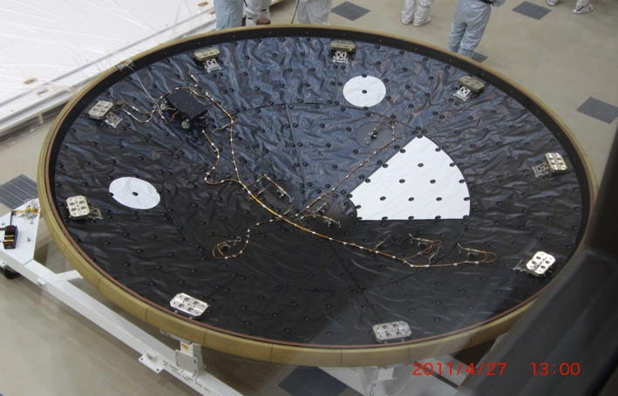
Figure Appx 5-2. MEDLI on MSL heat shield

Biomarker Detector System
Description
- Signs of Life Detector (SOLID) has been developed to detect extant life in planetary bodies.
- Sample processing involves solvent extraction of molecular biomarkers by means of sonication in the Sample Preparation Unit (SPU). Measurement is based on fluorescent antibody microarray technology in the Sample Analysis Unit (SAU). Large heritage from research, clinical and biotech sectors.
- Capability to interrogate for more than 500 molecular biomarkers in a single assay, starting from a particulate sample (soil, sediment or ice).
- SOLID has proven sensitivities down to 1-2 ppb (ng/mL) for peptides and proteins, and 10³-10⁴ cells or spores per mL.
- SOLID can be used for extraterrestrial life detection by targeting universal biomarkers such as amino acids, polymers, polysaccharides, whole cells and microbial spores.
- SOLID can also be used for Planetary Protection to monitor forward contamination during robotic/human operations in an extraterrestrial.
Rationale
- Determine if Martian environments contacted by humans are free of biohazards that might have adverse effects on exposed crew, and on other terrestrial species if uncontained Martian material would be returned to Earth.
- Do not know extent to which terrestrial contaminants introduced at a possibly inhospitable landing site could be dispersed into more hospitable sites.
Measurement detail
- Detect biomarkers present in Earth life (e.g., amino acids, peptides) that might also be components of Mars life, at concentrations relevant to contamination limits for Mars Sample Return
Resources needed
- Mass: 7.4 kg
- Volume: 10 L
- Power: 12 W avg; 50 W peak
- Requires sampling system
- Cost: $26M ($13M NASA; $13M co-funding from Spain)
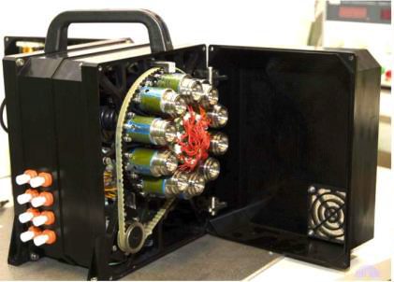
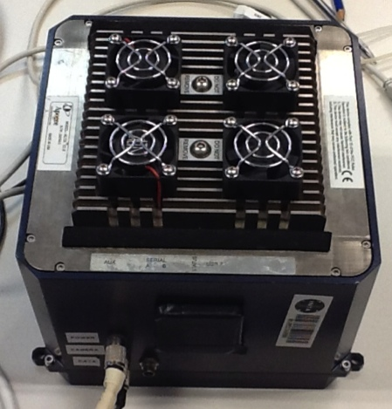
Fig. Appx 5-3. Biomarker Detector System. Left: SOLID Sample Preparation Unit. Right: SOLID Sample analysis unit

Surface Weather Station
Description
- REMS follow on for P, T, winds, humidity.
- Mini-TES or MCS like instrument for vertical T profiles. Deck or mast mounted, upward looking.
- Pancam with sun filters for total aerosols.
- LIDAR for aerosol profiles.
Rationale
- Provide density for EDL and ascent profiles, and validation data for global atmosphere models, in order to validate global model extrapolations of surface pressure
- Provide local-surface and near-surface validation data for mesoscale and large eddy simulation models in order to validate regional and local model atmospheric conditions.
Measurement detail
- Surface Pressure with a precision of 10⁻² Pa; Surface meteorological packages (including T, surface winds, relative humidity, aerosol column); both for Full diurnal cycle, Sampling rate > 0.01 Hz, for multiple Martian years.
- Upward-looking, high vertical resolution T & aerosol profiles below ~10 km; Sun tracking visible (near UV/IR) filters
Resources needed
- REMS as built:
  - Mass: 1.3 kg
  - Power: 19 W
  - Data Volume: ~1.6 MBytes/sol
  - Cost: $19.3M
- Operational concept: Sampling (approximately 24 times a day)
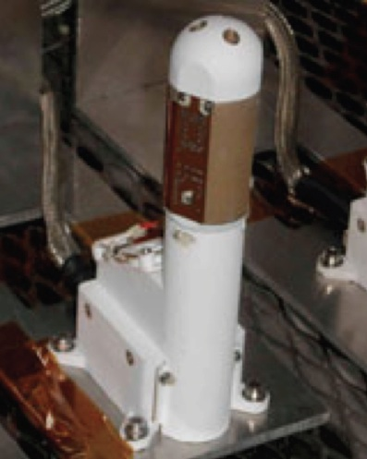 Fig Appx 5-4. Rover Environmental Monitoring Station (REMS)

Instrument Cost Estimation
A key constraint specified by the SDT charter was that the total cost of the instruments should be less than $100M (of which it is assumed for planning purposes that share of this budget to come from SMD would be $80M, with $20M contributed from some other entity). In order to build the strawman payload (Table 5-3 above), the SDT therefore required instrument cost estimates. As requested by the charter, the SDT turned to the Mars 2020 Project team for notional instrument costing assessments. For the purpose of this planning, it makes no difference which instruments are contributed, and which are U.S.-sourced, so neither the SDT nor the Project speculated on this.
Cost Estimation Procedure
For instruments that had very clear heritage (examples included APXS and Mastcam), the as-built/as-flown costs were inflated and adjusted based on available heritage or new functionality. Most of the other instruments were assessed using mass and power characteristics inputs into the NASA Instrument Cost Model (NICM) (Version 5 May 2012) database. NICM is a standard NASA instrument costing tool with a database of 140 instruments. Where previous costing work existed (examples include Green Raman), and/or where other analogous instrument data was available, that information was considered as well. In each case, the payload and project management adjusted costs based on our best understanding of TRL levels, technology challenges, MSL heritage compatibility, and previous development experience. The Project also had access to two additional costing models, PRICE and SEER, in the event that NICM and as-built analogs were not available or appropriate references - however, the Project did not find the need to use these models.
The estimated costs were targeted to be reasonable ROMs, but not worse case. The estimates included anticipated expenditure of reserve, although this was easier to estimate on instruments with clear as-built analogies. Accommodation assessments included mass, volume, and power margins based on instrument maturity. However, the cost to the flight system for accommodation was not included in the payload cost. Where instruments appeared to be incompatible with MSL heritage systems, alternate instruments were selected or the instrument cost estimates were increased under the assumption that significant modifications may be required.
Two alternate instrument payload suites were submitted for cost estimation (see Table 5-3 above). The estimated cost of the two suites were identical within the estimated error of the assessment. This provided a notional cross-check on the total aggregated costs for the totality of the instrumentation required to meet the stated objectives. In general, while any individual instrument cost assessment may have been too high or too low, the likelihood of the aggregated suite of instruments being substantially higher or lower than the estimated costs would be more limited.
The cost of the HEOMD candidate payloads was estimated by HEOMD personnel, not by the Mars 2020 Project. The Project did not review any cost estimation work done by either HEOMD or STMD. The project did make an estimate a $5M+ for accommodation costs of the IRSU CO2 experiment. This is likely to be the lowest possible accommodation cost for this instrument based on MSL RAD costs. Since the SDT charter does not place a constraint on the maximum amount of money to be contributed by either HEOMD or STMD, the estimated cost of these payloads played no role in SDT deliberations.

Appendix 6: Candidate Landing Site Supporting Information
Maps of Mars showing the distribution of candidate landing sites proposed and evaluated for MSL and additional sites proposed to calls for future missions (top) and sites proposed to MSL indicating the final four candidate sites for that mission (bottom). These sites were reviewed to establish the Reference Sites for the 2020 mission. Red lines in the top panel help define where proposed sites occur relative to latitudes of 30 degrees north and south of the equator. Areas indicated as black in the top panel are above +1 km elevation, whereas those in the lower panel are above 0 km elevation. The sites indicated by numbered dots in the top panel are listed in Table A6-1 that follows.

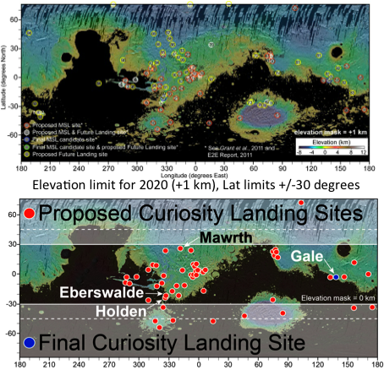

Table A6-1 lists the candidate landing sites for MSL and proposed to calls for candidate sites for future missions that were reviewed to establish Reference Sites for the proposed 2020 mission. Table A6-1 indicates the number corresponding to the dot in the map above, the site name (and multiple ellipses where applicable), site location, elevation, and brief description of the target materials and is generally sorted by lowest to highest elevation. Exceptions exist, however, where relief in the vicinity of a candidate site results in multiple elevations for the site or for some sites proposed for future missions (at the end) where the elevation was not available.

Table A6-1. Candidate Landing sites proposed for MSL and for future missions.
Dotª |  |  | Site Name^{b} |  |  |  | Center of Proposed Ellipse |  |  |  |  |  |  |  | Target
 |  |  |  |  |  |  | Lat (°N) |  |  | Lon (°E) |  |  | Elev (km)
76 |  |  | N. Hellas rim |  |  |  | -29.537 |  |  | 70.844 |  |  | -6 |  | resolve layering along northern rim of Hellas, correlate with Terby layers
 |  |  |  |  |  |  | -29.875 |  |  | 71.844 |  |  | -5.9 |  | correlate layers on northern rim of Hellas with Terby
51 |  |  | Dao Vallis |  |  |  | -38.9 |  |  | 81.2 |  |  | -6.0 |  | valley terminus, layered deposits
 |  |  |  |  |  |  | -39.5 |  |  | 82.7 |  |  | -6.0
 |  |  |  |  |  |  | -41.2 |  |  | 84.4 |  |  | -6.0
 |  |  |  |  |  |  | -40.7 |  |  | 85.6 |  |  | -5.4
 |  |  |  |  |  |  | -41.7 |  |  | 85.8 |  |  | -5.4
 |  |  |  |  |  |  | -43.3 |  |  | 86.8 |  |  | -5.4
3 |  |  | Eastern Melas Chasma |  |  |  | -11.6 |  |  | 290.5 |  |  | -5.8 |  | layered deposits
75 |  |  | N. Hellas rim |  |  |  | -29.0545 |  |  | 67.628 |  |  | -5.8 |  | layered deposits
 |  |  |  |  |  |  | -29.1215 |  |  | 66.701 |  |  | -5.4
97 |  |  | Coprates Chasma |  |  |  | -12.3575 |  |  | 295.958 |  |  | -5 |  | landing ellipse; exposure of light toned layered floor material
 |  |  |  |  |  |  | -12.167 |  |  | 295.647 |  |  | -5 |  | central Mons of the canyon exposing crustal bedrock enriched in Low Calcium Pyroxenes and possibly in phyllosilicates Iimage is located 2 kilometers north to the landing ellipse.
 |  |  |  |  |  |  | -12.588 |  |  | 296.087 |  |  | -5 |  | landing ellipse; exposure of light toned layered floor material
42 |  |  | Terby crater |  |  |  | -27.4 |  |  | 73.4 |  |  | -4.7 |  | hydrated layered deposits (lacustrine?), fluvial and ice-related morphology
 |  |  |  |  |  |  | -27.6 |  |  | 74.0 |  |  | -4.7
 |  |  |  |  |  |  | -28.0 |  |  | 74.1 |  |  | -4.5 |  | ancient basin bedrock
67 |  |  | Acidalia Mensa |  |  |  | 44.74 |  |  | 331.72 |  |  | -4.8 |  | Mound (interpreted as mud volcano) cut by polygon
 |  |  |  |  |  |  | 46.7 |  |  | 331.12 |  |  | -4.5
49 |  |  | Nili Fossae carbonate plains |  |  |  | 21.9 |  |  | 78.9 |  |  | -4.5 |  | layered phyllosilicates under sulfates
 |  |  |  |  |  |  | 2.17544 |  |  | 78.6099 |  |  |  |  | western carbonate plains
 |  |  |  |  |  |  | 21.6013 |  |  | 78.5413
 |  |  |  |  |  |  | 21.5093 |  |  | 78.6511
 |  |  |  |  |  |  | 21.7416 |  |  | 79.0604
 |  |  |  |  |  |  | 21.9456 |  |  | 78.6978
54 |  |  | Gale crater^{i} |  |  |  | -4.6 |  |  | 137.4 |  |  | -4.5 |  | layered deposits, exhumed channels
 |  |  |  |  |  |  | -5.7 |  |  | 137.6 |  |  | -3.6
68 |  |  | Acidalia Planitia |  |  |  | 40.08 |  |  | 333.27 |  |  | -4.5 |  | Densly occurring mounds (mud volcanoes)
 |  |  |  |  |  |  | 40.67 |  |  | 332.32 |  |  | -4.5
 |  |  |  |  |  |  | 44.53 |  |  | 317.3 |  |  | -4 |  | thumbprint terrain (mud volcanoes)
Dotª |  | Site Name^{b} |  |  |  | Center of Proposed Ellipse |  |  |  |  |  |  |  | Target
 |  |  |  |  |  | Lat (°N) |  |  | Lon (°E) |  |  | Elev (km)
87 |  | Northeast Chryse: Diapiric Mounds - Ghost Crater |  |  |  | 33 |  |  | 336.63 |  |  | -4.1 |  | large mounds associated with rim of ghost crater may represent hydrothermal diapirism in lacustrine setting, possibly involving involve fluid movement from great depth.
 |  |  |  |  |  | 32.91 |  |  | 336.76 |  |  | -4.1
95 |  | Amazonis |  |  |  | 46.16 |  |  | 188.79 |  |  | -4.03 |  | Subsurface access into ground ice;  Mid-Amazonian age outflows.
14 |  | Valles Marineris |  |  |  | -3.8 |  |  | 324.6 |  |  | -4.0 |  | floor/walls
52 |  | Vastitas Borealis |  |  |  | 70.5 |  |  | 103.0 |  |  | -4.0 |  | salt, ice/impact tectonics
66 |  | Northern Chryse |  |  |  | 32.2 |  |  | 322.7 |  |  | -4 |  | mud flow mounds
85 |  | Northern Chryse: Diapiric Mounds - Ghost Crater (site 1) |  |  |  | 33.87 |  |  | 321.86 |  |  | -3.95 |  | large possible diapiric mounds
84 |  | South Central Chryse: Diapiric Mounds - Simud Chaos (site 2) |  |  |  | 33.84 |  |  | 322 |  |  | -3.95 |  | large mounds (thought to be diapiric in nature)
 |  |  |  |  |  | 14.77 |  |  | 320.86 |  |  | -3.9 |  | Large mounds associated with rim of ghost crater may represent hydrothermal diapirism in lacustrine setting, possibly involving fluid movement from great depth.
86 |  | Central Chryse: Linear Trend of Diapiric Mounds |  |  |  | 25.06 |  |  | 327.01 |  |  | -3.893 |  | large possible diapiric mounds
 |  |  |  |  |  | 26.3 |  |  | 326.27 |  |  | -3.887
 |  |  |  |  |  | 25.98 |  |  | 326.31 |  |  | -3.887
12 |  | Eos Chasma |  |  |  | -10.7 |  |  | 322.0 |  |  | -3.8 |  | quartz or silica-rich materials, aqueous geomorphology
17 |  | Tiu Valles |  |  |  | 22.9 |  |  | 327.8 |  |  | -3.8 |  | fluvial and lacustrine deposits
79 |  | Libya Montes Layered Coastal Cliffs |  |  |  | 3.62 |  |  | 85.89 |  |  | -3.7 |  | Layered coastal cliffs of Arabia "shoreline"
 |  |  |  |  |  | 3.53 |  |  | 85.99 |  |  | -3.7
 |  |  |  |  |  | 3.44 |  |  | 85.94 |  |  | -3.7
25 |  | Becquerel crater |  |  |  | 21.5 |  |  | 351.4 |  |  | -3.6 to -3.8 |  | layered deposits
 |  |  |  |  |  | 21.3 |  |  | 352.5 |  |  | -3.6 to -3.8
100 |  | Trouvelot crater |  |  |  | 16.1345 |  |  | 347.049 |  |  | -3.62 |  | central uplift, possible hydrothermal activity
 |  |  |  |  |  | 15.76 |  |  | 347.264
 |  |  |  |  |  | 15.185 |  |  | 347.142 |  |  |  |  | landing ellipse and southern crater rim
 |  |  |  |  |  | 15.863 |  |  | 346.817 |  |  |  |  | fluidized ejecta from the inner crater, which may have excavated hydrothermally altered material from the main Trouvelot uplift region
9 |  | Eos Chasma Alluvial |  |  |  | -13.4 |  |  | 317.5 |  |  | -3.5 |  | alluvial fan
50 |  | Western Isidis |  |  |  | 14.2 |  |  | 79.5 |  |  | -3.5 |  | escarpment, volatile sink
 |  |  |  |  |  | 18.0 |  |  | 79.6 |  |  | -3.5
69 |  | North Pole C (Gemini Lingula) |  |  |  | 82.86 |  |  | 354.5 |  |  | -3.3 |  | Polar layered deposits, ice
Dotª | Site Name^{b} |  |  |  | Center of Proposed Ellipse |  |  |  |  |  |  |  |  | Target
 |  |  |  |  | Lat (°N) |  |  | Lon (°E) |  |  | Elev (km)
77 | Libya Montes |  |  |  | 3.58 |  |  | 84.1 |  |  | -3.3 |  |  | Carbonates, phyllosilicates, basalt
 |  |  |  |  | 3.68 |  |  | 85.62 |  |  | -3.11
 |  |  |  |  | 3.57 |  |  | 84.43 |  |  | -2.5
22 | Marwth Vallis ^{f} |  |  | site 0 | 24.5 |  |  | 338.9 |  |  | -3.0 |  |  | Noachian layered phyllosilicates
 |  |  |  | site 1 | 24.7 |  |  | 340.1 |  |  | -3.1
 |  |  |  | site 2 | 24.0 |  |  | 341.0 |  |  | -2.3
 |  |  |  | site 3 | 23.2 |  |  | 342.2 |  |  | -3.4
 |  |  |  | site 4 | 24.9 |  |  | 339.4 |  |  | -3.4
 |  |  |  |  | 25.415 |  |  | 339.728 |  |  | -3.14 |  |  | Jarositic deposit, Phyllosilicate-  bearing layered deposits, Impactites
 |  |  |  |  | 25.3465 |  |  | 339.81 |  |  | -3.14
70 | Ismenius Cavus |  |  |  | 33.5 |  |  | 17 |  |  | -~3 |  |  | Paleolake. Phyllosilicates in crater breached by Mamers Vallis. Well formed delta on NE wall
 |  |  |  |  | 33.84 |  |  | 17.275
71 | North Pole B (the saddle) |  |  |  | 85.21 |  |  | 34.6 |  |  | -3 |  |  | Polar layered deposits, ice
78 | Libya Montes Layered Deposits |  |  |  | 2.83 |  |  | 85.7 |  |  | -2.8 |  |  | 1) Fe/Mg phyllosilicates and olivine mixtures in intermontane deposits 2) delta front with bright polygonally fractured material, Al phyllosilicates
93 | Cerberus Palus |  |  |  | 6.623 |  |  | 147.227 |  |  | -2.72 |  |  | Putative basement rock to investigate water/lava interactions. Possible hydrothermal site. Dikes
 |  |  |  |  | 6.7635 |  |  | 146.53
 |  |  |  |  | 6.77 |  |  | 146.45
 |  |  |  |  | 6.793 |  |  | 146.367
94 | Sabrina Delta |  |  |  | 11.681 |  |  | 313.169 |  |  | -2.72 |  |  | delta stratigraphy
 |  |  |  |  | 11.7145 |  |  | 313.247 |  |  | -2.72 |  |  | delta stratigraphy
 |  |  |  |  | 11.8805 |  |  | 313.378 |  |  | -2.72 |  |  | landing ellipse and traverse to putative delta
 |  |  |  |  | 11.9905 |  |  | 313.443 |  |  | -2.72 |  |  | Center of proposed landing ellipse to access putative delta
96 | Firsoff crater |  |  |  | 2.63579 |  |  | 350.398 |  |  | -2.7 |  |  | equatorial layered deposits (ELDs, spring deposits),  Mud Volcanoes, Sulfates
 |  |  |  |  | 2.865 |  |  | 350.473 |  |  | -2.7
 |  |  |  |  | 2.17752 |  |  | 350.947 |  |  | -2.7
23 | Iani Chaos |  |  |  | -2.1 |  |  | 342.3 |  |  | -2.8 |  |  | Hematite- and sulfate-rich layered sediments
 |  |  |  |  | -2.6 |  |  | 342.2 |  |  | -2.7
 |  |  |  |  | -1.6 |  |  | 341.8 |  |  | -2.5 to -2.8
11 | Argyre |  |  |  | -56.3 |  |  | 318.0 |  |  | -2.7 |  |  | glacial/lacustrine features
 |  |  |  |  | -55.2 |  |  | 322.4 |  |  | -2.7
41 | Hellas |  |  |  | -44.0 |  |  | 46.0 |  |  | -2.6 |  |  | ancient basin bedrock

Dotª | Site Name^{b} | Center of Proposed Ellipse |  |  | Target
 |  | Lat (°N) | Lon (°E) | Elev (km)
4 | Juventae Chasma | -4.8 | 296.8 | -2.7 | sulfates
 |  | -4.5 | 297.5 | -2.0 | layered sulfates
 | Juventae Plateau | -4.6 | 296.4 | 2 | Sulfates, silica, aqueous deposits
15 | Holden crater^{d} | -26.7 | 325.0 | -2.0 | Layered fluvial and lacustrine materials, fans
 |  | -26.4 | 325.1 | -1.9
 |  | -26.4 | 325.1 | -1.9
 |  | -26.9145 | 326.452 | -2.198 | Layered materials, Delta, Prodelta, Channels, Probable phyllosilicates
 |  | -26.8535 | 326.346 | -2.198
44 | Northeast Syrtis Major | 16.3 | 78.0 | -3.2 | Hesperian volcanic, Noachian layered deposits
 |  | 16.4 | 77.4 | -2.8
 |  | 16.1 | 76.7 | -2.2
 |  | 17.1 | 75.4 | -1.1
 |  | 16.2 | 76.6 | -2.1 | diverse mafics, Noachian layered phyllosilicates
 |  | 17.8 | 77.1 | -2.6 | diverse aqueous alteration minerals on Noachian-Hesperian boundary
46 | Nili Fossae crater (Jezero) | 18.4 | 77.6 | -2.6 | fan, layered deposits, inverted channels
 |  | 18.5187 | 18.673 |  | western fan
 |  | 18.518 | 18.884 |  | fan
 |  | 18.4718 | 77.8217 |  | possible fluvial bedforms in fan
 |  | 19.0336 | 77.3795 |  | feeder channel for fan
 |  | 18.6996 | 78.1389 |  | possi le bedforms indicative of flow direction
 |  | 18.1563 | 78.2007 |  | possible volcanic feature?
 |  | 18.7035 | 77.8958 |  | relationship between fan, eastern channel, possible volcanic deposits
81 | Utopia Region Seismic Network | 23.3695 | 127.6816 | -3.956 | Mars geophysical network to investigate interior structure and proceses and determine present level of volcanic/tectonic activity
 |  | 3.6229 | 136.4472 | -2.638
 |  | 15.6195 | 105.7068 | -2.539
 |  | -11.33 | 329.5589 | -0.82
83 | Chryse Region Seismic Network | 14.79 | 320.73 | -3.9 | Mars geophysical network to investigate interior structure and proceses and determine present level of volcanic/tectonic activity
 |  | 27.7446 | 347.0187 | -2.634
 |  | 10.6068 | 316.7862 | -2.504
 |  | -16.5306 | 162.7855 | -0.517
65 | North Pole A | 88 | 275.6 | -2.58 | Polar layered deposits, ice
7 | Northern Xanthe | 11.4 | 314.7 | -2.6 | Hypanis Vallis highlands, valley walls
 |  | 8.0 | 312.7 | -1.0
 |  | 6.9 | 312.8 | -1.0

Dotª | Site Name^{b} | Center of Proposed Ellipse |  |  | Target
 |  | Lat (°N) | Lon (°E) | Elev (km)
57 | Athabasca Vallis | 10.0 | 157.0 | -2.5 | dunes, streamlined forms, fissures
58 | Elysium (Avernus Colles) | 1.4 | 168.7 | -2.5 | iron-rich materials at valley terminus
 |  | -3.1 | 170.6
 |  | -3.1 | 170.7
 |  | 0.2 | 172.5
13 | Hale crater | -35.7 | 323.4 | –2.4 | gullies
82 | Aeolis Meanders | -5.71438 | 153.495 | -2.35 | meandering inverted channels. Possible oxbow lakes and  floodplain overbank deposits, Channels, MFF materials
 |  | -5.82915 | 153.734 | -2.35
53 | Aeolis Region | -5.1 | 132.9 | -2.3 | lobate fan delta
55 | Northwestern slope valleys | -4.9 | 146.5 | -2.3 | flood, fluvial morphology
73 | crater SW of Neisten crater | -28.282 | 56.818 | -2.2 | layers exposed in crater on northern rim of Hellas
20 | Margaritifer basin | -11.7 | 337.3 | -2.2 | Fluvial deposits
 |  | -12.8 | 338.1 | -2.1
18 | Ladon basin | -18.8 | 332.5 | -2.1 | chloride and nearby phyllosilicates
45 | Nilo Syrtis | 23.0 | 76.0 | <-2.0 | Phyllosilicates
6 | Xanthe Terra | 2.3 | 309.0 | -2.0 | delta deposit
27 | Miyamoto crater^{g}, Southwestern Meridiani (formerly Runcorn) | -1.8 | 352.4 | -2 to -1.7 | layered deposits, hematite
 |  | -3.4 | 352.6 | -2.0 | phyllosilicates, sulfates, adjacent to hematite-bearing plains
 |  | -3.5 | 352.3 | -1.9 | layered phyllosilicates and chloride deposits, inverted channels
1 | Melas Chasma | -9.8 | 283.6 | -1.9 | Paleolake, sulfates
31 | Vernal crater (Southwest Arabia Terra) | 6.0 | 355.4 | -1.7 | layered deposits (fluvio-lacustrine?), methane, spring deposits
74 | Neisten crater | -28.0865 | 58.118 | -1.7 | layered deposits
 |  | -27.6335 | 57.803 | -1.5
88 | Southern Mawrth Vallis | 19.814 | 342.654 | -1.65 | Smectites (Fe, Mg) and phyllosilicates (Al)
 |  | 19.72 | 342.85 | -1.65
35 | Northern Sinus Meridiani | 2.6 | 358.9 | -1.6 | layered deposits
26 | Chloride west of Miyamoto crater (site 17) | -3.2 | 351.6 | -1.6 | chloride salts

Dotª | Site Name^{b} | Center of Proposed Ellipse |  |  | Target
 |  | Lat (°N) | Lon (°E) | Elev (km)
30 | South Meridiani Planum | -3.3 | 354.4 | -1.6 | sulfate plains and phyllosilicate uplands
 |  | -3.1 | 354.6
36 | Northern Sinus Meridiani | 2.4 | 3.5 | -1.5 | layered deposits
 |  | 1.9 | 0.4 | -1.4
 |  | 3.1 | 3.3 | -1.4
33 | Northern Sinus Meridiani crater lake | 5.5 | 358.1 | -1.5 | layered deposits
34 | West Arabia Terra | 8.9 | 358.8 | -1.5 | layered deposits
48 | Nili Fossae carbonate | 21.7 | 78.8 | -1.5 | phyllosilicates, carbonates
16 | Eberswalde crater^{e} | -23.9 | 326.7 | -1.5 | layered deposits, fan delta, channels
 |  | -23.0 | 327.0 | -1.5
 |  | -24.0 | 325.6 | -0.6 to -0.4
 |  | -23.8 | 327.0 | -0.7 to -0.6
29 | Meridiani Planum bench | 8.3 | 354.0 | ~-1 to –1.5 | Hematite- and sulfate-rich layered sediments
 |  | 7.9 | 354.0
 |  | 8.4 | 354.5
8 | ShalbatanaVallis | 7.0 | 317.0 | -1.3 | phyllosilicates
28 | East Margaritifer Terra | -5.6 | 353.8 | -1.3 | chlorides, phyllosilicates
32 | Northern Sinus Meridiani | 1.6 | 357.5 | -1.3 | layered deposits, ridges, hematite
37 | East Meridiani | 0.0 | 3.7 | -1.3 | sulfate and hydrated materials, phyllosilicates in region
5 | Ritchey crater | -28.3 | 308.9 | -1.2 | clays, alluvial/fluvial deposits
24 | Margaritifer Terra Chloride Site 10 | -13.1 | 345.3 | -1.2 | chloride salts
47 | East Nili Fossae | 21.8 | 78.6 | -1.2 | phyllosilicates, mafics
39 | Northern Sinus Meridiani | 2.4 | 6.7 | -1.1 | layered deposits
21 | Samara Vallis | -23.6 | 339.8 | -1.0 | valley networks, fluvio-lacustrine basin
99 | Crater North of Echus Chaos | 15.0995 | 284.688 | -0.0725 | central crater mound sediments, crater rim materials
 |  | 15.31 | 284.838 | -0.0725
 |  | 15.1755 | 284.54 | -0.0725
59 | Ariadnes Colles | -35.0 | 174.2 | -0.1 | phyllosilicates, possible sulfates
98 | Schiaparelli Crater | -3.0185 | 13.7125 | -0.15 | Hydrated minerals, Rock specimens from rim of Schiaparelli
 |  | -4.2415 | 13.378 | -0.15

Dotª | Site Name^{b} | Center of Proposed Ellipse |  |  | Target
 |  | Lat (°N) | Lon (°E) | Elev (km)
19 | Wirtz crater | -49.0 | 334.0 | -0.6 | gullies
43 | Nili Fossae Trough^{h} | 21.0 | 74.5 | -0.6 | Noachian phyllosilicates, bedrock, clay-rich ejecta, Hesperian volcanics
 |  | 20.691 | 74.505
63 | Avire crater | -41.25 | 200.14 | -0.77 | Gullies, mid-latitude fill material, layered lobate features, dunes
72 | Antoniadi crater | 24.07 | 63.07 | 0.1 | Granitoid, phyllosilicates, zeolites
 |  | 20.471 | 62.83 | 0.1
 |  | 20.34 | 62.91 | 0.1
38 | Chloride Site 15 | -18.4 | 4.5 | 0.2 | chloride salts
56 | South Terra Cimmeria | -36.0 | 156.0 | 0.4 | gullies
 |  | -35.0 | 156.0
40 | Southern mid-latitude (SML) craters | -49.0 | 14.0 | 0.5 | viscous flow features, gullies, patterned ground, dissected mantles
60 | Columbus Crater | -28.8 | 194 | 0.9 | layered deposits, kaolinite, smectites, jarosite, mono- & polyhydrates sulfates
2 | Western Candor Chasma | -5.5 | 284.5 | 2.0 | sulfates, layered deposits
 |  | -5.5 | 284.5 | 2.0
64 | Noctis Labyrinthus | -6.798 | 260.956 | 2.2 | Smectites, gypsum, opal, light toned deposits
 |  | -6.854 | 261.052 | 2.2
 |  | -6.843 | 261.151 | 2.2
61 | Kamnik crater | -37.49 | 198.13 | 2.3 | Gullies, mantling material, mid-latitude “fill”
62 | Naruko crater | -36.55 | 198.2 | 2.7 | Gullies, mantling material, mid-latitude “fill”
10 | Argyre | -49.7 | 316.0 | -- | ancient basin bedrock
89 | Ladon Vallis | -20.4775 | 329.86 |  | light toned material
 |  | -20.178 | 329.79
 |  | -20.4775 | 329.86
 |  | -19.6455 | 327.6 |  | central landing ellipse
 |  | -19.6455 | 327.503 |  | western landing ellipse
 |  | -19.638 | 327.689 |  | eastern landing ellipse
90 | Ladon Basin | -19.638 | 327.689 |  | eastern portion of landing ellipse
 |  | -19.6455 | 327.6 |  | central portion of landing ellipse
 |  | -19.6455 | 327.503 |  | western portion of landing ellipse
91 | Aram Chaos | 2.21 | 339.1015 |  | western portion of landing ellipse
 |  | 2.214 | 339.1945 |  | central portion of landing ellipse
 |  | 2.199 | 339.29 |  | central portion of the ellipse
 |  | 2.21 | 339.38 |  | eastern portion of the ellipse
92 | Crater in SE Eos Mensa | -11.36 | 317.1 |  | carbonate-beaing crust, LCP mafic rocks
 |  | -11.44 | 316.9
 |  | -10.99 | 317.06

Dotª | Site Name^{b} | Center of Proposed Ellipse |  |  | Target
 |  | Lat (°N) | Lon (°E) | Elev (km)
92 | Crater in SE Eos Mensa | -11.36 | 317.1 |  | carbonate-beaing crust, LCP mafic rocks
 |  | -11.44 | 316.9
 |  | -10.99 | 317.06
80 | Hashir crater | 3.601 | 84.909
 |  | 3.526 | 84.855
 |  | 3.412 | 84.882
 |  | 3.306 | 84.779
 |  | 3.219 | 84.862
 |  | 3.144 | 84.713
 |  | 3.420 | 84.589
101 | McLaughlin crater | 21.696 | 337.588
 |  | 21.920 | 337.650
 |  | 22.099 | 337.672
 |  | 21.929 | 337.851
 |  | 21.912 | 337.441
 |  | 22.130 | 337.900
 |  | 21.495 | 337.387
 |  | 21.498 | 337.582
 |  | 21.498 | 337.774
102 | Candidate landing site in northern Hellas region | -29.139 | 78.116

Appendix 7: Reference Landing Site Summary Characteristics

All figures in this appendix are adapted from presentations given during the community landing site selection workshops for MSL.

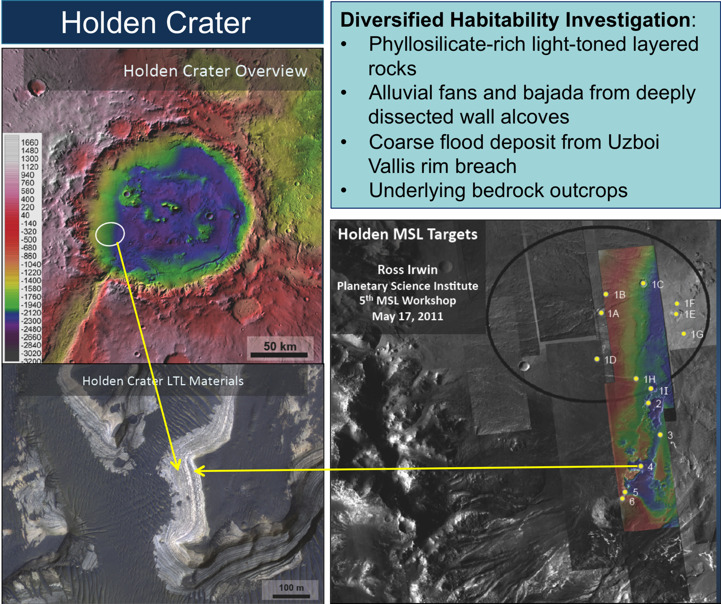
Reference Site: Holden Crater. Description from MSL landing site selection community workshop, Ross Irwin, John Grant, James Wray

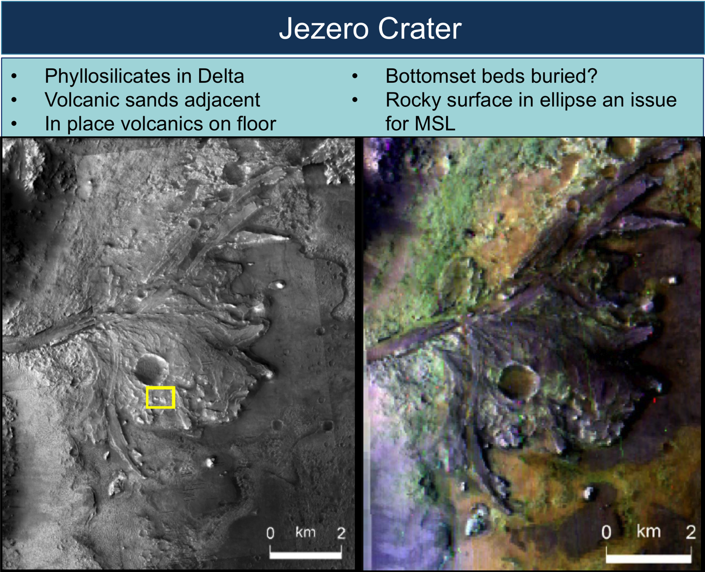
Reference Site: Jezero Crater. Fassett, Ehlmann, Harvey and others

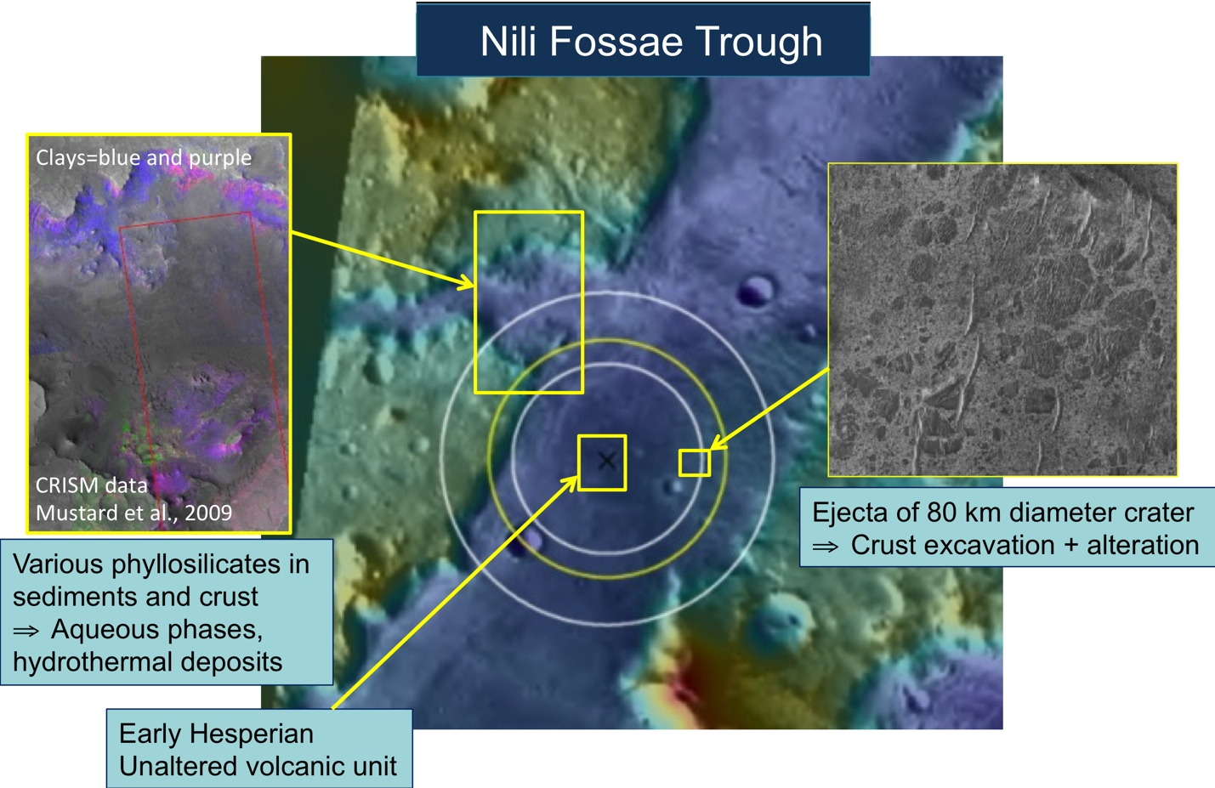

Reference Site: Nili Fossae Trough. After Mustard et al.
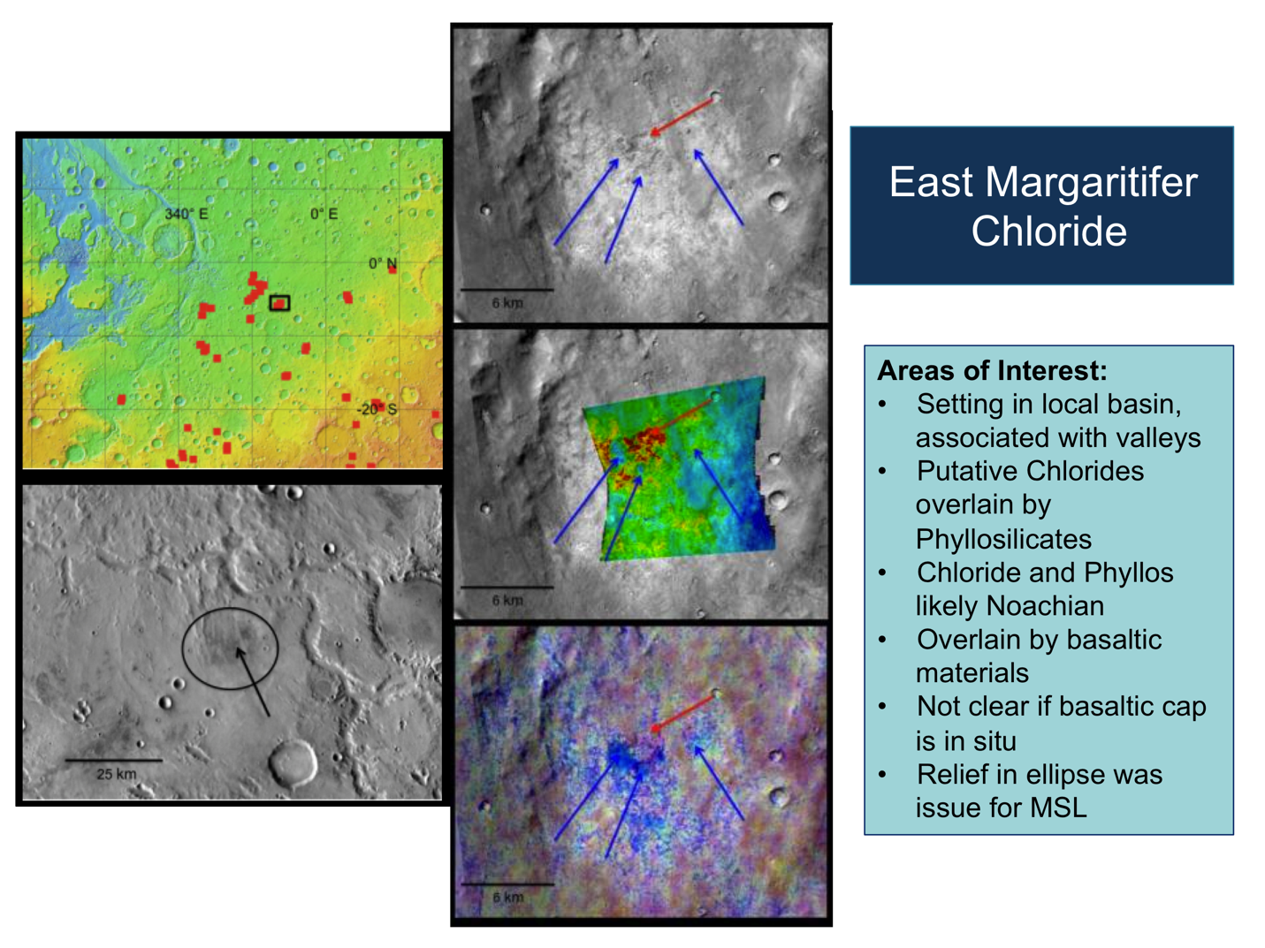

Reference Site: East Margaritifer Chloride. From presentation by Christensen et al. 5/2010

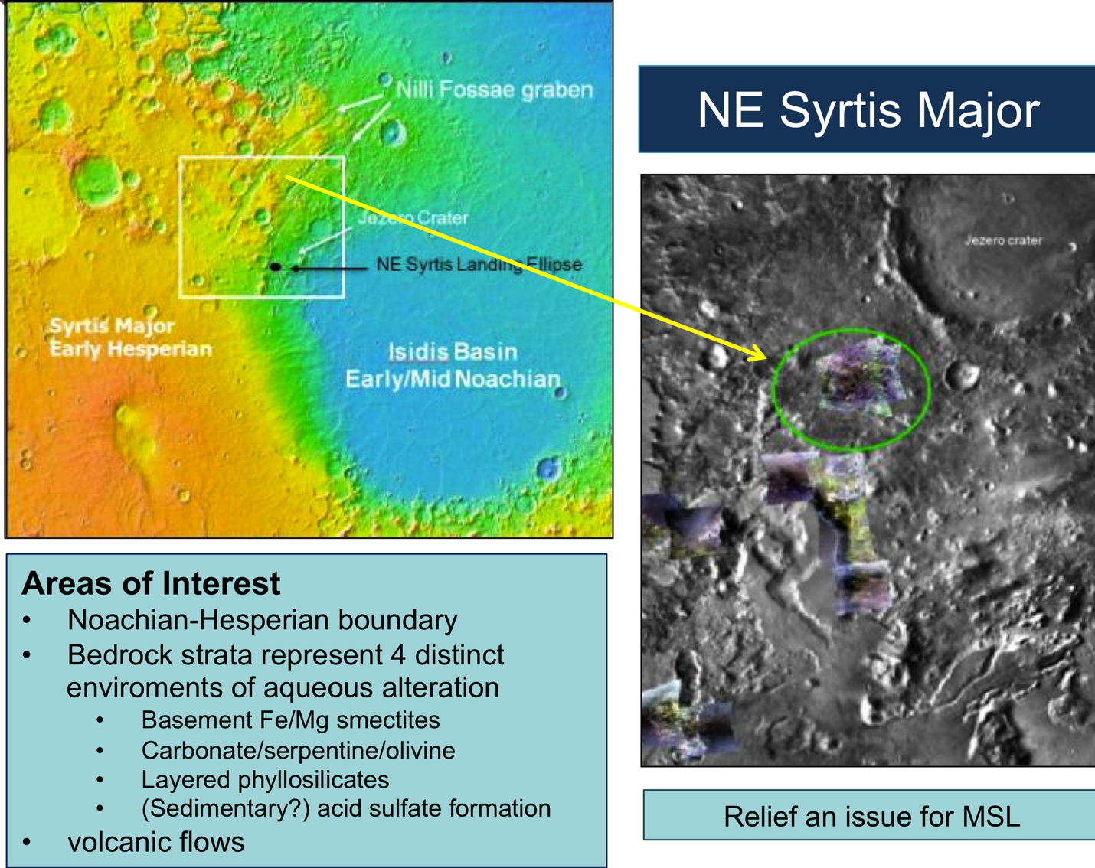

Reference Site: NE Syrtis Major. From Presentation by Mustard, Ehlmann, and Skok 5/2010

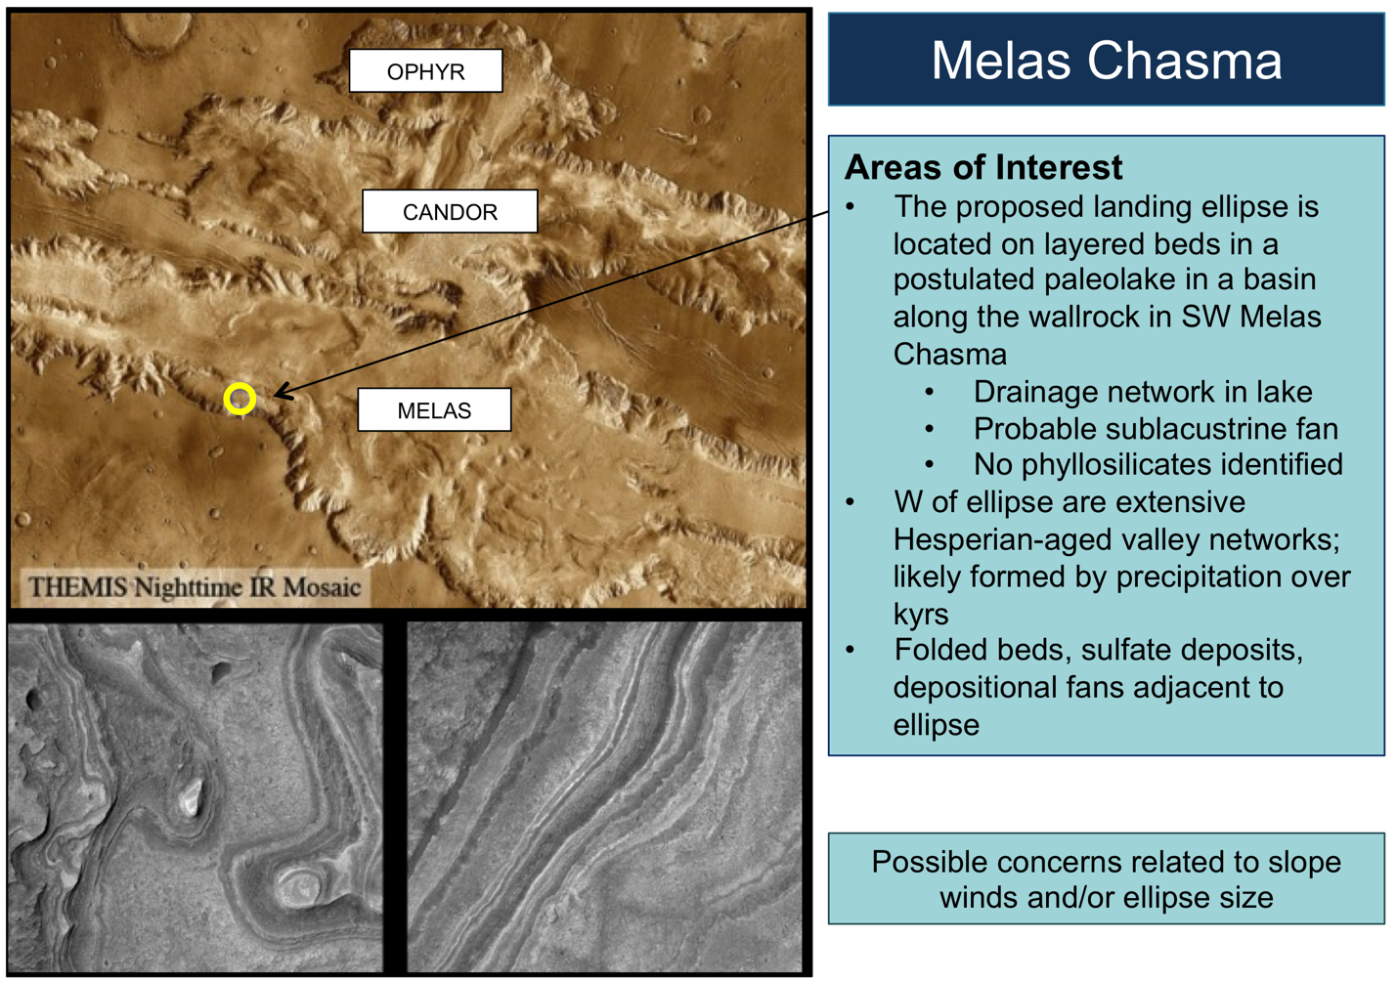

Reference Site: Melas Chasma. After Weitz, Quantin, Metz et al

Appendix 8: Surface Operations Scenario Modeling

Model Overview and Assumptions
The conclusions presented in Section 7 were informed by the results of a detailed model of the Mars 2020 mission operations system. This model incorporates estimates of the flight system and ground system capabilities based on the Mars Exploration Rover (MER) and Mars Science Laboratory (MSL) missions to Mars.
The model makes certain assumptions about the characteristics of the Mars 2020 mission, including:
- The surface mission lifetime would not exceed 1 Martian year (669 sols).
- The mission would use MSL-like communications and operations strategies; specifically:
  - Fixed local mean solar time X-band windows in the Martian morning for commanding (uplink) communications.
  - Two UHF relay orbiter passes per Sol; with the UHF pass in the Martian afternoon having sufficient volume for decisional data and low latency for return of the data to Earth.
  - Eight-hour ground planning cycle, which includes analysis of received telemetry; determination of plans for the next sol; generation, validation, and review of command products to implement the next sol’s plan; and delivery of command products for radiation. For comparison, MSL’s current planning cycle duration is 10 hours; at landing, MSL’s cycle duration was 16 hours.
  - Some fraction of the mission would be performed in “Mars Time” operations. So-called “Mars Time” assumes that scheduling of the ground data analysis and uplink planning cycle follows the procession of the receipt of telemetry (downlink) and the deadline for commanding (uplink) as they “walk” around the Earth clock due to the phasing of Earth time and Mars time. This scheduling strategy yields the highest number of sols that permit reactive operations.
- The “commissioning” phase, during which the various rover subsystems would be checked out and science instruments would be commissioned, is assumed to take 60 sols. By way of comparison, MSL’s commissioning phase consisted of 25 sols of rover subsystem checkouts before the rover was ready to initiate nominal science operations. In addition, first-time activities required additional scrutiny, resulting in reduced science efficiency for those periods. First time activities on MSL included first use of the scoop, first use of the CHIMRA, first use of the drill, among others.
- The margin policy is that 25% of the mission duration is “unproductive”, i.e., does not directly contribute towards meeting science objectives (This is consistent with MSL’s operational margin policy at launch). The margin is intended to cover:
  - Communication problems (e.g., outages in the Deep Space Network, relay asset safing, long latencies);
  - Non-determinism of in situ operations (including repeating operations that failed);
  - Increases in activity time or energy needs during operations;
  - Increases in the time required for activities due to data volume constraints (which are not currently included in the model);
  - Increases in time or energy required for activities due to better understanding of rover and instrument design during development;
  - Flight software uploads during surface operations;
  - Anomaly diagnosis and resolution.
- No operations occur during the period subtending < 2° Sun-Earth-Mars angle (i.e., Solar Conjunction, which spans 11 sols during the Mars-2020 Primary Mission).
- The rover and cache do not have to be at a specific location, for eventual retrieval and return to Earth, at the end of the Primary Mission. That is, no time would be spent driving the cache to a specific location; the entire Primary Mission period would be available for addressing the mission’s science objectives, including sample caching.
- The cache would be capable of holding a minimum of 31 samples, a minimum of 2 of which are blanks that would be cached during the Commissioning phase of the mission.

The model divides the mission into three major activities – traverse (driving), fieldwork, and coring/caching.

Traverse Model (Sols spent driving)
Notionally in the model, the activities contained within a single “driving sol” consist of:
- Driving
- Post-drive contextual imaging and mineralogy measurements
- Post-drive go-and-touch fine-scale imaging and close-up fine scale elemental chemistry measurements.
Note: “Go-and-touch” capability has been demonstrated on MER. Parts of this capability—specifically, the ability to track and traverse to visual targets autonomously, and the ability to analyze workspace images for hazards and autonomously unstow the arm—are either currently or planned to be part of the MSL flight software before the conclusion of MSL’s prime mission.
There are four different types of driving Sols in the model, based on the type of terrain and the proximity to scientific targets.
Long-Traverse Sols are the “workhorse” drive sols for covering distances between Regions of Interest (ROI’s), and from landing to the first ROI. They include:
- Traverse an average of 100 m/Sol – which is the current estimate for MSL. (For comparison, MER averaged 59 m/Sol.)
- Mid-drive contextual science imaging and mineralogy measurements.
- Traverse documentation imaging.
- Imaging to support planning of next traverse.
- Opportunistic contextual imaging and mineralogy measurements (as fits into plan).
Terrain-Limited Traverse Sols are just like Long Traverse sols, but cover a shorter distance due to difficult terrain. They include:
- Traverse up to 50 m (MER averaged 23 m/short traverse sol).
- Traverse documentation imaging.
- Imaging to support planning of next traverse.
- Opportunistic contextual imaging and mineralogy measurements (as fits into plan).
Time-Limited Traverse Sols traverse a shorter distance than Long Traverse sols, because time is needed for remote observations in order to characterize the ROI being approached. They include:
- Traverse up to 50 m (MER averaged 23 m/short traverse sol).
- Traverse documentation imaging.
- Imaging to support planning of next traverse.
- Contextual imaging panorama.
- Contextual mineral measurements.
- Contextual imaging of candidate contact targets.
Target-Limited Traverse Sols are shorter traverses because targets for approach can only be selected within a limited range due to instrument fields of view. These sol types contain:
- Traverse up to 20 m (end with target within instrument workspace).
- Traverse documentation imaging.
- Imaging to support planning of next traverse.
- Imaging to support planning of in-situ science.
Note that Target-Limited Traverse Sols are not counted as separate sols within the current model; instead the model assumes “go and touch” autonomy on the rover (which has been demonstrated on MER and parts of which are already or are planned to be included in the MSL flight software by the conclusion of its prime mission), which effectively combines these “approach” activities into the fieldwork sol types.

Fieldwork Model (Sols spent conducting fieldwork)
The focus in this modeling effort has been on determining the robotic actions necessary to characterize the geology to an extent that it would be possible to select materials for coring and caching. As articulated elsewhere in this report, the measurements necessary to cache samples are the same as the measurements required to fulfill Objectives A and B. These robotic actions are combined into the so-called “fieldwork” section of the mission duration breakdown, and can be defined as the activities necessary to understand the geology, habitability, and biosignature detection and preservation potential of a site.
In the model, “fieldwork” consists of:
- Contextual imaging measurements.
- Contextual mineralogy measurements.
- Targeted fine scale imaging, mineralogy, close-up fine scale elemental chemistry, and organic detection measurements.
- Rock surface brushing and abrading.
- Re-do (on abraded/brushed surface) of fine scale imaging, mineralogy, close-up fine scale elemental chemistry, and organic detection measurements.
Depending on the geological complexity and scientific richness of a site, this process would be iterated a number of times.
There are three sol types in the fieldwork model: Simple Surface Contact, Abraded Contact, and Context Measurement. In the model, it was assumed that there was a set number of each of the three fieldwork sol types per core acquired and cached; the ratios of each sol type assumed was determined from the E2E-iSAG (2011) findings, which were in turn derived from experiences with Spirit and Opportunity. The ratios used were as follows:
- 4.5 Context Measurement sols per core collected and cached.
- 5 Simple Surface Contact sols per core collected and cached.
- 2 Abraded Contact sols per core collected and cached.
Simple Surface Contact Sol is an example approach for initial characterization of a target, which may lead to a decision to prepare the surface (by brushing or abrading it) for acquiring the 2020 rover’s fine-scale imaging, fine-scale mineralogy, close-up fine scale elemental chemistry, and organic detection measurements. This sol type includes:
- Context imaging.
- Fine scale image mosaic of target.
- Overnight close-up fine scale elemental chemistry measurement (which is not considered decisional data for the next sol’s plan).
To proceed to the next (Abraded) sol type in operations, ground-in-the-loop would be needed for science selection of the abrasion target, and to construct the command sequence for the robotic arm to perform abrasion on the selected target.
Abraded Contact Sol is an example approach (brushing would be another) for preparing a rock surface and then acquiring key fine-scale imaging, fine-scale mineralogy, close-up fine scale elemental chemistry, and organic detection measurements. This sol type includes:
- Abrade target patch.
- Context imaging of abraded patch.
- Context mineral measurement of abraded patch.
- Fine-scale image mosaic of abraded patch.
- Fine-scale organic, mineralogy, and elemental chemistry measurements of abraded patch.
- Overnight fine-scale fine scale elemental chemistry measurement.
For the two straw payloads (Blue and Orange) considered for the current model, the assumption was that the time required to both acquire all of the decisional data and return it to Earth took longer than a single sol. Thus, this “sol type” was assumed to take 4 sols for the Blue straw payload, and 3 sols for the Orange straw payload (both described in Table 5-3).
To proceed to the coring/caching sol type in operations, ground-in-the-loop would be needed for science selection of where to acquire the core, and to construct the command sequence for the robotic arm to perform coring and caching of the selected target.
Context Measurement Sol is a sol in which context measurements—which require neither arm motion nor mobility—are collected to aid in future fine scale context measurements or target selection. This sol type could be planned without decisional data; thus, it can be (and on MER and MSL is) used during sols when reactive operations (i.e., ground-in-the-loop) is not possible (known as “restricted sols”) due to, for example, communications/ground schedule phasing. In the model (with the current communications and operations schedule assumptions), this sol type is not counted separately in the number of sols for fieldwork, since it replaces sols that would otherwise be “unproductive” due to restricted sols. This sol type includes:
- Targeted context imaging and mineralogy measurements.

Coring and Caching Model (Sols spent coring and caching)
Notionally in the model, “coring and caching” consists of
- Coring.
- Post-coring context and fine-scale imaging of the borehole and tailings.
- Post-coring contextual, fine-scale and close-up mineralogical, organic and fine scale elemental chemistry measurements of the borehole and its tailings.
- Insertion of encapsulated core sample into cache.
There is only a single Core and Cache Sol type. On that sol the following activities are performed:
- Acquire core sample.
- Cache sample.
- Visual documentation imaging.
- Fine-scale image measurement of core site.
- Context mineral measurement of core site.
Of note, the model does not include any specific provisions for sample change-out (i.e., removal and replacement of a cached sample). The model also assumes that the core sample is not examined by the science instruments before it is encapsulated and cached. The model further does not assume that any cores will be extracted which are not cached.

Free Parameters
Given the assumptions described above, there is some flexibility to adjust the following aspects of the scenario in order to meet the science objectives (which correspond to different points in the triangular trade-space in Figure 7-2):
- The total traverse distance.
- Adjustments to the E2E-iSAG (2011) ratios of the fieldwork sol types per sample (expressed as number of cores per “unit” of fieldwork).
- The number of cached samples.

In addition, the model permits adjustments to many of the assumptions described above, which was used to help assess sensitivity to changes in the assumptions. For example:

- The long-traverse rate (expressed as average number of meters traversed per long traverse sol).
- The number of Sols spent working Mars time.
- The number of Sols spent working 7-day Earth time operations.
- The number of Sols spent working 5-day Earth time operations (includes holidays off).

Model results

In addition to the point design (Figure 7-4) from the interior of the triangular trade-space illustrated in Figure 7-2, scenario models were built for cases illuminating the points of the trade-space: maximizing, in turn, fieldwork, driving, or coring/caching. These scenario models are shown here:

- More Fieldwork (and less driving and coring/caching)
The following concept collects 5 cores from 4 Regions of Interest separated by 3 km total in 1 Mars year. This assumes a MSL operations model (Mars time through Sol 90, 7-day ops through Sol 180, 5-day ops afterwards), and no augmentations to MSL baseline capability.

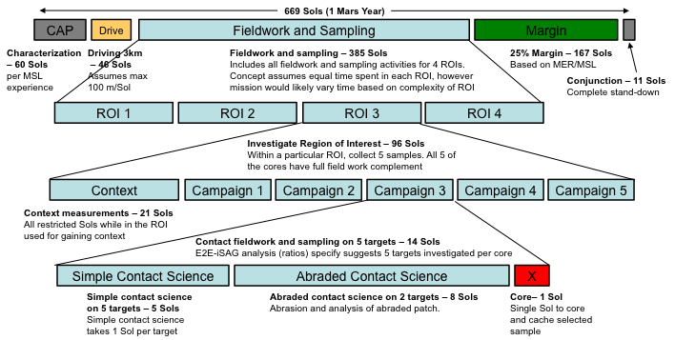

- More Driving (and less fieldwork and coring/caching)

The following concept collects 4 cores from 5 Regions of Interest separated by 15 km total in 1 Mars year. Assumes MSL operations model (Mars time through Sol 90, 7-day ops through Sol 180, 5-day ops afterwards), and no augmentations to MSL baseline capability.

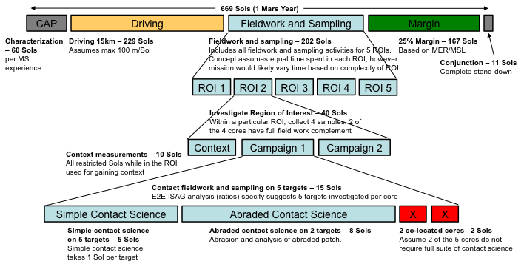

- More Coring/Caching (and less driving and fieldwork)

The following concept collects 8 cores from 4 Regions of Interest separated by 5 km total in 1 Mars year. Assumes MSL operations model (Mars time through Sol 90, 7-day ops through Sol 180, 5-day ops afterwards), and no augmentations to MSL baseline capability.

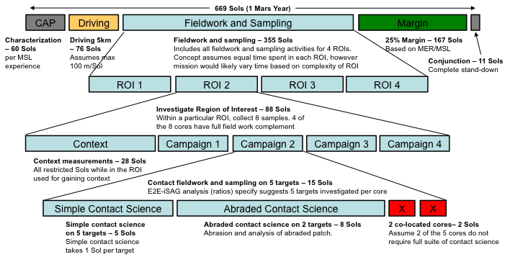

Appendix 9: Errata

Aug, 1 2013 Errata Sheet
For the document and appendices titled:
Report of the Mars 2020 Science Definition Team
Mustard, J.F., M. Adler, A. Allwood, D.S. Bass, D.W. Beaty, J.F. Bell III, W.B. Brinckerhoff, M. Carr, D.J. Des Marais, B. Drake, K.S. Edgett, J. Eigenbrode, L.T. Elkins-Tanton, J.A. Grant, S. M. Milkovich, D. Ming, C. Moore, S. Murchie, T.C. Onstott, S.W. Ruff, M.A. Sephton, A. Steele, A. Treiman
The report dated July 1, 2013 (Mars_2020_SDT_Report_Final.pdf) has been updated to repair the following errors. All corrections are included in the electronic file posted on Aug 1. This errata sheet should be added to versions printed before that.
Page 37: Update phrasing of Finding B-9 to recover text corrupted during the editing process:
Full evaluation of the potential for biology must include the ability to detect multiple categories of PBS in situ and characterize their geologic context (including habitability and biosignature preservation potential). A thorough characterization and definitive discovery of Martian biosignatures would require analyses of samples returned to Earth.
Figure 3-11 moved to page 37 from page 35.
Page 44: duplicate Finding B-12 removed; content identical to Finding B-11 on page 41.
Page 80: Correct Table 5-3 (strawman payload) to match Finding 8-14 by reporting Range Trigger as Threshold.
Page 93: Correct Figure 6-4 to be consistent with Figure 6-3 by removing phrase “MSL quality”
Page 93: Corrected reference from Anderson et al 2012 to Anderson et al 2012a; page 110 corrected reference from Anderson et al 2012 to Anderson et al 2012 b.
Page 94: Corrected reference from MSR-SSG (2005) to MSR-SSG-II (2005); OCSSG (2004) to OCSSG (2003)
Reference list updated with the following missing references:
Anderson, M. S., I. Katz, M. Petkov, B. Blakkolb, J. Mennella, S. D’Agostino., J. Crisp, J. Evans, J. Feldman and D. Limonadi. “In Situ Cleaning of Instruments for the Sensitive Detection of Organics on Mars.” Review of Scientific Instruments 83, 105109 (2012a). DOI 10.1063/1.4757861
MSR-SSG-II (2005), G. J. MacPherson (Chair), D. Bogard, M. Coleman, A. Colman, J. Crisp, J. Eiler, M. Golombek, A. Haldemann, B. Jakosky, L. Leshin, T. Lowenstein, P. Mahaffy, S. Mukherjee, T. Onstott, D. Papanastassiou, L. Pratt, C. Shearer, D. Sumner, A. Vasavada, A. Zent. “The First Mars Surface-Sample Return Mission: Revised Science Considerations in Light of the 2004 MER Results.” Unpublished white paper, 68 p., in Appendix III of ND-SAG (2008), "Science Priorities for Mars Sample Return." Astrobiology 8, no. 3 (2008): 489-535. posted March 2008 by the Mars Exploration Program Analysis Group (MEPAG) at http://mepag.jpl.nasa.gov/reports/ndsag.html.
OCSSG, (2003) P.R. Mahaffy, D.W. Beaty, M. Anderson, G. Aveni, J. Bada, S. Clemett, D. Des Marais, S. Douglass, J. Dworkin, R. Kern, D. Papanastassiou, F. Palluconi, J. Simmonds, A. Steele, J.H. Waite, A.P. Zent, Report of the Organic Contamination Science Steering Group. Unpublished white paper, http://mepag.jpl.nasa.gov/reports/index.html
The updated electronic version can be found at http://mepag.jpl.nasa.gov/reports/mep_report.html

