Appendix 5 to the report ‘Planning for Mars Returned Sample Science: Final report of the MSR End-to-End International Science Analysis Group (E2E-iSAG)’:
Reference Landing Sites

A report requested by the Mars Exploration Program Analysis Group (MEPAG)

July 31, 2011

Recommended bibliographic citation:

MEPAG E2E-iSAG (2011) Planning for Mars Returned Sample Science: Final report of the MSR End-to-End International Science Analysis Group (E2E-iSAG); Appendix 5—Reference Landing Sites, 14 pp., posted March, 2012 by the Mars Exploration Program Analysis Group (MEPAG) at http://mepag.jpl.nasa.gov/reports/.
Or:
Mangold, N., Grant, J., C. Allen, A. Allwood, R. Barbieri, D. Beaty, P. Boston, M. Carr, M. Grady, V. Heber, C. Herd, B. Hofmann, P. King, S. McLennan, G.G. Ori, A. P. Rossi, F. Raulin, S. Ruff, M. Sephton, B. Sherwood Lollar, S. Symes, and M. Wilson (2011) Planning for Mars Returned Sample Science: Final report of the MSR End-to-End International Science Analysis Group (E2E-iSAG); Appendix A—Reference Landing Sites, 14 pp., posted March, 2012, by the Mars Exploration Program Analysis Group (MEPAG) at http://mepag.jpl.nasa.gov/reports/.

Inquiries regarding this report should be directed to John Grant (grantj@si.edu) or Nicolas Mangold (nicolas.mangold@univ-nantes.fr), landing site experts for the E2E team, or David Beaty (David.Beaty@jpl.nasa.gov).

JPL Document Review Clearance CL#12-0889

5.1 Establishing a Reference Landing Site Set

Meeting the Mars science community’s objectives of MSR is heavily dependent on whether there are places on Mars that host the desired materials for sampling and whether a rover can access them. In order to establish the potential for at least one site on Mars to satisfy the highest priority MSR science objectives, we initiated a process to look for reference candidate landing sites that could assist in framing the engineering requirements needed to access them. Reference landing sites are not intended to serve as a short list of candidate sites for a sample return mission and have no preference relative to any other sites that might eventually be proposed. The search for these reference landing sites began with a review of the ~60 landing sites proposed for the MSL mission (Grant et al. 2010) and ~25 landing sites proposed for possible future missions and possessing varying objectives. Although the overall objectives for the 2018 mission concept differ from those of these other missions, they were viewed as a good starting point because of some overlap in science objectives and because many of the sites considered for other missions are partially to nearly completely covered by high resolution spatial and spectral resolution data (e.g., from MRO, MEx, and Odyssey). We chose sites with an eye toward providing a range of characteristics for both science and engineering that could be used to help define landing and roving requirements. Sites with substantial existing image coverage were favored because such data enable meaningful engineering studies of the possible 2018 EDL system requirements for accessing the eventual landing site.
When evaluating the preliminary list of candidate sites for 2018, a sub-group of the E2E focused on four threshold criteria listed in Table 9. These threshold criteria relate primarily to the inferred depositional setting and age of the rocks considered to be of highest priority for sample return and include the strong desire for the presence of igneous rocks. Additional qualifying criteria were identified, ranging from morphologic evidence of setting to the age of volcanic units to be accessed (Table 9). However, these were not included in identification of reference sites because there was concern that too many criteria would overly constrain the number of viable sites. Because the reference sites are not intended to serve as a short list for an actual mission, the more relaxed constraints allowed us to define reasonable science and engineering criteria. A more rigorous and open landing site selection process would follow for an actual mission. We anticipate that once formal criteria are defined, a call for candidate sites would be made to the science community, initiating a comprehensive site selection process based on those employed for MER and MSL (e.g., Grant et al., 2004; 2010).
The reference sites that emerged from this activity include: five candidates studied extensively for the MSL landing site; the MER landing site in Gusev crater; and an additional site at a relatively high northern latitude. We assumed a landing ellipse comparable to that of MSL (~20x25 km). Each of the sites appears to encompass all of the threshold science criteria and define a latitude range of approximately 35°N to 15°S, elevations ranging from ~0.5 km (MOLA) and lower, and a variety of relief (much of which was viewed as unacceptable for MSL). A description of each of the reference sites follows.

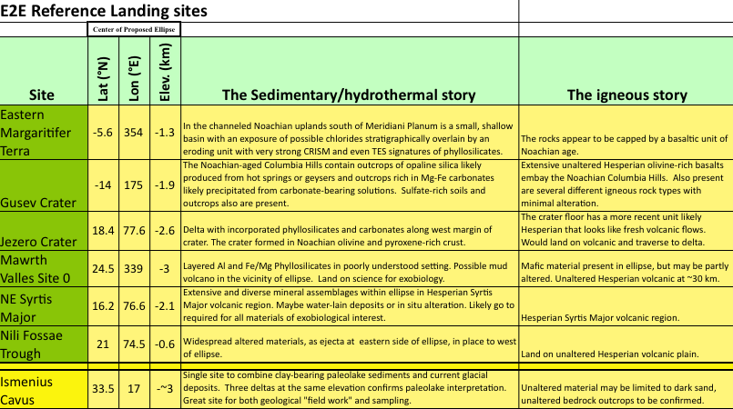

Table 1: Table of potential landing sites

Fig. A6-1: Localization of sites proposed for MSL selection with the seven reference sites discussed below indicated with arrows.

Eastern Margaritifer Terra
Location: 5.6°S, 353°E, -1 km. Eastern Margaritifer Terra is located in the channeled highlands of likely Noachian age, south of Meridiani Planum (Fig. A6-2).
Habitability Context: The small basin where the ellipse is located contains phyllosilicates, and possibly chlorides (Osterloo et al., 2008). It is located west of ancient valley networks cutting into the bedrock with a phyllosilicate-bearing unit, which overlies a chloride-bearing unit at the base (Christensen et al., 2008). These units are reachable inside the ellipse, but may require a traverse from out of the ellipse to the east if hazards preclude landing in the ellipse.
Igneous context: The sequence of units exposed by erosion in this basin has an unaltered, basaltic unit at the top of the sequence.
Concerns: Basaltic capping material may be windblown material or impact ejecta but not in place lava flows. Landing hazards at Margaritifer are significant as are trafficability concerns (Fig. A6-2):

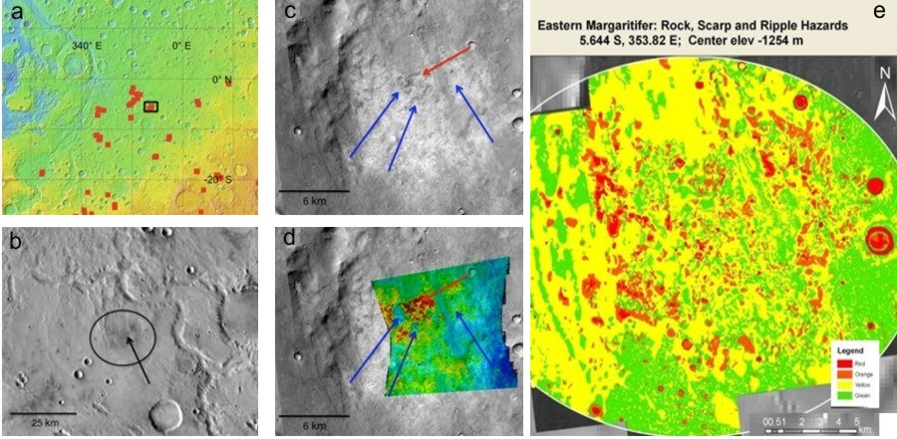
Fig. A6-2: (a) Location of Eastern Margaritifer Terra ellipse in the equatorial regions of Mars. (b) Location of the ellipse in the plateau dissected by valley networks (c) Morphology and TES mineralogy (d) showing chloride deposits in bright terrain (after Christensen et al., 2008). (e) Rock/scarps and ripple dunes combined hazards at Margaritifer Terra (after Golombek et al., 2008).

Gusev Crater
Location: 14.3S, 175E, -2 km. Gusev is a 160 km diameter crater located south of Apollinaris Patera in the Noachian highlands, at the mouth of Ma’adim Vallis (Fig. A6-3).
Habitability context: Within the Columbia hills in the center of Gusev, Spirit encountered soil and outcrops of nearly pure opaline silica, a clear manifestation of hydrothermal processes (e.g., Squyres et al., 2007, 2008, Yen et al., 2008) and entirely consistent with a hot spring and/or geyser origin (Ruff et al., 2011). Outcrops containing as much as 34% by weight Mg-Fe carbonate also were identified, perhaps representing another manifestation of hydrothermal processes (Morris et al., 2010). Sulfate-rich soils are yet another indication of the role of water. Thus, Gusev crater has proved to be mineralogically diverse despite an apparent lack of evidence for the paleolake that motivated its selection as a MER landing site.
Igneous context: Columbia Hills are surrounded by early Hesperian, olivine-rich flood basalts similar to lunar mare (Greeley et al., 2005, Arvidson et al., 2006) with well constrained age in the Early Hesperian. More diversity and older igneous rocks are also reported inside the Columbia Hills (e.g. Mc Sween et al., 2006).
Concerns: Rocks for habitability are “go to”. Latitude near -15° quite south for the 2018 mission.
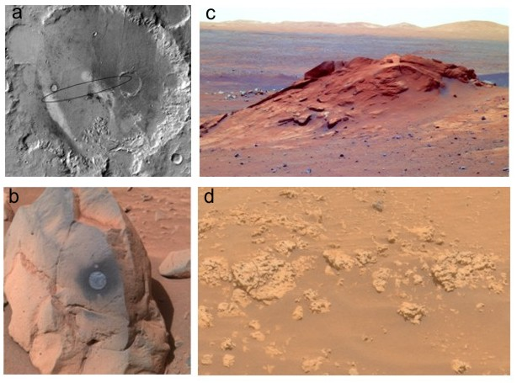
Fig. A6-3: (a) Gusev crater with Themis daytime IR mosaic (Milam et al., 2003) (MER-Spirit ellipse in black). (b) Olivine-bearing basalts. (c) Comanche rock carbonate outcrops. (d) Home Plate opaline silica outcrop.

Jezero crater
Location: 18°N, 78°E, -3 km. Jezero is a 50 km diameter crater located east of Nili Fossae, northwest of the Isidis basin (Fig. A6-4).
Habitability context: Two valleys enter the crater having deposited 50 m thick fans interpreted to have formed inside a lake (Fassett and Head, 2005). An outlet at the eastern side of the crater also favors an open basin system with a lake. The fans contain hydrated minerals and possibly carbonates and would have collected material from the altered highlands (Ehlmann et al., 2008a, 2008b).
Igneous context: The crater floor contains mafic minerals showing rough textures consistent with Hesperian age volcanic flows. Olivine-bearing material present regionally may be accessible after traverse.
Concerns: Crater floor mafic material may or may not be in place. The rocky surface in ellipse was an issue for MSL.
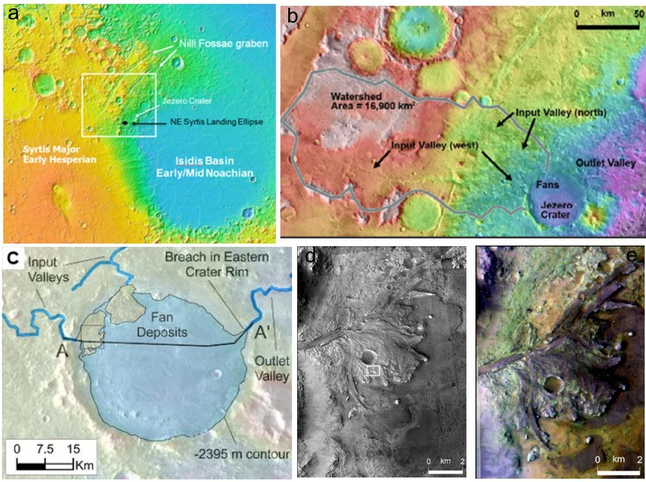
Fig. A6-4: (a) Regional map of Syrtis Major-Nili Fossae-Isidis basin region showing Jezero at the edge of the Isidis impact (b) Watershed of the two input valleys leading to Jezero crater (Fasset and Head, 2005). (c) Geomorphic map of the two fans and the input and outlet valleys (Fasset and Head, 2005), (d)and (e) Close-up over the southern fan with phyllosilicates in purple color and carbonates in green (Ehlmann et al., 2008).

Mawrth Vallis
Location: 25°N, 339°E, -3 km. Mawrth vallis is an outflow channel located at the edge of the highlands close to the dichotomy boundary in the northern hemisphere (Fig. A6-5). The site selected here occurs on the highland plateau inside a Noachian unit.
Habitability context: The Mawrth Vallis region is an area displaying evidence for substantial alteration, mainly in the form of phyllosilicates (e.g., Poulet et al., 2005, Loizeau et al., 2007, 2010, Bishop et al., 2008), which is considered of high interest for understanding early Mars environment and its astrobiological potential (Michalski et al., 2010). Layered materials bearing Al-clays and Fe/Mg clays crop out inside the proposed site, with high abundances (Poulet et al., 2008), likely related to pedogenetic or diagenetic processes at or close to the surface (Loizeau et al., 2007, Michalski et al., 2010). A dome interpreted as a possible mud volcano is present in the vicinity (Loizeau et al., 2010).
Igneous context: Igneous materials are present inside the ellipse as undetermined mafic signatures in the darkest material (Poulet et al., 2008), and Hesperian age volcanic flows in the western side of Oyama crater that are reachable after a 20-30 km long traverse.
Concerns: Mafic minerals inside ellipse may not be unaltered. Reaching Oyama floor would be a long traverse. Terrain likely rougher than that of the ellipse proposed for MSL (east of Oyama crater).
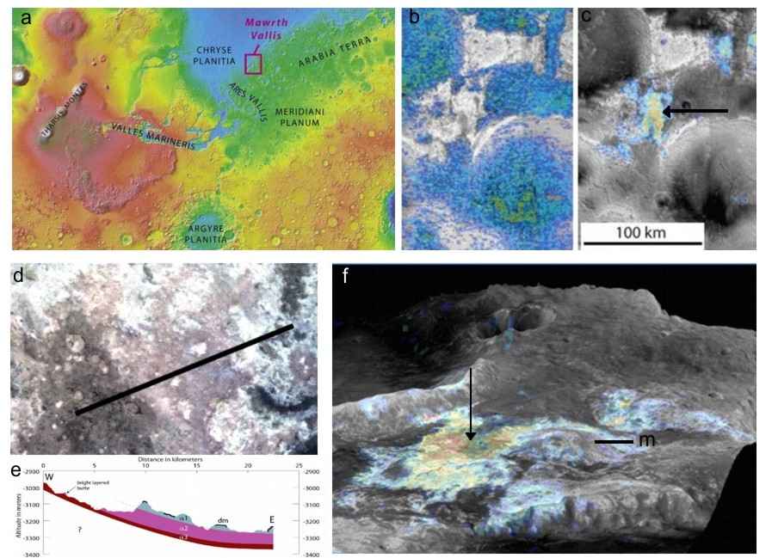
Fig. A6-5: (a) Location of Mawrth Vallis region close to the dichotomy boundary. OMEGA map (from blue to red) of pyroxene (b) and hydrated minerals (c) of interest for the selected site (with arrow) (from Loizeau et al., 2007). (d) HRSC color image of the phyllosilicate unit with corresponding cross-section (e) showing the upper bluish unit corresponds to Al-bearing phylloslicates, bright reddish unit to Fe/Mg bearing phyllosilicates and the darker unit contain pyroxene minerals mixed with hydrated minerals, corresponding to partially altered bedrock. (f) A 10 km in diameter dome (m) located west of the targeted area could correspond to a mud volcano.
Nili Fossae Trough
Location: 21°N, 75°E, -0.6 km. Nili Fossae Trough is located on Early Hesperian volcanic flows on the floor of the main Nili graben (Fig. A6-6a).
Habitability context: The site contains phyllosilicates in both layered and massive units (Mustard et al., 2007, 2009, Mangold et al., 2007). Phyllosilicates in the crust are interpreted as hydrothermal alteration (Mangold et al., 2007, Mustard et al., 2009). Local kaolinite outcrops could correspond to weathering episodes (Ehlmann et al, 2009). More diversity is accessible east of the ellipse within the ejecta breccia of the crater Hargraves, which enables a sampling of altered crustal rocks though not in place (Fig. A6-6).
Igneous context: Early Hesperian volcanic flows are accessible in the ellipse, that are well defined and devoid of alteration (Mangold et al., 2007). Pieces of unaltered igneous rocks are also found in the crustal outcrops (Mustard et al., 2009).
Concerns: The high elevation (-0.6 km) and rough terrain are challenges for this site.
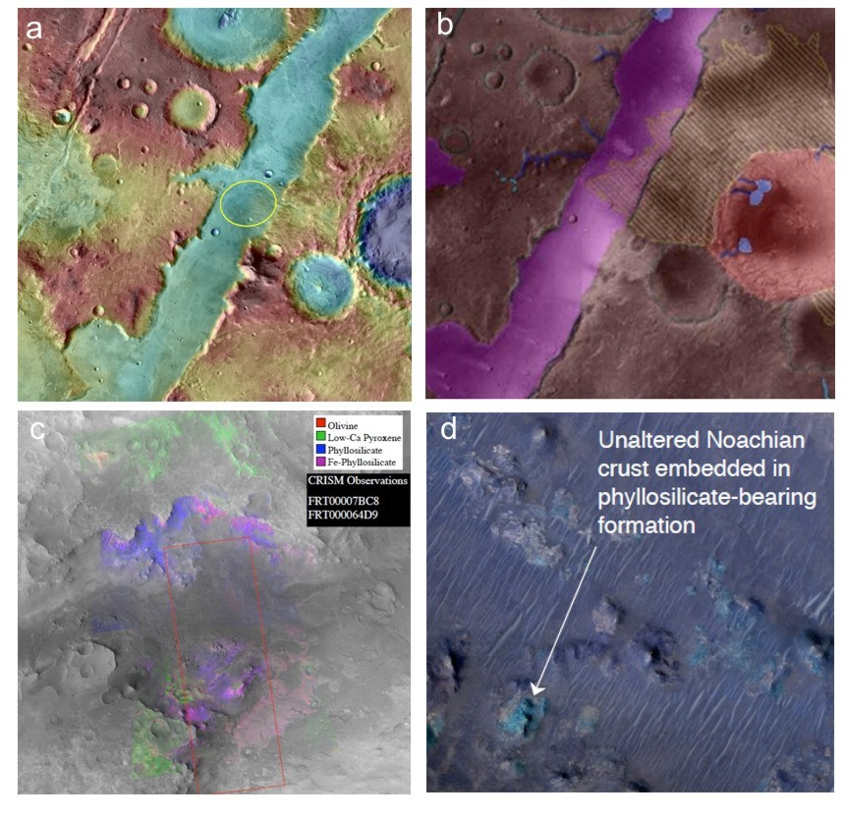
Fig. A6-6: (a) Nili Fossae in Themis image with topography in color. Ellipse in yellow was proposed for MSL. (b) Geologic map of the same area (from Mangold et al. 2007). (c) CRISM data over the canyon outlet north of the ellipse (Mustard et al., 2009). (d) HiRISE close-up of altered terrain containing pieces of unaltered mafic bedrock (Mustard et al., 2008).

Northeast Syrtis Major
Location: 16°N, 77°E, -2 km. This site is located at the boundary between the Hesperian plains of Hesperia Planum and the altered crust of Nili Fossae region (Fig. A6-7a).
Habitability context: Presence of highly altered rocks, locally in layered deposits (Fig. A6-7). Sulfates may exist inside the layered material and carbonates are present in the altered olivine-bearing unit (Ehlmann et al., 2008, 2009, Mustard et al., 2007, 2009). This site has a well-defined stratigraphy with potential cross section from the Hesperian to the Noachian terrains (Ehlmann et al., 2008).
Igneous context: Early Hesperian volcanic flows may be after a drive, but most of the sulfates, phyllosilicates, and carbonates should be accessible within the proposed landing ellipse. Laves to the southare well defined and devoid of alteration (Mangold et al., 2007, Ehlmann et al., 2009).
Concerns: The relative rough relief within the region was a concern for MSL selection and made it difficult to place an ellipse viewed as safe relative to other MSL final candidate sites. Outcrops for astrobiological interest are land on, whereas volcanic are “go to” and associated with a potentially difficult traverse.
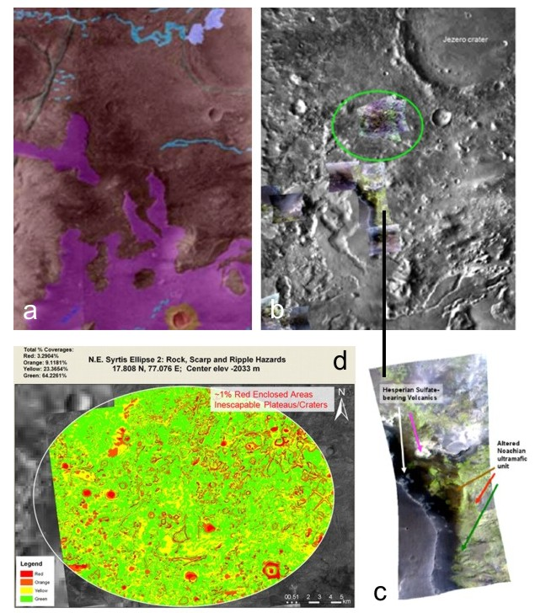
Fig. A6-7: (a) geologic map of the boundary between Syrtis Major Planum lava flows (purple) and Noachian highlands (brown). (b) THEMIS mosaic with superimposed CRISM data showing diversity in the crust (Ehlmann et al. , 2009). (c) Close-up on CRISM data showing sulfates below the volcanic plains (smooth area to the bottom left) and altered mafic rocks in greenish color.

Ismenius Cavus
Location: 34°N, 17°E, -3 km. Ismenius Cavus is a 60 x 90 km trough in Ismenius Lacus (Fig. A6-8).
Habitability context: This site includes the presence of a paleolake attested to by three delta fans at the same elevation, phyllosilicates on layered deposits on the floor of the trough, and mid-latitude glaciers on its side (Dehouck et al., 2010). The latter may open a unique opportunity to collect in the same mission material from the Early Mars period and from Amazonian ice deposits. Phyllosilicates are found inside lacustrine deposits or bottomsets of the main deltaic fan (Dehouck et al., 2010). Depth of the paleolake would have been 600 m given the elevation of the three delta fans.
Igneous context: Mafic minerals detected inside the site as sand sheets and dunes. The source of sand is unknown, possibly from basaltic scarp of the depression.
Concerns: Presence of in place igneous rocks needs to be demonstrated. It is at high latitude (34°N) that may not be possible for the 2018 mission.
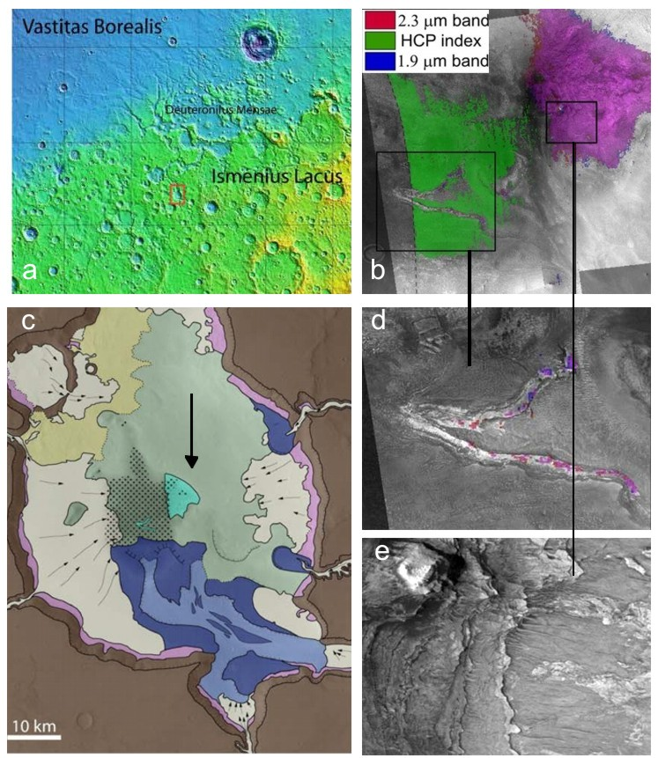
Fig. A6-8: (a) location of Ismenius Cavus south of the ice-rich Deuteronilus Mensae region. (b) Pyroxene (green) and Phyllosilicates (purple) identified at the bottom of Ismenius Cavus. (c) geologic map showing the phyllosilicates (in turquoise color) where landing may be possible. Blue areas correspond to three delta fans, including from Mamers Vallis at the souther edge. (d) and (e) show respectively HiRISE close-up. Figures from Dehouck et al (2010).
References:

Arvidson, R. E., Squyres, S. W., Anderson, R. C., Bell III, J. F., Brückner, J., Cabrol, N. A., Calvin, W. M., Carr, M. H., Christensen, P. R., Clark, B. C., Crumpler, L., Des Marais, D. J., d’Uston, C., EconomouT., Farmer, J., Farrand, W. H., Folkner, W., Golombek, M., Gorevan, S., Grant, J. A., Greeley, R., Grotzinger, J., Guinness, E., Hahn, B. C., Haskin, L., Herkenhoff, K. E., Hurowitz, J. A., Hviid, S., Johnson, J. R., Klingelhöfer, G., Knoll, A. H., Landis, G., Leff, C., Lemmon, M., Li, R., Madsen, M. B., and 25 others (2006), Overview of the Spirit Mars Exploration Rover Mission to Gusev Crater: Landing Site to Backstay rock in the Columbia Hills, J. Geophys. Res. 111, E02S01, doi:10.1029/2005JE002499.
Bishop, J. L. et al. (2008) Phyllosilicate Diversity and Past Aqueous Activity Revealed at Mawrth Vallis, Mars. Science 321, 830. DOI: 10.1126/science.1159699.

Christensen, P.R. Osterloo M., Hamilton V., Edwards C., Wray J;, Anderson F. S, 2008, Aqueous mineral deposits in an ancient, channeled, equatorial terrain, Mars Science Laboratory 2nd workshop, Pasadena.

Dehouck, E., N. Mangold, S. Le Mouélic, V. Ansan, F. Poulet (2010). Ismenius Cavus, Mars: A deep paleolake with phyllosilicate deposits, Planet. Space Sci., 58 (6) 941-946.
Ehlmann, B. L., J. F. Mustard, C. I. Fassett, S. C. Schon, J. W. Head III, D. J. DesMarais, J. A. Grant, and S. L. Murchie (2008a), Clay-bearing minerals and organic preservation potential in sediments from a Martian delta environment, Jezero crater, Nili Fossae, Mars, Nat. Geosci., 1, 355–358, doi:10.1038/ngeo207.

Ehlmann, B. L., and 13 authors (2008b), Orbital identification of carbonate-bearing rocks on Mars, Science, 322, 1828–1832, doi:10.1126/science.1164759.

Ehlmann, B. L., et al. (2009a), Identification of hydrated silicate minerals on Mars using MRO-CRISM: Geologic context near Nili Fossae and implications for aqueous alteration, J. Geophys. Res., 114, E00D08, doi:10.1029/2009JE003339.

Fassett, C. I., and J. W. Head III (2005), Fluvial sedimentary deposits on Mars: Ancient deltas in a crater lake in the Nili Fossae region, Geophys. Res. Lett., 32, L14201, doi:10.1029/2005GL023456.

Golombek, M., (2008), Surface Characteristics Supporting Safety Evals, Third Mars Science Laboratory landing site workshop, Monrovia.
Greeley R., Foing B.H., McSween H.Y., Neukum G., Pinet P., van Kan M., Werner S.C., Williams D.A., Zegers T.E., 2005. Fluid lava flows in Gusev crater, Mars J. Geophys. Res., 110 (E5), E05008.
Loizeau D., N. Mangold, F. Poulet, J.-P. Bibring, A. Gendrin, V. Ansan, C. Gomez, Y. Langevin, B. Gondet, P. Masson, . Neukum (2007) Phyllosilicates in the Mawrth Vallis region of Mars, J. Geophys. Res., 112, E.08S08.
Loizeau, D., N. Mangold, F. Poulet, V. Ansan, E. Hauber, J.-P. Bibring, B. Gondet, Y. Langevin, P. Masson, G. Neukum (2010) Stratigraphy in the Mawrth Vallis region through OMEGA, HRSC color imagery and DTM, Icarus, 205 (2), 396-418.
Mangold, N., F. Poulet, J. Mustard, J-P. Bibring, B. Gondet, Y. Langevin, V. Ansan, Ph. Masson, C. Fassett, J. Head, H. Hoffmann, G. Neukum, (2007) Mineralogy of the Nili Fossae region with OMEGA/MEx data: 2. Aqueous alteration of the crust, J. Geophys. Res., 112, E08S04.
McSween H. Y., Ruff S. W., Morris R. V., Bell J. F., Herkenhoff K., Gellert R., Stockstill K. R., Tornabene L. L., Squyres S. W., Crisp J. A., Christensen P. R., McCoy T. J., Mittlefehldt D. W. and Schmidt M. (2006) Alkaline volcanic rocks from the Columbia Hills, Gusev crater, Mars. J. Geophys. Res. 111, E09S91, doi:10.1029/2006JE002698.
Michalski, J. R., J.-P. Bibring , F. Poulet, D. Loizeau, N. Mangold, E. Noe Dobrea, J. L. Bishop, J. J. Wray, N. K. McKeown, M. Parente, E. Hauber, F. Altieri, F. G. Carrozzo, P. B. Niles (2010) The Mawrth Vallis Region of Mars: A Potential Landing Site for the Mars Science Laboratory (MSL) Mission, Astrobiology 10 (7) 687-703.
Milam, K. A., K. R. Stockstill, J. E. Moersch, H; Y. McSween Jr., L. L. Tornabene, and A.a Ghosh, M. B. Wyatt and P. R. Christensen, (2003), THEMIS characterization of the MER Gusev crater landing site, J. Geophys. Res., VOL. 108, NO. E12, 8078, doi:10.1029/2002JE002023.

Morris, R. V., S. W. Ruff, R. Gellert, D. W. Ming, R. E. Arvidson, B. C. Clark, D. C. Golden, K . Siebach, G. Klingelhöfer, C. Schröder, I. Fleischer, A. S. Yen, S. W. Squyres (2010), Identification of carbonate-rich outcrops on Mars by the Spirit rover, Science, 329(5990), 421-424, doi:10.1126/science.1189667.

Mustard, J. F., F. Poulet, J. W. Head, N. Mangold, J-P. Bibring, S. M. Pelkey, C. Fassett, Y. Langevin, G. Neukum, (2007) Mineralogy of the Nili Fossae region with OMEGA/Mex data: 1. Ancient Impact Melt in the Isidis Basin and Implications for the Transition from the Noachian to Hesperian, J. Geophys. Res., 112, E08S03.
Mustard J.F., (2008), Mineralogic and Morphologic diversity at Nili Fossae trough, Third Mars Science Laboratory landing site workshop, Monrovia.
Mustard, J. F., B. L. Ehlmann, S. L. Murchie, F. Poulet, N. Mangold, J. W. Head, J.-P. Bibring, and L. H. Roach (2009), Composition, Morphology, and Stratigraphy of Noachian Crust around the Isidis basin, J. Geophys. Res., doi:10.1029/2009JE003349.
Osterloo, M.M., et al., Chloride-bearing materials in the southern highlands of Mars, 2008. Science 319: p. DOI: 10.1126/science.1150690.

Poulet, F., J.-P. Bibring, J. F. Mustard, A. Gendrin, N. Mangold, Y. Langevin, R. E. Arvidson, B. Gondet, and G. Gomez (2005), Phyllosilicates on Mars and implications for the early Mars history, Nature, 438, 623–627, doi:10.1038/nature04274.

Poulet, F., Mangold, N., Loizeau, D., Bibring, J.-P., Langevin, Y., Michalski, J., Gondet, B., 2008. Abundance of minerals in the phyllosilicate-rich units on Mars. Astron. Astrophys. 487, L41–L44.

Ruff, S. W., Farmer, J. D., Calvin, W. M., Herkenhoff, K. E., Johnson, J. R., Morris, R. V., Rice, M. S., Arvidson, R. E., Bell III, J. F., Christensen, P. R. and Squyres, S. W. (2011) Characteristics, distribution, origin, and significance of opaline silica observed by the Spirit rover in Gusev crater, Mars. J. Geophys. Res. 116, E00F23, doi10.1029/2010JE003767.
Squyres S. W., Aharonson O., Clark B. C., Cohen B. A., Crumpler L., de Souza P. A., Farrand W. H., Gellert R., Grant J., Grotzinger J. P., Haldemann A. F., Johnson J. R., Klingelhofer G., Lewis K W., Li R., McCoy T., McEwen A. S., McSween H. Y., Ming D. W., Moore J. M., Morris R. V., Parker T. J., Rice J. W., Ruff S., Schmidt M., Schroder C., Soderblom L. A., and Yen A. (2007) Pyroclastic activity at Home Plate in Gusev Crater, Mars. Science 316, 738-742.
Squyres, S. W., Arvidson, R. E., Ruff, S., Gellert, R., Morris, R. V., Ming, D. W., Crumpler, L., Farmer, J., Des Marais, D. J., Yen, A., McLennan, S. M., Calvin, W., Bell, III, J. F., Clark, B. C., Wang, A., McCoy, T. J., Schmidt, M. E. and de Souza Jr., P. A. (2008) Detection of silica-rich deposits on Mars. Science, 320, 1063-1067
Yen, A. S., et al. (2008), Hydrothermal processes at Gusev Crater: An evaluation of Paso Robles class soils, J. Geophys. Res., 113(E06S10), doi:10.1029/2007JE002978.

