Two rovers to the same site on Mars, 2018: Possibilities for Cooperative Science

Prepared by the MEPAG 2-Rover International Science Analysis Group (2R-iSAG):
John Grant (Smithsonian Institution; co-chair), Frances Westall (CNRS, Orléans; co-chair), Dave Beaty (Mars Program Office, JPL/Caltech), Sherry Cady (Portland State University), Mike Carr (U.S. Geological Survey, retired), Valérie Ciarletti (LATMOS-IPSl, Velizy), Angioletta Coradini (INAF, Rome), Anders Elfving (ESA), Danny Glavin (Goddard Space Flight Center), Fred Goesmann (MPI for Solar Sys. Res., Lindau), Joel Hurowitz (JPL/Caltech), Gian Gabriele Ori (IRSPS, Pescara), Roger Phillips (Southwest Research Institute), Chris Salvo (Mars Program Office, JPL/Caltech), Mark Sephton (Imperial College, London), Marguerite Syvertson (JPL/Caltech), Jorge Vago (ESA)

July 10, 2010

Recommended bibliographic citation:

MEPAG 2R-iSAG (2010). Two rovers to the same site on Mars, 2018: Possibilities for Cooperative Science, 46 pp., posted July 21, 2010, by the Mars Exploration Program Analysis Group (MEPAG) at http://mepag.jpl.nasa.gov/reports/
Or:
Grant, J., Westall, F., and the MEPAG 2R-iSAG team (2010). Two rovers to the same site on Mars, 2018: Possibilities for Cooperative Science, 46 pp., posted July 21, 2010, by the Mars Exploration Program Analysis Group (MEPAG) at http://mepag.jpl.nasa.gov/reports/

Inquiries regarding this report should be directed to John Grant (grantj@si.edu), Frances Westall (westall@cnrs-orleans.fr), David Beaty (David.Beaty@jpl.nasa.gov), or Jorge Vago (Jorge.Vago@esa.int).
Executive Summary
Within the framework of the proposed joint NASA/ ESA 2018 mission to Mars, the 2-Rover International Science Analysis Group (2R-iSAG) committee was convened by the Mars Exploration Program Analysis Group (MEPAG) to evaluate the potential for incremental science return through the simultaneous operation at the same landing site of two rovers, specifically ESA’s ExoMars, and a NASA-sourced rover concept designated here as MAX-C. The group was asked to consider collaborative science opportunities from two perspectives: 1) no change to either rover, and 2) some change allowed.
As presently planned/envisioned, the ExoMars and MAX-C rovers would have complementary science objectives and payloads. Initiated in 2002 and currently approved for launch in 2018, ESA’s ExoMars’ science objectives are (1) to search for signs of past and present life, and (2) to characterize the subsurface in terms of physical structure, presence of water/ice, and its geochemistry. The payload selected to achieve its goals is centered around the ability to obtain samples from the subsurface with a 2m drill. It comprises panoramic and high resolution cameras and a close up imager (microscope) as well as a ground-penetrating radar to characterise the surface and sub-surface environment and to choose relevant sites for drilling. Infrared (IR) spectroscopy would provide downhole mineralogy while the mineralogy of the drilled materials would be obtained by IR/ Raman spectroscopy and X-ray diffraction (XRD). Laser desorption-gas chromatography-mass spectrometry (LD-GC-MS) and pyrolysis GC-MS would determine the composition of organic molecules including any chiral preference in molecular structure. A life marker chip (LMC) is designed to detect and identify markers of fossil or extant life.
The currently proposed objectives of MAX-C are to cache suitable samples from well-characterised sites that might contain evidence of past life and/or prebiotic chemistry in preparation for a possible future Mars Sample Return mission. The emphasis is on detailed site evaluation to determine the potential for past habitability and preservation of physical and chemical biosignatures. The strawman payload (which has not been selected) therefore includes instrumentation for surface characterization: an abrading tool, a 5 cm drill, a panoramic camera and near-infrared (NIR) spectrometer, a set of arm-mounted instruments capable of interrogating the abraded surfaces by creating co-registered 2-D maps of visual texture, major element geochemistry, mineralogy, and organic geochemistry, and a rock core acquisition, encapsulation, and caching system.
The value of collaborative activity can only be judged with respect to a stated scientific objective. To this end, the previously stated objectives of ExoMars and MAX-C as independent entities have been analyzed for significant common aspects. We conclude that these two rovers have two crucial shared objectives that could, in fact, form the basis of highly significant collaborative exploration activity. We therefore propose the following set of scientific objectives for a 2018 dual rover mission, consisting of both a shared component and an independent component.
1. At a site interpreted to contain evidence of past environments with high habitability potential and with high preservation potential for physical and chemical biosignatures,
a) Evaluate the paleoenvironmental conditions;
b) Assess the potential for preservation of biotic/ prebiotic signatures;
c) Search for possible evidence of past life and prebiotic chemistry.
2. Collect, document, and package in a suitable manner a set of samples sufficient to achieve the scientific objectives of a possible future sample return mission.
Achieving these shared objectives would result in greater science return than would be likely using two independent rovers with independent objectives.
Because the rovers would not be identical, they would have separate capabilities that could be exercised independently in addition to their contributions to the above shared objectives. Separate objectives for ExoMars would include (3) characterization of the stratigraphy of ancient rocks and the aqueous/geochemical environment as a function of depth in the shallow subsurface (up to 2 m depth), and (4) the search for possible signs of present life. For MAX-C they would include (5) lateral characterizatio of exposed sequences of geological units over several kilmometers, and documention of geological and geochemical variation at scales from 10³ down to 10⁻⁵ m.
The proposed payloads for ExoMars and MAX-C rovers have complementary capabilities. Most obviously, ExoMars plans vertical exploration capabilities, via a drill, that would not be present on MAX-C, and MAX-C would have better horizontal mobility and rapid reconnaissance capabilities than ExoMars. A primary finding of this analysis is that, given this technological complementarity and the complementary scientific objectives listed above, there are a number of ways in which cooperative exploration activity by these two rovers would add significant value without making hardware changes to either. For instance, MAX-C could enhance the science value of ExoMars drilling operations by exploring and gathering data both to help choose drill sites and to better characterize the geologic context of the drill samples. If some hardware change is allowed, even more important scientific value could be added through cooperative action. For example, there would be a major upgrade to the returned sample collection if one or more of the ExoMars samples from depth could be added to the MAX-C sample cache.
The most beneficial impact on the total science return of a possible 2-rover mission would be certain hardware modification in the systems implicating:
- landing hazard avoidance to allow landing in a mixed-terrain site,
- improvements to the ExoMars and MAX-C sample transfer systems to allow subsurface ExoMars samples to be cached for possible return to Earth.
- the ability to command and receive adequate data from each rover twice per sol would significantly enhance efficient surface science operations.
- extending the ExoMars roving capabilities to ~10 km and its nominal life time from 180 to 360 sols.
To be complete, carrying out cooperative 2-rover science activities would imply making certain compromises by each rover. Some important consequences of carrying out cooperative activity include: 1) less time available for pursuing each rover’s independent objectives, 2) the need to share a landing site that might not be optimized for either rover (e.g. safe site for sky crane and pallet, ExoMars restrictions for a “go-to” site, need for hazard avoidance), 3) and the need for some hardware modifications. The significant cooperative added value of these activities however warrants their consideration.

- Introduction
Over the past several years, NASA and ESA have separately developed planning for rovers that could be flown to Mars in the next decade. In ESA’s case, a rover equipped with a drill constituted the central element of the ExoMars mission, a concept put forward in 2002 as a result of planning activity that extended back to 1999 (Brack and others 1999; Westall and others 2000). The ExoMars rover mission was first formally proposed in 2005 for launch in 2011. However, it suffered a series of programmatic delays and it is now (as of May, 2010) approved by ESA for launch in 2018. In NASA’s case, its rover has been referred to as MAX-C (Mars Astrobiology Explorer-Cacher). It was first defined in detail using this name in 2009 (MEPAG MRR-SAG 2010) as a result of planning activity that began in 2006 (see MEPAG MRR-SAG 2010). ESA and NASA are presently studying a single joint mission to Mars for the 2018 launch opportunity, which would deploy two rovers at the same landing site using a single EDL system. The purpose of this report is to evaluate opportunities for collaborative science in the two-rover mission scenario, to identify consequences of this mission implementation, and to suggest possible solutions to achieve the proposed science goals.
A number of recent actual and proposed missions have made use of multiple separate spacecraft elements (see Appendix B). Two excellent recent summaries have been published by Burgard and others (2005) and Leitner (2009). Although there have been several dual-elementmissions to Mars starting with Mariners 6/7 in 1969, all except Mars Pathfinder have involved the launching of two independent spacecraft. Only with Mars Pathfinder was there mutual dependence on the martian surface in this case between the Sojourner rover and the static lander (Golombek et al., 1999). In addition, several missions with multiple landers have been proposed that would make simultaneous observations of the same phenomena such as seismic and atmospheric activity from different vantage points.
However, there are very few actual or proposed examples in Appendix B of the kind of cooperation we are exploring in this report. We will be evaluating the use of two vehicles, each of which would be independently capable of discovery and discovery response, both to increase the possibility of discovery, and to allow for mutual discovery response. This kind of cooperative exploration has never been attempted before.
  - Charter.
The 2R-iSAG committee (2-Rover International Science Analysis Group) was formed early December, 2009 with the mandate to first examine what cooperative science could be done by ExoMars and the proposed MAX-C as they are currently defined, and then to address additional cooperative science that could be achieved with some changes in capability, the possibility of changes to ExoMars being more limited than those for MAX-C (see Appendix I for full charter). It was assumed that the two rovers would be delivered to Mars on a shared pallet. A presentation on 2R-iSAG’s analysis was given to MEPAG on March 17, 2010 and the discussion that ensued was very helpful in refining the analysis presented in this report.
- Science and Engineering, When Envisioned as 1-rover Missions.
  - ESA’s ExoMars Rover.
    - History
The premise for the ExoMars rover is that, early in the history of Mars, environmental conditions were compatible with an independent origin of life (Westall, 2005; Southam and Westall, 2007), and that some of the processes considered important for the origin of life on Earth may have acted on early Mars. Furthermore, within the framework of ESA’s long term Aurora programme, determining whether there is or was life on Mars is essential for planning future human missions.
    - Science (when originally envisioned as a stand-alone mission)
The scientific objectives of the ExoMars mission would therefore be (1) to search for signs of past and or present life, and (2) to characterize the subsurface in terms of its physical structure, presence of water/ice, and its geochemistry.
ExoMars would be looking for physical and geo/biochemical traces of life that would necessarily be different for extant and extinct life. On Earth, microbial life can be broken down into chemical components or biomarkers, such as amino acids, nucleobases, sugars, phospholipids, pigments etc. Extant martian life may not be based on the same components, but it would be built around repetitive complex molecules that could not be produced by abiotic means. As with terrestrial life, it is likely that martian life forms would favor the lighter stable carbon isotopes over the heavier ones; and it is also likely that structural characteristics, such as chirality, would be a representative feature of martian life. Ideally, if organic traces of martian life were to be found, identification of molecules with a different chirality to that on Earth (e.g. excess of D amino acids rather than L amino acids common to terrestrial life) would be a clear signature of an independent origin of life on Mars. Extinct martian life may be expressed as the fossilized remains of microbial colonies or structures, as well as by the organic residues of the past life forms. Depending on the degree of preservation and degradation/alteration of the latter, it should still be possible to determine the degree of complexity and the structural characteristics of the organic molecules. Finally, whether or not life appeared on Mars, there would be a trace of the exogenous prebiotic organic input from meteoritic and cometary infall throughout its geological record.
The present surface of Mars is, however, inhospitable for extant life as we know it. It is extremely cold and dry (life needs available liquid water), its atmosphere is very tenuous (6 mbar), all surface environments are subjected to very high levels of UV and ionizing radiation and, furthermore, one or more oxidant species is present in the surface materials. Past life may be exposed at the surface, for example in a stratified impact crater wall or in impact ejecta, as fossilized remnants and, depending on the protective qualities of the rock in which the fossil remains occur, organic molecules may still be present below the surface. If life is still present on Mars, it would be in protective subsurface environments. Similarly, it is more likely that organic biomarkers would be present in the subsurface rather than in the oxidized surface. Thus, use of a drill to access the subsurface and characterize the strata that could potentially contain traces of past or present life, are important aspects in ExoMars’ search for martian life.
    - Engineering System
The ExoMars rover would be solar powered and smaller than MSL but larger than MER. Each wheel pair (there are six wheels) would be suspended on an independently pivoted bogie, and each wheel can be independently steered and driven. All wheels can be individually pivoted to adjust the Rover height and angle with respect to the local surface, and thereby create a sort of walking ability, particularly useful in soft, non-cohesive soils, such as dunes. ExoMars features a 2-meter drill to obtain subsurface samples for analysis by its payload instruments. The Pasteur payload, focused on the search for traces of life and geochemistry research, includes a panoramic camera system (with a wide angle stereo pair plus a high-resolution camera), a close-up imager, a ground-penetrating radar, a miniaturized IR spectrometer inside the drill, an IR imaging spectrometer, a Raman spectrometer, an X-ray-/X-rayfluorescence diffractometer, a laser desorption and gas chromatograph mass spectrometer (LDMS + Pyr-GCMS), and an antibody immunoassay instrument. ExoMars is presently required to last 180 sols, conduct measurements in at least 6 different locations, and analyze 26 core samples, including 3 mission blanks.

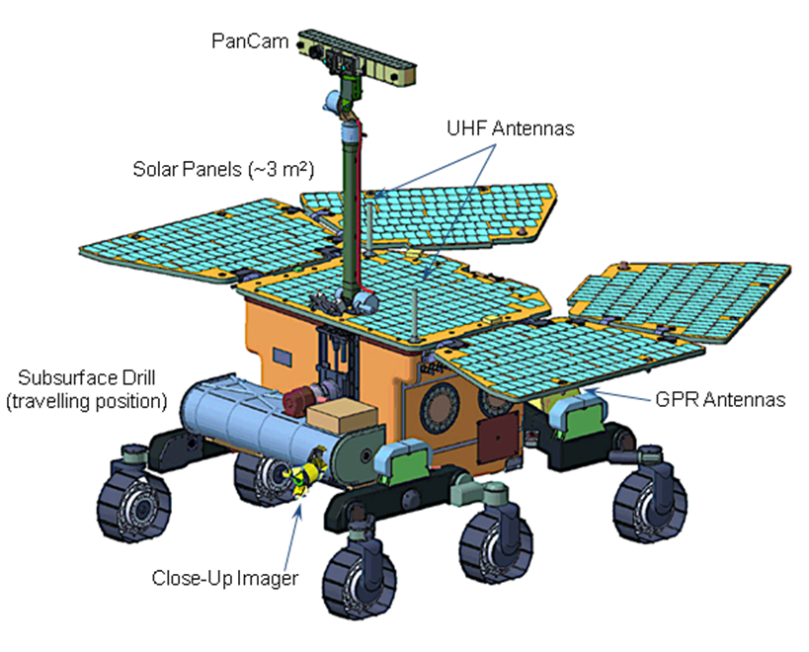
Figure 1. Computer-generated representation of ExoMars, in its roving configuration, as envisioned April, 2010.
  - MAX-C.
    - Background
A MEPAG Science Analysis Group (MEPAG MRR-SAG, 2010) was formed in 2009 to formulate a mission concept for a single rover mission that could be launched in 2018 and that would address two general objectives: (1) conduct high-priority in situ science and (2) make concrete steps towards the potential return of samples to Earth. In order to reflect the dual purpose of this proposed 2018 rover mission, the MRR-SAG proposed the name Mars Astrobiology Explorer-Cacher (MAX-C). Based on programmatic and engineering considerations the MRR-SAG assumed that the MAX-C mission would use the Mars Science Laboratory (MSL) sky crane landing system, have a targeting accuracy of ~ 7 km (semi-major axis landing ellipse), include a single solar-powered rover similar in size to ExoMars, have a mobility range of at least 10 km to traverse across the landing ellipse, a lifetime on the martian surface of at least one Earth year, and no requirement to visit a Planetary Protection Special Region. In the development of the MAX-C concept, the MRR-SAG did not consider the possibility of a two rover mission to the same site.
2.2.2. Science Objectives
Over most of the last decade, the Mars Exploration Program has pursued a strategy of “follow the water” (formally introduced in 2000; see documentation in MEPAG 2008). While this strategy has been highly successful in the Mars missions of 1996-2007, it is increasingly appreciated that assessing the full astrobiological potential of martian environments requires going beyond the identification of locations where liquid water was present (e.g., Hoehler 2007; Knoll and Grotzinger 2006). These considerations have led MEPAG to adopt recently “Seek the Signs of Life” as its next broad exploration strategy (MEPAG 2009).
The scientific objectives proposed by MRR-SAG (2010) for the MAX-C mission are summarized in the following statement: At a site interpreted to represent high potential for past habitability, and with high preservation potential for physical and chemical biosignatures: evaluate the paleoenvironmental conditions, characterize the potential for preservation of biotic or prebiotic signatures, and access multiple sequences of geological units in a search for evidence of past life and/or prebiotic chemistry (MEPAG MRR-SAG, 2010). In addition, MRR-SAG recognized that MAX-C would need to contribute to a projected future Mars sample return mission by preparing a returnable, intelligently selected set of diverse rock core samples of high scientific value. This cache would be left in a position (either on the ground or on the rover) where it could be recovered by a subsequent sample return mission, thus placing the program on the pathway of a 3-element Mars sample return campaign.
The primary investigation strategies envisioned by MRR-SAG included comprehensive characterization of the macroscopic and microscopic fabric of sedimentary materials, identification of the organic molecules, reconstruction of the history of mineral formation as an indicator of preservation potential and geochemical environments, and determination of specific mineral compositions as indicators of oxidized organic materials or coupled redox reactions characteristic of life. It was concluded that this type of information would be critical to select and cache relevant samples for addressing the life question in samples intended for possible study in sophisticated laboratories on Earth. In addition, detailed characterization of the geology of the landing site would be essential to our understanding of conditions that may have enabled or challenged the development of life and would guide the search for evidence of ancient life and/or prebiotic chemistry within the landing site region and more broadly across Mars.
2.2.3. Proposed Engineering System (when envisioned as a 1-rover mission)

Some preliminary engineering for MAX-C as a 1-rover mission was considered by the Mars Program Office subsequent to the MRR-SAG vision of the mission. Conceptually, MAX-C, as a single rover mission, would have employed heritage from both the Mars Exploration Rover (MER) and MSL missions. The proposed MAX-C rover was envisioned as a MER-class rover, upsized to accommodate the need to collect and cache samples. In a 1-rover scenario for 2018, the selection and caching of samples by MAX-C were envisioned to be based on measurements made by its scientific payload. Although specific instruments to accomplish the MAX-C science objectives have not yet been defined or selected, the following payload for the MAX-C mission was proposed by MRR-SAG: (1) an abrading tool to produce a flat surface for subsequent analysis and a drill to collect 10 mm diameter cores up to 50 mm long , (2) mast- or body-mounted instruments including a panoramic camera and near-infrared (NIR) spectrometer capable of establishing local geologic context and mineralogical remote sensing to identify targets for close-up investigation, (3) a set of arm-mounted instruments capable of interrogating the abraded surfaces by creating co-registered 2-D maps of visual texture, major element geochemistry, mineralogy, and organic geochemistry to understand the diversity of the samples at the landing site and to select an outstanding set of rock cores samples for potential return to Earth, and (4) a rock core acquisition, encapsulation, and caching system of the standards specified by MEPAG Next Decade Science Analysis Group (MEPAG ND-SAG 2008).

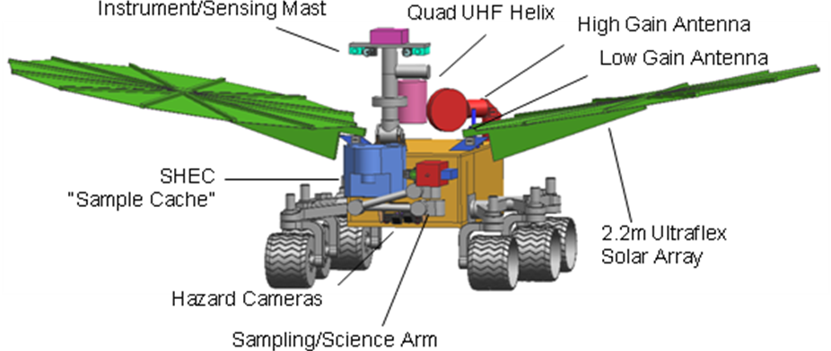
Figure 2. Computer-generated representation of the proposed MAX-C rover, in its roving configuration, as envisioned April, 2010.
Abraded rock surfaces having high scientific value as determined by the MAX-C instrument payload could then be acquired by MAX-C’s sampling handling system, encapsulated, and deposited in a sample cache. Specific requirements for the cache would be the subject of future trade-off studies, but it might be feasible to incorporate a cache of at least 20 cores, plus some extra sleeves/caps to allow for swap-out and/or sample loss. The capability for the proposed MAX-C rover to drop off the sample cache at a location favorable for retrieval by a subsequent mission would be important to facilitate rapid access by a potential “fetch” rover. Once the cache is dropped off, the MAX-C rover could go into more rugged terrain for its own in situ science without increasing the risk to a potential sample return. This would benefit the analysis of potential returned samples by expanding the regional context of those collected samples.

  - Potentially Useful Complementarity.
In many regards, ExoMars and MAX-C have complementary objectives and payloads. While the principle objective of both missions would be the search for evidence of life and past habitable environments, the two approaches are different. The main focus for ExoMars is the subsurface. In its search for evidence of life, ExoMars would spend a significant part of its life-time and resources drilling and analyzing subsurface materials. In contrast, the main approach of MAX-C would be on characterizing the local and regional geology as expressed in outcrops so that an array of intelligently selected samples could be collected and cached for eventual return to Earth. The two approaches nicely complement each other. While ExoMars would be drilling MAX-C could be exploring and gathering data both to help choose subsequent drill sites and to better characterize the geologic context of the drill samples. The reconnaissance capabilities of MAX-C thus would have the potential for significantly enhancing the science value of the ExoMars drilling operations. Similarly, ExoMars has the potential for significantly enhancing the science value of the samples cached by MAX-C. Possibly the most desirable attribute of a returned cache of samples would be inclusion of some samples that contain organic matter. Organic matter is much more likely to be preserved below the surface than on it. The drilling by ExoMars has the potential for not only providing samples from below the surface for caching but also for identifying geologic units that contain organic matter that would otherwise be missed by surface instruments, but which could be further sampled by MAX-C.
FINDING #1. The proposed ExoMars and MAX-C rovers have complementary capabilities. Most obviously, ExoMars would have vertical exploration capabilities via a drill not present on MAX-C, while MAX-C has would have better horizontal mobility and rapid reconnaisance capabilities. This complementarity naturally lends itself to cooperative exploration and sample caching opportunities.
- A Potential Cooperative 2-Rover Mission: Candidate Scientific Objectives.
It is possible to take the set of scientific objectives of the two rovers, as they were envisioned by their separate planning teams, and identify the stated or implied objectives they have in common, as well as the objectives that would be unique to each rover. This leads to the formulation of a proposed set of objectives for a possible 2018 2-rover mission.
    - Candidate Shared Scientific Objectives.
Ancient Life. As discussed above, these two rovers are being designed independently (and at different times) but have a common objective in the search for possible ancient life on Mars. However, the two rovers would have rather different strategies for pursuing this objective.. Achieving this objective would require that the rovers be sent to a site that has ancient rocks that may have preserved the evidence of ancient life. There are three specific derived sub-objectives within this overall objective that are common to the scientific planning of both rover activities. , These sub-objectives should be incorporated into a common overall objective statement.
- The paleoenvironmental conditions, as reconstructed from the rocks at the site, should be interpreted from the sedimentary structures, geochemical parameters and mineralogical evidence that relates to the potential for habitability. This would require interrogation of rocks of different character, and of known relationship to each other, which implies access to outcrops. Once a field-based model for the ancient environmental conditions exists, it would serve as the context for deciding how and where to collect samples, and for the interpretation of any samples that might be returned to Earth for more detailed investigation.
- The potential for preservation of different kinds of biosignatures throughout the post-depositional geologic history of a set of rocks should be evaluated. Traces of biological activity can be preserved in rocks as specific properties, such as the isotopic ratios of different elements, the presence of biominerals and biologically-produced textures (at different scales), and inorganic and organic geochemical signatures, all of which could be altered by one or more post-depositional geological processes. This cannot be done in general for Mars, but must be done at every site for which the search for life is to be attempted.
- Within the rocks investigated at the landing site that are interpreted to represent an ancient environment with high potential for ancient habitability, as well as high potential for the preservation of a life-related signal (if present), search for the evidence of past life. Since it is possible that Mars may never have had life, it is also important to investigate possible traces of pre-biotic chemistry since this might help us to understand why life never arose on Mars, if that is the situation.
Support Mars Sample Return. A long-range strategic intent of both NASA and ESA is to achieve a set of scientific objectives that would only be possible using samples returned to Earth (for a full discussion of proposed MSR science, see MEPAG ND-SAG, 2008). Furthermore, NASA and ESA have publically stated their desire to carry out MSR as a partnership between these two agency partners, and possibly others (see, e.g. iMARS, 2008; Coradini 2009; Coradini 2010; McCuistion 2009; McCuistion 2010). Recent technical analysis has shown that the most effective way to carry out a sample return goal is as part of a campaign of missions that would involve three separate flight elements (Li and Hayati 2010), the first of which would be a rover mission that would prepare a scientifically compelling, potentially returnable, cache of samples. To solidify and sustain the partnership through the duration of the MSR campaign, it would be necessary for the samples acquired and packaged in 2018 to be judged valuable by both organizations. Strictly speaking, it does not matter whether this shared objective would be completed by the actions of one or both rovers, only that it be completed at a sufficient level of quality.
Although one of the primary purposes of the proposed MAX-C, when it was envisioned as a single-rover mission, was to carry out this caching action (MEPAG MRR-SAG 2010), this was not the case with ExoMars. For ExoMars, when it was envisioned as an individual mission, this was not possible because there was no pathway to return samples to Earth. However, if ExoMars were delivered to the same site as MAX-C, this possibility would exist—ExoMars would be at the place where the sample cache would be assembled and where the future Mars Ascent Vehicle necessary to lift the samples off the surface would land. Thus, the opportunity for ExoMars to contribute to an MSR-related objective would provide an additional role for ExoMars in 2018 and extend the partnership beyond the 2018 mission to a potential future joint MSR mission.
Several factors that would play a role in ensuring that the cache of samples would be of sufficient quality to justify the return step include 1) understanding the geological variations at the various collection sites, so that the sample collection would reflect the diversity of materials found in the region studied, 2) sample acquisition and encapsulation in a manner that preserves sample quality at the time of collection, and 3) Documentation of the field context of the samples must be documented so that the samples could be interpreted properly when returned.
    - Candidate Independent Scientific Objectives.
Subsurface science. A key hypothesis to be tested by ExoMars would be that organic material of critical importance to the search for life on Mars is preserved at shallow depth, and not preserved at the martian surface. To test this hypothesis, ExoMars would be equipped with a sampling drill capable of accessing the subsurface to a depth of 2 m, along with several instruments designed to evaluate the subsurface samples acquired. In addition, in support of this objective, the rover would need the capability to interpret subsurface geological relationships by means of geophysical sounding.
Modern Life. One instrument on ExoMars (the Life Marker Chip) has the capability to detect modern life, should any be encountered.. This capability does not exist on the proposed MAX-C. Of relevance here is the concept that environments on Mars where terrestrial life may propagate are referred to as “special regions” (COSPAR 2008). (Conceptually, special regions are environmental niches within which terrestrial life forms could reproduce, and potentially colonize the planet. Although there are many physico-chemical limits to terrestrial life, two are most useful in interpreting Mars—lower limits on temperature and water activity; see MEPAG SR-SAG, 2006). We have no information about the habitability requirements of martian life forms since they have not yet been detected and it has therefore not been possible to measure their vital properties. However, if martian life resembles terrestrial life, it is most likely that it would be found in these same special regions. Unfortunately, as of this writing, no sites on Mars have been identified that have the properties of special regions (there are places on Mars for which the data needed to classify them is uncertain, but that, nevertheless, are treated as if they are special for planetary protection purposes). In addition, deliberately targeting a special region would require increased sterilization of the spacecraft, which would have an effect on its cost. For these reasons, MAX-C’s proposed scientific objectives (MEPAG MRR-SAG 2010) do not include the search for extant life. One way to think about ExoMars’ modern life objective is that it would look for life in environments that are not hospitable to Earth life.
Surface science. We know from investigations of ancient traces of life on Earth, as preserved in the geologic record, that scale matters. Biosignatures of microbial life may be very small, especially those related to the types of primitive organisms that might have inhabited Mars (10s µm or less). On the other hand, determination as to whether rocks at the outcrop level were formed in a habitable environment and whether they could have preserved potential biosignatures requires wide-ranging field investigations that may reach a scale of meters to several km. The need to investigate a variety of surficial outcrops over a range of spatial scales, which may also cross temporal boundaries, is an essential component of a credible life search process.
    - Proposed objective statement, 2018 2-Rover Mission.
Given the above considerations, as well as the broader context of current scientific objectives for the exploration of Mars (MEPAG 2008; MEPAG 2009; NRC 2007), we propose the following statement of primary scientific objectives for a 2018 2-rover mission.
POTENTIAL PRIMARY SCIENTIFIC OBJECTIVES, 2018 DUAL-ROVER MISSION
Overall Scientific Objectives
- At a site interpreted to contain evidence of past environments with high habitability potential, and with high preservation potential for physical and chemical biosignatures,
  - Evaluate paleoenvironmental conditions;
  - Assess the potential for preservation of biotic and/or prebiotic signatures;
  - Search for possible evidence of past life and prebiotic chemistry
- Collect, document, and package in a suitable manner a set of samples sufficient to achieve the proposed scientific objectives of a potential future sample return mission.
Independent Scientific Objectives
ExoMars Rover
- Characterize the stratigraphy of ancient rocks and the aqueous/geochemical environment as a function of depth in the shallow subsurface (up to 2 m depth).
- Search for possible signs of present life
MAX-C Rover
- Characterize exposed sequences of geological units across a lateral extent of several km, documenting geological and geochemical variation at scales from 10^3 down to 10^-5 m.

FINDING #2. The currently stated scientific objectives for MAX-C and ExoMars are similar enough that they could be combined into two major shared objectives, along with separate objectives for each rover. Defining a shared purpose for a 2-rover mission would be critical to driving a spirit of cooperation between two operations teams that might be facing different political and cultural pressures.

- A Potential Cooperative 2-Rover Mission: Preliminary Engineering Design.
The potential 2018 mission would land NASA’s MAX-C and ESA’s ExoMars rovers together on a pallet using the sky crane concept developed for the Mars Science Laboratory (Steltzner et al., 2006). This mission would be launched in May 2018 on a NASA-supplied launch vehicle on a Type I trajectory and would arrive approximately 8 months later in January 2019, near the end of the martian dust storm season. The rovers would land in a region of Mars between latitudes 25°N and 5°S (the ExoMars rover is currently designed for 5S to 35N, and MAX-C has latitude constraints of 25°N and 15°S, so the mission is likely to settle for the intersection of the ranges, 5S to 25N). The starting point of this analysis is the assumption that, in the 2-rover configuration, there would be no change to either rover’s scientific payload relative to the way they were considered as separate 1-rover missions (see Section 2 above).
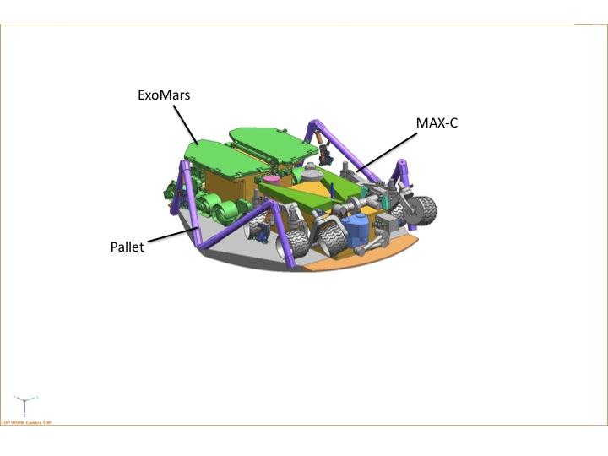
Figure 3. Computer-generated representation of the proposed MAX-C and ExoMars rovers in their stowed configuration, on the landing pallet, as envisioned April, 2010.
In the current design, the rovers would be enclosed in an aeroshell inside the cruise stage for the duration of cruise. The entry system would consist of the aeroshell, which would protect the pallet, rovers, and descent stage during cruise and entry, and a supersonic parachute to slow the entry vehicle until the sky crane and its payload are released. The descent stage would employ a platform above the pallet and rovers to provide powered descent and a sky crane to lower the platform and rovers onto the surface of Mars. After the pallet has touched down, the bridle to the pallet would be cut and the sky crane would fly away from the touchdown site. Alternative systems for Entry, Descent, and Landing are also being studied.
Once the pallet has been deployed onto the martian surface, the platform would be leveled by bipods to provide a more controlled egress path from the top deck. Egress would be accomplished utilizing inflated textile egress ramps deployed over the bipods, thereby providing a safe and controlled path in any direction from the top deck of the landing pallet. After egress, the two rovers would go through a checkout period and then begin science operations.

- OPPORTUNITIES FOR COLLABORATIVE SCIENCE.
  - Idea Generation and Prioritization.
Through internal brainstorming and discussion, as well as through extensive interaction with the external Mars science community, the 2R-iSAG committee developed the list of possible opportunities to add value through cooperation in a 2-rover mission shown in Table 1. The list of ideas was prioritized on the basis of the value of the science added and expected implementation difficulty. Science criteria included degree of positive impact on ExoMars science objectives, degree of impact on the proposed MAX-C objectives, including MSR, and the value of the collective science added. Implementation factors included cost, resources, and risk. In addition, the prioritized list was divided into two groups. Group 1 ideas assume that the both ExoMars and MAX-C would remain as currently configured. Group 2 ideas assume that changes could be made to the current configurations.
The engineering impact of each concept was analyzed in three areas: Cost, Resources, and Risk. Cost primarily involved an analysis for the suggested new hardware, additional support hardware, and new teams to implement both science and hardware. Resources included mass, power, data, workforce, and schedule. Each idea was analyzed for cost and resource impacts to MAX-C and ExoMars individually. Risk included the complexity of the change (subsystem to both rovers), technology development, testing and validation/verification, and the needed interaction between rovers (ranging from none to rover-to-rover contact). Each of the three areas was assigned a rating of Minor, Medium, or Major impact to the currently designed system. The most significant relationships involving benefit and consequences are summarized graphically on Figure 4.

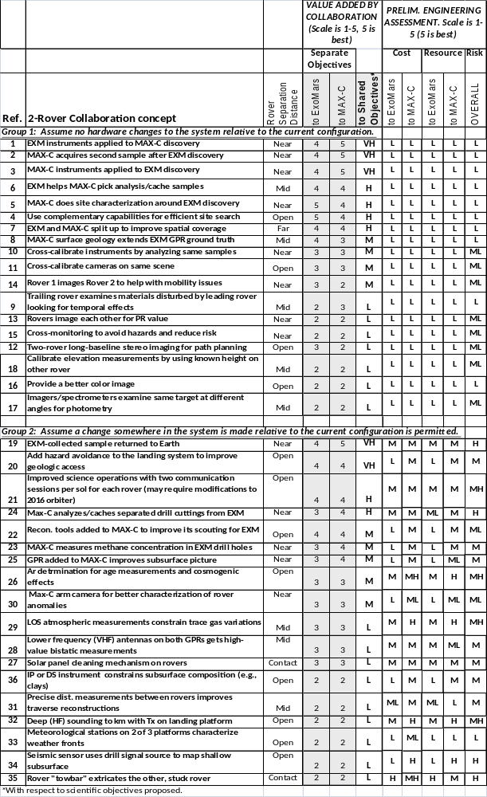
Table 1. List of possible ways that the MAX-C and ExoMars rovers could add value through cooperation. Abbreviations. EXM: ExoMars, MAX-C: Mars Astrobiology Explorer-Cacher, GPR: Ground-Penetrating Radar, PR: Public Relations, UHF: Ultra High Frequency, VHF: Very High Frequency, LOS: Line of sight, IP: Induced Polarity, DS: TBD.

  - Group 1 concepts (no hardware change allowed)
    - Follow up on one rover’s discovery using the others’ sampling equipment and instruments.
The two rovers would have complementary instruments. ExoMars’ instruments would make detailed analyses of subsurface drill cores, including measurements of volatiles and organics; those of MAX-C emphasize primary rock chemistry and mineralogy. ExoMars instruments could be applied to a MAX-C discovery and vice versa in order to take advantage of the two complementary instrument sets and obtain more comprehensive analyses, particularly of especially interesting or contentious samples.
    - Use MAX-C to scout for drill locations for ExoMars
Take advantage of MAX-C’s higher mobility, faster measurement capability and much higher limit on the number of samples that could be interrogated to serve as a scout to help identify drill locations for ExoMars. This could significantly improve the chances that ExoMars would acquire samples that have the highest potential for achieving its objectives and acquiring samples most suitable for caching.
    - Use ExoMars’ data to help select samples to go into the MAX-C cache and to help document their context.
The data collected by ExoMars might be extremely important in helping to make the crucial decisions on which rock samples to add to the MAX-C cache. The geological context within which the collection needs to be assembled, and eventually interpreted, would need to be the result of information obtained by both rovers.
    - The rovers could spend part of their mission exploring independently, such as moving up and down a stratigraphic section.
This would improve our knowledge of the heterogeneity of the site leading to better knowledge of the geologic context in which drilling, sampling and other collaborative work would be performed. It would also lead to better path planning.
FINDING #3. A number of specific ways have been identified in which exploring a single martian landing site with the proposed ExoMars and MAX-C rovers, given the objectives above, would add scientific value compared to exploring the same site with only one of the two rovers.
- There are important ways in which two cooperating rovers could improve total mission science return without making any hardware change (relative to current designs) to either rover.

  - Group 2 concepts (some hardware change allowed)
    - Cache ExoMars-acquired samples for return to Earth via MSR
Follow-up on a compelling discovery by the ExoMars analytic instruments in a sample acquired by the ExoMars drill by having ExoMars collect a second sample, either from deeper in the same drill hole, or from a second, adjacent drill hole; and have the capability to cache the sample for potential return to Earth by a future MSR mission. There are several possibilities involving the proposed MAX-C, ExoMars, the landed platform, and the projected MSR Lander as to how the sample transfer could be managed and the pathway by which it would end up on a potential MSR
    - Enabling: Although these are not scientific objectives in their own right, the following two concepts would enable a more complete science program: 1). Add hazard avoidance to the common landing system to allow landing at more geologically diverse sites than would otherwise be possible. This capability must also be implemented for MSR. 2). Solve the telecommunications bottleneck.
These changes would potentially have a major effect on rover operations by allowing landing at sites where the main targets of interest are within the landing ellipse, thus eliminating long time-consuming traverses out of and back into the landing ellipse. A telecommunications bottleneck would be created by having the two rovers at the same site—this would need to be addressed to achieve full commandability of the rovers.
    - Consider adding additional reconnaissance tools such as methane detection and GPR to MAX-C to improve selection of ExoMars drill sites.
The addition of reconnaissance tools to MAX-C could improve decisions about where to locate the ExoMars drill holes, thereby improving the possibility of making a compelling discovery. However, measurement of trace gas composition would have reconnaissance value only if it occurs at the scale of surface operation, which may be indicated by MSL. Addition of a second GPR would provide more coverage and, when used in tandem, would give a better 3-dimensional view of the landing sites, thereby providing information on regolith depth and bedrock configuration between outcrops. The benefits versus cost of these additions have yet to be determined.
    - Improve the lifetime and range of the ExoMars rover, so that it would better match the capability of MAX-C.
It would be far easier to select a common landing site that would make effective use of the rovers’ capabilities if the two rovers were more similar in these two respects.

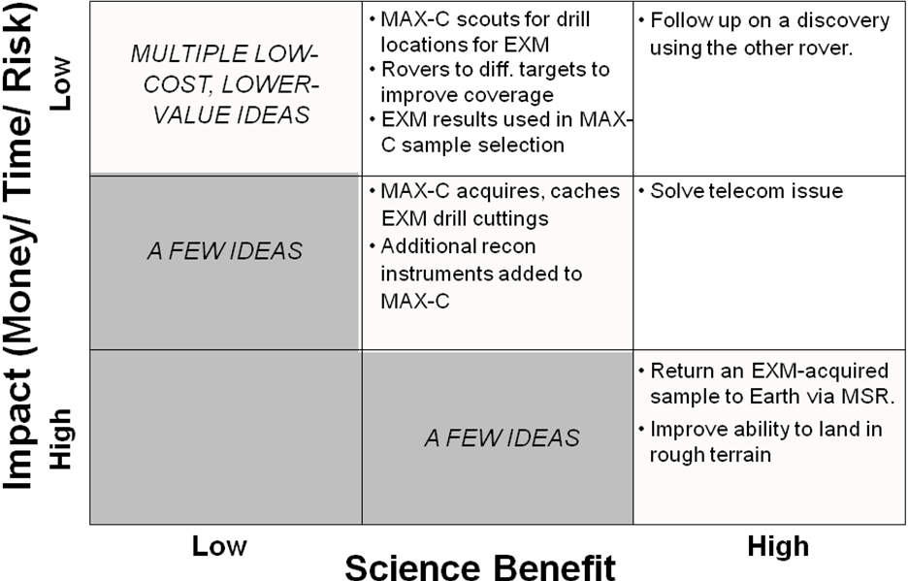
Figure 4. Summary of the relationship between benefit and consequences of operating the proposed 2018 MAX-C and ExoMars rovers cooperatively. (See detailed discussion related to drill cuttings below).
  - Public Outreach: A Special Note
An aspect of the MER rovers Spirit and Opportunity that has connected well with the public is the fact that they are our surrogates on Mars. They are the equivalent of a human geologist moving around in the field, studying rock outcrops. Their stereo cameras allow them to have a human-like, 3-D view of the terrain. They are able to move across the martian terrain as a geologist would do and, with their arm, they can touch and analyze the rocks. They can communicate by means of transmitting and receiving radio signals from Earth. The notion of two rovers - one from Europe and one from the US - working collaboratively on the surface of Mars, working together towards common objectives and to potentially be available to help with difficulties, would represent a "first" in planetary exploration and would provide an inspiring story for the global community at several levels. We believe that the public outreach planners in both NASA and ESA would be able to capitalize enormously on these aspects.

- POSSIBLE OPERATIONS SCENARIOS
The two rovers having a common landing pallet would by definition begin their journeys on the martian surface together (Fig. 5). Once MAX-C’s cache has been collected, MAX-C would need to drive to a safe landing area for MSR-L (Fig. 5) in order to get the driving distance for the potential MSR fetch rover as low as possible. There would be no reason for ExoMars to do this so the rovers would likely end their lives separated. There are multiple pathways in between that would involve both independent and collaborative activity (see Fig. 6).
Each rover team would require an early, independent, check-out phase to learn how to operate its vehicle. Subsequent operations would depend strongly on whether the targets of interest are within the landing ellipse (mixed terrain site) or outside the ellipse with the consequent necessity of a long drive to reach the targets (go-to site). For a mixed terrain site, after checkout, the rovers could travel to separate sites and explore independently. ExoMars would drive and drill. MAX-C would roam further, scouting the area for interesting sites for joint operations. Although independent, they would remain within close driving distance (< a few km?) so that should either rover make an exciting find, the other rover could join it and the combined capabilities of the rovers could be used to exploit the find. The process of independent and cooperative operations would be repeated (Fig. 6) until the MAX-C cache is complete, at which time MAX-C would travel to the center of the MSL-L landing ellipse and leave its cache. Subsequent operations would depend on what was found earlier.
Operations at a Go-to site would be quite different (Fig. 5, left side). After the check-out phase both rovers might be faced (depending on where they are in the ellipse) with a drive of several kilometers that could take months in order to reach the main targets of interest. The drive could be done in two ways. It is unlikely that nothing of interest would be seen on the way. MAX-C could move ahead as quickly as possible, scout the area of interest, and guide ExoMars to the most interesting sites. Meanwhile ExoMars would be driving and occasionally drilling targets of secondary interest. Alternatively, the rovers could remain within easy driving distance (this would have to be quantified through additional study) of each other while going to the main target area so that they could work cooperatively should any of the secondary targets prove compelling.

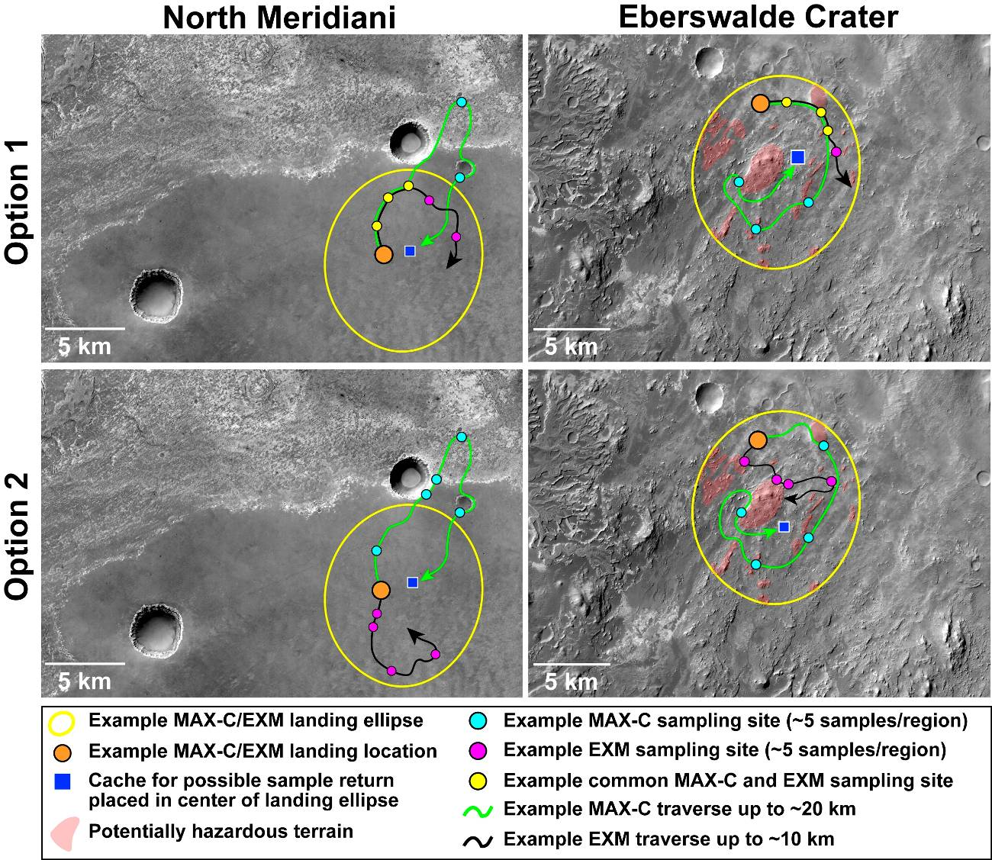
Figure 5. Example ellipses of operations at a go-to site (North Meridiani, left) and a mixed terrain site (Eberswalde crater, right). Ellipses based on landing sites proposed for the 2011 Mars Science Laboratory, landing ellipses for the 2018 mission might differ. An example site in North Meridiani (left) would comprise a “Go-to” site where the landing would occur on the smooth Meridiani plains in the southern portion of the image and the ExoMars and MAX-C rovers would then be required to travel up to 10 km and 20 km, respectively, to interrogate the primary science targets (including possible fluvial morphologies) in the somewhat higher relief terrain to the north (note that the traverse that would required by ExoMars in this scenario significantly exceeds its current design capability). The greater traverse of the MAX-C rover would relate to the need to return to the center of the landing ellipse to make cached samples available to the fetch rover on MSL-L (whose range (TBD) would be limited to the MSR landing error ellipse). Another example ellipse provides access to a mixed terrain site within Eberswalde crater where the ellipse would be located on the crater floor, possibly providing access to materials including lacustrine deposits associated with past flooding and ejecta from the nearby Holden crater. Nevertheless, the primary science target within Eberswalde would be also outside of the ellipse and would involve access to a fluvial deltaic system on western wall of the crater. ExoMars could rove up to 10 km within the ellipse and sample lacustrine and other deposits while MAX-C could traverse up to 20 km to interrogate materials comprising the ellipse. In the case of Eberswalde, relief within the ellipse (red shaded areas) that likely represent the highest priority local science targets also comprise landing hazards. Therefore, the ability to access a mixed terrain site, which would hold high priority targets for both rovers, would probably require hazard avoidance capability during landing. Subframe of CTX images P18_008218_1815_XI_01N002W (left, near 1.5N, 357.2E) and B02_010474_1558_XI_24S033W (right, near 23.9S, 326.7E).

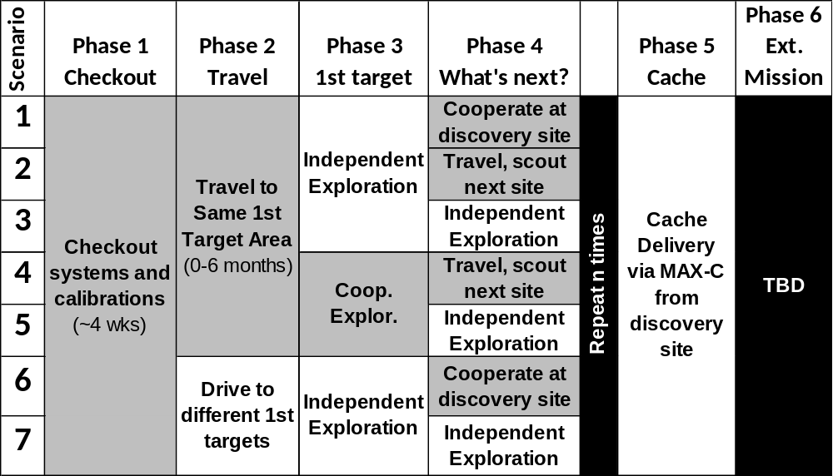
Figure 6. Two-rover scenario planning. A wide range of operational scenarios could be envisaged according to whether the two rovers land at a Go-to site (e.g. scenarios 1-5) or a Mixed terrain site (e.g Scenarios 6 & 7) and according to what discoveries are subsequently made.
FINDING #4. The two rovers would begin their traverses on the Martian surface from the same landing site location. It is presumed that they would end their lives separated after achieving their cooperative science and exploration goals. There are multiple potential operational scenarios in between that would involve sequential independent and cooperative activity. Determining the optimal scenario would depend on the attributes of the landing site and the history of discovery within that site by each of the two rovers. In order to allow for discovery response, scenario planning must remain flexible and mutually, not individually, optimized.

- TWO ROVERS TO THE SAME SITE: SOME CONSEQUENCES
A reality is that sending two rovers to work in concert at the same landing site would inevitably lead to benefits in some areas and some adverse consequences in others. Table 2 lists many ways in which benefit could be achieved by cooperation. However, there are many significant ways in which these proposed rovers are not identical, including the ability to survive the martian cold, rate of movement across the surface, amount of time required to carry out scientific investigations, etc. There would be a “least common denominator” aspect to their joint operation: If the two rovers are to function together, both rovers would have to be managed to the parameters of the least capable rover. In every area, some excess capability on one rover or the other would remain unused. This inefficiency has to be carefully considered in comparison to the value that could be added by the various activities listed in Table 2.
Almost all of the various kinds of considerations related to adverse consequences can be grouped in two categories: Issues that would arise from sharing a common landing site, and issues that would arise because of short lifetimes (the durations of which are not knowable in advance).
  - Time
Both rovers have been proposed with individual sets of scientific objectives to achieve during their nominal mission lifetime. The type of coordinated rover operations described in this report would require resources, including the time necessary to implement the recommended joint activities.
The cooperative science activities could be introduced in the rovers’ missions, but at the expense of some of the time to be dedicated to individual mission objectives. This means that, if both types of science (cooperative and single-rover science) are considered to be of high value, the rovers’ nominal mission lifetime would have to be extended (Note, this applies more to ExoMars than MAX-C).
Example: Present 180-sol Reference Surface Mission for the ExoMars Rover
The ExoMars rover has a nominal mission lifetime of 180 sols. Its Reference Surface Mission includes an agreed, realistic sequence of scientific measurements that the project team utilizes to drive the rover industrial design work. The Reference Surface Mission is used to size the rover’s subsystems, such as power, energy, thermal, communications, data processing, avionics, etc. For locomotion purposes, the Reference Surface Mission assumes that the ExoMars rover has landed in difficult, Viking 1-like terrain. The latter is important because the rover’s 100 m/sol driving distance is defined for that terrain.
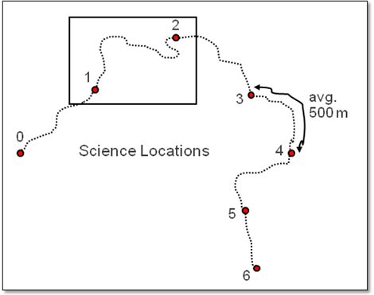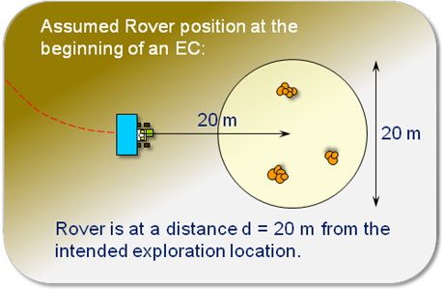
Figure 7: ExoMars Rover Reference Surface Mission: 180 sols, built using modules called Experiment Cycles (EC) and Vertical Surveys (VS).
The ExoMars Rover’s 180-sol Reference Surface Mission (Fig. 7) consists of:
- ROVER EGRESS: 10 sols
- MOBILITY COMMISSIONING: 3 sols
This strategy is necessary to distance the rover from the landing site where organic contamination from rocket exhaust would contaminate the terrain prior to opening up the analytical laboratory to the Martian environment (TBC by project).
- BLANK ANALYSIS RUNS: 3 sols
To demonstrate that the Rover’s sample pathway is free from terrestrial organic contamination.
- 6 EXPERIMENT CYCLES: 12–18 sols, depending on distance travelled
Resulting in 6 surface and 6 subsurface samples.
- 2 VERTICAL SURVEYS: 18 sols
At one location, collect and analyze samples at 0, 50, 100, 150, and 200-cm depth in a single borehole. Resulting in 10 additional subsurface samples per vertical survey. It is assumed that only minimal displacements (tens of meters) are necessary.

The total duration allocated for egress, commissioning, and science activities would be 145 sols. The remaining 35 sols constitute a margin reserve against possible operational difficulties.
Analysis in view of possible two-rover collaboration:
It is clear that some activities at the beginning of the mission would have to be performed regardless of whether it would be a single or a dual rover science scenario. This includes the egress (which might last longer for two rovers), the commissioning, and probably the first three experiment cycles. The science and engineering teams would probably need these cycles to familiarize themselves with the vehicle, the instruments, the science, and to ensure a smooth flow of operations (approx. 50–60 sols).
This would leave roughly 90 sols in the nominal mission for pursuing the ExoMars rover’s science objectives. This is not much time and introducing two-rover cooperative science within such a science operations scenario would not be very realistic.
The goal of this section has been to illustrate that, in order to effectively perform scientifically desirable two-rover operations, time becomes an essential resource.

  - Sharing a Common Landing Site
There are several implications of sharing a common landing site. Note that the landing site must satisfy the requirements of three vehicles, MAX-C, ExoMars and MSR-L (with its fetch rover), not just the two that are the subject of this report. The choice of the landing site would presumably be limited by the most restrictive requirements for the three missions.
    - Latitude limitations and trafficability capability
Although the plan would be for both MAX-C and ExoMars to land together on the same pallet, the two rovers would have different power/thermal designs, which would lead to different latitude limitations, and they would have different trafficability capabilities.
    - Telecommunications
Collocated rovers would introduce two interesting telecommunications issues: overlapping view periods and resulting contention for services from relay orbiters, and the possibility of direct rover-to-rover communications.
Two collocated rovers would have completely overlapping view periods for any relay orbiter that passes overhead. Even if independent surface operations lead to a separation of 10-20 km between the rovers, from the altitude of the relay orbiters the contact periods would still almost completely overlap. However, the current suite of operational relay orbiters (ODY, MEX, and MRO), as well as the baseline plans for the 2013 MAVEN and 2016 ExoMars/TGO missions, incorporate relay payloads that can only support a single user spacecraft at a time. As a result, only one rover at a time would be able to access a relay service when an orbiter would be in view. This situation could be addressed by three strategies:
- One strategy would be to simply alternate relay contact opportunities between the two rovers: one relay overflight would be allocated to rover A, and the next overflight to rover B. This strategy has several drawbacks. First, it would reduce the overall contact time for each rover by a factor of two, with a corresponding reduction in the potential data return from each rover. Second, it would decrease the frequency of relay contacts for each rover by that same factor of two, increasing the gap times between contacts for each rover and thus impacting the pace of surface science operations. Depending on site latitude and relay orbit, each rover might have as few as two geometric contacts per sol for a given relay orbiter; losing half of these contacts would jeopardize the ability to sustain a one-sol rover planning cycle, which typically depends on AM and PM contact opportunities.
- A slightly improved strategy would be to split each geometric relay contact in half, allocating the first half of the overflight to one rover and the second half to the other. This would allow both rovers to benefit from each relay overflight opportunity, supporting a rapid planning cycle for surface operations; however, the potential data volume from each rover would be still reduced by a factor of two due to the time sharing. In addition, some additional data loss would result from the finite time required to effect the handover from one rover to the other, which would be occurring in the middle of the overflight when link performance would be typically at its maximum.
- The optimal strategy would be to implement a multiple access capability on the relay orbiter, allowing the orbiter to simultaneously support links to both rovers. This would enable each rover to take maximum advantage of the relay orbiter overflights, both in terms of the frequency of contact opportunities as well as the integrated contact time (and resulting data volume).
With two collocated rovers, there would also be the possibility of direct rover-to-rover communication links. (Note that the Pathfinder Lander and Sojourner Rover utilized a direct surface-to-surface link; in fact, that was how all command and telemetry services were provided to the rover.) Direct rover-to-rover communications could in principle support exchange of information between the two rovers, supporting autonomous operations and closure of decision loops at Mars on time scales much faster than would be possible with Earth in the loop. However, such inter-rover autonomy might be beyond current capabilities, although direct rover-to-rover communications could be motivated by other considerations. For instance, current plans call for the proposed MAX-C rover to incorporate a direct-from-Earth (DFE) X-band link capable of delivering commands to the rover each sol (and capable of low-data volume contingency telemetry return). On the other hand, the ExoMars rover does not plan any DFE communications capability. But with a rover-to-rover surface link, MAX-C could serve as a relay provider for ExoMars, forwarding commands from Earth via MAX-C’s DFE link. Note that the baseline UHF radios currently planned for the ExoMars and MAX-C rovers would not support a direct rover-to-rover cross link, as both rovers are designed to receive in the 435-450 MHz band (for orbit-to-surface forward links) and transmit in the 390-405 MHz band (for surface-to-orbit return links). A modification to one or both radios would be required to enable direct rover-to-rover communications. Such a communication strategy would effectively require “line-of-sight”. Diffraction effects can enable some transmission beyond geometric line-of-sight, but would be a full research project to understand the link characteristics as a function of surface morphology, surface dielectric properties, etc.

    - Relationship of science targets to the landing ellipse
Ensuring a safe landing with the sky crane and pallet system envisioned for the proposed 2018 mission would likely result in landing terrain engineering requirements that are more constraining than those applicable for the MSL mission, such as ensuring that pallet attitude after landing would be safe for the egress of the rovers. To be sufficiently safe, the site may need to be smooth and flat with targets of interest outside the ellipse (Go-to site). A travel distance of at least 10 km might be needed to reach the desired targets. However, having the landing system with hazard avoidance capability (i.e., the ability to move laterally TBD meters if hazards are identified during descent) would allow us to consider scientifically compelling sites with a mixture of safe and unsafe terrain (mixed terrain site), thereby potentially eliminating “go-to” sites.
 |  | LANDING #1 |  | LANDING #2
 | Criterion | MAX-C | ExoMars | MSR-L
1 | Safe landing | Essential | Essential | Essential
2 | Large geological variability (to support multiple MSR objectives) | Important, but hard/ impossible to define | Desired, but must also include sedimentary deposits | Same as MAX-C
3 | Ancient habitability hypothesized | Required | Required | Not new
4 | Modern habitability hypothesized | Neither required nor precluded | Desired? | Might be precluded
5 | Preservation potential for >1 biosignature | Required | Required | Not new
6 | Potential for organic preservation | Desired | Required | Same as EXM
7 | Access to extensive outcrop | Required | Desired; but many small outcrops also OK | Same as MAX-C
8 | Interesting regolith within landing ellipse | Acceptable, but currently not required | Acceptable, but currently not required | Required
9 | Science targets within landing ellipse | Acceptable, and lower science risk than #10 | Currently required | Cache within landing ellipse
10 | Go-to capability (traverse out of landing ellipse) | Might be necessary to achieve all of the above | Requires investigation to determine how capable ExoMars would be | Cache within landing ellipse
Table 2. Preliminary landing site criteria for MAX-C, ExoMars and the MSR-Lander, all of which would share a common landing site.
FINDING #5. Having ExoMars and MAX-C share a landing site has multiple implications, including accepting common latitude restrictions (despite different thermal constraints/designs), accepting the geological attributes of the common landing site, and introducing a very constraining telecommunications bottleneck. Reconciling these kinds of issues would require compromises, relative to current planning, by one or both rovers.

    - Planetary Protection
Having the two rovers launched, transported to Mars, and landed together would mean that except for portions that are deliberately protected, they would share a common contamination state. For each mission, there would be a sensitive portion that would require a lower contamination threshold. In the case of ExoMars, it would have instruments that are designed to make life detection measurements on Mars and therefore the sample acquisition, transportation and analysis sub-systems would need to be cleaner than the rest of the rover. In the case of the proposed MAX-C, its sample contact surfaces must be kept clean because those samples would be used for a variety of scientific and planetary protection purposes at the potential conclusion of MSR. Once cleaned, both of these subsystems would need to be protected against recontamination by Earth-sourced biological contamination until completion of their primary missions on Mars. However, the same issues would exist if either of these rovers were delivered by itself, so this would not be a consequence of the 2-rover scenario.
There is, however, a different kind of concern related to planetary protection. Under current planetary protection policy (COSPAR 2008), there would be a fixed limit to the amount of bioload that could be delivered to the martian surface per landed event. If these rovers were delivered to Mars separately in two landed events, the amount of acceptable bioload would be twice the acceptable level as in a scenario involving one landed event. This implies that the landed hardware in a 2-rover scenario would need to be cleaned to significantly lower thresholds.

- DISCUSSION
The requirements for the specific landing location for the 2-rover pallet system and the proposed MSR-L are likely to be very restrictive. Sparsely cratered, level areas with low rock frequencies, few breaks in slope or positive relief features would be needed. Unfortunately, the characteristics that create hazards are the very ones that make a site scientifically attractive. Craters, breaks in slope, hills and scattered boulders provide access to rocks, would enable the remote sensing instruments to detect targets of interest, and provide stratigraphic depth for sampling. With a nominal ellipse diameter of 10 km, the two rovers must be capable of travelling 5 km out of the ellipse then a few additional km as they conduct their exploration of the science target area. After assembling its cache, MAX-C must travel an additional 5 km or more back to the center of the ellipse. The current projected life time and rover range of ExoMars would be both incompatible with landing at a Go-To site. In the nominal reference mission plan of 180 sols (Section 7.1), ExoMars would travel roughly 2 km, far short of what would be needed for a Go-to site.
There are different approaches to this dilemma. A search could be made in the hope of finding hazard-free, scientifically acceptable sites. Given the desire for caching rock samples for potential later return to Earth, we consider this approach unlikely to succeed. The second approach would be to incorporate hazard avoidance into the landing system. The third approach would be to extend the range and lifetime of ExoMars, something that might also be needed for a collaborative mission even at a land-on site (section 7.1)
FINDING #6. It is a concern that ExoMars, as presently designed, would likely be unable to achieve its scientific objectives at a “go-to” site. The experience with the MSL landing site selection process is that go-to sites were (and still are) of critical importance to achieving a broad enough spectrum of candidate sites. In order for the planning of a 2-rover 2018 mission to make sense, it would be necessary to undertake one of the following actions:
- Provide a broad enough set of candidate landing sites with internal scientific targets through one of two means:
- Identify safe “land-on” sites (science targets that do not represent hazards present within the landing ellipse) of sufficiently high priority;
- Establish the ability to land safely on sites that contain internal hazards that also constitute scientific targets (EDL hazard avoidance);
- Increase the ExoMars nominal mission duration AND mobility range, such that go-to sites become viable.

If hardware changes somewhere in the system are possible, we have concluded that the following four changes would most benefit the envisioned possible 2-rover mission.
  - Hazard avoidance
The addition of hazard avoidance to the landing system has the potential for significantly enhancing the joint mission. The characteristics of the site must be such as to enable, with a high degree of probability, safe landing of both the pallet carrying the two rovers and the vehicle for potential subsequent return of samples to Earth. Landing errors are still unknown but, without hazard avoidance, are likely to be close to 10 km (95% probability), so that a 20 km in diameter site almost free of hazards would be required. A flat, sparsely cratered plain free of blocks or hills, while ideal for landing, would be the least desirable kind of site for science. Relief features such as craters, cliffs and hills provide access to bedrock and allow different stratigraphic units to be sampled so that a variety of rock units of different origin and age could be examined. Without hazard avoidance the rovers would likely have to land at a bland, minimally interesting site (Go-to site), and then travel several kilometers to reach geologically heterogeneous terrain where the science objectives could more readily be addressed. The long journey would not be without hazards even in bland terrain, as demonstrated by Opportunity. The addition of hazard avoidance would enable landing between relief features such as low hills and craters, thereby avoiding the need for a long journeys out of the ellipse and, for MAX-C, back to the center of the ellipse. By enabling both rovers to achieve their prime objectives within the ellipse, there would naturally be more opportunities for collaborative actions and for response to one another’s discoveries.
  - Rover Range/Lifetime
Because of the potential conflict between science desires and engineering requirements for safe landing just alluded to, the joint landing might have to be at a Go-to site. This would require a drive up to 10 km long and several months in duration in order to exit the landing ellipse. The current ExoMars reference surface mission being used to size the rover lasts 180 sols. During this time the rover would be expected to explore 6 different locations, travelling approximately 2 km. The ExoMars rover is designed to cover 70 m/sol on Viking 1-like terrain (very rocky), but is capable to achieve speeds of up to 100 m/hr on flatter terrains. Extending the ExoMars roving capabilities to 10 km and 360 sols would preserve the option of landing at a Go-to site and travelling to a geologically more compelling site.
  - Sample transfer.
Introduction
The scientific value of the sample collection cached by the proposed MAX-C could be considerably enhanced if subsurface materials acquired and analyzed by ExoMars could be transferred to MAX-C for inclusion in the cache. This would be particularly true of materials in which ExoMars had detected organics. As presently configured, ExoMars cannot deliver a sample from depth within a drill hole to MAX-C for caching. MAX-C could access tailings from a hole drilled by ExoMars but the tailings would be a mix of materials from all levels within the hole that would have been oxidized under the conditions existing at the surface. The capability of transferring samples obtained from the subsurface to MAX-C for caching would capitalize on the capability of the Mars Organic Molecule Analyzer (MOMA) in selecting samples that are particularly relevant for the assessing the possibility of past or present life for return to Earth.
The ExoMars drill is designed to carry out discrete coring runs, and the mechanical nature of the sample collected may range from solid rock cores to fragmented rock to a large proportion of loose material (depending on the nature of the material being drilled). In addition, the action of the drill bit would produce cuttings, which would be cleared from the hole by means of auger flights, thereby creating a stratified cuttings cone at the surface. In the interest of completeness, the potential acquisition and storage of both core and cuttings from and ExoMars drill hole is included in this analysis. As shown in Figure 8, there are several potential pathways for retrieving an ExoMars-acquired sample by the MSR fetch rover, some of which involve the landing pallet. Key distinctions between these pathways include whether the sample would be core or drill cuttings, whether the sample would be encapsulated (if at all) and, finally, where the sample would be stored while waiting for the fetch rover. This leads us to four primary classes of scenario (see Table 3), several of which have some variants.
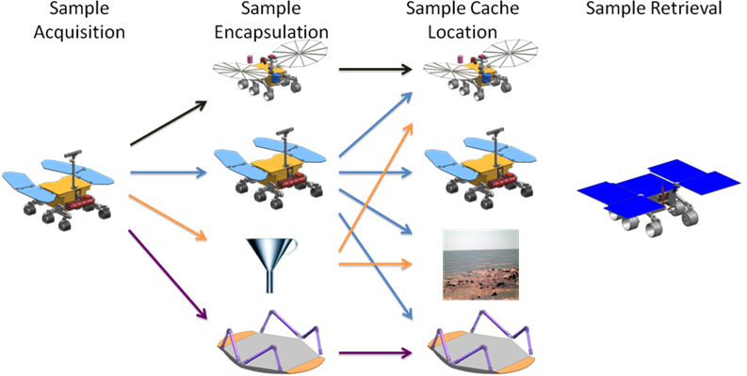
Figure 8. Potential sample transfer pathways for an ExoMars-acquired sample to end up on MSR. Upper row: MAX-C; second row: ExoMars; third row: delivery to the martian surface; fourth row: Landing pallet.

Science priorities
The relative scientific value of the samples that might be returned via these different scenarios (first set of columns in Table 3) is driven primarily by the amount of oxidation and loss of volatiles that the samples would suffer. These effects depend on the amount of time between sample acquisition and sample encapsulation, and on the quality of that encapsulation. The authors of this report do not have sufficient information to generate quantitative estimates of sample damage as a function of time prior to encapsulation, and a relevant follow-up study is recommended. However, our preliminary assumption is that the samples would suffer little damage if they could be encapsulated in an airtight manner within one week whereas, if they are not encapsulated until the fetch rover arrives (potentially ≥ 6-8 years from sample acquisition), there would be severe degradation in the quality of the samples with consequent impact on their science value. Once properly encapsulated, it is assumed that the scientific value of the samples could be preserved, either at the martian surface, or in orbit, indefinitely.
A second factor that would affect the scientific value is the mechanical integrity of the samples. For some of the sample transfer scenarios, it might be difficult to transfer a whole core without breaking it (perhaps into multiple pieces), but this is definitely less important than volatile loss and oxidation. Prior documentation of the core before encapsulation would mitigate this necessity.
There are some special scientific issues associated with the possibility of collecting the ExoMars drill cuttings.
- The most important scientific objectives proposed for both MAX-C and ExoMars require access to bedrock, for which the context can be interpreted on a regional scale using the methods of photogeology. The current plan for ExoMars drilling is to start the hole in regolith, and to achieve penetration of bedrock only in the lower part of the hole. “Cuttings” obtained from the regolith portion of such a hole would have a very different scientific significance than true cuttings from the bedrock portion, and these must be considered separately.
- Drill cuttings are always less useful scientifically than whole core samples for at least three reasons:
  - Textural information about how different parts of the rock relate to each other would largely or wholly be lost,
  - Cuttings delivered to the surface are not exclusively from a defined depth. Cuttings from a depth of interest would entrain material from higher up the hole as the sample moves up the auger flights. Thus, it would arrive at the surface having mixed material from different depths,
  - Crushing of the rock into a fine particle size greatly increases its surface area and chemical reactivity—thus samples in this form are far more vulnerable to degradation by processes like oxidation and volatile loss/gain.
Despite these limitations, it is definitely possible to use cuttings to answer certain kinds of scientific questions. However, the usefulness of cuttings is commonly dependent on both the grain size distribution of the cuttings (and especially on the size of the largest particles), and how they are collected. The authors of this report do not have information on the expected size distribution of the cuttings that would be produced by the ExoMars drill bit. Sampling a surface cuttings cone could have the effect of averaging the geology of the hole. If the downhole scientific priorities are keyed to specific subsurface intervals, those intervals may be hard to detect/interpret. However, the value of the cuttings is potentially sufficient, if encapsulated quickly after their production, and this potential needs to be assessed in better detail by a future planning team. Note that if MAX-C is designed with the capability to collect samples of granular materials (which would be necessary for MAX-C to be able to sample regolith), this capability might be used to collect the cuttings and the decision could be made by the science team at the time of the mission. This might make collecting the cuttings the easiest way to get subsurface material into the proposed MAX-C cache.
It would be scientifically optimal for ExoMars to encapsulate the sample immediately after drilling. Encapsulation would need to be airtight, as is assumed for MAX-C. The character of the seals on the sample tubes is of crucial importance to minimize oxidation, volatile loss, and mechanical damage. If ExoMars is unable to encapsulate the samples to the same standard of quality as MAX-C, it would be scientifically preferable for the latter to do the encapsulation. All scenarios that do not involve encapsulated samples are of significantly lower scientific priority.

FINDING #7. A scientific priority for sample transfer is to achieve air-tight sample encapsulation relatively quickly after sample collection. It does not matter which spacecraft platform would perform this encapsulation. Further study is needed of the potential scientific value of the ExoMars drill cuttings as returned samples.

Impact on design and operations
The right side of Table X lists two kinds of evaluation information: 1). Relative impact on the design, 2). Relative impact on surface operations at Mars.
- The factors that most influence the design are whether or not ExoMars could encapsulate a sample, whether or not ExoMars could store a sample in a recoverable position, whether or not it is possible to transfer a sample between ExoMars and MAX-C (potentially for encapsulation by MAX-C), and whether or not there would be a need for some sample manipulation by the fetch rover (this would necessarily be true, for example, in the case of an unencapsulated sample placed on the surface).
- The factors that most influence operations are how much extra driving ExoMars would need to do (for example, to deliver a sample to the pallet), time implications for MAX-C (for example, waiting to receive a sample from ExoMars) and, most importantly, implications for the driving distances for the fetch rover (having samples stored in two places makes the recovery job much harder).
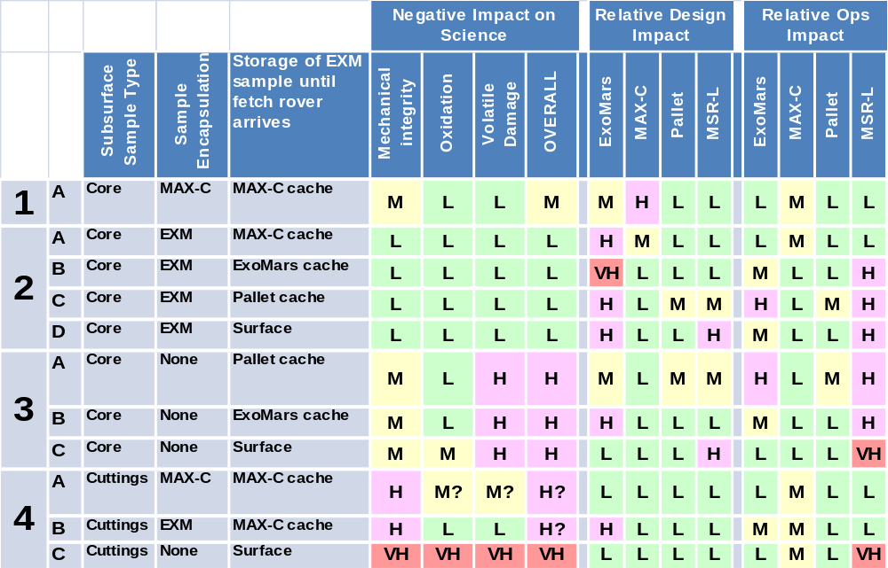
Table 3. Evaluation of potential sample transfer pathways for an ExoMars-acquired subsurface sample to the proposed MSR fetch rover. The potential value of drill cuttings is assumption-dependent, and is discussed in detail in Section 4.3.

  - Communications
Surface operations for the 2018 MAX-C and ExoMars rovers would be significantly enhanced if the proposed 2016 ExoMars/Trace Gas Orbiter (and, potentially, the 2013 MAVEN orbiter) implemented a multiple access communications capability, allowing both rovers to fully benefit from the relay services available from every overflight of each orbiter. Both projects should examine their surface operations concepts to evaluate the potential benefit of direct rover-to-rover links. In particular, the ESA ExoMars rover should assess the benefit of MAX-C-to-ExoMars Rover links to support delivery of ExoMars Rover commands via relay through the MAX-C rover, using its X-band DFE capability. If this functionality were deemed necessary, appropriate modifications to the rover radios would need to be implemented.
FINDING #8. The following hardware changes would have the most beneficial impact on total science return of this potential 2-rover mission:
- Implementation of landing hazard avoidance to allow targeting sites containing multiple instances of outcrops that include identifiable stratigraphic sequences relevant for achieving the mission's search for past life objective;
- Improvements to ExoMars and MAX-C sample transfer systems to allow subsurface ExoMars samples to be encapsulated for potential return to Earth;
- Provide a multiple access relay capability on the proposed 2016 ExoMars/Trace Gas Orbiter (and, potentially, the 2013 MAVEN orbiter) to allow simultaneous support to both rovers during each overflight; modify the UHF radios on one or both rovers to enable rover-to-rover communications, supporting direct exchange of information between rovers and allowing delivery of commands to ExoMars via MAX-C’s direct-from-Earth link.
- Extend ExoMars roving capabilities to ~10 km, and its nominal life time from 180 to 360 sols to facilitate go-to site options for the 2018 landing opportunity.

- CONCLUSIONS
  - Landing the proposed MAX-C and ExoMars rovers together would create interesting options for cooperative science that could increase the collective science return without change to either rover. More valuable cooperative science would require some changes.
- The most obvious ways in which the additional science benefits have the potential to exceed/justify the costs:
  - Allow an ExoMars-acquired subsurface sample to be returned to Earth via a potential future MSR
  - Use the proposed MAX-C rover as an advance scout to help identify drill hole locations for the ExoMars rover.
  - Complementary instruments and sampling devices could be used on compelling discoveries.
- Realizing the benefits of the proposed 2-rover scenario would have three primary impacts:
  - Cooperative, two-rover time use on the martian surface would reduce the time available for each rover’s independent objectives.
  - The need to share a landing site would involve certain compromises, such as a safe (but geologically uninteresting) site for sky crane and pallet, given the ExoMars restrictions for a “go-to” site. Mitigation likely would require hazard avoidance capability and identification of mutually suitable sites.
  - Costs associated with hardware change.
- The most obvious recommended hardware changes:
  - Landing hazard avoidance, to allow a mixed-terrain site “with character.”
  - Improvements to ExoMars and MAX-C sample transfer systems to allow a subsurface ExoMars sample to be potentially returned to Earth.
  - Increase telecommunication sessions to twice per sol for each rover. This would be important for efficient surface science operations.
  - Extend ExoMars roving capabilities to ~10 km, and its nominal life time from 180 to 360 sols.
- Acknowledgements
An early draft of the list of possible options for collaborative science and their priorities (Table 2 of this report) was discussed with multiple colleagues within the Mars exploration community, including: the leaders of the MRR-SAG committee; ExoMars project leadership; the ExoMars Science Working Group; ExoMars instrument science colleagues; the JPL Mars Program Office science team; ~8-10 MER scientists; and professional colleagues of several team members. This resulted in the addition of several new ideas, valuable clarification of others, and refinement of our perception of their relative priorities. Chad Edwards (Chief Telecommunications Engineer, Mars Program Office, JPL) provided extensive input to the telecommunications analysis. Gerhard Kminek (Planetary Protection Officer, ESA) provided input to the section on planetary protection. An early draft of this report was presented orally on March 17, 2010 at the MEPAG meeting in Monrovia, and the ensuing discussion was very helpful in refining the ideas contained in this report. A portion of this work was carried out at the Jet Propulsion Laboratory, California Institute of Technology, under a contract with the National Aeronautics and Space Administration.

- References
Brack A, Clancy P, Fitton B, Hofmann B, Horneck G, Kurat G, Maxwell J, Ori G, Pillinger C, Raulin F and others. (1999) An integrated exobiology package for the search for life on Mars. In: Life Sciences: Exobiology. edited by F Raulin, K Kobayashi and A Bracks, Pergamon Press Ltd, Oxford, p 301-308.
Burgard W, Moors M, Stachniss C, and Schneider FE. (2005) Coordinated multi-robot exploration. Ieee Transactions on Robotics, 21, 376-386.
Chicarro A. (1993) MARSNET. Report on the Phase A Study. European Space Agency Publication, Paris.
Coradini M. (2009) The ExoMars Programme. Presentation given July 29, 2009 at MEPAG meeting #21, Providence, RI. 23 p. PPT file posted by MEPAG at: http://mepag.jpl.nasa.gov/meeting/jul-09/04-Mepag_Coradini.ppt
Coradini M. (2010) The ESA/NASA ExoMars Programme. Presentation given Mar. 17, 2010 at MEPAG meeting #22, Monrovia, CA. 35 p. PPT file posted by MEPAG at http://mepag.jpl.nasa.gov/meeting/jul-09/04-Mepag_Coradini.ppt
COSPAR (2008) Planetary Protection Policy, originally written October 2002, amended March 2005; http://www.cosparhq.org/scistr/PPPolicy.htm
ESA (2010) ExoMars Science Management Plan, Issue 5, Rev. 4 (dated Feb. 12, 2010), EXM-MS-PL-ESA-00002, 60 pages. May be accessed at the following website: http://exploration.esa.int/science-e/www/object/index. cfm?fobjectid=46849#
Ezell E, and Ezell L. (1984) On Mars, Exploration of the Red Planet 1958-1978. NASA SP-4212.
Golombek MP, Anderson RC, Barnes JR, Bell JF, Bridges NT, Britt DT, Bruckner J, Cook RA, Crisp D, Crisp JA and others. (1999) Overview of the Mars Pathfinder Mission: Launch through landing, surface operations, data sets, and science results. Journal of Geophysical Research-Planets, 104, 8523-8553.
Harri A, Pellinen R, Uspensky M, Siili T, Linkin V, Lipatov A, Vorontsov V, and Ivankov A. (2004) Mars atmospheric science network -METNET. Proceedings of the 55th International Astronautical Conference, no. IAC-04-IAA.3.7.2.02.
Hoehler TM. (2007) An energy balance concept for habitability. Astrobiology, 7, 824-838.
Hörz F, Lofgren G, Eppler D, and Ming D. (2010) Lunar surface operations with dual rovers. In: 41st Lunar and Planetary Science Conference, LPI, #1234, Houston.
iMARS (2008), Preliminary Planning for an International Mars Sample Return Mission: Report of the International Mars Architecture for the Return of Samples (iMARS) Working Group. Unpublished white paper, 60 p, posted July, 2008 by the Mars Exploration Program Analysis Group (MEPAG) at http://mepag.jpl.nasa.gov/reports/iMARS_FinalReport.pdf.
Knoll AH, and Grotzinger J. (2006) Water on Mars and the prospect of Martian life. Elements, 2, 169-173.
Kofman W, Herique A, Goutail JP, Hagfors T, Williams IP, Nielsen E, Barriot JP, Barbin Y, Elachi C, Edenhofer P and others. (2007) The comet nucleus sounding experiment by radiowave transmission (CONSERT): A short description of the instrument and of the commissioning stages. Space Science Reviews, 128, 413-432.
Kursinki E. R. (2004) Mars Atmospheric Constellation Observatory (MACO) Concept, Occultations for Probing Atmosphere and Climate (OPAC-1). Springer-Verlag, Berlin, p 393-405.
Kursinki E. R. , J. Lyons, C. Newman, and M. Richardson (2009) Dual Satellite Mars Climate and Chemistry Mission Concept. 7 p. white paper submitted to the National Research Council’s 2009 Planetary Decadal Survey. May be accessed at the following website:
http://www8.nationalacademies.org/ssbsurvey/DetailFileDisplay.aspx?id=39
Lebreton JP, Witasse O, Sollazzo C, Blancquaert T, Couzin P, Schipper AM, Jones JB, Matson DL, Gurvits LI, Atkinson DH and others. (2005) An overview of the descent and landing of the Huygens probe on Titan. Nature, 438, 758-764.
Leitner J. (2009) A Survey of Multi-Robot Cooperation in Space. Automation, Robotics and Control Systems. ARCS 09 Conference.
Li F, and Hayati S. (2010) Mars Sample Return Discussions. presentation given Feb. 23, 2010 to the Planetary Science Decadal Survey Steering Committee, Irvine, CA. 45 p. PPT file posted at: http://www.spacepolicyonline.com/pages/images/stories/PSDS%20Steering%20Cmte%20Feb%202010%20Li-Hayati.pdf.
Marsal O, Venet M, Counil JL, Ferri F, Harri AM, Spohn T, and Block J. (2002) The NetLander geophysical network on the surface of Mars: General mission description and technical design status. Acta Astronautica, 51, 379-386.
Matson DL, Spilker LJ, and Lebreton JP. (2002) The Cassini/Huygens mission to the Saturnian system. Space Science Reviews, 104, 1-58.
McCuistion D. (2009) MEPAG July 2009. presentation given July 29, 2009 at MEPAG meeting #21, Providence, RI. 13 p. PPT file posted by MEPAG at: http://mepag.jpl.nasa.gov/meeting/jul-09/02-MEPAG%20July-09.ppt
McCuistion D. (2010) MEPAG July 2010. presentation given Mar. 17, 2010 at MEPAG meeting #22, Monrovia, CA. 20 p. PPT file posted by MEPAG at: http://mepag.jpl.nasa.gov/meeting/mar-10/Mccuiston-MEPAG_March-10.ppt
MEPAG MRR-SAG (2010) The Mars Astrobiology Explorer-Cacher (MAX-C): A Potential Rover Mission for 2018; Final Report of the Mars Mid-Range Rover Science Analysis Group. Astrobiology, 10, 127-163.
MEPAG ND-SAG (2008) Science Priorities for Mars Sample Return. Astrobiology, 8, 489-535.
MEPAG SR-SAG (2006), Findings of the Mars Special Regions Science Analysis Group, Astrobiology, 6, 677-732. doi:10.1089/ast.2006.6.677.
MEPAG (2008) Mars scientific goals, objectives, investigations, and priorities: 2008, edited by J. R. Johnson, 37 p. report posted September, 2008, by the Mars Exploration Program Analysis Group (MEPAG) at: http://mepag.jpl.nasa.gov/reports/.
MEPAG (2009) Seeking signs of life on a terrestrial planet: An integrated strategy for the next decade of Mars exploration, edited by J. S. Mustard, 7 p. white paper posted September, 2009, by the Mars Exploration Program Analysis Group (MEPAG) at: http://mepag.jpl.nasa.gov/decadal.
Nesnas, I. A. , P. Abad-Manterola, J. Edlund, J. Burdick, “Axel Mobility Platform for Steep Terrain Excursions and Sampling on Planetary Surfaces,” IEEE Aerospace Conference, Big Sky, Montana, March 2007.
NRC (2007) An Astrobiology Strategy for the Exploration of Mars. The National Academies Press, Washington, D.C.
Schenker PS, Huntsberger TL, Pirjanian P, Baumgartner ET, and Tunstel E. (2003) Planetary rover developments supporting Mars exploration, sample return and future human-robotic colonization. Autonomous Robots, 14, 103-126.
Southam, G. and Westall, F. , 2007. Geology, life and habitability. T. Spohn, (Ed. ) Treatise on Geophysics – Vol. 10 Planets and Moons, Elsevier, Amsterdam. 421-438.
Squyres SW, Arvidson RE, Baumgartner ET, Bell JF, Christensen PR, Gorevan S, Herkenhoff KE, Klingelhofer G, Madsen MB, Morris RV and others. (2003) Athena Mars rover science investigation. Journal of Geophysical Research-Planets, 108, 21.
Steltzner A, Kipp D, Chen A, Burkhart D, Guernsey C, Mendeck G, Mitcheltree R, Powell R, Rivellini T, San Martin M, Way D (2006) Mars Science Laboratory entry, descent, and landing system, Aerospace Conference, IEEE, doi: 10.1109/AERO.2006.1655796. http://ieeexplore.ieee.org/xpl/freeabs_all.jsp?arnumber=1655796
Stoker CR, Roush TL, Arvidson RE, Bresina JL, Bualat MG, Edwards LJ, Flueckiger LJ, Washington RM, Nguyen LA, Thomas H and others. (2002) Two dogs, new tricks: A two-rover mission simulation using K9 and FIDO at Black Rock Summit, Nevada. Journal of Geophysical Research-Planets, 107, 13.
Stroupe A. (2005) Behavior-based multi-robot collaboration for autonomous construction tasks. Proceedings of the IEEE/RSJ international conference on intelligent robots and systems.
Westall, F. , 2005. Early Life on Earth and Analogies to Mars,in T. Tokano (Ed. ) Water on Mars and Life. Advances in Astrobiology and Biogeophysics, pp. 45–64.
Westall F, Brack A, Hofmann B, Horneck G, Kurat G, Maxwell J, Ori GG, Pillinger C, Raulin F, Thamas N and others. (2000) An ESA study for the search for life on Mars. Planetary and Space Science, 48, 181-202.
Woffinden DC, and Geller DK. (2007) Navigating the road to autonomous orbital rendezvous. Journal of Spacecraft and Rockets, 44, 898-909.

- APPENDICES
Appendix A. 2R-iSAG Charter

Introduction
NASA and ESA have recently discussed the possibility of landing two Mars rovers, ExoMars and MAX-C, in the same landing event using the MSL sky crane landing system. This would mean that the two rovers would start their Mars operations at the same place. The scientific objectives of the ExoMars rover have been defined by TBD. The proposed scientific objectives of the MAX-C rover, and the rover design and operational scenario needed to achieve those objectives, are described by MRR-SAG (2009). Although the science of these two proposed rovers has been discussed separately, there has not yet been an analysis of possible exploration strategies, priorities, and possible cooperative scientific objectives involving the cooperative operation of these two rovers.
As presently defined, these two rovers would have the following general attributes:
- ExoMars would have the capability of sampling the subsurface to a depth of 2 m, MAX-C has the capability of sampling to a depth of 5 cm.
- MAX-C would have the capability to cache samples for potential subsequent recovery by the proposed MSR-L and its fetch rover, ExoMars would not.
- Both rovers would have the capability to measure rock/soil properties (such as texture, mineralogy and chemistry), although with instrument suites that would mostly be non-overlapping. The analytic capabilities therefore would involve different components of the rocks/soils, different accuracy/precision, different detection limits, and different spatial resolution.
- MAX-C is presumed to have enough roving range to explore outside the landing error ellipse, ExoMars does not.
- ExoMars has a subsurface geophysical instrument, MAX-C would not.

Requested Tasks
- Given the ExoMars and MAX-C rovers as they are currently defined, what cooperative science could be done?
- Given some leeway with changes to the scientific capabilities of MAX-C, and with lesser leeway on ExoMars, what additional cooperative science could be done?

Methods
- The team is expected to carry out its deliberations primarily or entirely by e-mail and teleconference exchanges. If a face-to-face meeting is deemed to be necessary, it could be considered.

Deliverables, Schedule
- The iSAG is expected to begin its discussions by the end of November, 2009.
- A mid-term status presentation, in PPT format, is requested by Jan. 31, 2010.
- A presentation on final results is to be given at the MEPAG meeting of Mar. 17-18, 2010 (Monrovia, CA).
- A text-formatted final report, that summarizes the essential messages and that incorporates the feedback from the MEPAG discussion, is requested by April 17, 2010.
- Be prepared to give a presentation to the Decadal Survey’s Mars Panel at their third and final meeting in approximately April-May, 2010.

Jack Mustard, MEPAG Chair
Michael Meyer, NASA Lead Scientist
Jorge Vago, ESA ExoMars Project Scientist
October 31, 2009

Appendix B. Examples of cooperative exploration using two or more robots

Purpose | vehicle/instrument | Description | Result |  | Reference
Planetary exploration | Viking  (NASA) | Two identical landers analysing different areas of Mars | More rapid exploration of an unknown planet | (Ezell and Ezell 1984)
Planetary exploration | Mars Exploration Rovers (MERs) | Two identical rovers exploring different areas of Mars | More rapid exploration of an unknown planet | (Squyres and others 2003)
Planetary exploration | Mars Pathfinder | A rover and live lander performing cooperative exploration of the same site | Science goal achievement through localization of the rover by the lander and contextual imaging/spectral mapping of the landing site. | (Golombek and others 1999)
Planetary exploration | FIDO/K9  (NASA) | Two rovers with complementary instrumentation in a field test (Nevada) | Better science goal achievment with two complementary rovers | (Stoker and others 2002) |  | Study
Planetary exploration | Lunar electric rovers (LERs)  (NASA) | Two identical lunar electric rovers | Rovers should have complementary configurations for better science achievement | (Hörz and others 2010) |  | Study
Planetary exploration | MarsNet  (ESA)  Mars Environmental SURvey (MESUR)  (NASA) | Mutiple light-weight rovers Landers for surface and atmospheric study | Long-term meteorological and seismic measurements; better science return (geophysics); more rapid data on atmosphere; redundancy | (Chicarro 1993) |  | Proposed mission concept
Planetary exploration | (NASA) | 4 identical light-weight landers in different locations on Mars | Simultaneous observation in different locations of the planet (geophysics) | (Marsal and others 2002) |  | Cancelled mission (2003)
Planetary exploration | MetNet | Tens of light-weight landers in different locations | Simultaneous in situ observations all over the planet (atmospheric science) | (Harri and others 2004) |  | Proposed mission concept
Planetary exploration | COmet Nucleus Sounding Experiment by Radiowave Transmission (CONSERT) (ESA) | Orbiter + Lander | Tomography of a comet nucleus | (Kofman and others 2007)
Planetary exploration | ExoMars (2016)  (ESA) | Lander + Rover | Exobiology + Geophysics + Atmospheric science | (ESA 2010)  (PCR)  Board Report  EXM-MS-RP-ESA-00005 |  | Redesigned mission (2009)
Planetary exploration | Multi-robot exploration | Exploration of an unknown environment using a robotic team | Cooperating robots accomplish task in less time; redundancy (positive- fault tolerant); overlapping information (positive) | (Burgard and others 2005) |  | Study
Planetary exploration | Cassini-Huygens  (NASA/ESA) | Exploration of Saturn system using an orbiter and a lander (Titan) | Faster and more efficient exploration of a planetary system | (Lebreton and others 2005; Matson and others 2002)
 | Mars Atmospheric Constellation Observatory (MACO) | Satellite-to-satellite microwave occultations | Determine vertical profiles of water vapor, CO2, temperature, pressure, and wind. | (Kursinki 2004; Kursinski et al., 2009)
Infrastructure building for future human presence on a planet or in space | Lunar Electric Rovers (LERs) | Two identical lunar electric rovers | Redundancy- safety for human occupants | (Hörz and others 2010) |  | Study
 | Robot Work Crew  (NASA) | Coordinated robots for habitat building |  | (Schenker and others 2003) |  | Study
 | Limbed Excursion Mechanical Utility Robots (LEMUR) (NASA/ESA) | In-orbit construction; work on terrain |  | (Stroupe 2005) |  | Study
 | Cliff-descending robots  (NASA) | Two robots for descending a cliff; one serves as an anchor and the other rapels down the cliff. | Only way to investigate very steep terrain | Nesnas et al., 2007 |  | Study
 | ATVs  (NASA/ESA/JAXA) | Automated transfer and docking vehicles | Safety, efficiency, cost | (Woffinden and Geller 2007) |  | Study
Astronomy | ESA’s Herschel and Planck | Two observatories with complementary instruments operating at Lagrangian point | Common service modules and other components | (Leitner 2009) |  | Mission
General robotics | Multi-robot cooperation in space | Literature review | Need well-designed multi-robot systems to achieve good performance; weight saving, redundancy, robustness; adaptability, self-repair | (Leitner 2009) |  | Review

Appendix C. ACRONYM GLOSSARY
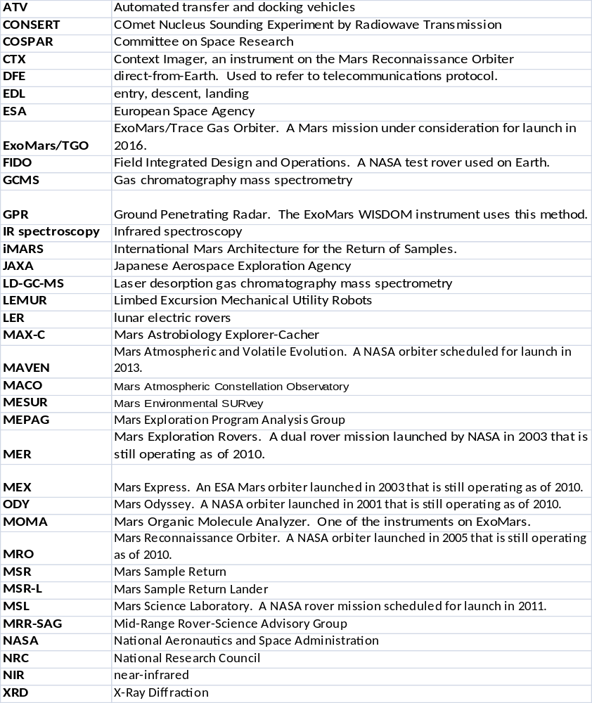
Note to publisher: The following artwork is proposed as a cover illustration for the journal.
New artwork needed here.

Caption: To be written.

Final Report of the MEPAG 2-Rover International Science Analysis Group (2R-iSAG)

